Session 2 - Python Syntax, Keywords, Variables & Comments: Task Report

Task 1: Swiggy order variables
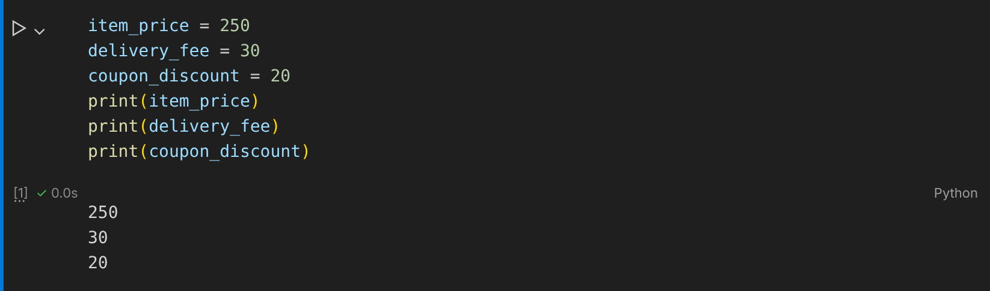

Task 2: Flipkart free delivery check (if-else)
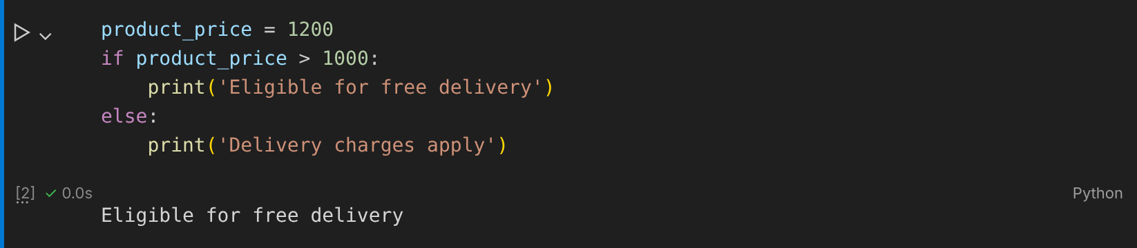

Task 3: Single-line and multi-line comments
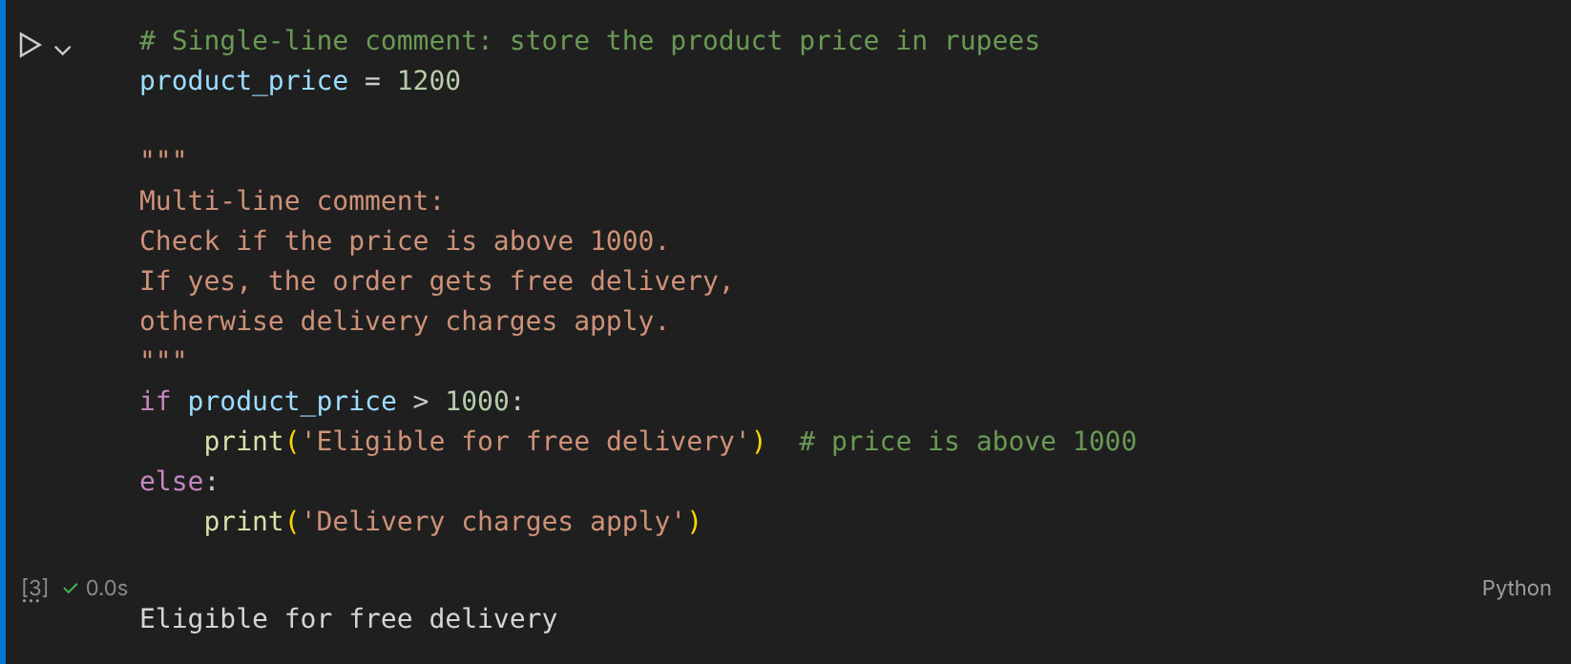

Task 4: IPL match variables (snake_case)
