Session 3 - Data Types in Python: Task Report

Task 1: Variables and their data types
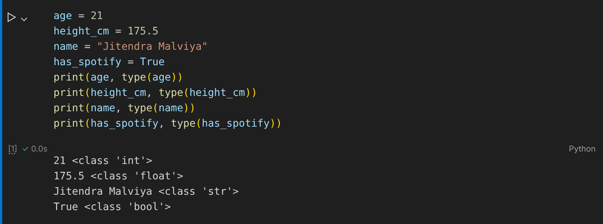

Task 2: total_cart_amount() function
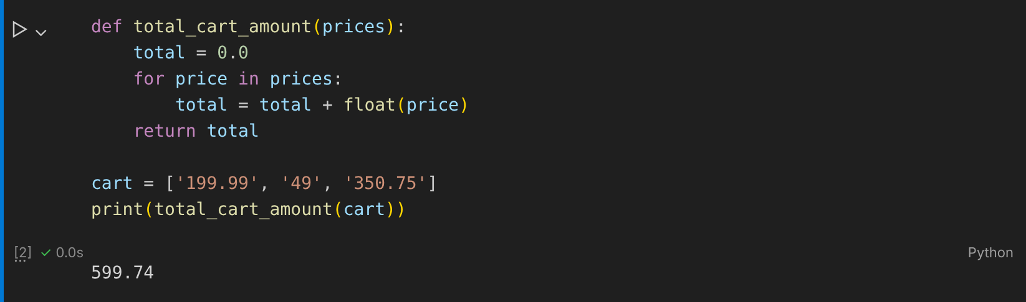

Task 3: Cricket score with input()
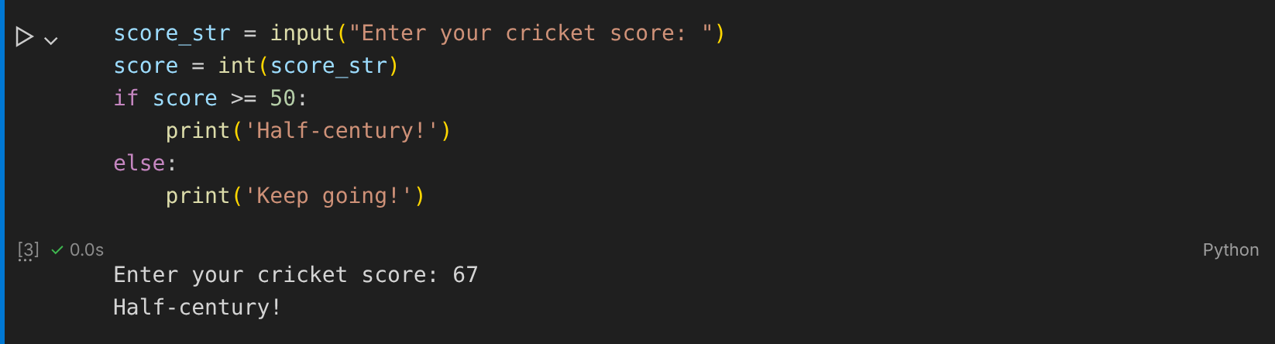

Task 4: is_premium string to boolean
