Session 4 - Strings: Task Report

Task 1: Lowercase and replace dash
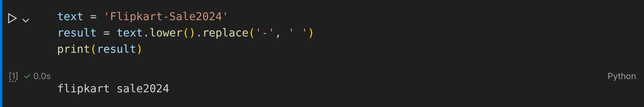

Task 2: Clean the product name
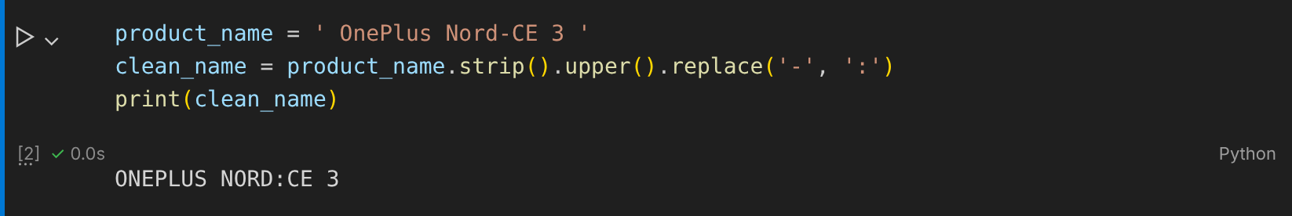

Task 3: split_product_code() function
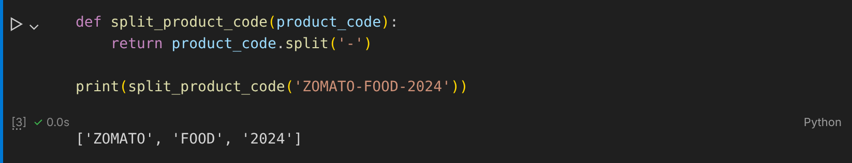

Task 4: Extract 'Premium' using slicing
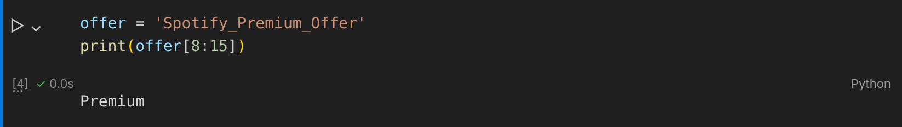

Task 5: Format the Myntra deal message
