Session 5 - Lists & Tuples: Task Report

Task 1: Create the playlist_ids list
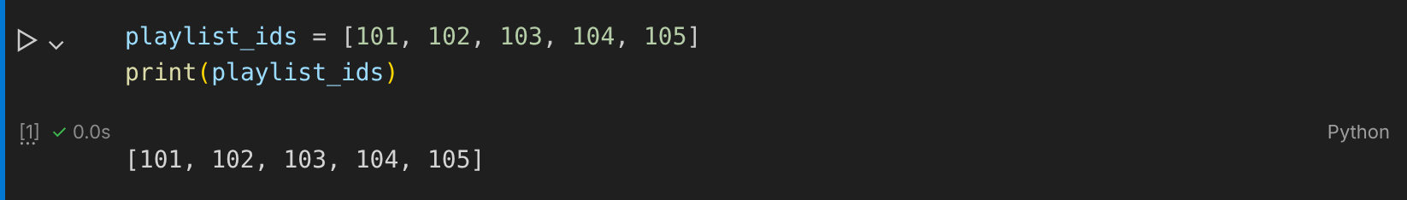

Task 2: Add song IDs with append() and extend()
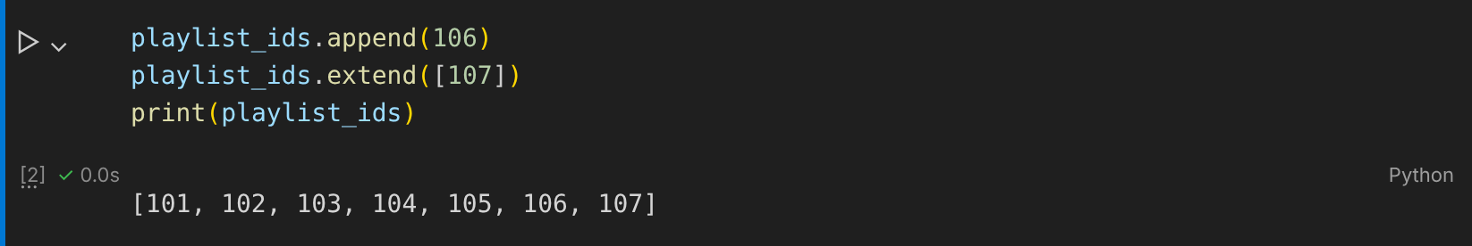

Task 3: Remove the last played song with pop()
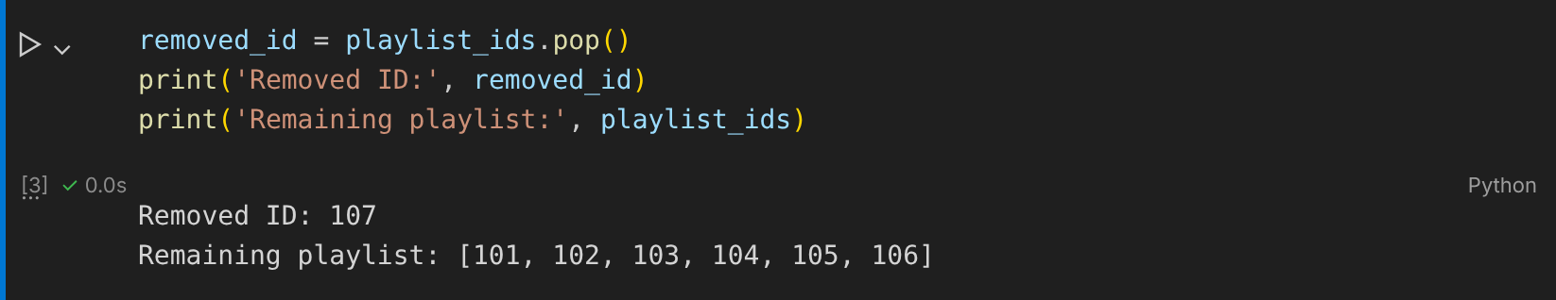

Task 4: Tuple immutability error (insta_filters)
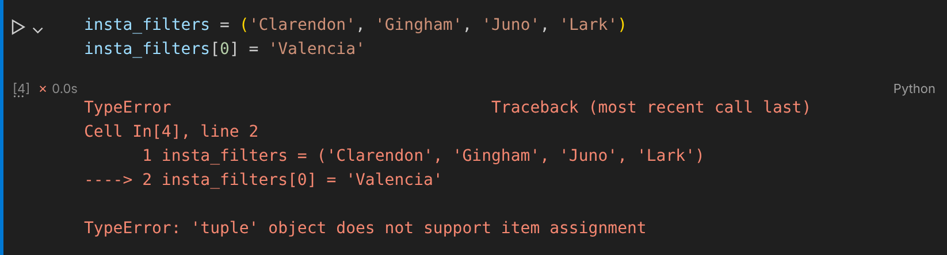

Task 5: List vs tuple scenario
