Session 6 - Dictionaries & Sets: Task Report

Task 1: Create the insta_followers dictionary
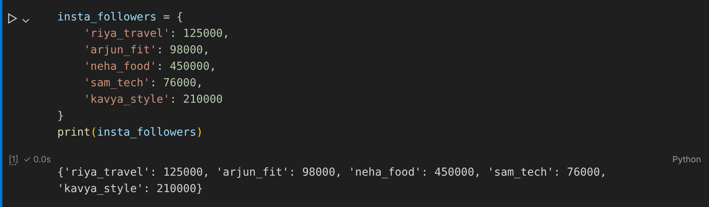

Task 2: Add, update and delete an influencer
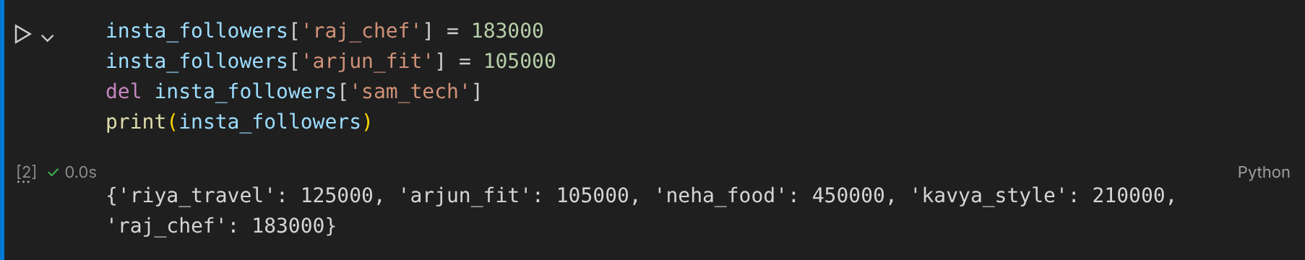

Task 3: Food items costing more than ₹200
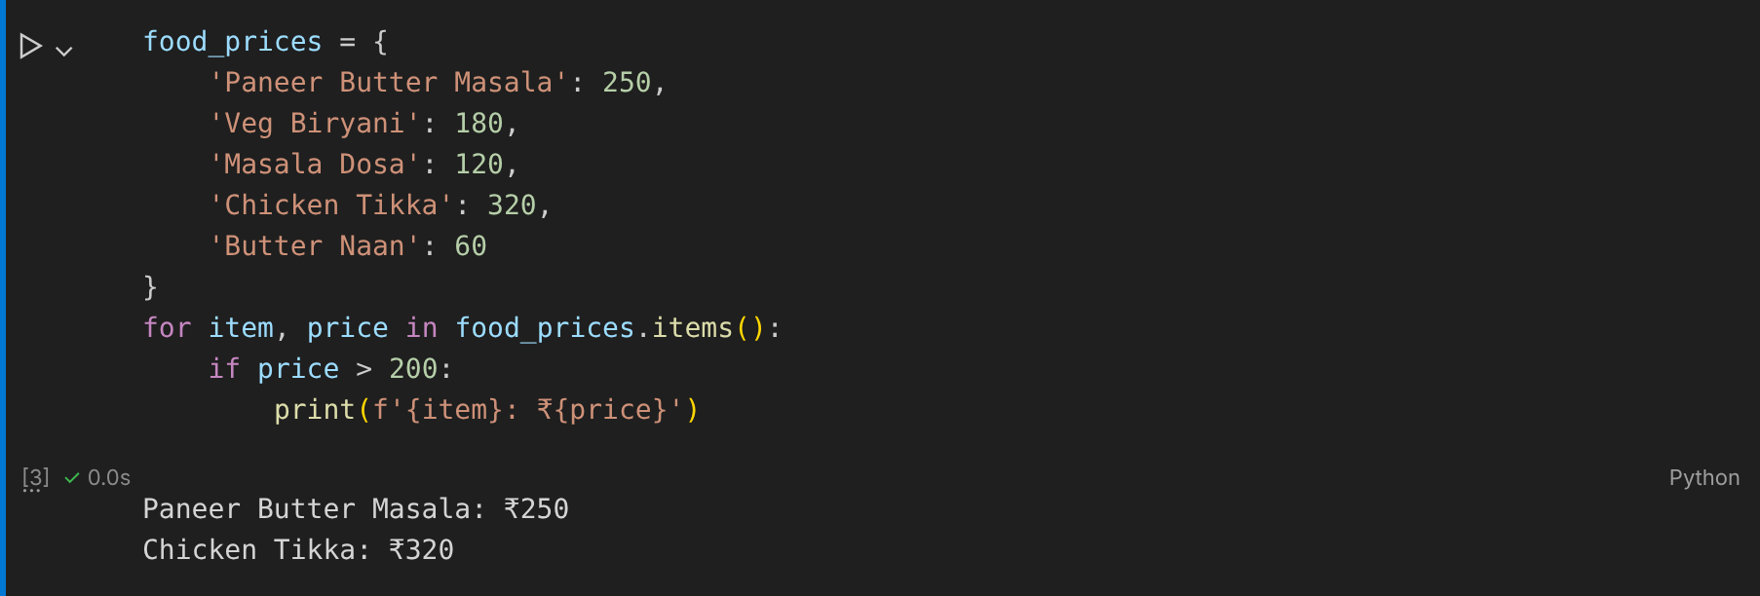

Task 4: Users on both platforms (set intersection)
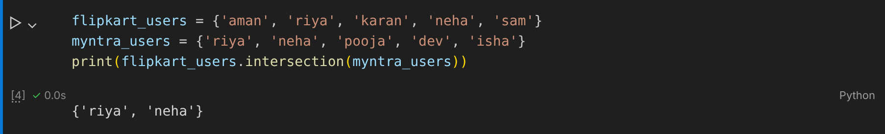

Task 5: get_unique_artists() function (set union)
