Session 7 - Conditional Statements: Task Report

Task 1: Spotify listening time check
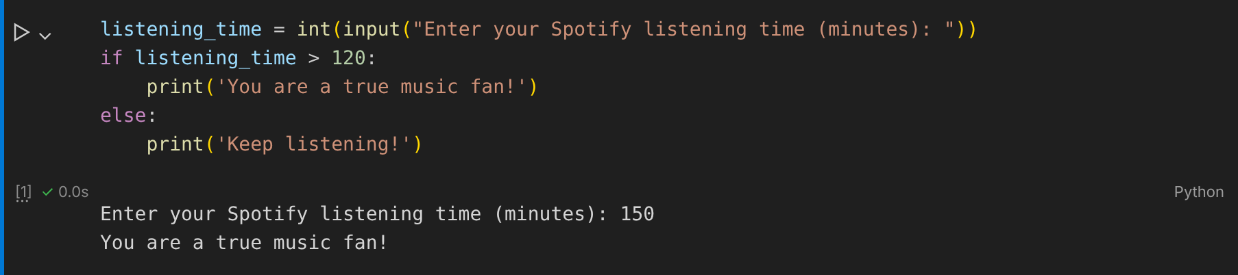

Task 2: Zomato order amount check
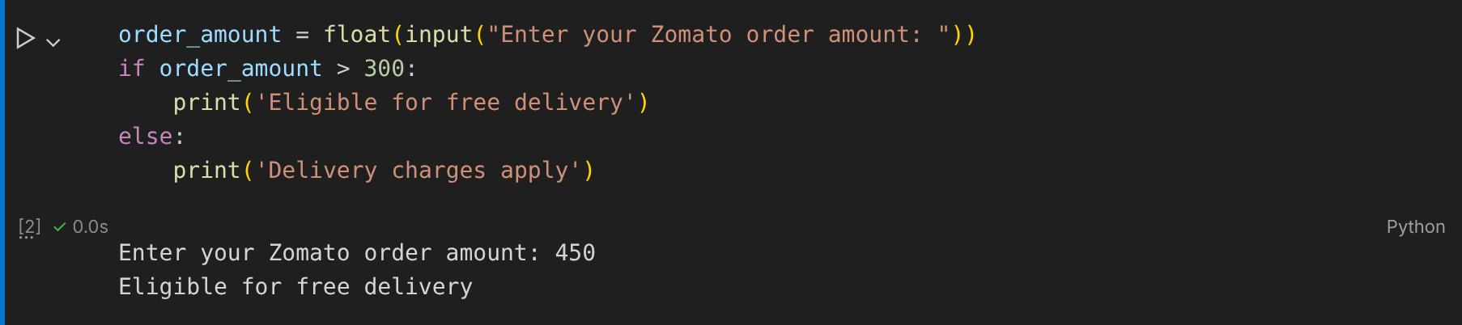

Task 3: Flipkart cart discount (if-elif-else)
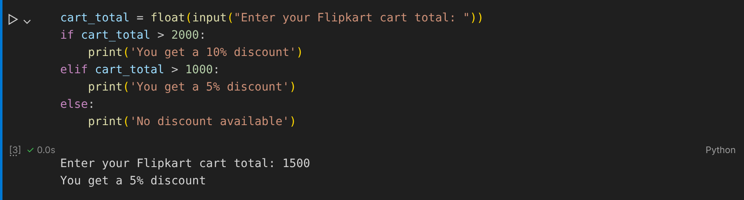

Task 4: IPL fantasy points (nested if-else)
