Session 8 - Loops: Task Report

Task 1: Print food delivery apps (for loop)
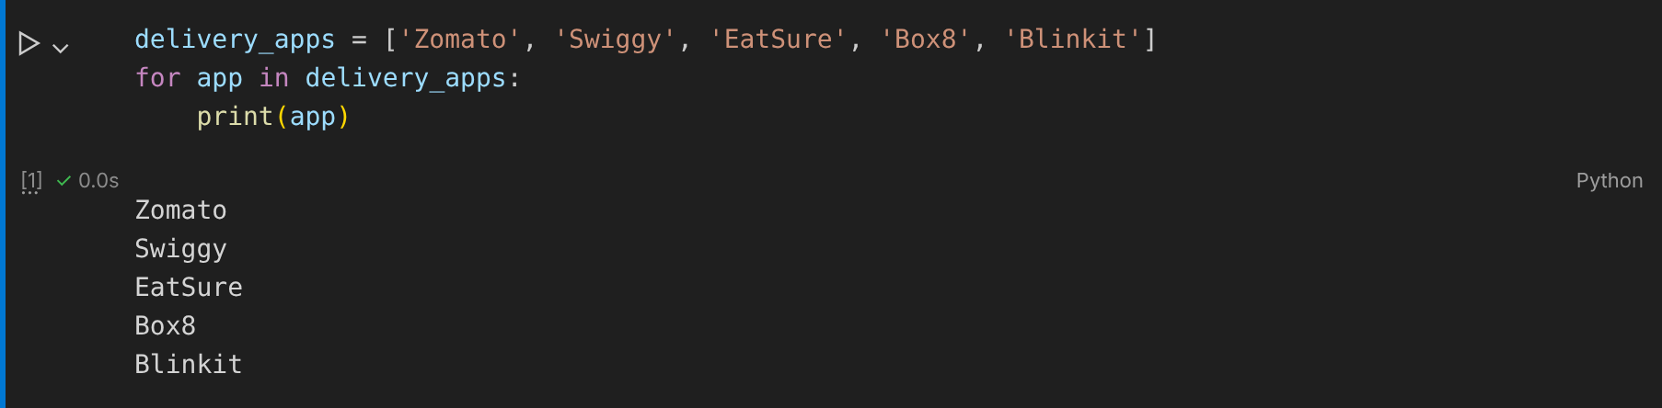

Task 2: First day above 10,000 steps (while loop)
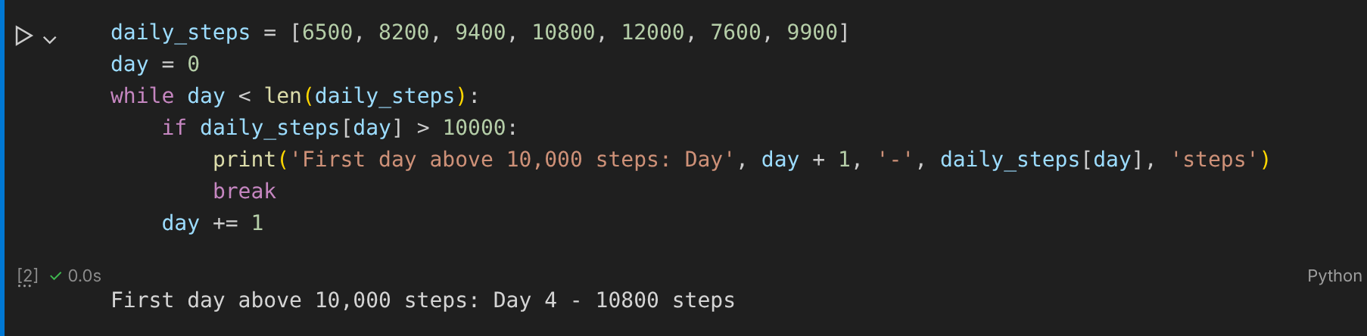

Task 3: IPL teams longer than 6 characters (continue)
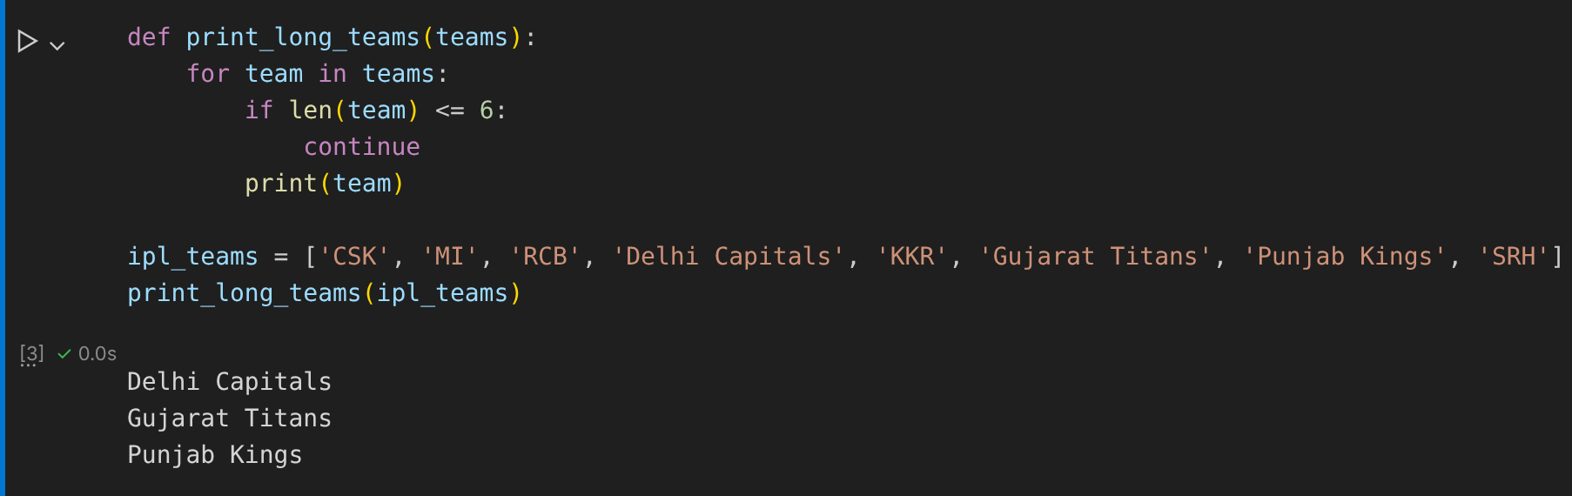

Task 4: Song positions and durations (enumerate)
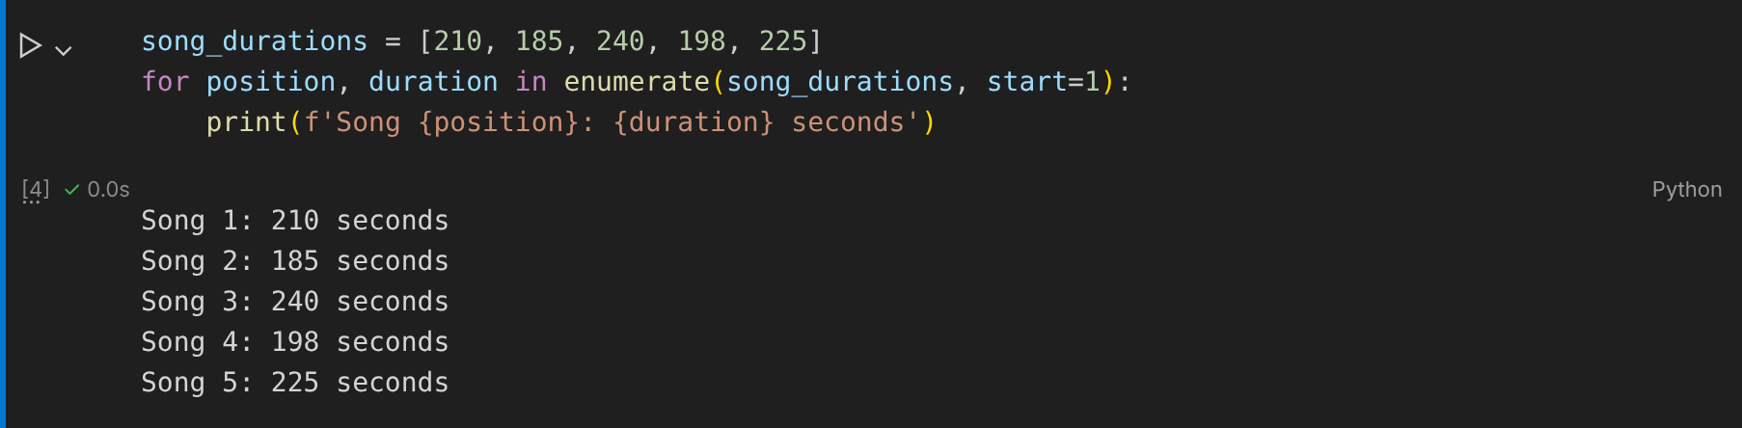

Task 5: Flipkart cart total (break and continue)
