Session 9 - Functions: Task Report

Task 1: calculate_final_price() function
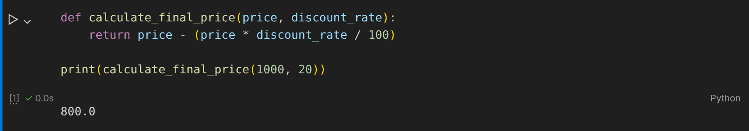

Task 2: get_delivery_charge() with default city
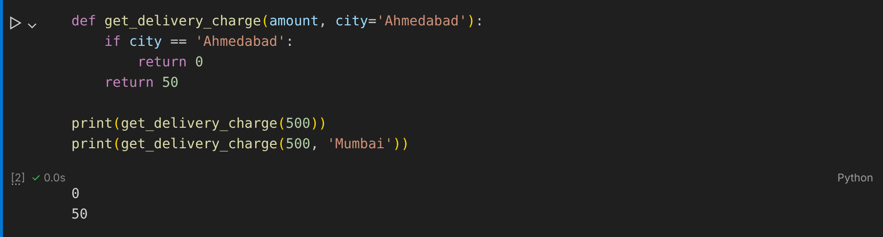

Task 3: format_price() with default currency
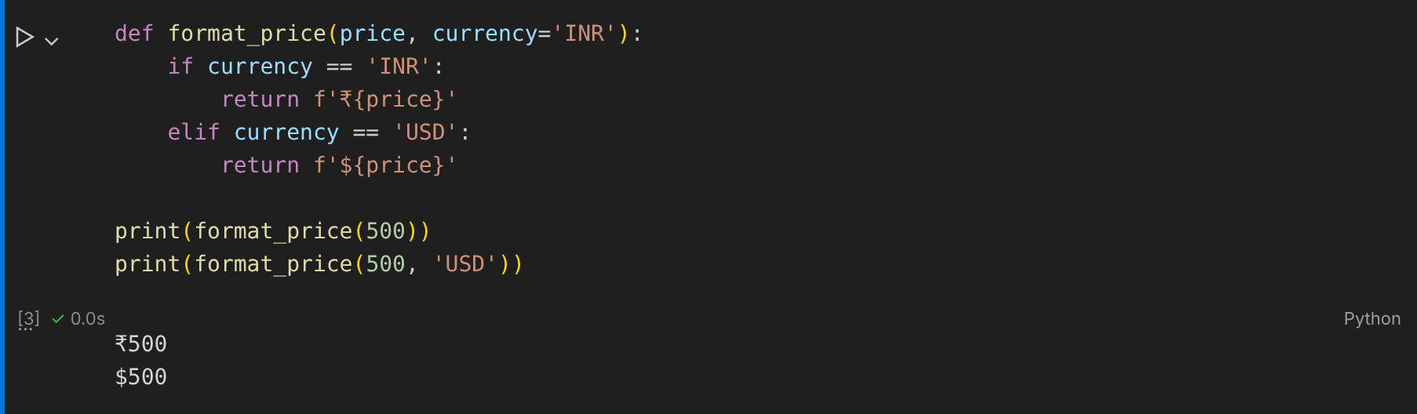

Task 4: apply_coupon() with default coupon_code
