Session 16 - SQL Project - Sales Analysis

Task 1: Import food delivery orders CSV into the FoodOrders table
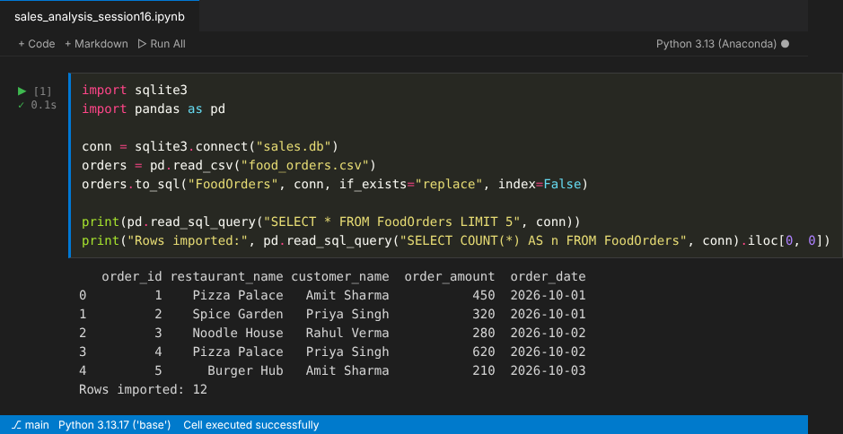

Task 2: Create the TopSongs table and insert 5 records
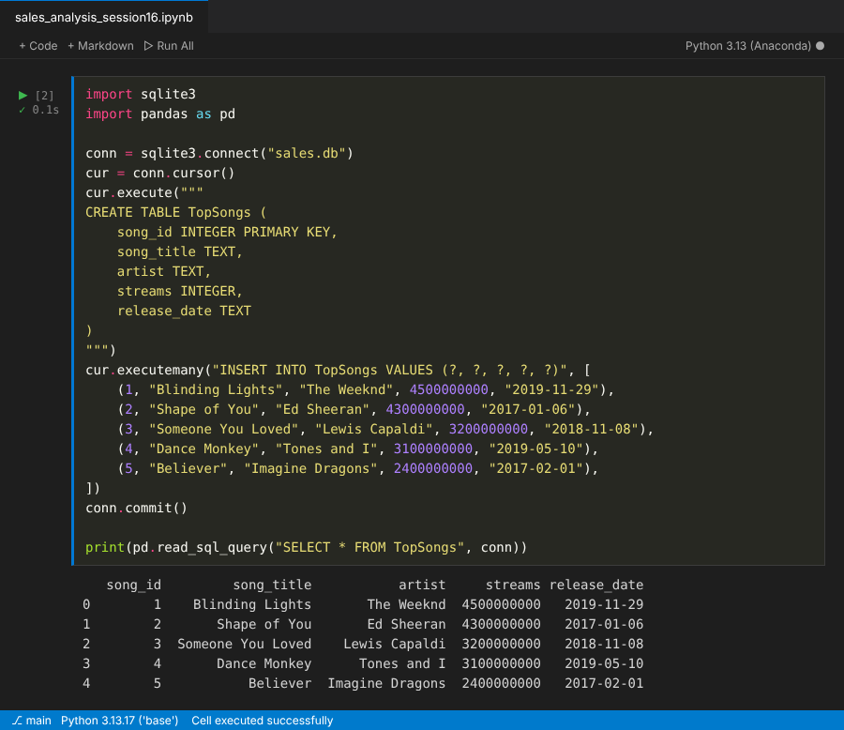

Task 3: Top 3 customers by total spent
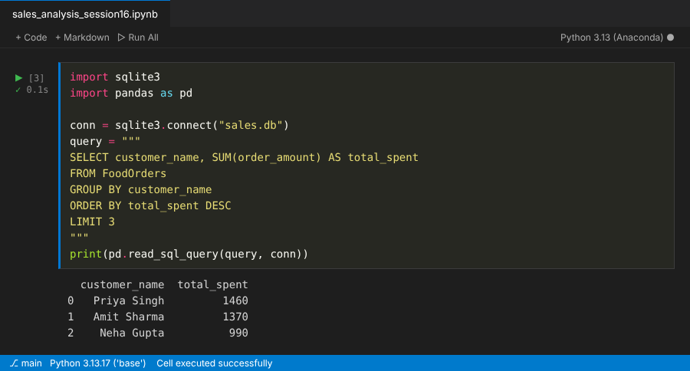

Task 4: Restaurant performance report
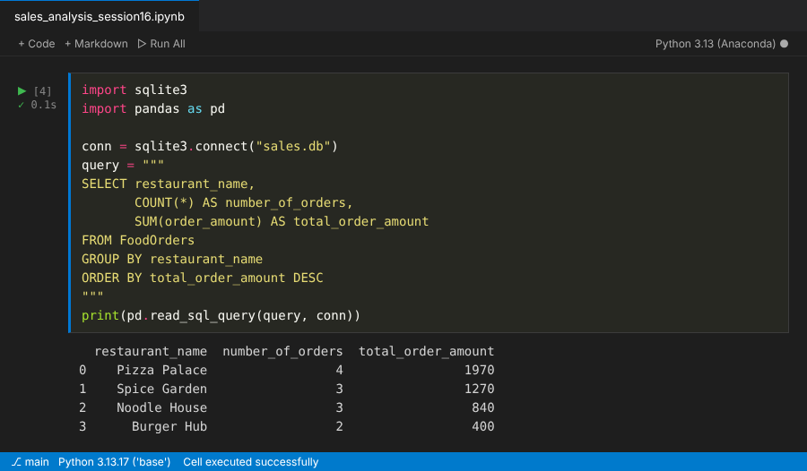

Task 5: KPIs for FoodOrders (kpi_name, kpi_value)
