Session 17 - SQL Project - HR Analysis

Task 1: Create the Restaurant table and insert sample rows
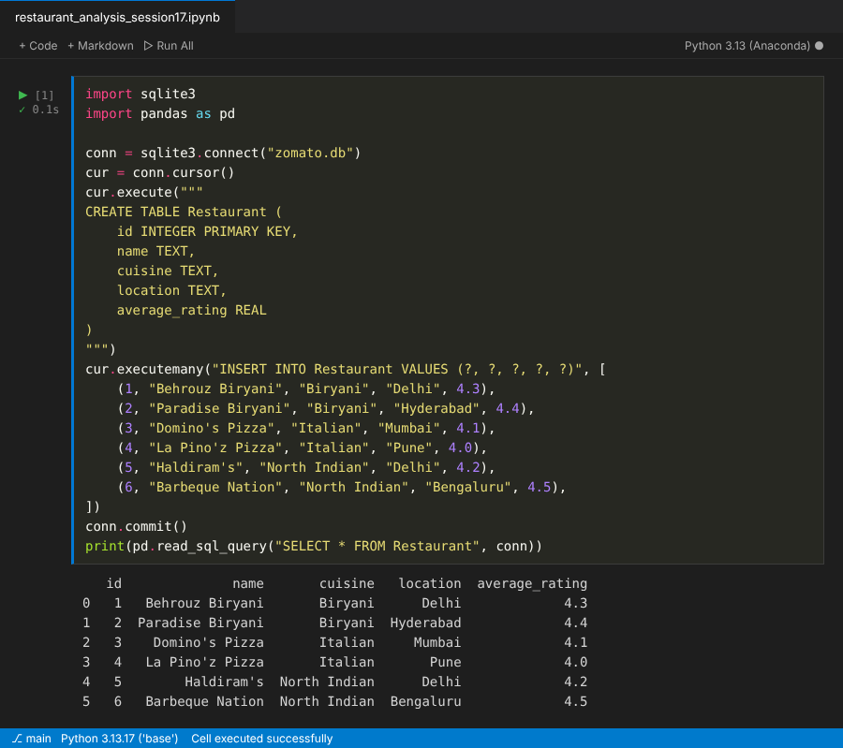

Task 2: Number of restaurants per cuisine
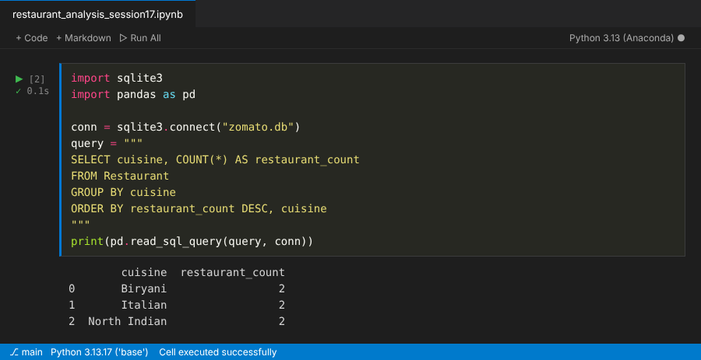

Task 3: Create the Review table and insert 12 reviews
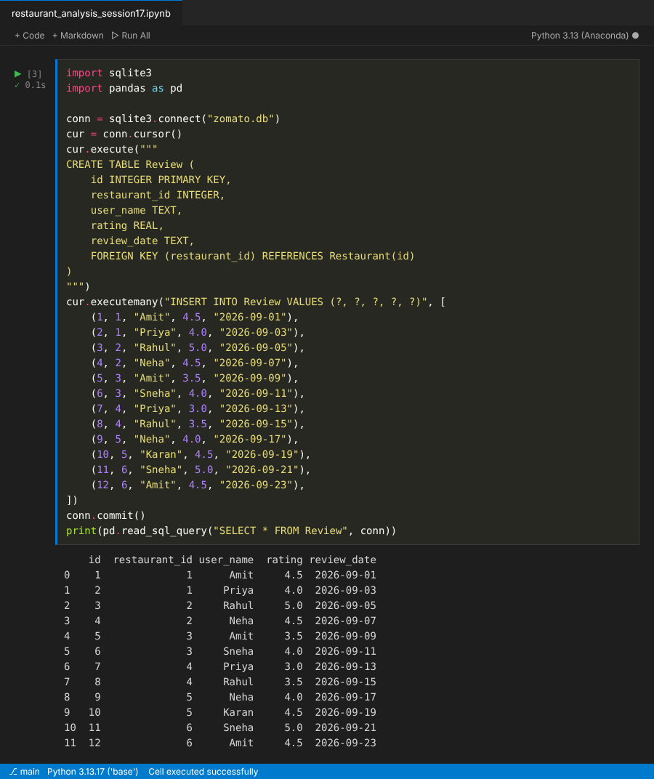

Task 4: Average review rating per restaurant (JOIN)
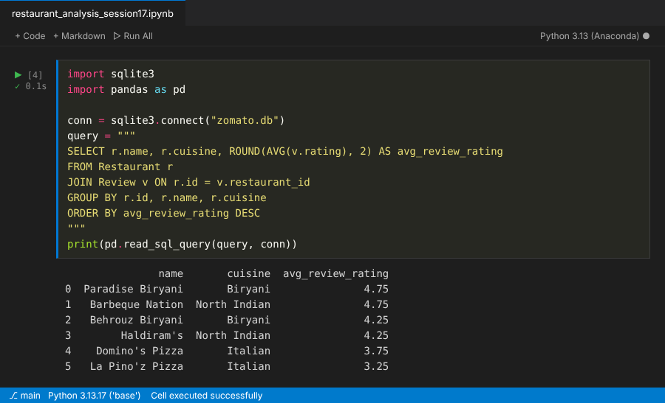

Task 5: Rank restaurants by rating within each cuisine
