Session 18 - Interview Questions + Final Revision

Task 1: Artists with more than 3 songs
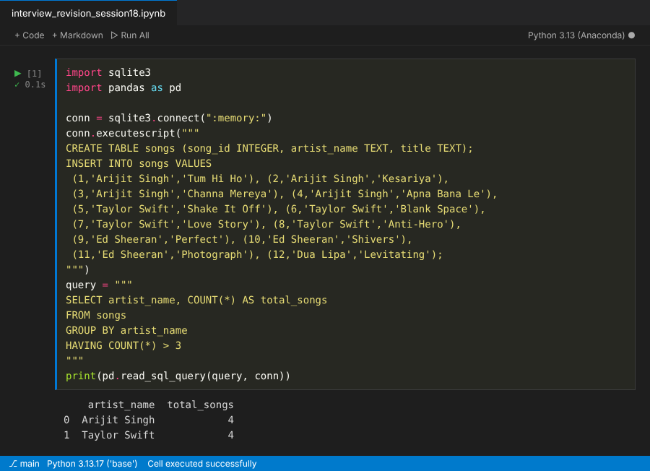

Task 2: Username with total order amount (JOIN)
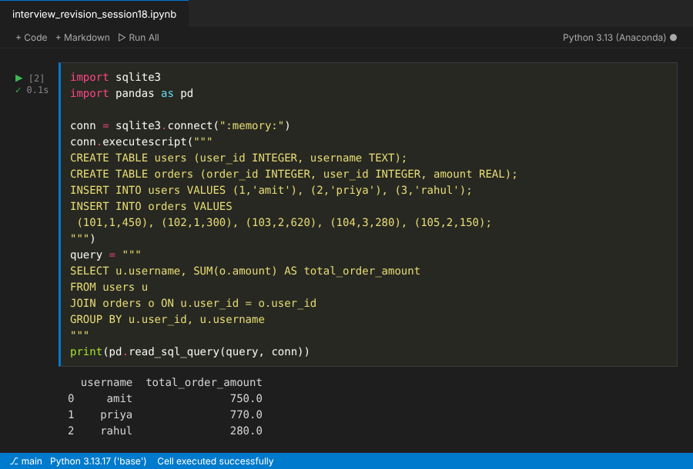

Task 3: Restaurants rated above the average (subquery)
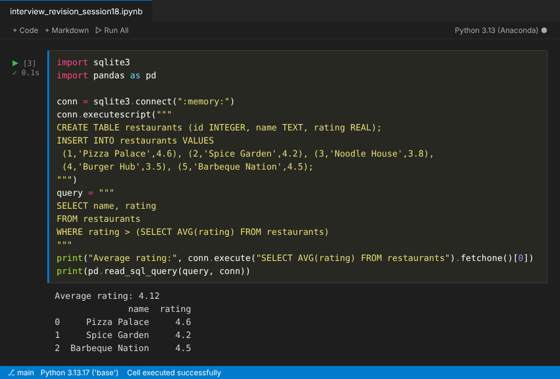

Task 4: Running total per user (window function)
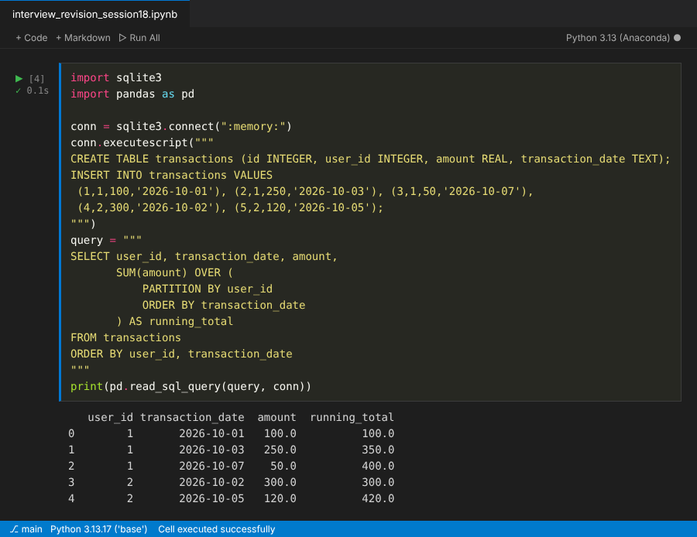

Task 5: Two optimizations for a Flipkart category and price filter
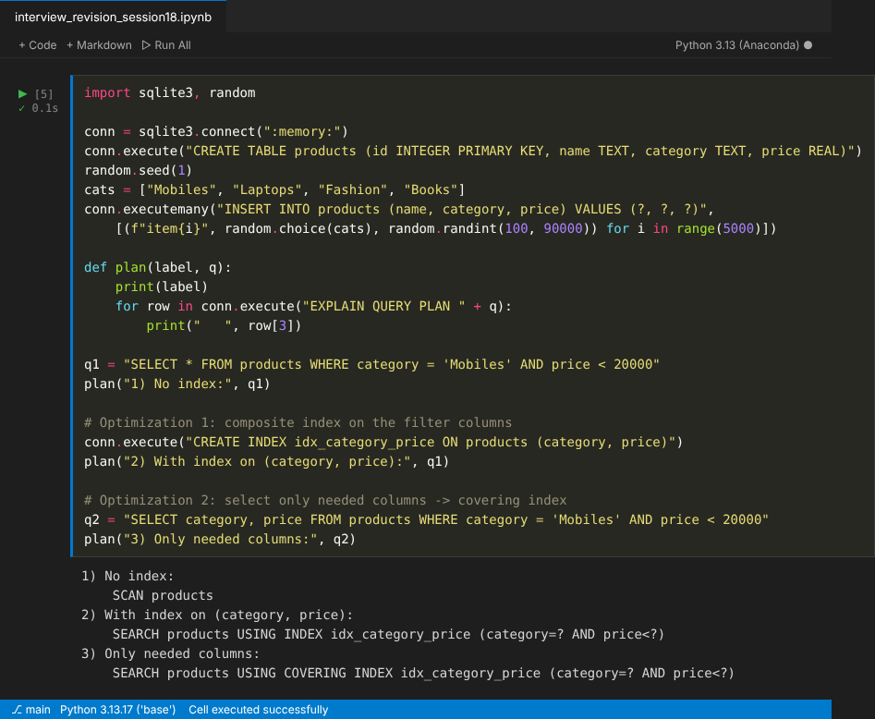
- Composite index on (category, price): the database jumps straight to the matching category and price range instead of scanning every row (SCAN became SEARCH).
- Select only the needed columns instead of SELECT *: the index alone can answer the query (COVERING INDEX), so the database never reads the full table rows.

