Session 2: Database Setup + CREATE TABLE

Task 1: Install SQLite and verify the connection
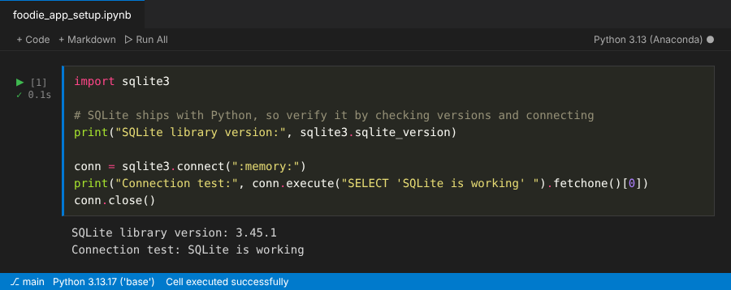

Task 2: Create the foodie_app database
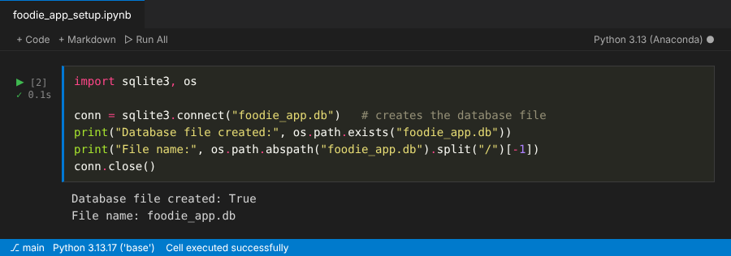

Task 3: Create the restaurants table
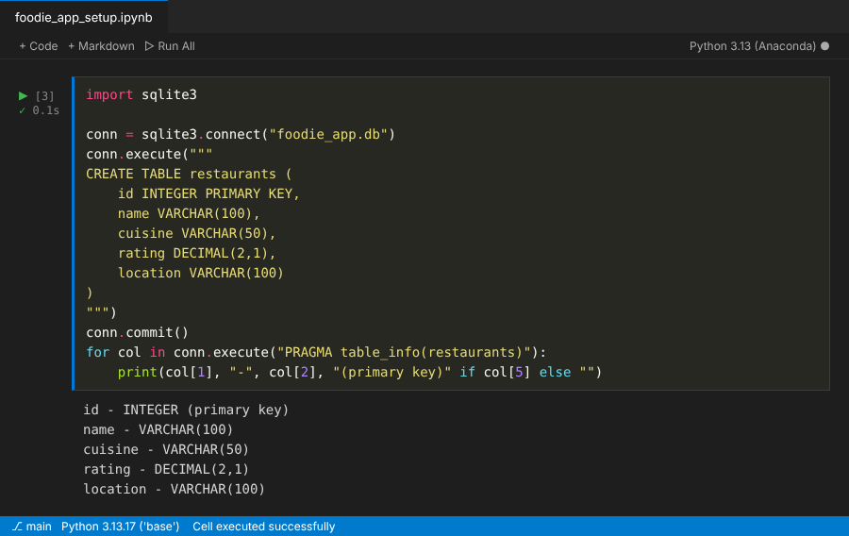

Task 4: Create the users table
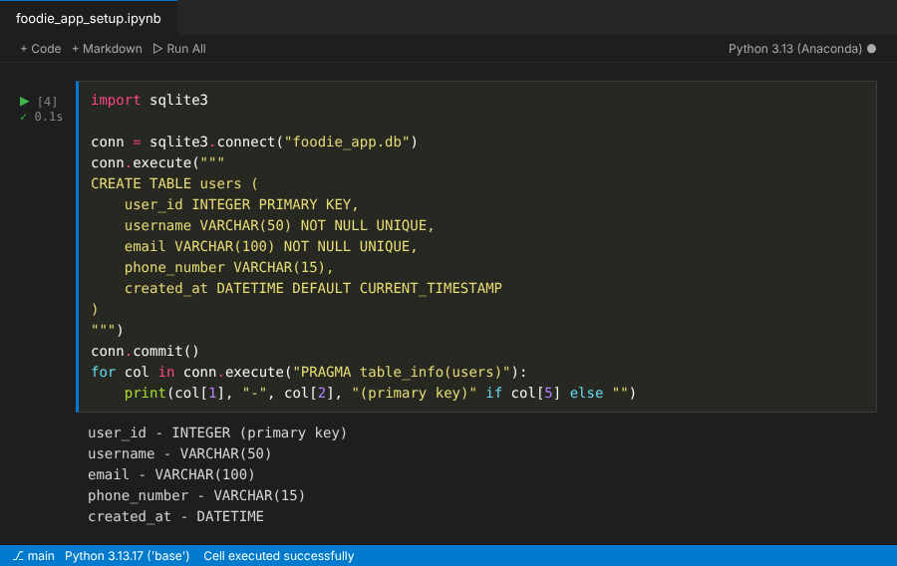

Task 5: Intentional error and its fix
