Session 3: INSERT, UPDATE & DELETE

Task 1: Create the Playlist table and insert one favorite song
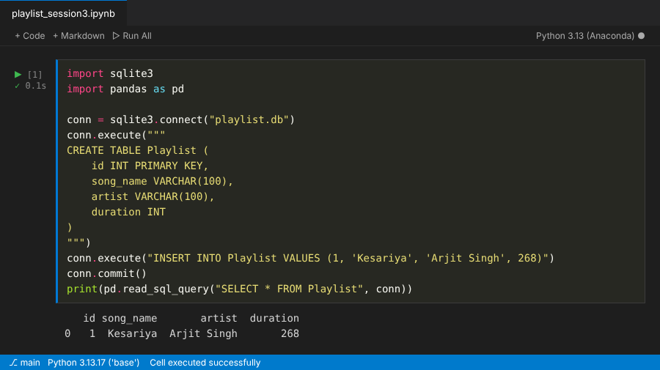

Task 2: Insert 3 new songs
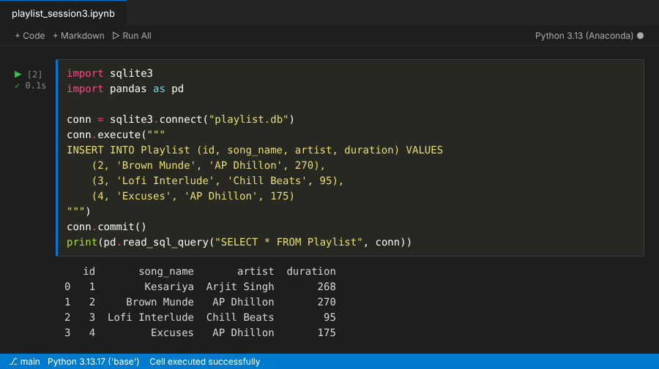

Task 3: Fix the artist name typo with UPDATE
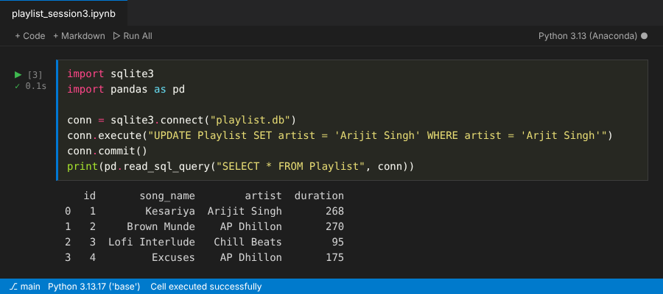

Task 4: Delete songs shorter than 120 seconds
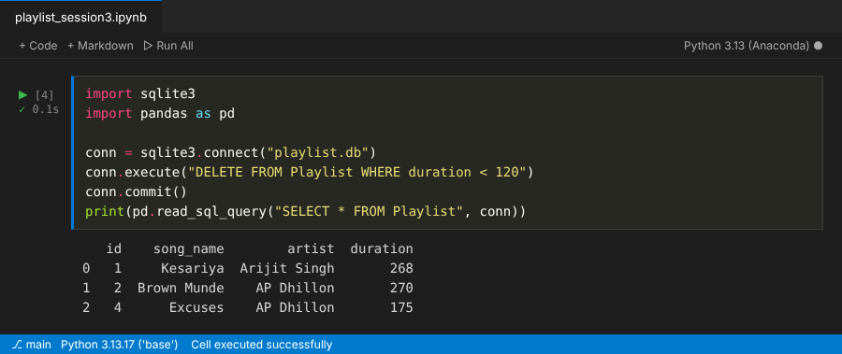

Task 5: Add (Remix) to AP Dhillon songs longer than 180 seconds
