Case Study: Zomato Bangalore Restaurants - SQL Analysis

Task 1: Top 5 highest-rated North Indian restaurants in Koramangala
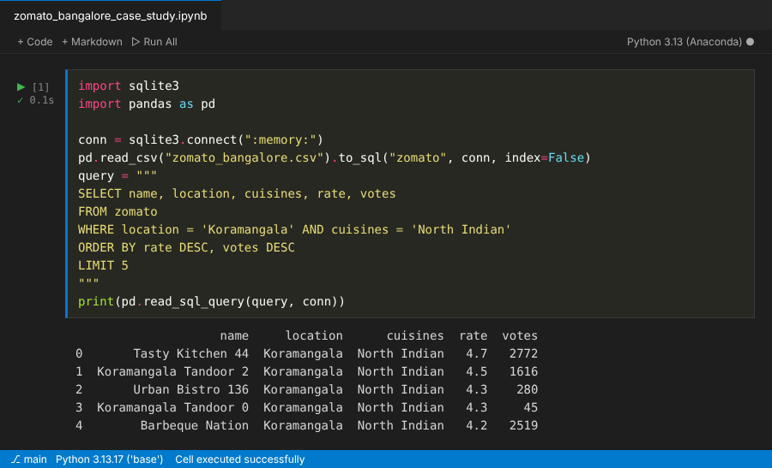

Task 2: Average cost for two per cuisine and the 3 most expensive cuisines
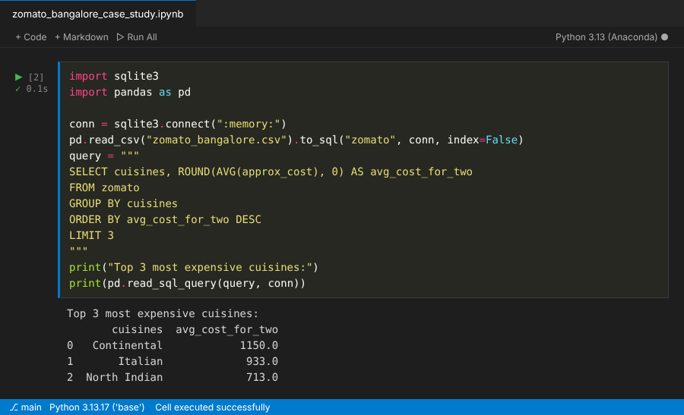

Task 3: Online-delivery restaurants rated below 3.0
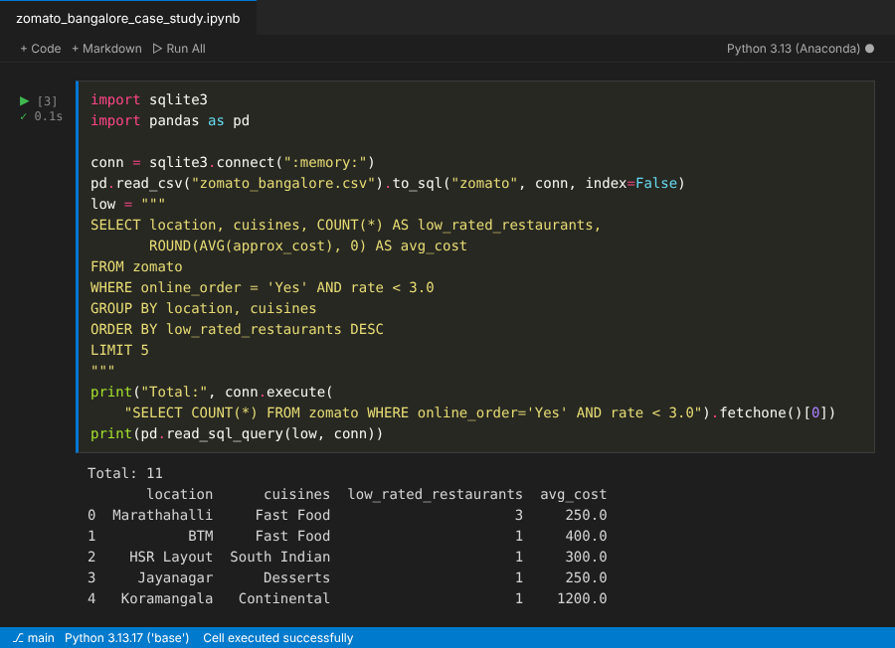
Marketing strategy:
- Low ratings cluster in budget Fast Food outlets in Marathahalli and BTM (average cost about 250 to 400 for two), so run a quality and delivery-time campaign there first.
- Partner with these outlets on faster delivery, a rating-recovery offer for repeat customers, and a push for fresh reviews after improvements.

Task 4: Market segments by average cost for two
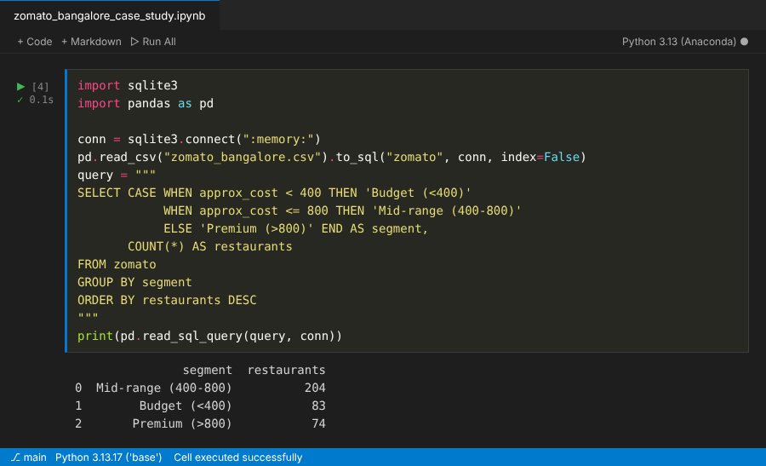

Task 5: Top 10 restaurant chains by number of outlets
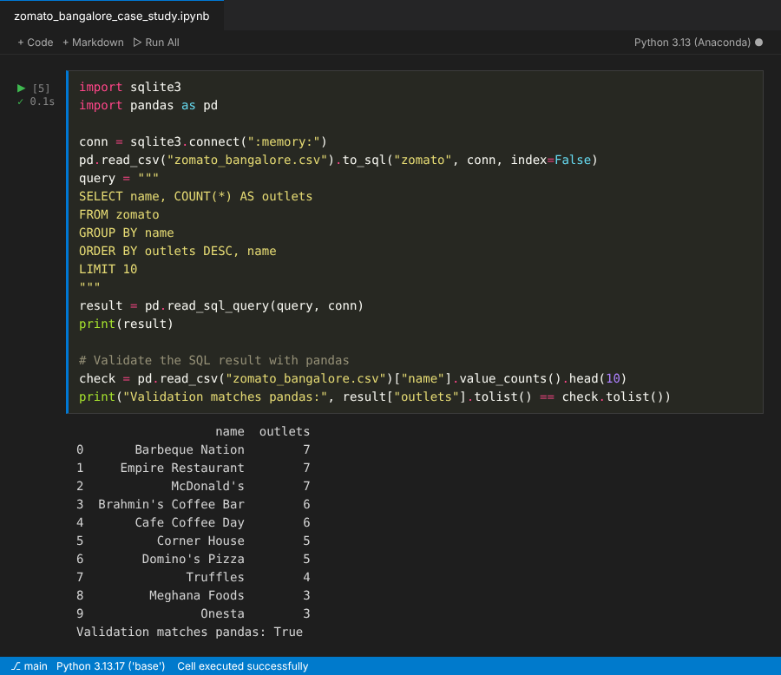
Validation: the SQL result was cross-checked with a pandas value_counts() on the same data and matched.

