ssSESSION -1 Database Introduction & SQL Basics
Task 1
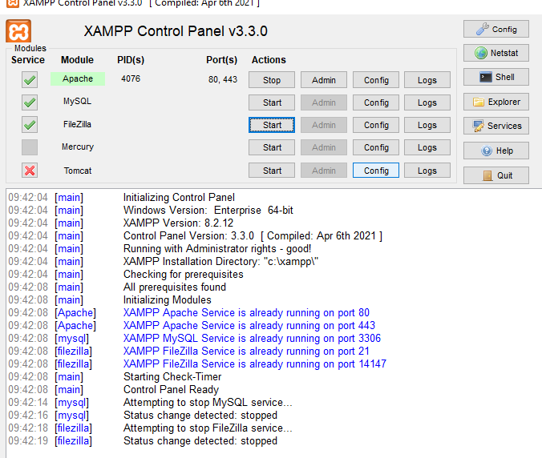
CREATE DATABASE music_streaming_app;
USE music_streaming_app;
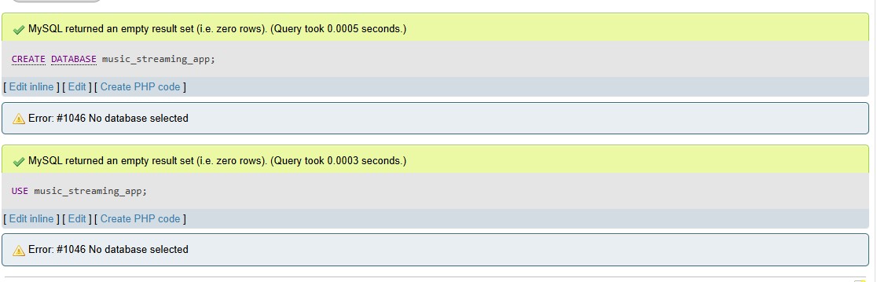

Task – 2
CREATE TABLE playlists (
playlist_id INT PRIMARY KEY,
name VARCHAR(255),
created_by VARCHAR(255)
);
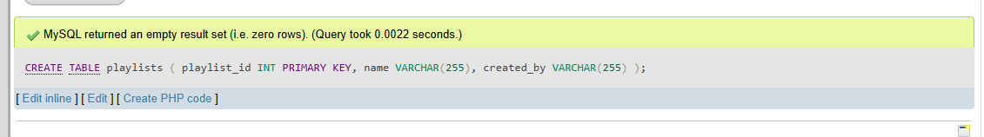
Task -3
INSERT INTO playlists (playlist_id, name, created_by) VALUES
(1, 'Bollywood Hits', 'Amit'),
(2, 'Chill Vibes', 'Priya'),
(3, 'Workout Mix', 'Rohan');
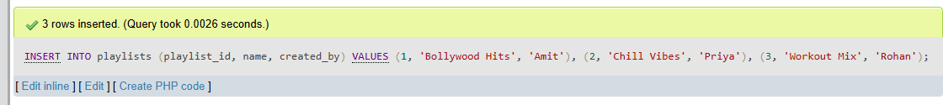
Task – 4
SELECT *
FROM playlists
WHERE created_by = 'Amit';
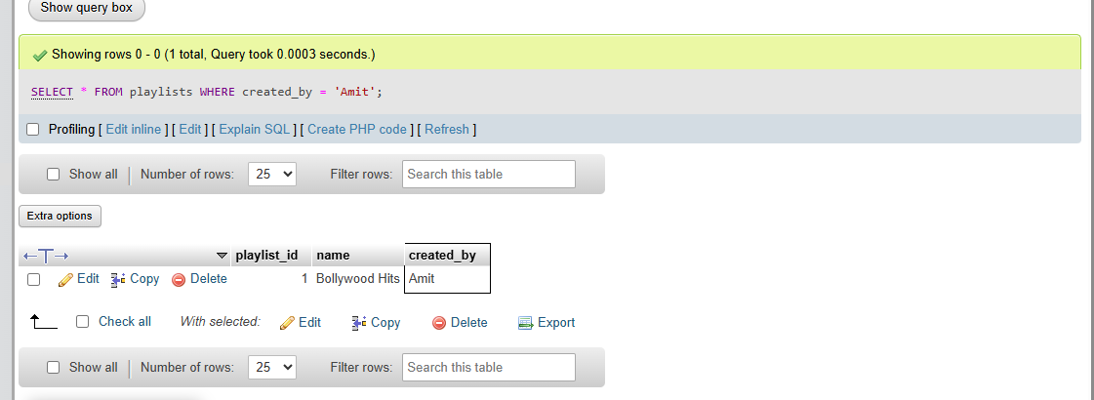

Task – 5
Table, Row, and Column Explanation (Zomato Example)
Imagine you are looking at the database of a food delivery platform like Zomato:
- Table (restaurants): The entire structured spreadsheet or collection holding a specific type of data. In Zomato, the restaurants table stores all information about listed eateries.
- Column (Attribute/Field): The vertical categories defining specific data points each restaurant must provide. Examples include restaurant_id, restaurant_name, cuisine, and rating.
- Row (Record/Tuple): A single horizontal entry representing one individual restaurant across all defined columns. For example: [101, 'Haldiram’s', 'North Indian / Sweets', 4.3]

SESSION -4
Task – 1
CREATE TABLE MusicPlaylist (
id INT PRIMARY KEY,
song_name VARCHAR(100),
artist VARCHAR(100),
genre VARCHAR(50),
duration DECIMAL(4, 2)
);
INSERT INTO MusicPlaylist (id, song_name, artist, genre, duration) VALUES
(1, 'Blinding Lights', 'The Weeknd', 'Synthwave', 3.20),
(2, 'Shape of You', 'Ed Sheeran', 'Pop', 3.53),
(3, 'Levitating', 'Dua Lipa', 'Pop', 3.23),
(4, 'Starboy', 'The Weeknd', 'R&B', 3.50),
(5, 'Believer', 'Imagine Dragons', 'Rock', 3.24);

SELECT *
FROM MusicPlaylist;

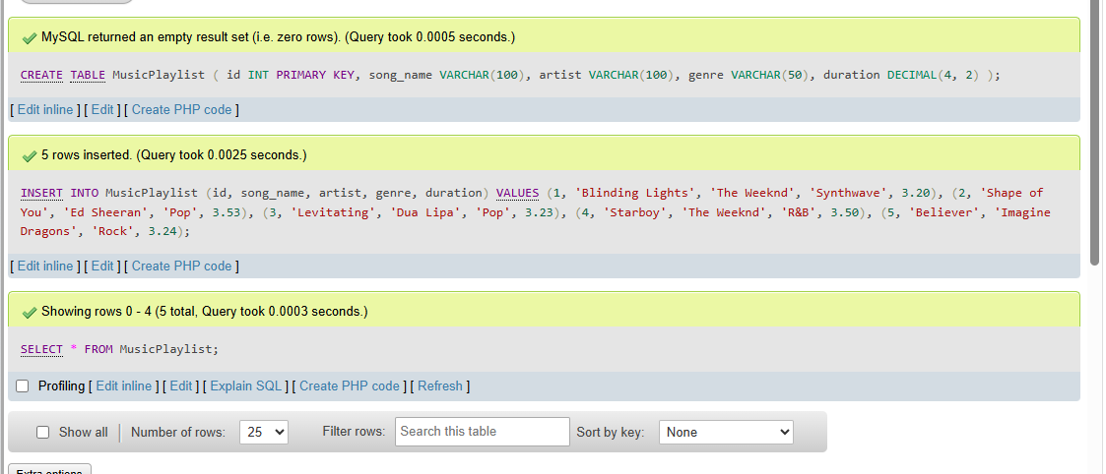
Task – 2
SELECT song_name, artist FROM MusicPlaylist LIMIT 3;
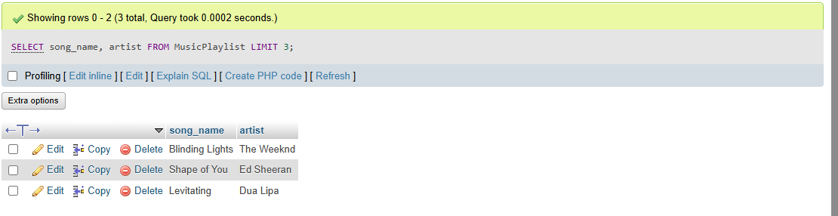
Task – 3
SELECT DISTINCT restaurant
FROM FoodOrders;
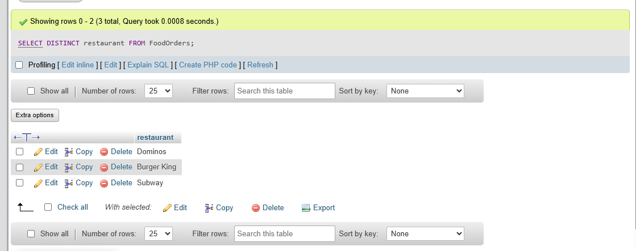
Task – 4
SELECT
food_item AS `Dish`,
order_date AS `Date Ordered`
FROM FoodOrders;

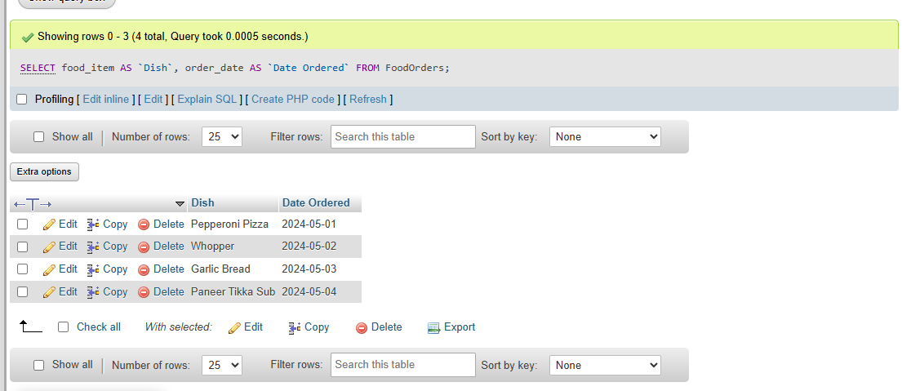
Task – 5
SELECT DISTINCT food_item, restaurant FROM FoodOrders LIMIT 2
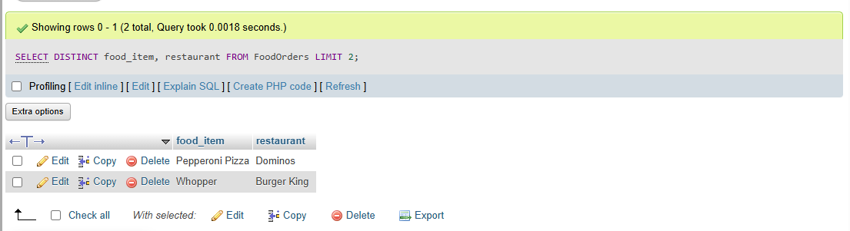

SESSION -5
Task – 1
CREATE TABLE Restaurants (
id INT PRIMARY KEY,
name VARCHAR(100),
cuisine VARCHAR(50),
rating DECIMAL(2, 1),
city VARCHAR(50)
);
INSERT INTO Restaurants (id, name, cuisine, rating, city) VALUES
(1, 'Swagat Restaurant', 'South Indian', 4.3, 'Ahmedabad'),
(2, 'Swadisht Snacks', 'Fast Food', 3.8, 'Surat'),
(3, 'Dragon House', 'Chinese', 4.5, 'Ahmedabad'),
(4, 'Little Italy', 'Italian', 4.2, 'Vadodara'),
(5, 'Swaad Punjab Da', 'North Indian', 3.4, 'Surat');
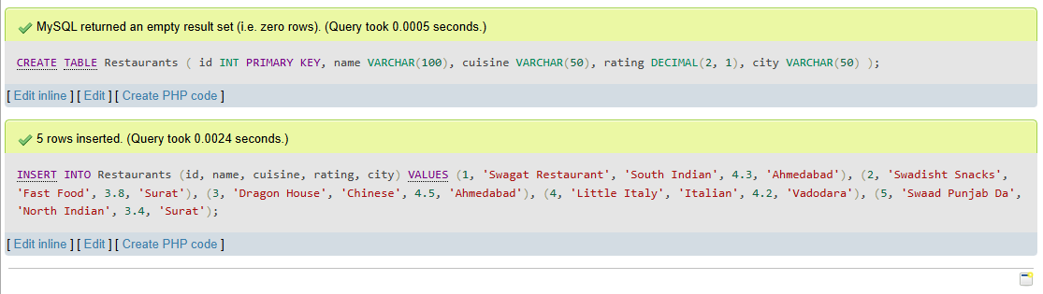

Task – 2
SELECT *
FROM Restaurants
WHERE rating > 4.0
AND city IN ('Ahmedabad', 'Surat');
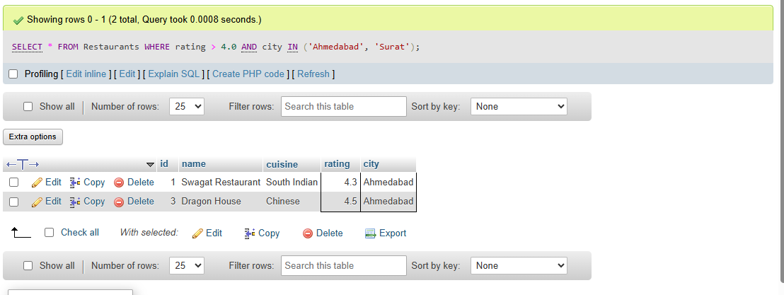
Task – 3
SELECT *
FROM Restaurants
WHERE name LIKE 'Swa%';
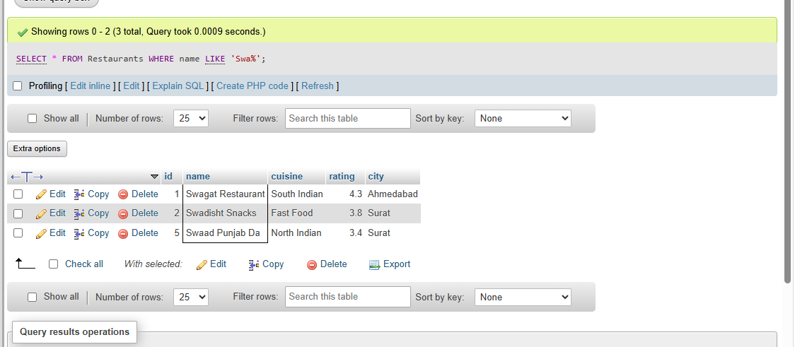

Task – 4
SELECT *
FROM Restaurants
WHERE rating BETWEEN 3.5 AND 4.5;
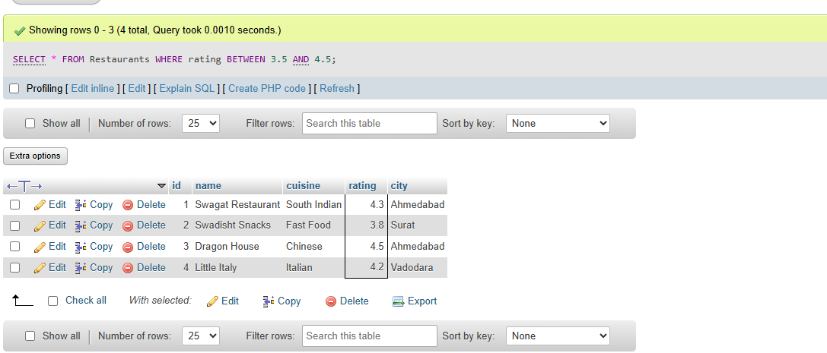
Task – 5
SELECT *
FROM Restaurants
WHERE cuisine IN ('Chinese', 'Italian', 'South Indian');
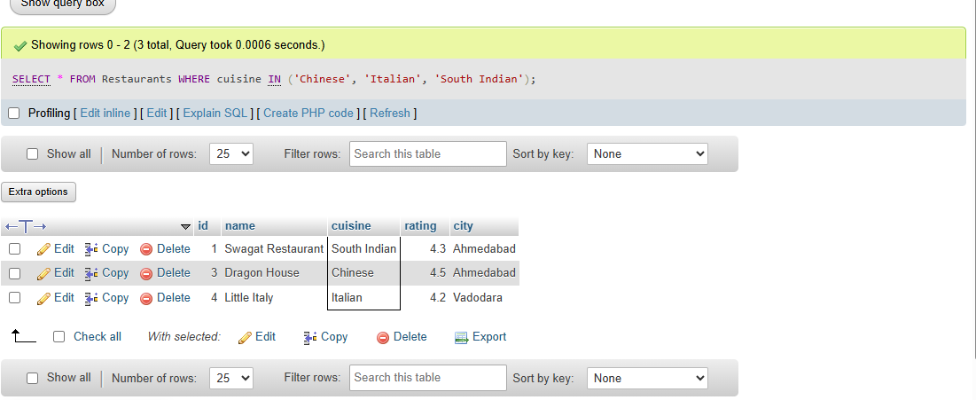

SESSION -6
Task – 1
SELECT *
FROM products
ORDER BY price ASC;
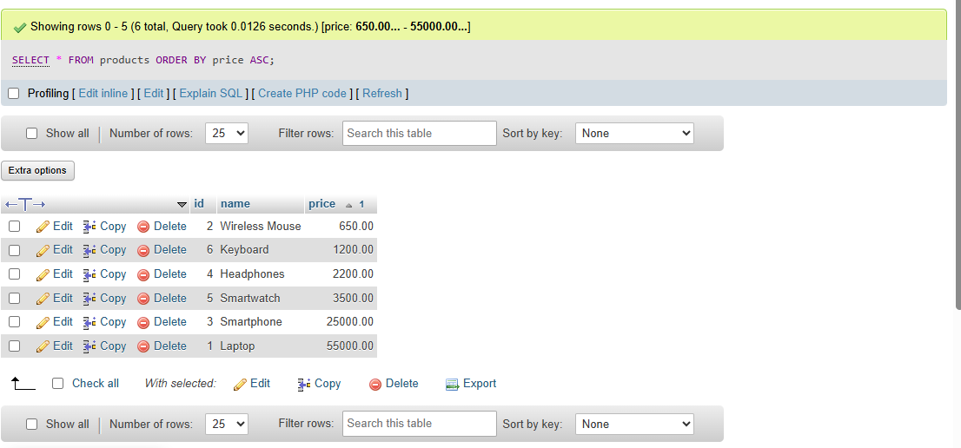
Task - 2
SELECT * FROM products ORDER BY price DESC LIMIT 5;
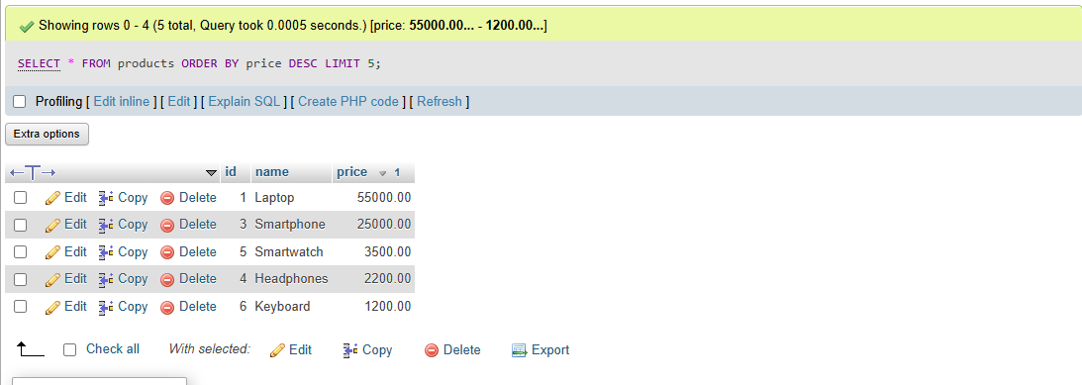
Task – 3
SELECT title, release_year, rating FROM movies ORDER BY release_year DESC, rating DESC;
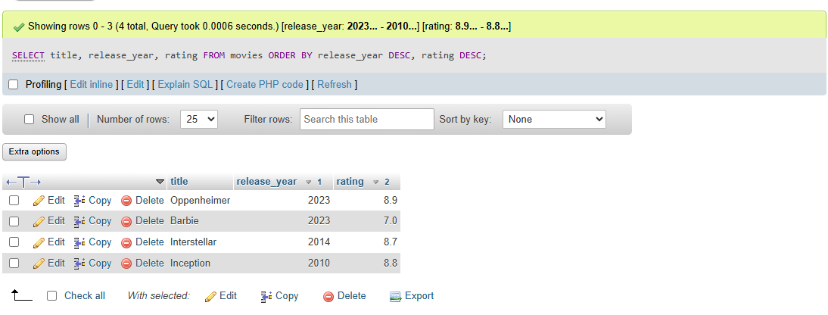
Task – 4
SELECT *
FROM restaurants
ORDER BY name ASC
LIMIT 10;
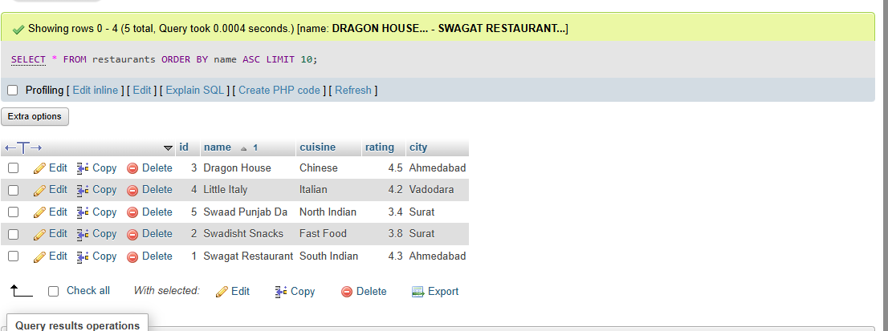
Task – 5
SELECT *
FROM songs
ORDER BY play_count DESC, id DESC
LIMIT 3;
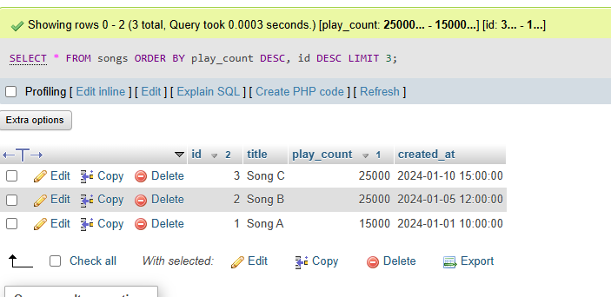

SESSION -7
Task – 1
CREATE TABLE Orders (
order_id INT PRIMARY KEY,
user_name VARCHAR(100),
total_amount DECIMAL(10, 2),
order_date DATE
);
INSERT INTO Orders (order_id, user_name, total_amount, order_date) VALUES
(1, 'Rahul', 1250.50, '2024-05-01'),
(2, 'Priya', NULL, '2024-05-02'),
(3, 'Rahul', 450.00, '2024-05-03'),
(4, 'Amit', 2300.00, '2024-05-04'),
(5, 'Sneha', 890.00, '2024-05-05');
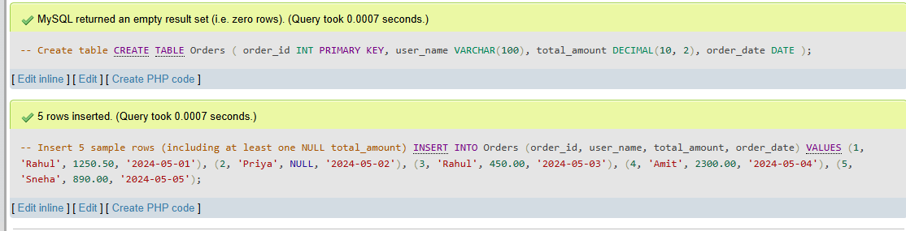

Task – 2
SELECT
user_name,
COUNT(*) AS order_count
FROM Orders
GROUP BY user_name;
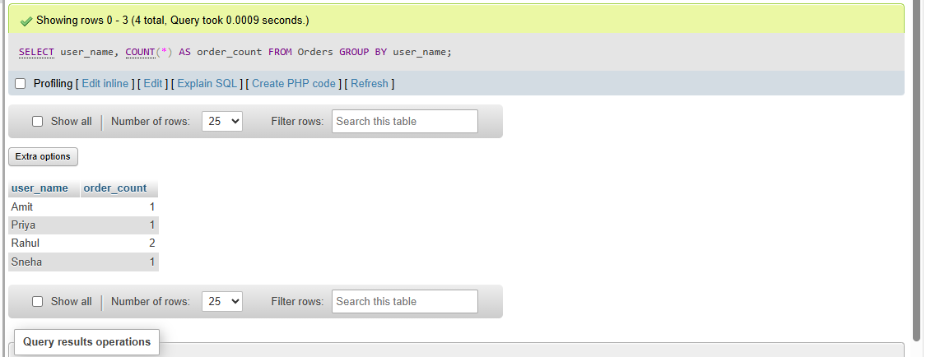
Task – 3
SELECT AVG(total_amount) AS average_total_amount
FROM Orders;
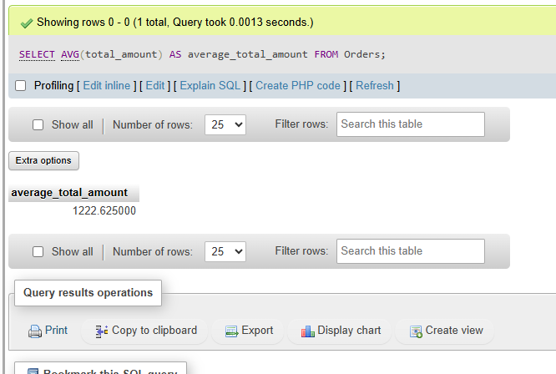

Task – 4
SELECT
MAX(total_amount) AS max_order_amount,
MIN(total_amount) AS min_order_amount
FROM Orders;
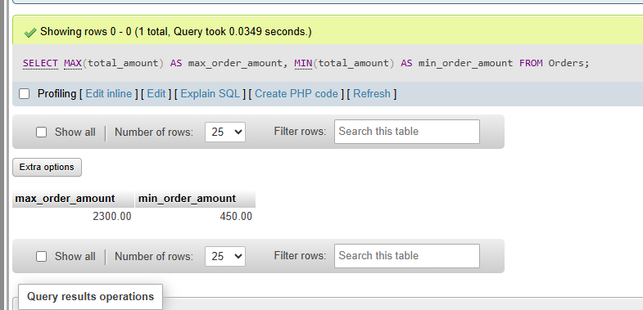
Task – 5
SELECT SUM(total_amount) AS total_sales
FROM Orders
WHERE total_amount IS NOT NULL;
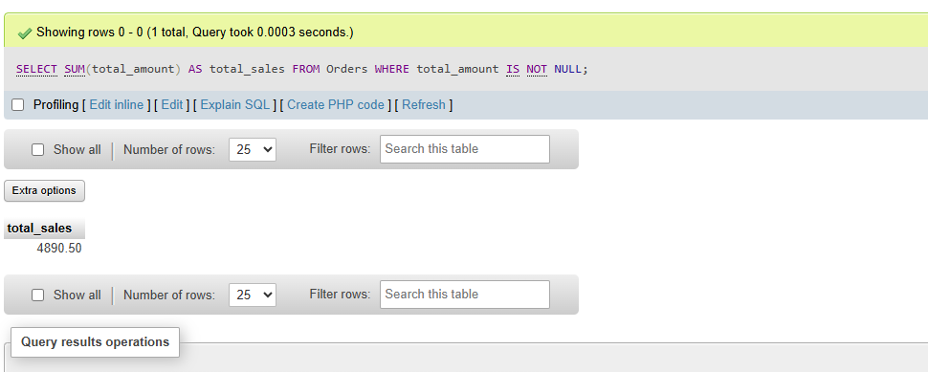

SESSION -8
Task – 1
DROP TABLE IF EXISTS Orders;

CREATE TABLE Orders (
order_id INT PRIMARY KEY,
user_id INT,
payment_method VARCHAR(50),
amount DECIMAL(10, 2)
);
INSERT INTO Orders (order_id, user_id, payment_method, amount) VALUES
(1, 101, 'UPI', 250.00),
(2, 102, 'Card', 550.00),
(3, 101, 'Wallet', 150.00),
(4, 103, 'COD', 400.00),
(5, 104, 'UPI', 750.00),
(6, 102, 'Card', 320.00),
(7, 101, 'UPI', 180.00),
(8, 103, 'COD', 120.00);
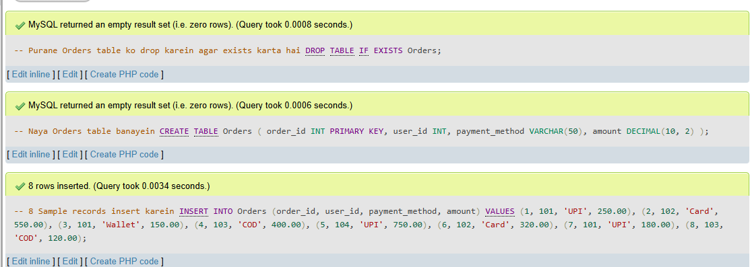
Task – 2
SELECT
payment_method,
COUNT(*) AS total_orders
FROM Orders
GROUP BY payment_method;
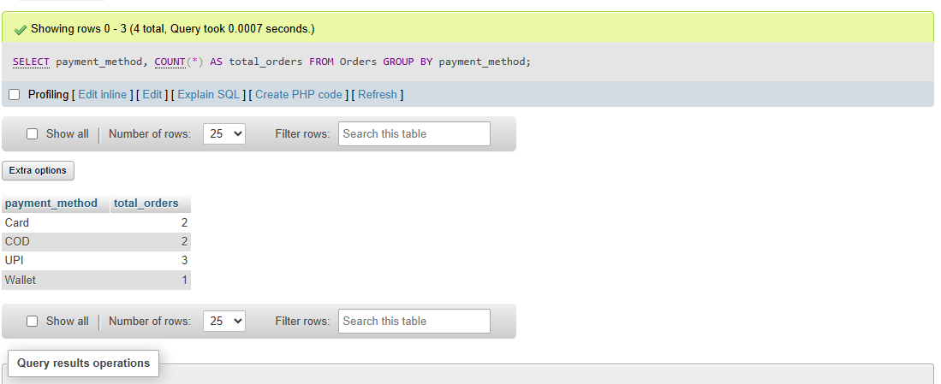

Task – 3
SELECT
user_id,
SUM(amount) AS total_spend
FROM Orders
GROUP BY user_id;
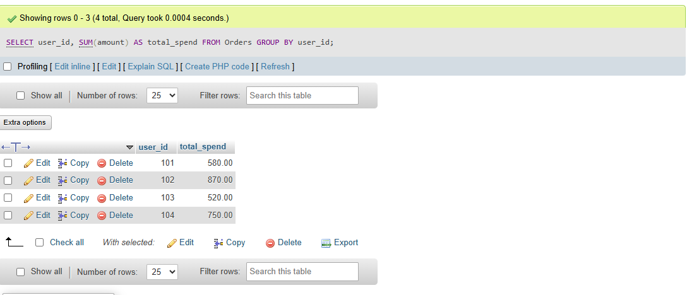
Task – 4
SELECT
payment_method,
AVG(amount) AS average_amount
FROM Orders
GROUP BY payment_method
HAVING AVG(amount) > 300;
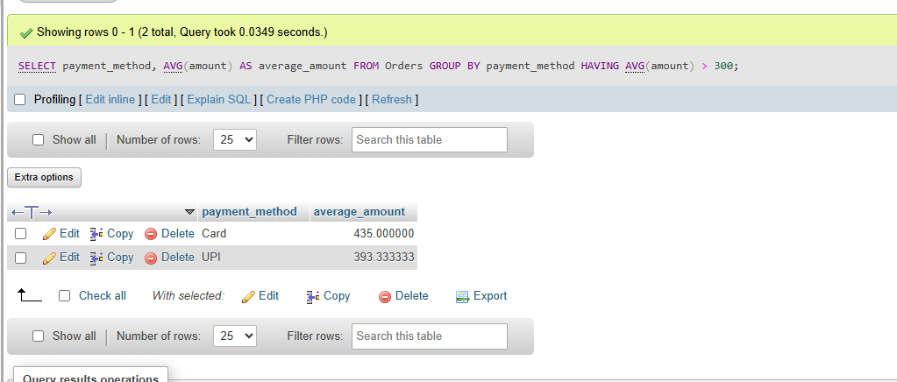

Task -5
Difference Between WHERE and HAVING
- WHERE: Filters individual rows before any grouping or aggregation takes place. It cannot use aggregate functions like SUM(), AVG(), or COUNT().
- HAVING: Filters groups after the GROUP BY clause has aggregated the rows. It is used specifically with aggregate functions.
Example Queries:
# SELECT payment_method, COUNT(*) AS count_of_large_orders FROM Orders WHERE amount > 200 GROUP BY payment_method;
OR

# SELECT payment_method, COUNT(*) AS total_orders
FROM Orders
GROUP BY payment_method
HAVING COUNT(*) > 1;
SESSION -9
Task – 1
DROP TABLE IF EXISTS dishes;
DROP TABLE IF EXISTS restaurants;

CREATE TABLE restaurants (
id INT PRIMARY KEY,
name VARCHAR(100),
city VARCHAR(50)
);
CREATE TABLE dishes (
id INT PRIMARY KEY,
restaurant_id INT,
dish_name VARCHAR(100),
price DECIMAL(8, 2)
);

INSERT INTO restaurants (id, name, city) VALUES
(1, 'Swagat Restaurant', 'Ahmedabad'),
(2, 'Dragon House', 'Surat'),
(3, 'Little Italy', 'Vadodara'),
(4, 'Cafe Mocha', 'Ahmedabad');

INSERT INTO dishes (id, restaurant_id, dish_name, price) VALUES
(101, 1, 'Masala Dosa', 120.00),
(102, 1, 'Idli Vada', 80.00),
(103, 2, 'Hakka Noodles', 180.00),
(104, 2, 'Manchurian', 200.00),
(105, 3, 'Margherita Pizza', 350.00),
(106, 3, 'Pasta Alfredo', 300.00),
(107, 999, 'Mystery Burger', 150.00);
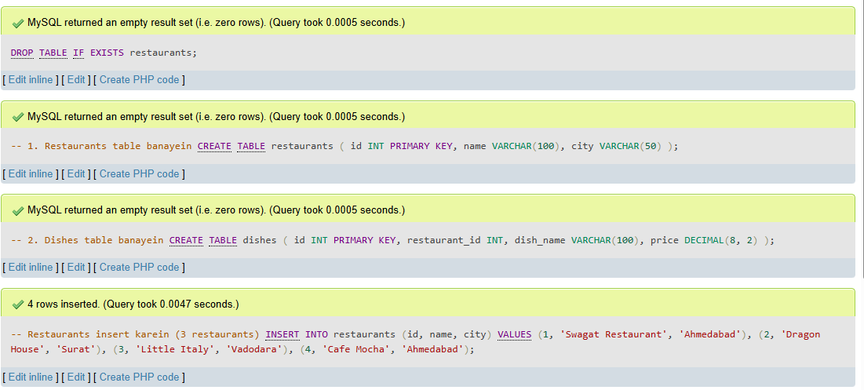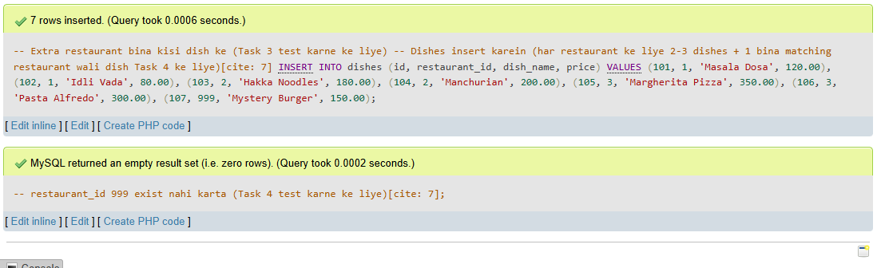
Task – 2
SELECT
d.dish_name,
d.price,
r.name AS restaurant_name,
r.city
FROM dishes d
INNER JOIN restaurants r
ON d.restaurant_id = r.id;
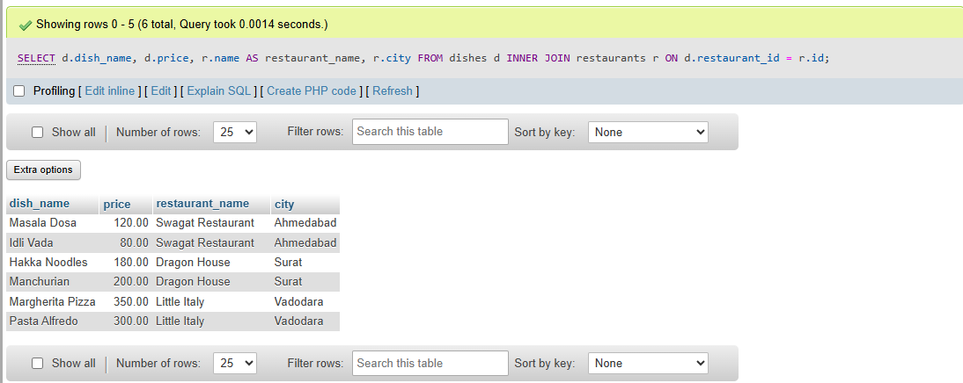
Task – 3
SELECT
r.id AS restaurant_id,
r.name AS restaurant_name,
r.city,
d.dish_name,
d.price
FROM restaurants r
LEFT JOIN dishes d
ON r.id = d.restaurant_id;
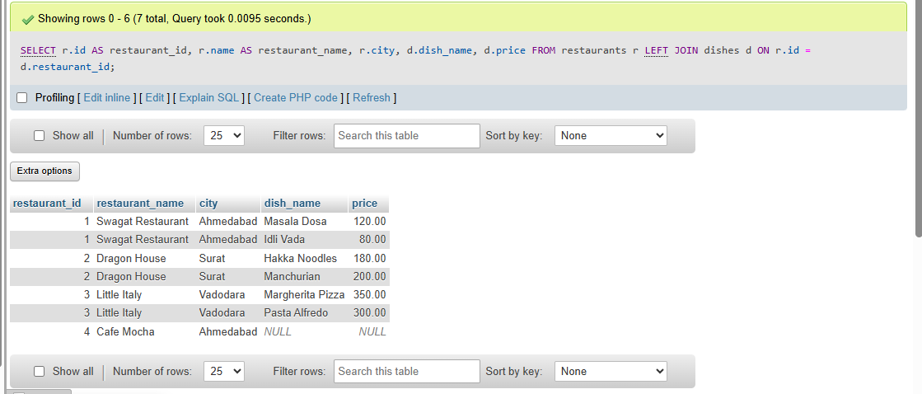

Task – 4
SELECT
d.id AS dish_id,
d.dish_name,
d.price,
r.name AS restaurant_name,
r.city
FROM restaurants r
RIGHT JOIN dishes d
ON r.id = d.restaurant_id;
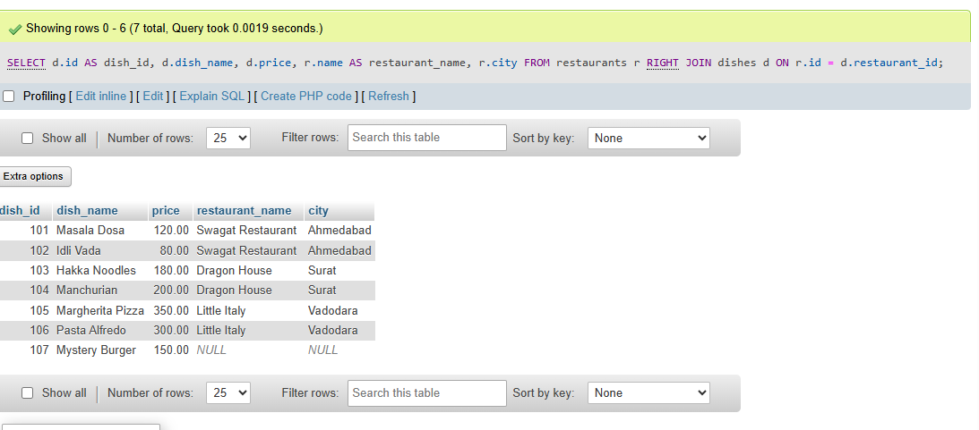
Task – 5
Spotify Playlist Scenario (Explanation & Query)
- Join Type to Use: LEFT JOIN (assuming playlists is the left table)[cite: 7].
- Explanation: An INNER JOIN would exclude any playlist that has zero songs in it[cite: 7]. By using a LEFT JOIN with playlists on the left and songs on the right, all playlists will be included in the output; if a playlist is empty, the song details will simply display as NULL[cite: 7].
SQL Query:
SELECT
p.playlist_id,
p.name AS playlist_name,
s.id AS song_id,
s.song_name,
s.artist
FROM playlists p
LEFT JOIN playlist_songs ps
ON p.playlist_id = ps.playlist_id
LEFT JOIN songs s
ON ps.song_id = s.id;

OR
SELECT
p.playlist_id,
p.name AS playlist_name,
s.song_name,
s.artist
FROM playlists p
LEFT JOIN songs s
ON p.playlist_id = s.playlist_id;

SESSION -10
Task – 1
CREATE TABLE Influencers (
id INT PRIMARY KEY,
name VARCHAR(100)
);

CREATE TABLE Collaborations (
id INT PRIMARY KEY,
influencer1_id INT,
influencer2_id INT,
collab_date DATE
);
INSERT INTO Influencers (id, name) VALUES
(1, 'Tanmay'),
(2, 'Kusha'),
(3, 'Bhuvan'),
(4, 'Prajakta');

INSERT INTO Collaborations (id, influencer1_id, influencer2_id, collab_date) VALUES
(101, 1, 2, '2024-03-10'),
(102, 2, 3, '2024-04-15');
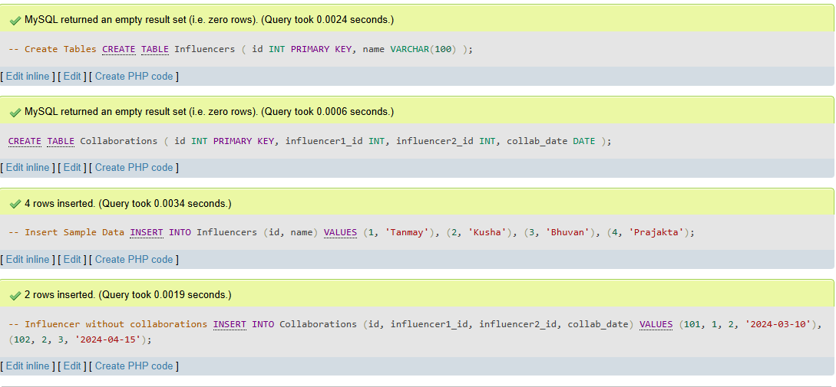
SELECT i.name AS influencer_name, c.collab_date, p.name AS partner_name
FROM Influencers i
LEFT JOIN Collaborations c ON i.id = c.influencer1_id
LEFT JOIN Influencers p ON c.influencer2_id = p.id
UNION
SELECT i.name AS influencer_name, c.collab_date, p.name AS partner_name
FROM Influencers i
RIGHT JOIN Collaborations c ON i.id = c.influencer1_id
LEFT JOIN Influencers p ON c.influencer2_id = p.id;
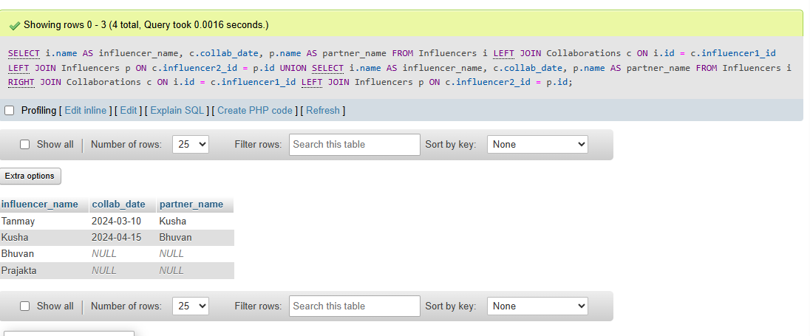

Task - 2
SELECT
child.playlist_name AS playlist_name,
parent.playlist_name AS parent_playlist_name
FROM Playlists child
LEFT JOIN Playlists parent
ON child.parent_playlist_id = parent.id;
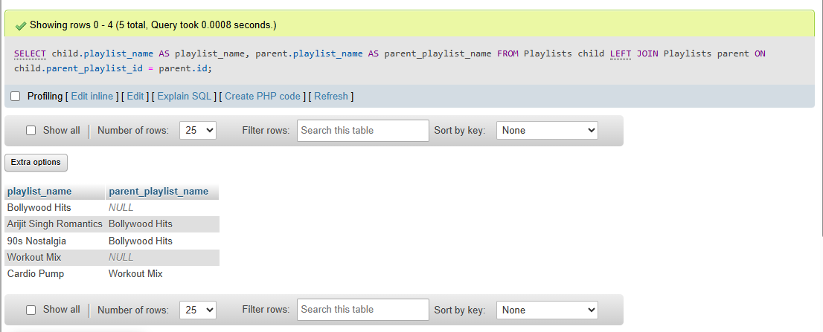
Task – 3
SELECT
u.username,
o.order_date,
p.amount AS payment_amount
FROM Users u
LEFT JOIN Orders o
ON u.id = o.user_id
LEFT JOIN Payments p
ON o.id = p.order_id;
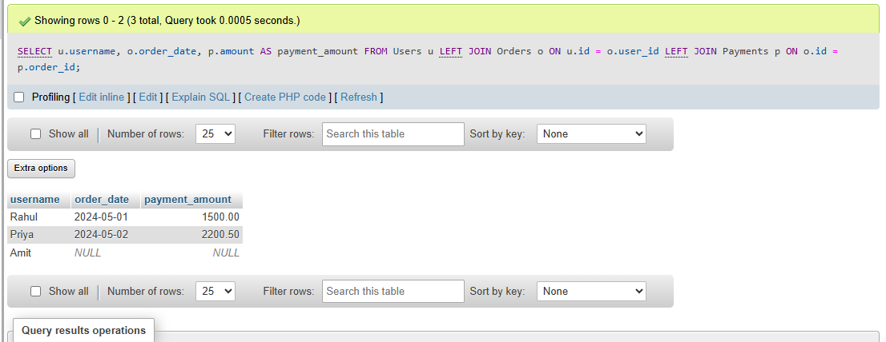

Task – 4
Why duplicates happen:
A one-to-many relationship exists between restaurants and reviews (one restaurant can have multiple reviews), so joining them causes the restaurant details to repeat for every matching review row.
SELECT DISTINCT
r.id,
r.name,
r.city
FROM restaurants r
JOIN Reviews rev
ON r.id = rev.restaurant_id;
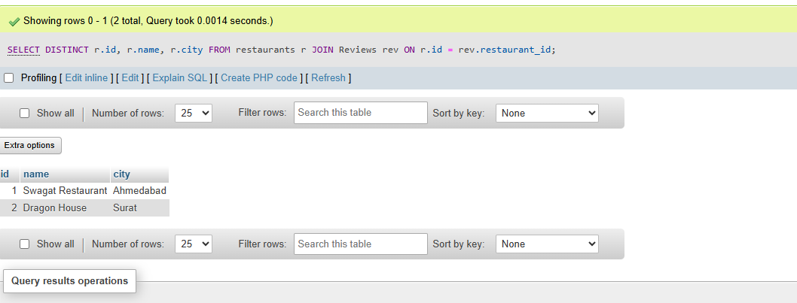

Task -5
SELECT
p.id,
p.name AS product_name,
c.name AS category_name
FROM Products p
JOIN Categories c
ON p.category_id = c.id;
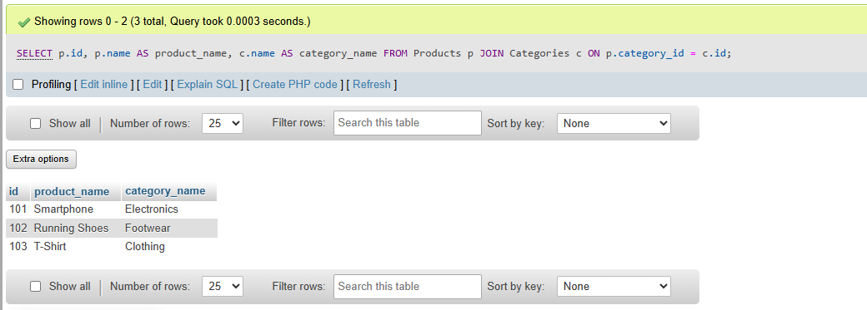

SESSION -11
Task – 1
SELECT *
FROM Restaurants r1
WHERE r1.rating > (
SELECT AVG(r2.rating)
FROM Restaurants r2
WHERE r2.city = r1.city
);
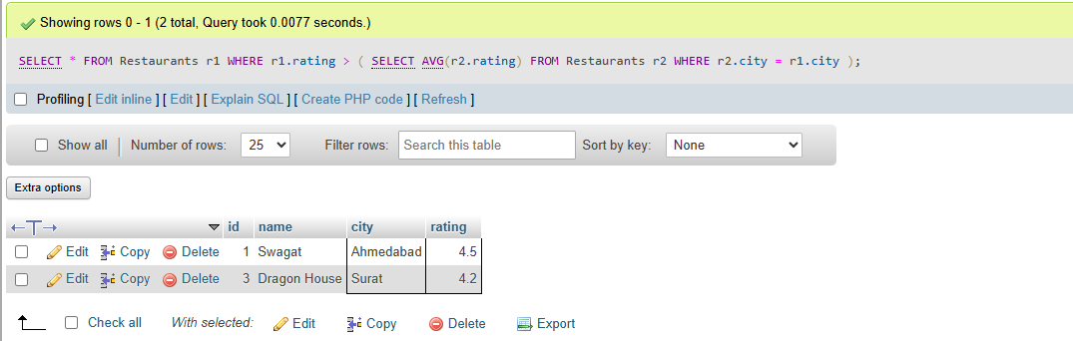

Task – 2
SELECT
name,
(
SELECT COUNT(*)
FROM Orders
WHERE Orders.user_id = Users.id
) AS total_orders
FROM Users;
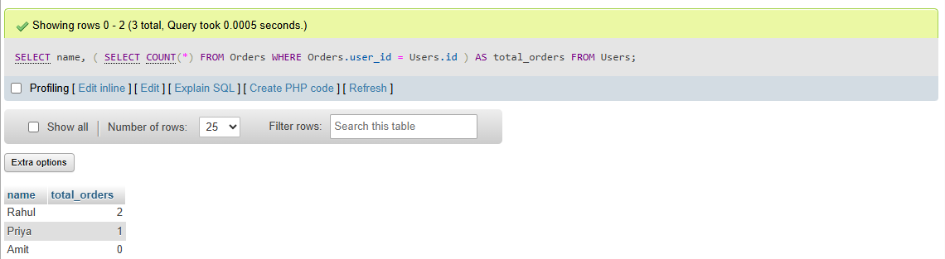

Task – 3
SELECT title
FROM Movies
WHERE id IN (
SELECT movie_id
FROM Reviews
WHERE rating = 5
);
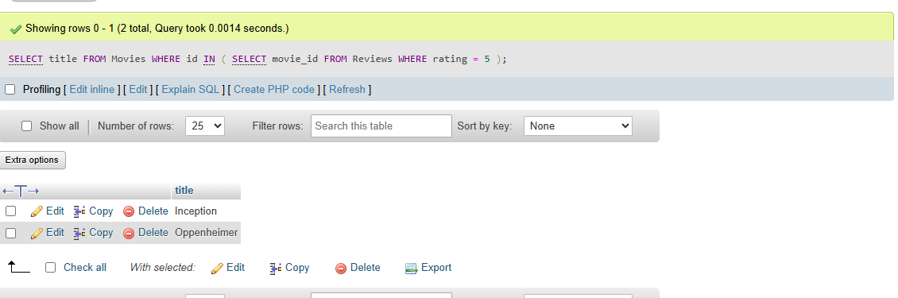

Task – 4
SELECT name
FROM Sellers s
WHERE (
SELECT COUNT(DISTINCT category_id)
FROM Products p
WHERE p.seller_id = s.id
) = (
SELECT COUNT(*)
FROM Categories
);
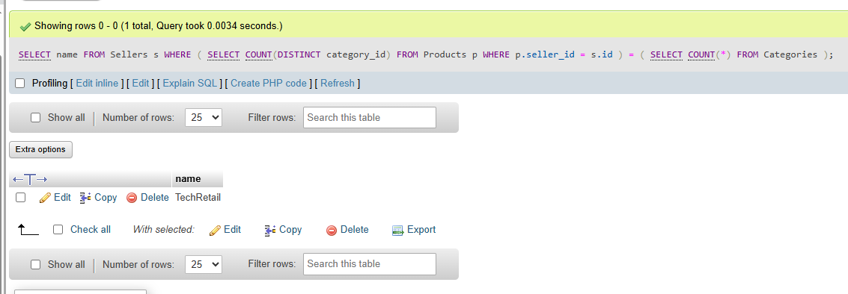
SESSION -12
Task – 1
WITH TopRatedProducts AS (
SELECT *
FROM Products
WHERE rating > 4.5
)
SELECT *
FROM TopRatedProducts;
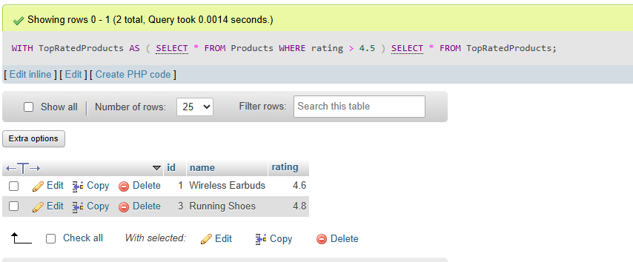
Task – 2
WITH AhmedabadRestaurants AS (
SELECT *
FROM Restaurants
WHERE city = 'Ahmedabad'
)
SELECT *
FROM AhmedabadRestaurants
WHERE delivery_charge < 50;
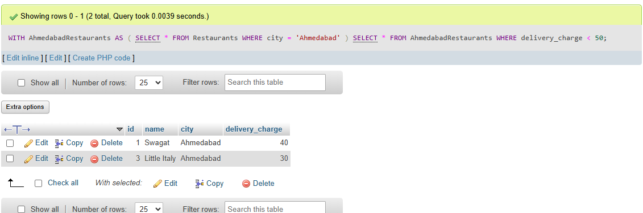

Task – 3
WITH TopUsers AS (
SELECT
'Top User' AS category,
username AS item_name,
followers_count AS metric_count
FROM Users
ORDER BY followers_count DESC
LIMIT 3
),
TopPosts AS (
SELECT
'Top Post' AS category,
post_title AS item_name,
likes_count AS metric_count
FROM Posts
ORDER BY likes_count DESC
LIMIT 3
)
SELECT * FROM TopUsers
UNION ALL
SELECT * FROM TopPosts;
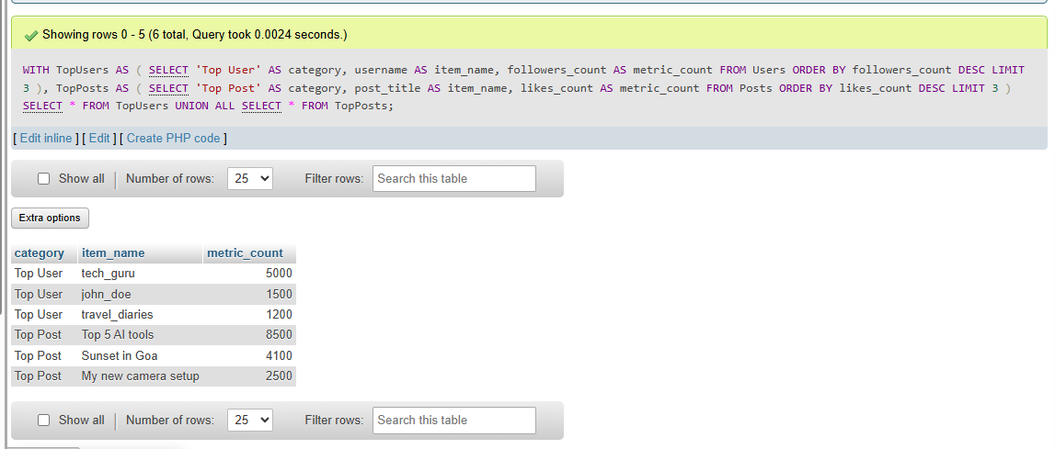

Task – 4
WITH RECURSIVE NextSevenDays AS (
SELECT CURRENT_DATE AS booking_date, 1 AS day_count
UNION ALL
SELECT DATE_ADD(booking_date, INTERVAL 1 DAY), day_count + 1
FROM NextSevenDays
WHERE day_count < 7
)
SELECT booking_
date FROM NextSevenDays;
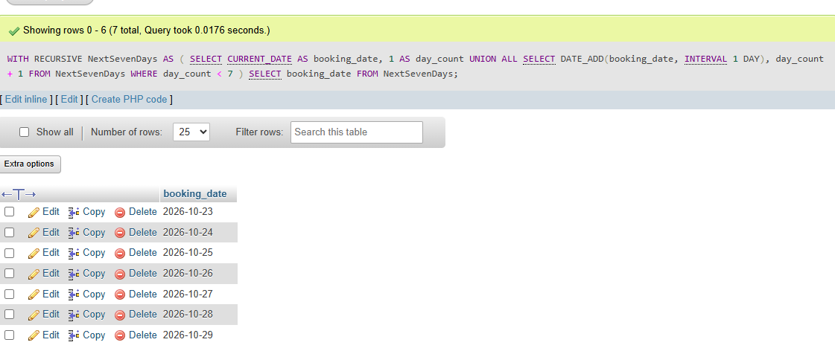

Task – 5
WITH PopularUsers AS (
SELECT id, username, followers_count
FROM Users
WHERE followers_count > 1000
)
SELECT * FROM PopularUsers;
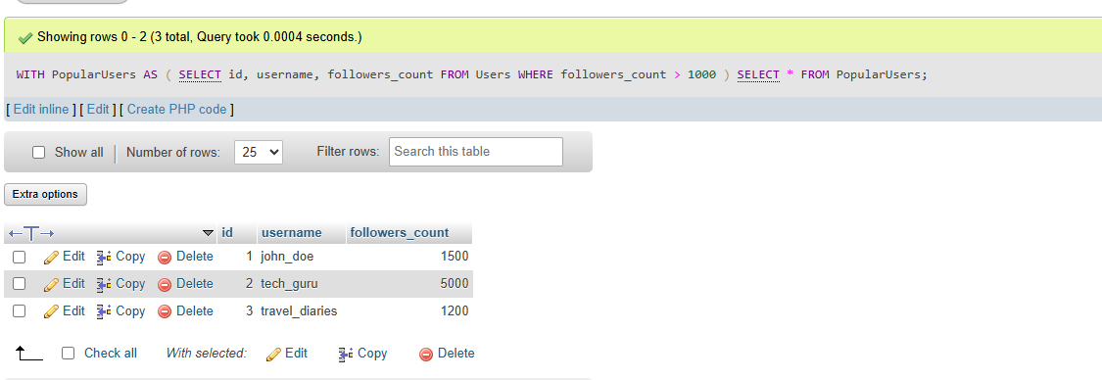

\
SESSION -13
Task – 1
DROP TABLE IF EXISTS Playlists;

CREATE TABLE Playlists (
id INT PRIMARY KEY,
user_id INT,
playlist_name VARCHAR(100),
total_likes INT
);

INSERT INTO Playlists (id, user_id, playlist_name, total_likes) VALUES
(1, 101, 'Bollywood Hits', 450),
(2, 101, 'Romantic Vibes', 300),
(3, 101, 'Workout Pump', 300),
(4, 102, 'Lofi Chill', 500),
(5, 102, 'Study Beats', 150),
(6, 102, 'Night Drive', 420),
(7, 103, 'Acoustic Morning', 250),
(8, 103, 'Rock Classics', 250);
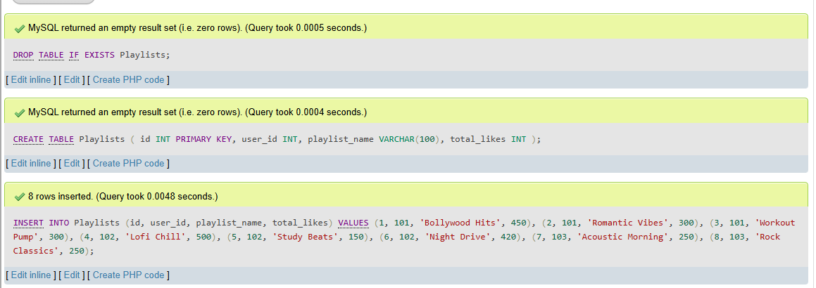

Task – 2
SELECT
id,
user_id,
playlist_name,
total_likes,
ROW_NUMBER() OVER (ORDER BY total_likes DESC) AS row_num
FROM Playlists;
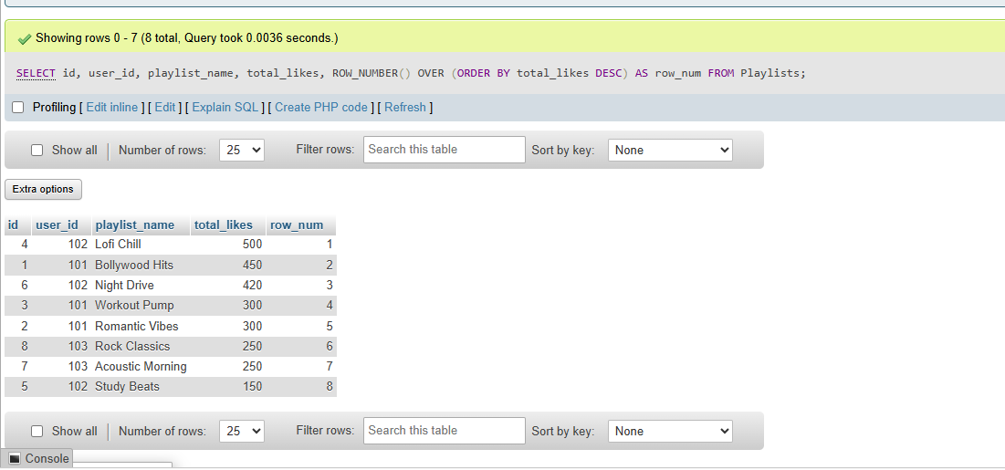

Task – 3
SELECT
playlist_name,
user_id,
total_likes,
RANK() OVER (ORDER BY total_likes DESC) AS playlist_rank
FROM Playlists;
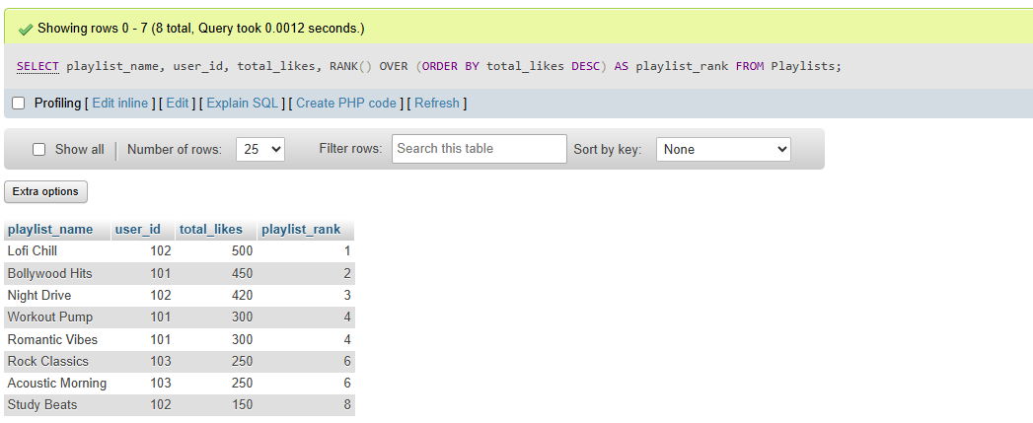

Task – 4
SELECT
playlist_name,
user_id,
total_likes,
DENSE_RANK() OVER (PARTITION BY user_id ORDER BY total_likes DESC) AS dense_rank_val
FROM Playlists;
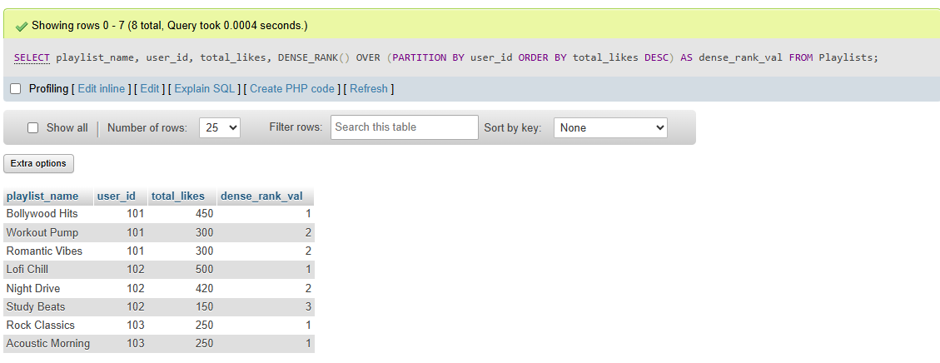

Task – 5
WITH RankedPlaylists AS (
SELECT
playlist_name,
user_id,
total_likes,
DENSE_RANK() OVER (PARTITION BY user_id ORDER BY total_likes DESC) AS rnk
FROM Playlists
)
SELECT
user_id,
playlist_name,
total_likes
FROM RankedPlaylists
WHERE rnk <= 2;
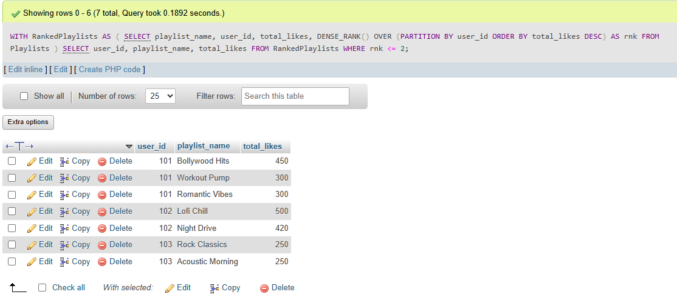

SESSION -14
Task – 1
DROP TABLE IF EXISTS Orders;

CREATE TABLE Orders (
order_id INT PRIMARY KEY,
user_id INT,
order_date DATE,
total_amount DECIMAL(10, 2)
);

INSERT INTO Orders (order_id, user_id, order_date, total_amount) VALUES
(1, 101, '2024-05-01', 350.00),
(2, 101, '2024-05-03', 420.00),
(3, 101, '2024-05-07', 280.00),
(4, 101, '2024-05-10', 500.00),
(5, 102, '2024-05-02', 150.00),
(6, 102, '2024-05-05', 600.00),
(7, 103, '2024-05-04', 220.00);
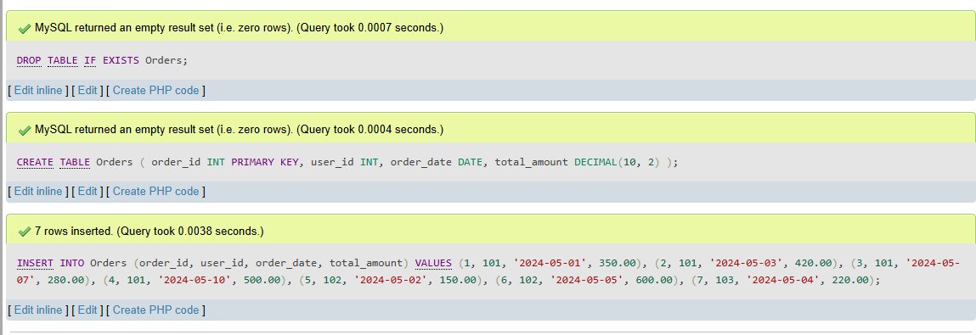

Task – 2
SELECT
user_id,
order_id,
order_date,
total_amount,
LAG(total_amount) OVER (
PARTITION BY user_id
ORDER BY order_date
) AS previous_order_amount
FROM Orders
ORDER BY user_id, order_date;
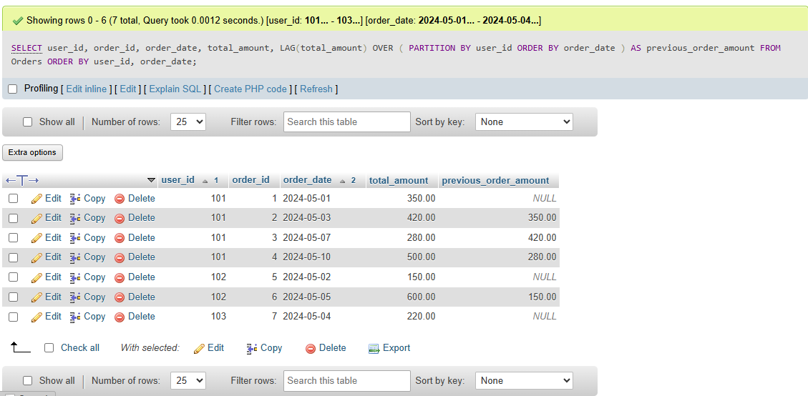

Task – 3
SELECT
user_id,
order_id,
order_date,
total_amount,
LEAD(total_amount) OVER (
PARTITION BY user_id
ORDER BY order_date
) AS next_order_amount
FROM Orders
ORDER BY user_id, order_date;
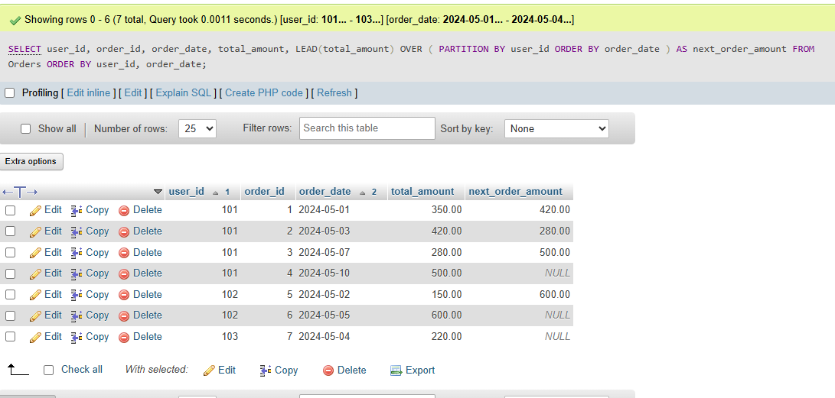

Task – 4
SELECT
order_id,
user_id,
order_date,
total_amount,
SUM(total_amount) OVER (
PARTITION BY user_id
ORDER BY order_date
ROWS BETWEEN UNBOUNDED PRECEDING AND CURRENT ROW
) AS running_total
FROM Orders;
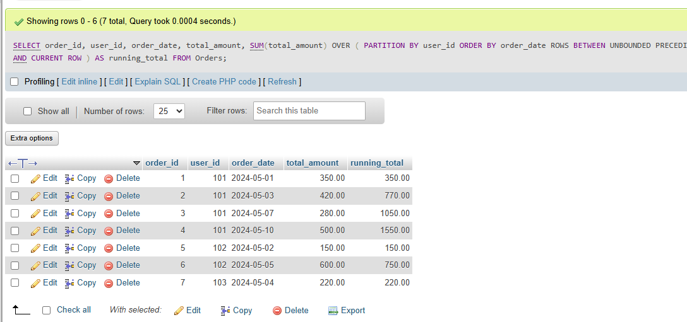

Task – 5
SELECT
order_id,
user_id,
order_date,
total_amount,
AVG(total_amount) OVER (
PARTITION BY user_id
ORDER BY order_date
ROWS BETWEEN 2 PRECEDING AND CURRENT ROW
) AS moving_avg
FROM Orders;
