Use Case Specification

DMT/RM01/TMP

|  |  |
| --- | --- |
| Project Code | PRJ_Makemyjourney_01 |
| Project Name | MakeMyJourney |

|  |  |  |
| --- | --- | --- |
| Prepared/Modified by | Role | Date of Preparation |
|  | Analyst | 7th August, 2016 |
| Reviewed by | Role | Date of Review |
|  |  | 8th August, 2016 |
| Approved by | Role | Date of Approval |
| Dayanand Patil | Consultant | 9th August, 2016 |
| Circulation List |  | Version Number of the template:1.1 |
| Version Number | 1.0 |  |

<<Customer>> REVIEW HISTORY

<<Customer comments on the Use case along with the signed off is tracked here>>

|  |  |  |  |  |  |  |
| --- | --- | --- | --- | --- | --- | --- |
| Version | <<Version number>> |  |  |  |  |  |
| Date | <<Date of Review>> |  |  |  |  |  |
| Reviewed by | << Reviewer Name>> |  |  |  |  |  |
| Reviewed UI Specification doc | << Whether UI Specification doc is reviewed >> |  |  |  |  |  |
| All Open Queries/issues closed | << Whether all the open queries and issues resolved>> |  |  |  |  |  |
| Agreement on Assumptions | <<Whether all the assumptions have been agreed upon by the customer>> |  |  |  |  |  |
| Sign Off | <<Signature>> |  |  |  |  |  |

Disclaimer:

The scope of the project ‘My profile Eclassroom’ is restricted to the contents of this signed off use case.

TABLE OF CONTENTS

1. Use Case Name:eClassroom 4

2. Actor(s) 5

3. Preconditions 5

4. Flow of Events 5

4.1 Basic Flow : User Registered Himself Successfully. 5

4.2 Alternative Flows 6

4.2.1. Alternate Flow 1: User registered Himself from Mobile Application 6

4.2.2. Alternate Flow 2: User Registered Successfully by re-entering the valid credentials 6

4.2.4.Alternate Flow 4 7

Exception Flow 1: Email Id is Not working 7

Exception Flow 2: Mobile Number is Not working 8

Exception Flow 3: Web Server Down 9

Exception Flow 4: Network Connectivity Error 9

Exception Flow 5: Database Connectivity Error 9

5. Post Conditions 10

6. Special Requirements 10

Performance 11

Availability 11

User Interface 11

Security 11

7. Business Rules 11

8. Diagrams 11

Use Case Diagram 12

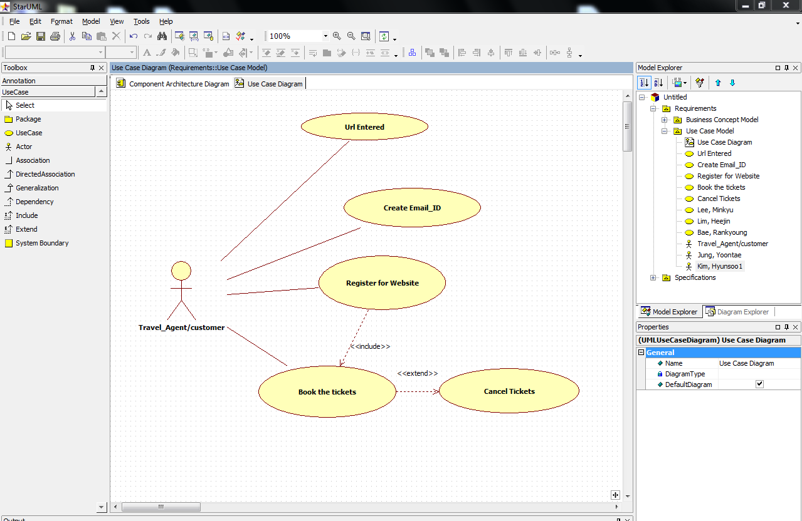 12

9. Scenarios 12

Success Scenarios 13

Failure Scenarios 13

10. Issues 13

12. Inter System Dependencies 13

13. Assumptions 13

# Use Case Name:eClassroom

Use Case ID: MakemyJourney.UC01

**Brief Description:** **MakeMyJourney** is India’s most well known and most preferred online airway, railway & bus booking service providing website. This website is used by the customers & travel agents to avail ticket reservation facilities.

# Actor(s)

Users(customers and travel agents)

# Preconditions

1. The User has already clicked link of signed up for the Makemyjourney web site.
2. After signed up user has navigated to register form.

# Flow of Events

4.1 Basic Flow : User Registered Himself Successfully.

Open Browser

Enter URL [**http://www.makemyjourney.co.in**](http://www.makemyjourney.co.in)

The system opens the sign up page

After that user is able to navigate on Makemyjourney registration form

User enters Username and checks avaibility of Username

If Username is valid that he can access to select security questions and Answer for it

User enters Firstname

User enters Lastname

User selects valid Gender

User Enters valid birthdate

User Enters valid Email Id

User Enters valid Mobile no

User click on submit button and popup will be there asking about reconfirm email Id and mobile no

After Clicking ‘OK’ button registration form will be submitted and one window opens giving message:”Thank you”

User will get link for activation of account on registered emai ld with mobile verification no,username and password.

By writing all valid fields user can click on submit button to activate his account for reserve the tickets.

* 1. Alternative Flows

4.2.1. Alternate Flow 1: User registered Himself from Mobile Application

Opens Application on mobile

The system opens the sign up page

After that user is able to navigate on Makemyjourney registration form

User enters Username and checks avaibility of Username

If Username is valid that he can access to select security questions and Answer for it

User enters Firstname

User enters Lastname

User selects valid Gender

User Enters valid birthdate

User Enters valid Email Id

User Enters valid Mobile no

User click on submit button and popup will be there asking about reconfirm email Id and mobile no

After Clicking ‘OK’ button registration form will be submitted and one window opens giving message:”Thank you”

User will get link for activation of account on registered emai ld with mobile verification no,username and password.

By writing all valid fields user can click on submit button to activate his account for reserve the tickets.

4.2.2. Alternate Flow 2: User Registered Successfully by re-entering the valid credentials

Open Browser

Enter URL [**http://www.makemyjourney.co.in**](http://www.makemyjourney.co.in)

The system opens the sign up page

After that user is able to navigate on Makemyjourney registration form

User enters Username and checks avaibility of Username is invalid it Will give error

User re-enters valid user name and again check for avaibility

If Username is valid that he can access to select security questions and Answer for it

User enters Firstname

User enters Lastname

User selects valid Gender

User Enters valid birthdate

User Enters valid Email Id

User Enters valid Mobile no

User click on submit button and popup will be there asking about reconfirm email Id and mobile no

After Clicking ‘OK’ button registration form will be submitted and one window opens giving message:”Thank you”

User will get link for activation of account on registered emai ld with mobile verification no,username and password.

By writing all valid fields user can click on submit button to activate his account for reserve the tickets.

4.2.4.Alternate Flow 4

Exception Flow 1: Email Id is Not working

Open Browser

Enter URL [**http://www.makemyjourney.co.in**](http://www.makemyjourney.co.in)

The system opens the sign up page

After that user is able to navigate on Makemyjourney registration form

User enters Username and checks avaibility of Username is invalid it Will give error

User re-enters valid user name and again check for avaibility

If Username is valid that he can access to select security questions and Answer for it

User enters Firstname

User enters Lastname

User selects valid Gender

User Enters valid birthdate

User Enters valid Email Id

User Enters valid Mobile no

User click on submit button and popup will be there asking about reconfirm email Id and mobile no

After Clicking ‘OK’ button registration form will be submitted and one window opens giving message:”Thank you”

User will not get link for activation of account on registered emai ld with mobile verification no,username and password so activation of account can not be done.

Exception Flow 2: Mobile Number is Not working

Open Browser

Enter URL [**http://www.makemyjourney.co.in**](http://www.makemyjourney.co.in)

The system opens the sign up page

After that user is able to navigate on Makemyjourney registration form

User enters Username and checks avaibility of Username is invalid it Will give error

User re-enters valid user name and again check for avaibility

If Username is valid that he can access to select security questions and Answer for it

User enters Firstname

User enters Lastname

User selects valid Gender

User Enters valid birthdate

User Enters valid Email Id

User Enters valid Mobile no

User click on submit button and popup will be there asking about reconfirm email Id and mobile no

After Clicking ‘OK’ button registration form will be submitted and one window opens giving message:”Thank you”

User will get link for activation of account on registered emai ld with mobile verification no,username and password.

If Mobile no is not working that 4 digit pin will not come on registered mobile and activation can not be done

Exception Flow 3: Web Server Down

Open Browser

Enter URL Enter URL [**http://www.makemyjourney.co.in**](http://www.makemyjourney.co.in)

The System displays an error message regarding web server unavailability.

Exception Flow 4: Network Connectivity Error

Open Browser

Enter URL Enter URL [**http://www.makemyjourney.co.in**](http://www.makemyjourney.co.in)

The system opens the sign up page

User try to navigate page for registration by clicking on it

The system displays an error message regarding network connectivity problem

Exception Flow 5: Database Connectivity Error

Open Browser

Enter URL Enter URL [**http://www.makemyjourney.co.in**](http://www.makemyjourney.co.in)

The system opens the signup page

User enters the valid Username in makemyjourney registration form

The system displays an error message regarding database connectivity problem.

# Post Conditions

| Flow Name | Post Condition |
| --- | --- |
| Sign up from home page | User will navigate to makemyjourney registration form |
| Checking username after second attempt by clicking on link of “Check avaibility” | User will be able enter other valid field and submit the registration form successfully |
| User check activation requirement on registered email Id and mobile no | User will be able to activate the accunt for book reservation ticket |
| User has given wrong information about email and mobile no. | User can not activate his account |
| Exceeded Login Attempts | The system should suspend the user account and should inform the user that his/her account has been blocked. |
| Web Server Down | The system should display an error message to the user regarding web server unavailability problem. |
| Database Connectivity Error | The system should display an error message to the user regarding the database connectivity problem. |
| Network Connectivity Error | The system should display an error message to the user regarding the network connectivity problem. |

# Special Requirements

Performance

1. Registration form should open within 5 seconds after clicking on Sign up button.

Availability

The Users can register 24x7 .

User Interface

* 1. The Labels of the form shall be bold
  2. Gender should be selected on registration form
  3. Submit and Reset button should be there on every page

Security

1. Remember my Credentials option should save username and password in html cookies.
2. The makemyjorney registration form will allow the user to Cancel the application at any point.
3. Username should be unique.

# Business Rules

| Business Rule Name | Business Rule Description | System action (if BR fails) |
| --- | --- | --- |
| BR01 | Username must be valid | User is prompted to re-enter the username credentials |
| BR02 | Required Fields on the Registration form should be filled | Displays error message “Please fill the required fields” |
| BR03 | Mobille no and email ID should be of correct | Display error message ”Enter valid mobile no and Email ID” |

# Diagrams

Use Case Diagram

# 

# Scenarios

Success Scenarios

* On sign up page navigates to makemyjourney registration page
* Username in registration form on second attempt and successful access usename
* User gets submit the registration form and get activation link on rgistered maild ID
* User gets 4 digit PIN on mobile no and able to activate account
* User Successfully submits the request by mobile app

Failure Scenarios

* Exceeded valid username Attempts
* Web Server Down
* Database Connectivity Error
* Network Connectivity Error
* Given wrong Email ID iand mobile number

# Issues

1. What is the maximum size of username ?
2. What if the email Id and mobile no is given wrong wrong?
3. What if the PIN is not generated by system?
4. Inter System Dependencies

**Module: ‘Activation page**’ gets impacted due to :

Use case name: Alternate Flow 1 and 2

**Impact**: If the user tries to give wrong email and mobile no , he should be denied to do so.

1. Assumptions
2. The User should be authenticate.
3. User should have Latest versions of leading browsers like Internet Explorer, Google Chrome,

Mozilla Firefox, Opera, Safari for best view of site.