Oracle Database Administration Services
KE_ORACLE_OPATCH_KNOWN_ISSUE

Submitted to



By



CIS, Wipro Limited

Document Details

Project Name | Innogy SE
Account | CIS
IT Component/Application Title | KE_ORACLE_OPATCH_KNOWN_ISSUE
Current Version | 1.2
List of Contributors | Ajay Zende , Jiten Pansara, Sreya Puthukudy
Customer Contact Information

Version History
(All revisions made to this document must be listed in chronological order. All revisions must be approved. Review and Approval can be done by an internal source or by the customer)
Version | Date of Revision | Description | Author | Reviewed By | Approved By
1.0 | 03-01-2018 | Intial Draft | Ajay Zende | Jiten Pansara | YogeshDesai
1.1 | 18-01-2018 | Document Completed | Ajay Zende | Jiten Pansara | YogeshDesai
1.2 | 17-12-2018 | Updated the content | Sreya Puthukudy | Jiten Pansara | Santosh Badiger

While applying PSU Patch on Database many times below error occurs
Where OPATCH unable to lock Central Inventory which resides under $ORACLE_HOME/oraInventory Directory Due to which OPATCH installation getting stuck and OPatch failed with error code 73.

Below are the steps to Fix issue

- Error:

When YOU encounter OPATCH error "Unable to lock Central Inventory

ApplySession failed: ApplySession failed to prepare the system. Unable to lock Central Inventory. Stop trying per user-request?
System intact, OPatch will not attempt to restore the system
OPatch failed with error code 73

- Solution

Go to ORACLE_BASE

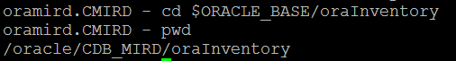

Check for Locks directory

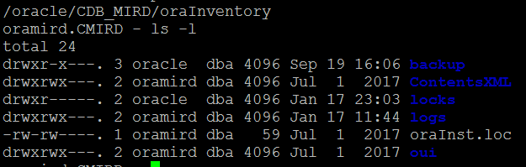
Remove “Locks” Directory

Rm -rf locks
And retry opatch.

