Name: Jitesh Singh SAP ID:1000019300 Section:D

Project Chosen: A GUI-Based Solution for 0/1 Knapsack Problems.

- Objective: Implement solutions for the 0/1 Knapsack problem using dynamic programming.
- Inputs:
  - Input a list of items with their respective weights and values as given in figure 3.1, through a graphical user interface (GUI) implemented using Swing components.
  - Take the maximum weight capacity of the knapsack as 8 kg.
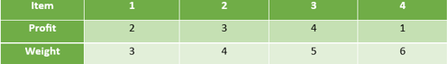
Fig 3.1

- Outputs:
  - Using the greedy approach of 0-1 knapsack, display the weight that’s stored in the knapsack with the maximum profit. Also display whether that solution would be the optimal solution or not.
  - Using the dynamic programming tabulation method approach display the solution matrix for 0/1 knapsack as in figure 3.2.
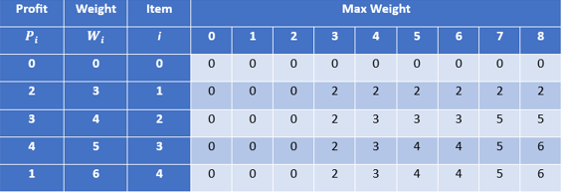
Fig.3.2

  - Also display the items selected for the optimal solution, and their maximum profit.

Source code:

import javax.swing.*;
import javax.swing.table.DefaultTableCellRenderer;
import javax.swing.table.DefaultTableModel;
import java.awt.*;
import java.awt.event.*;
import java.util.Arrays;
import java.util.Comparator;

public class EnhancedKnapsackGUI extends JFrame {
private JTable inputTable, dpTable;
private JTextField capacityField;
private JTextArea outputArea;

public EnhancedKnapsackGUI() {
// Frame setup
setTitle("0/1 Knapsack Solver");
setSize(1000, 700);
setDefaultCloseOperation(JFrame.EXIT_ON_CLOSE);
setLayout(new BorderLayout());

// Header Panel
JLabel header = new JLabel("0/1 Knapsack Problem Solver", JLabel.CENTER);
header.setFont(new Font("Arial", Font.BOLD, 24));
header.setForeground(Color.WHITE);
header.setBackground(new Color(0, 102, 153)); // Dark blue
header.setOpaque(true);
header.setPreferredSize(new Dimension(1000, 50));
add(header, BorderLayout.NORTH);

// Input Panel
JPanel inputPanel = new JPanel(new BorderLayout());
inputTable = createInputTable();
inputTable.setBackground(new Color(170, 225, 180)); // Mint green background
inputTable.setForeground(Color.BLACK);
inputTable.setFont(new Font("Arial", Font.PLAIN, 16));
inputTable.setRowHeight(174);
customizeTableHeader(inputTable);

JScrollPane tableScroll = new JScrollPane(inputTable);
inputPanel.add(tableScroll, BorderLayout.CENTER);

JPanel capacityPanel = new JPanel(new FlowLayout(FlowLayout.LEFT));
JLabel capacityLabel = new JLabel("Knapsack Capacity (kg):");
capacityLabel.setFont(new Font("Arial", Font.BOLD, 16));
capacityField = new JTextField("8", 5); // Default capacity
capacityField.setFont(new Font("Arial", Font.PLAIN, 16));
capacityPanel.add(capacityLabel);
capacityPanel.add(capacityField);
inputPanel.add(capacityPanel, BorderLayout.SOUTH);

add(inputPanel, BorderLayout.WEST);

// Output Panel
JPanel outputPanel = new JPanel(new BorderLayout());
outputArea = new JTextArea();
outputArea.setEditable(false);
outputArea.setBackground(new Color(240, 255, 243)); // Light blue background
outputArea.setForeground(Color.DARK_GRAY);
outputArea.setFont(new Font("Monospaced", Font.PLAIN, 16));

JScrollPane outputScroll = new JScrollPane(outputArea);
outputScroll.setBorder(BorderFactory.createTitledBorder("Results"));
outputPanel.add(outputScroll, BorderLayout.CENTER);

// DP Solution Matrix Table
JPanel dpPanel = new JPanel(new BorderLayout());
dpPanel.setBorder(BorderFactory.createTitledBorder("DP Solution Matrix"));
dpTable = new JTable(new DefaultTableModel());
dpTable.setBackground(new Color(81, 111, 241)); // Light beige
dpTable.setForeground(Color.WHITE);
dpTable.setFont(new Font("Arial", Font.PLAIN, 16));
dpTable.setRowHeight(60);
JScrollPane dpScroll = new JScrollPane(dpTable);
dpPanel.add(dpScroll, BorderLayout.CENTER);

JSplitPane splitPane = new JSplitPane(JSplitPane.VERTICAL_SPLIT, outputPanel, dpPanel);
splitPane.setDividerLocation(360);
add(splitPane, BorderLayout.CENTER);

// Buttons Panel
JPanel buttonPanel = new JPanel(new FlowLayout(FlowLayout.CENTER));
JButton greedyButton = new JButton("Greedy Approach");
JButton dpButton = new JButton("DP Approach");
JButton resetButton = new JButton("Reset");

greedyButton.setFont(new Font("Arial", Font.BOLD, 14));
dpButton.setFont(new Font("Arial", Font.BOLD, 14));
resetButton.setFont(new Font("Arial", Font.BOLD, 14));

greedyButton.setBackground(new Color(135, 206, 250)); // Light sky blue
dpButton.setBackground(new Color(144, 238, 144)); // Light green
resetButton.setBackground(new Color(255, 192, 201)); // Light pink

buttonPanel.add(greedyButton);
buttonPanel.add(dpButton);
buttonPanel.add(resetButton);

add(buttonPanel, BorderLayout.SOUTH);

// Button Actions
greedyButton.addActionListener(e -> calculateGreedy());
dpButton.addActionListener(e -> calculateDP());
resetButton.addActionListener(e -> resetAll());
}

// Create input table with editable fields
private JTable createInputTable() {
String[] columns = {"Item", "Value", "Weight"};
DefaultTableModel model = new DefaultTableModel(columns, 0) {
@Override
public boolean isCellEditable(int row, int column) {
return column != 0; // Prevent editing the "Item" column
}
};

for (int i = 0; i < 4; i++) {
model.addRow(new Object[]{i + 1, 0, 0}); // Default rows
}

JTable table = new JTable(model);
table.setRowHeight(25);
return table;
}

// Customize table header
private void customizeTableHeader(JTable table) {
table.getTableHeader().setFont(new Font("Arial", Font.BOLD, 16));
table.getTableHeader().setBackground(new Color(70, 130, 180)); // Steel blue
table.getTableHeader().setForeground(Color.WHITE);
DefaultTableCellRenderer renderer = (DefaultTableCellRenderer) table.getTableHeader().getDefaultRenderer();
renderer.setHorizontalAlignment(SwingConstants.CENTER);
}

// Reset all fields and outputs
private void resetAll() {
outputArea.setText("");
capacityField.setText("8");
dpTable.setModel(new DefaultTableModel()); // Clear DP table
}

// Greedy Approach Calculation
private void calculateGreedy() {
int n = inputTable.getRowCount();
int capacity;

try {
capacity = Integer.parseInt(capacityField.getText());
if (capacity <= 0) throw new NumberFormatException();
} catch (NumberFormatException ex) {
JOptionPane.showMessageDialog(this, "Please enter a valid positive integer for capacity.", "Input Error", JOptionPane.ERROR_MESSAGE);
return;
}

Item[] items = new Item[n];
try {
for (int i = 0; i < n; i++) {
int profit = Integer.parseInt(inputTable.getValueAt(i, 1).toString());
int weight = Integer.parseInt(inputTable.getValueAt(i, 2).toString());
if (profit <= 0 || weight <= 0) throw new NumberFormatException();
items[i] = new Item(profit, weight, profit / (double) weight);
}
} catch (NumberFormatException ex) {
JOptionPane.showMessageDialog(this, "Ensure all profit and weight values are positive integers.", "Input Error", JOptionPane.ERROR_MESSAGE);
return;
}

Arrays.sort(items, Comparator.comparingDouble(Item::getRatio).reversed());

int totalProfit = 0, totalWeight = 0;
StringBuilder result = new StringBuilder("Greedy Approach Selected Items:\n");

for (Item item : items) {
if (totalWeight + item.weight <= capacity) {
totalProfit += item.profit;
totalWeight += item.weight;
result.append("Item (Profit: ").append(item.profit).append(", Weight: ").append(item.weight).append(")\n");
}
}

result.append("Total Profit: ").append(totalProfit).append("\n");
result.append("Total Weight: ").append(totalWeight).append("\n");
outputArea.append("Note: This may not be the optimal solution.\n\n");
outputArea.append(result.toString());
}

// Dynamic Programming Approach Calculation
private void calculateDP() {
int n = inputTable.getRowCount();
int capacity;

try {
capacity = Integer.parseInt(capacityField.getText());
if (capacity <= 0) throw new NumberFormatException();
} catch (NumberFormatException ex) {
JOptionPane.showMessageDialog(this, "Please enter a valid positive integer for capacity.", "Input Error", JOptionPane.ERROR_MESSAGE);
return;
}

int[] profit = new int[n];
int[] weight = new int[n];

try {
for (int i = 0; i < n; i++) {
profit[i] = Integer.parseInt(inputTable.getValueAt(i, 1).toString());
weight[i] = Integer.parseInt(inputTable.getValueAt(i, 2).toString());
if (profit[i] <= 0 || weight[i] <= 0) throw new NumberFormatException();
}
} catch (NumberFormatException ex) {
JOptionPane.showMessageDialog(this, "Ensure all profit and weight values are positive integers.", "Input Error", JOptionPane.ERROR_MESSAGE);
return;
}

int[][] dp = new int[n + 1][capacity + 1];

for (int i = 1; i <= n; i++) {
for (int w = 1; w <= capacity; w++) {
if (weight[i - 1] <= w) {
dp[i][w] = Math.max(dp[i - 1][w], profit[i - 1] + dp[i - 1][w - weight[i - 1]]);
} else {
dp[i][w] = dp[i - 1][w];
}
}
}

String[] columnNames = new String[capacity + 4];
columnNames[0] = "Profit";
columnNames[1] = "Weight";
columnNames[2] = "Item";
for (int i = 0; i <= capacity; i++) {
columnNames[i + 3] = String.valueOf(i);
}

DefaultTableModel dpModel = new DefaultTableModel(columnNames, n + 1);
for (int i = 0; i <= n; i++) {
dpModel.setValueAt(i == 0 ? 0 : profit[i - 1], i, 0);
dpModel.setValueAt(i == 0 ? 0 : weight[i - 1], i, 1);
dpModel.setValueAt(i == 0 ? "0" : String.valueOf(i), i, 2);

for (int j = 0; j <= capacity; j++) {
dpModel.setValueAt(dp[i][j], i, j + 3);
}
}

dpTable.setModel(dpModel);
customizeTableHeader(dpTable);

int totalProfit = dp[n][capacity];
int w = capacity;
StringBuilder selectedItems = new StringBuilder("Selected Items:\n");

for (int i = n; i > 0; i--) {
if (dp[i][w] != dp[i - 1][w]) {
selectedItems.append("Item ").append(i)
.append(" (Profit: ").append(profit[i - 1])
.append(", Weight: ").append(weight[i - 1]).append(")\n");
w -= weight[i - 1];
}
}

outputArea.append("Dynamic Programming Approach completed.\n");
outputArea.append("Maximum Profit: " + totalProfit + "\n");
outputArea.append(selectedItems.toString());
}

// Item class for Greedy approach
static class Item {
int profit, weight;
double ratio;

Item(int profit, int weight, double ratio) {
this.profit = profit;
this.weight = weight;
this.ratio = ratio;
}

double getRatio() {
return ratio;
}
}

// Main method
public static void main(String[] args) {
SwingUtilities.invokeLater(() -> new EnhancedKnapsackGUI().setVisible(true));
}
}

- Explanation of Code in Segments

1. Class and GUI Setup
- The application extends JFrame to create a graphical window.
- Includes the following components:
  - inputTable: For user input of items (profits and weights).
  - dpTable: To display the DP solution matrix.
  - capacityField: A text field for knapsack capacity.
  - outputArea: Displays the results (selected items and profits).

2. Frame Initialization
- Sets up the frame with:
  - Title: "0/1 Knapsack Solver".
  - Size: 1000x700 pixels.
  - Layout: BorderLayout for organizing the UI into panels.

3. Header Panel
- Displays a styled header with a bold title at the top.

4. Input Panel
- Includes:
  - inputTable: Editable table where users input:
    - Profit and Weight of each item.
    - First column shows Item IDs (not editable).
  - capacityField: A text field for entering the knapsack's capacity (default: 8).

5. Output and DP Solution Matrix Panels
- Output Area: Displays the results, including selected items and their total profit.
- dpTable: Displays the DP solution matrix as a table.

6. Button Panel
- Contains buttons for functionalities:
  - Greedy Approach: Uses a greedy algorithm to select items.
  - DP Approach: Uses dynamic programming for an optimal solution.
  - Reset: Clears inputs and outputs.

7. Input Table Creation
- Creates a table with columns: Item ID, Value, Weight.
- Prepopulated with 4 default rows for items.

8. Reset Functionality
- Clears the output area, resets the capacity field, and clears the DP table.

9. Greedy Approach
- Steps:
  - Parses user input for profits and weights.
  - Sorts items by profit-to-weight ratio in descending order.
  - Adds items to the knapsack until the capacity is reached.
- Result: Displays the total profit and selected items (may not be optimal).

10. Dynamic Programming Approach
- Steps:
  - Builds a DP table to store maximum profit for each weight capacity.
  - Uses a recurrence relation to calculate the optimal solution:
    - Either include the current item or skip it.
  - Backtracks to identify the selected items.
- Result: Provides the maximum profit and corresponding items (optimal solution).

11. Item Class
- Encapsulates the attributes for the greedy approach:
  - Profit, Weight, and Profit-to-Weight Ratio.

12. Main Method
- Launches the GUI in a separate thread to ensure smooth operation

- Upon executing the code, the GUI will be displayed as follows:
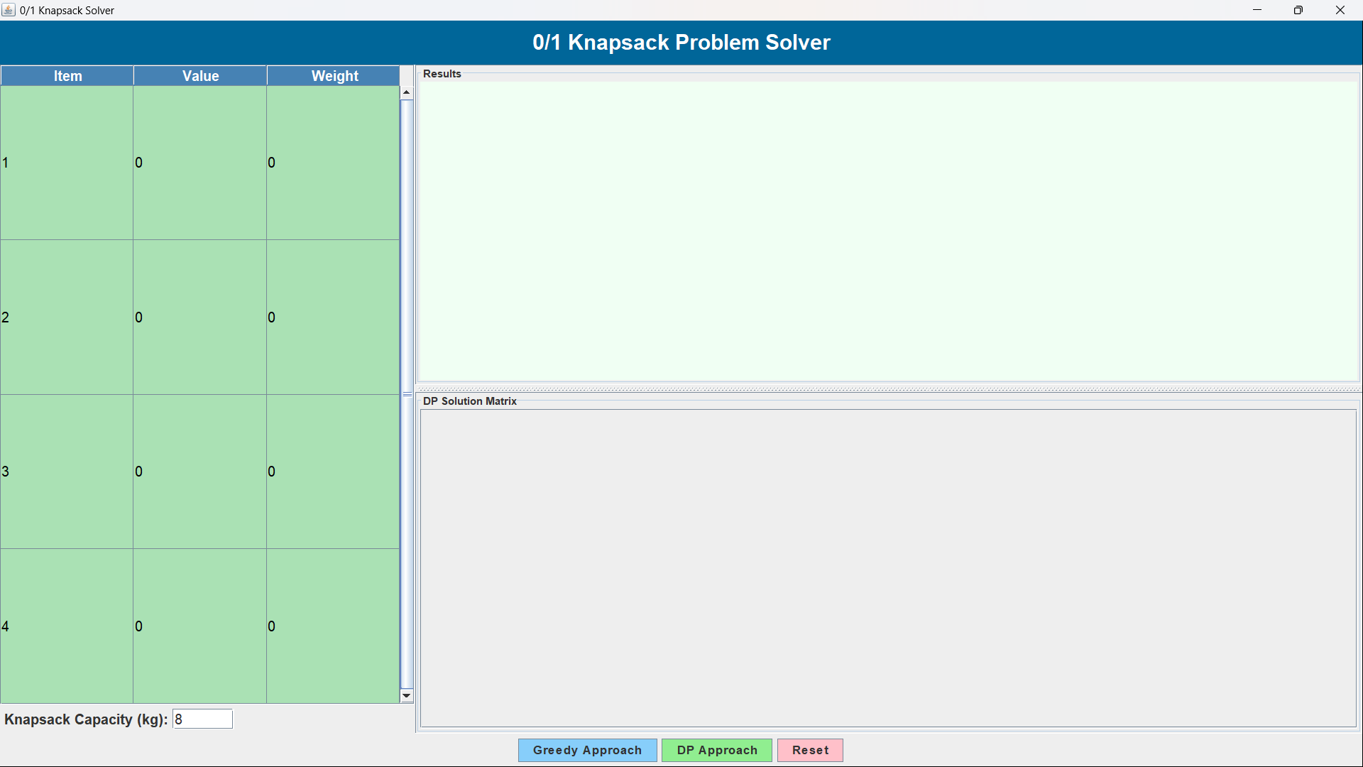

If a user attempts to calculate the Greedy or DP approach without providing input, an
error message will be displayed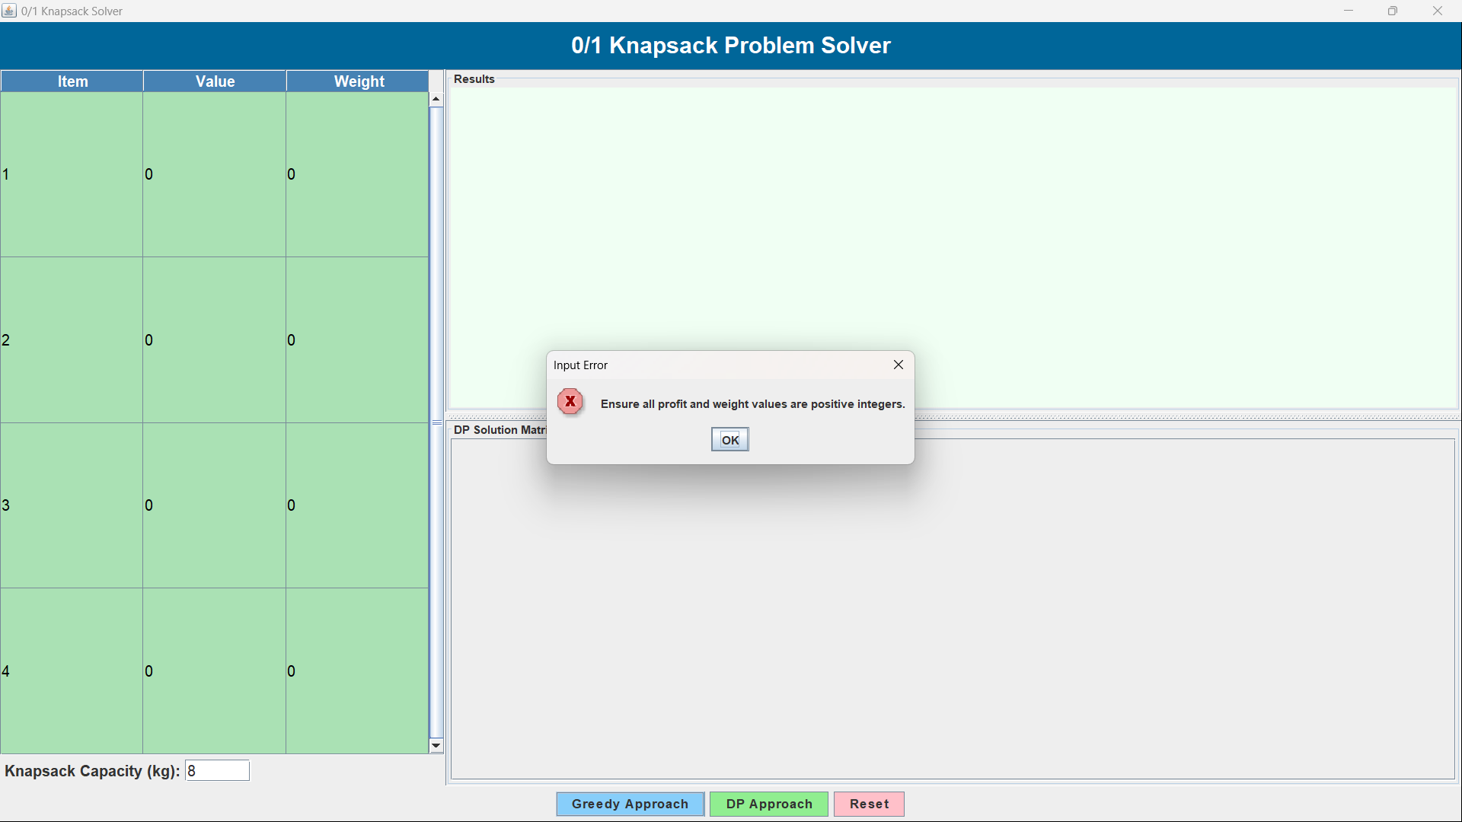
The inputs are as follows:
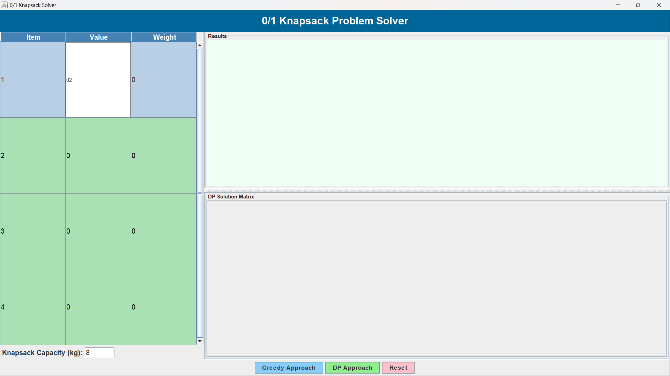

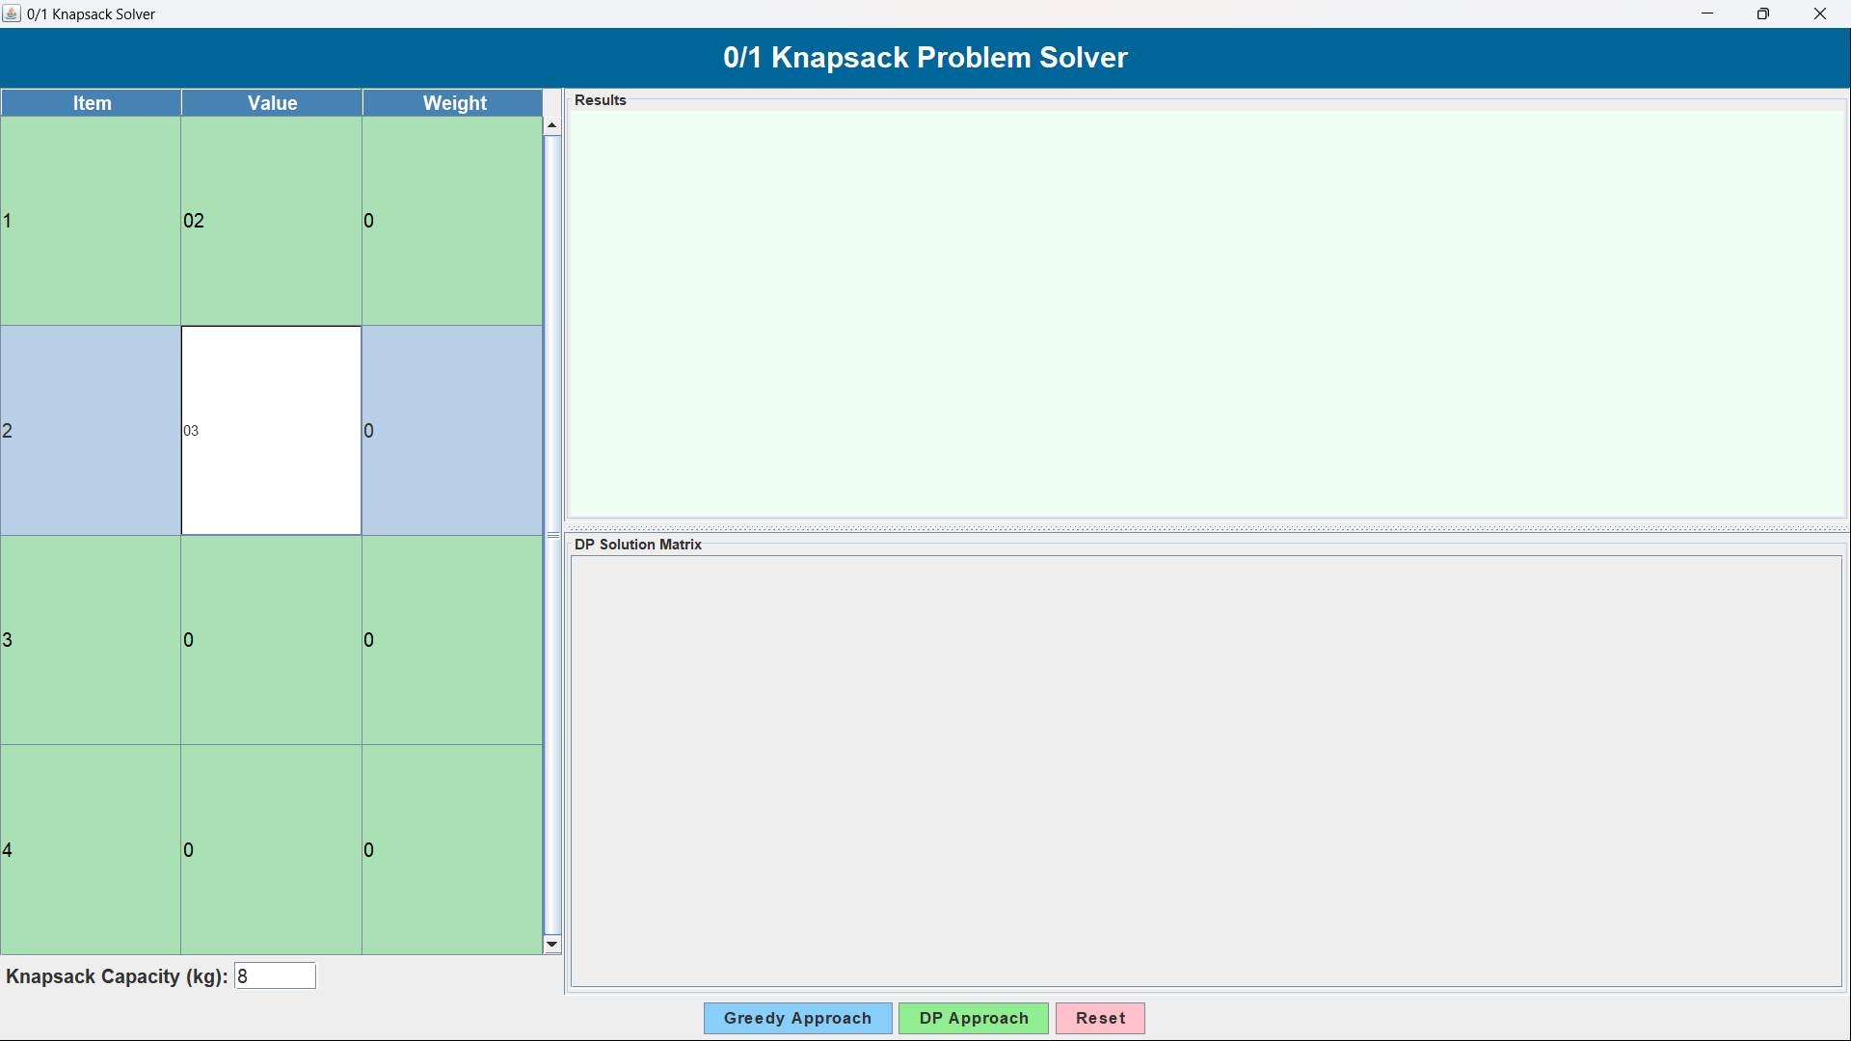

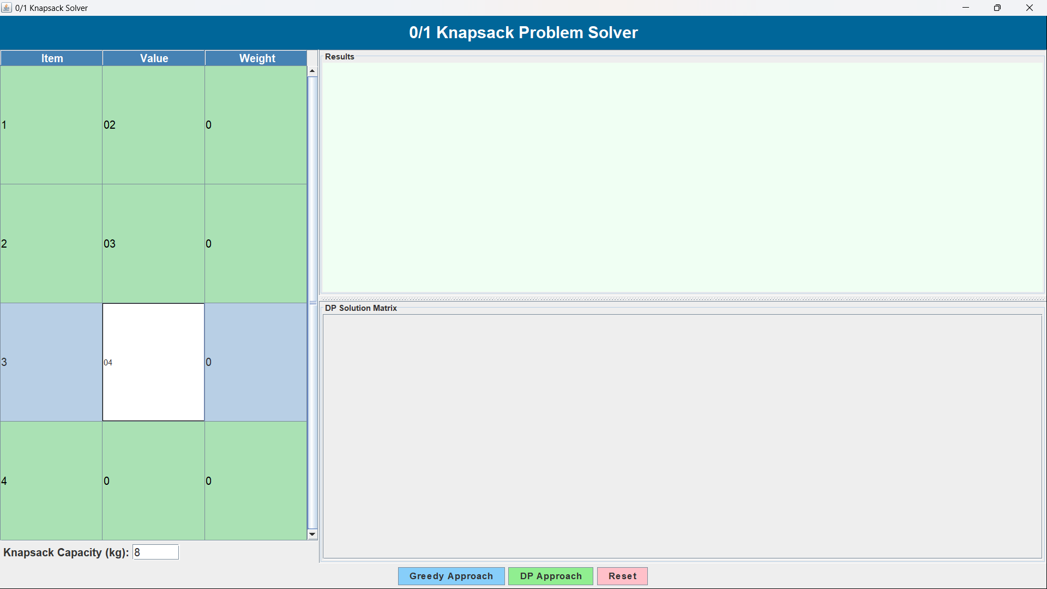

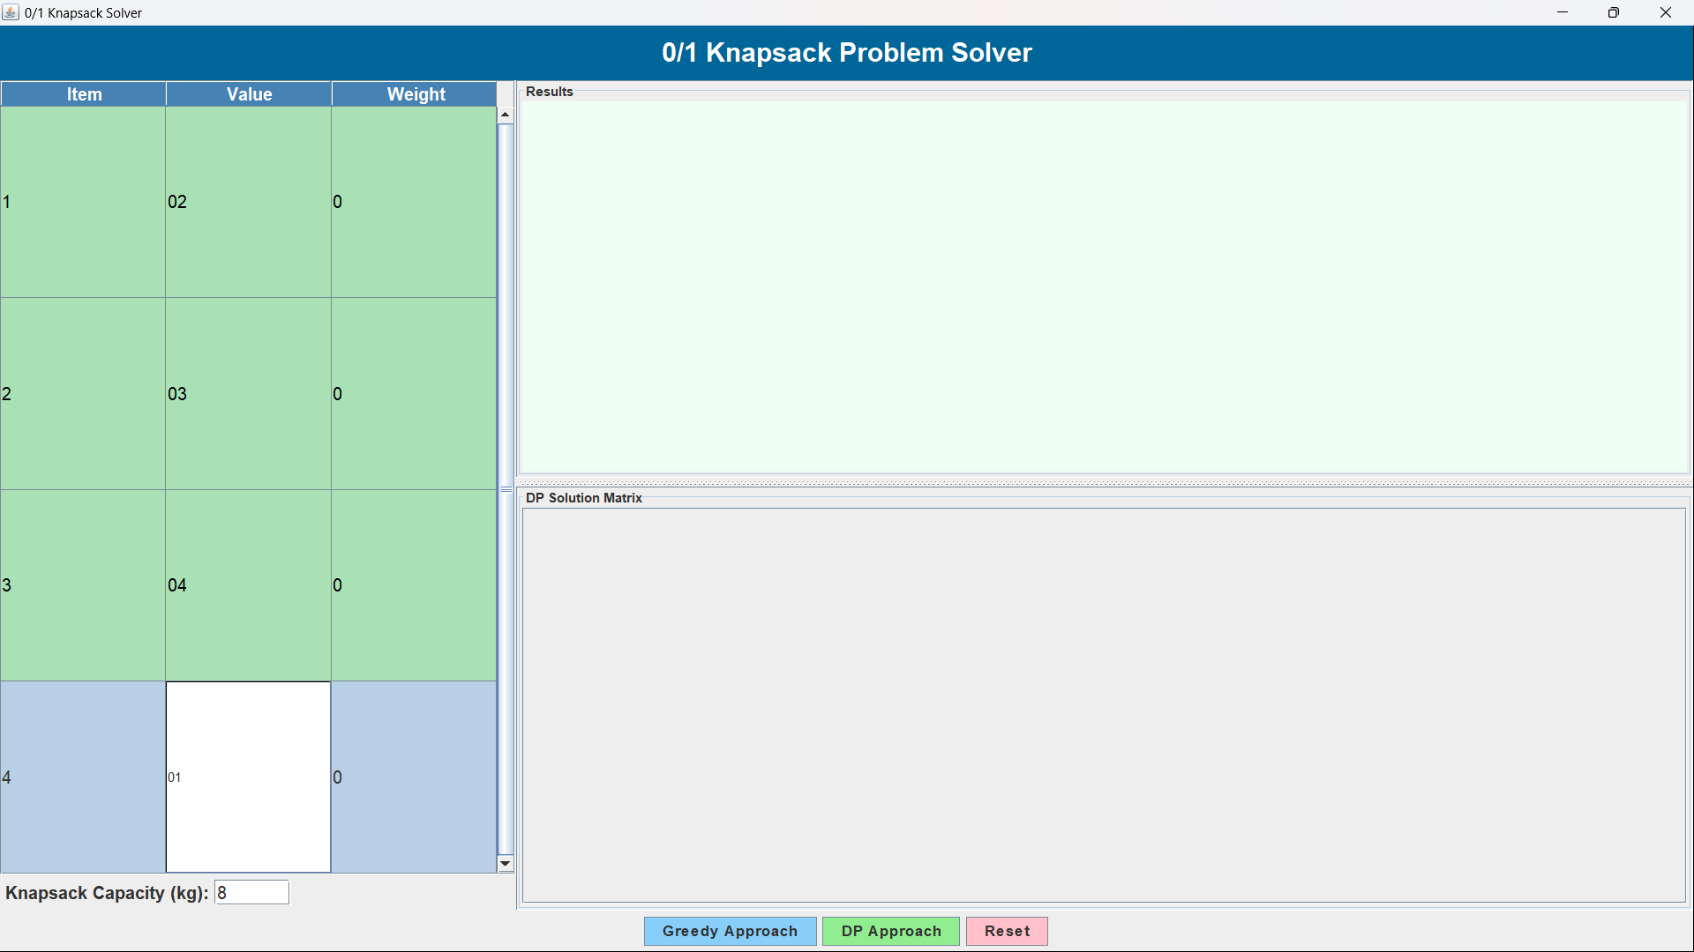

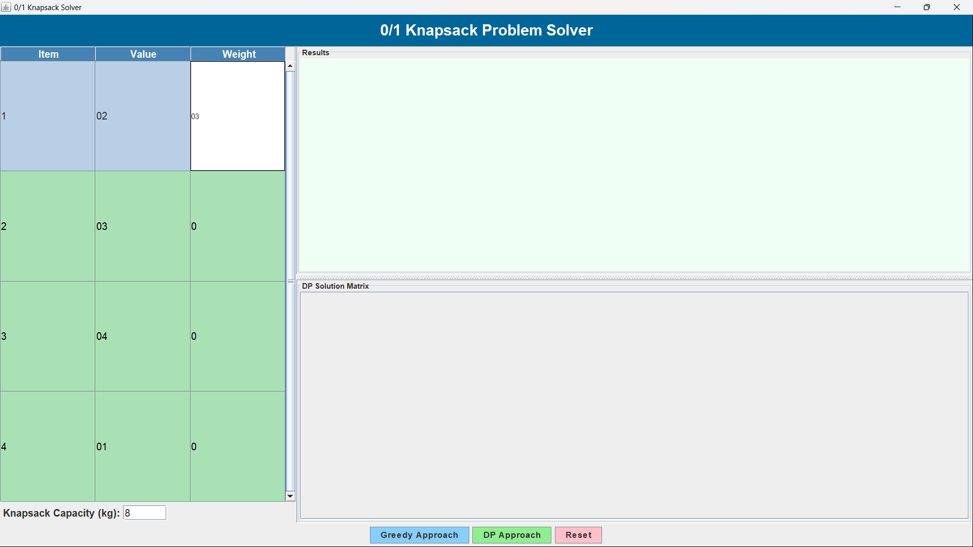

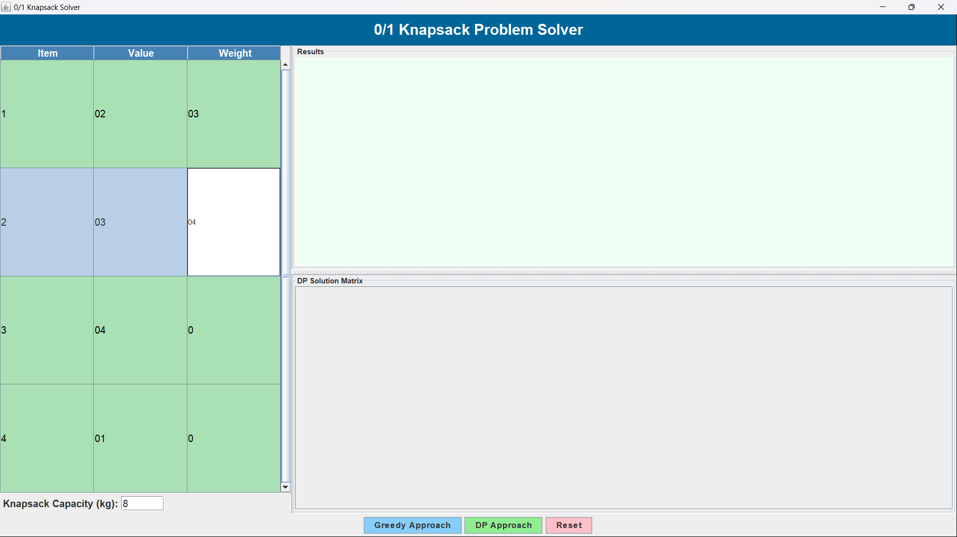

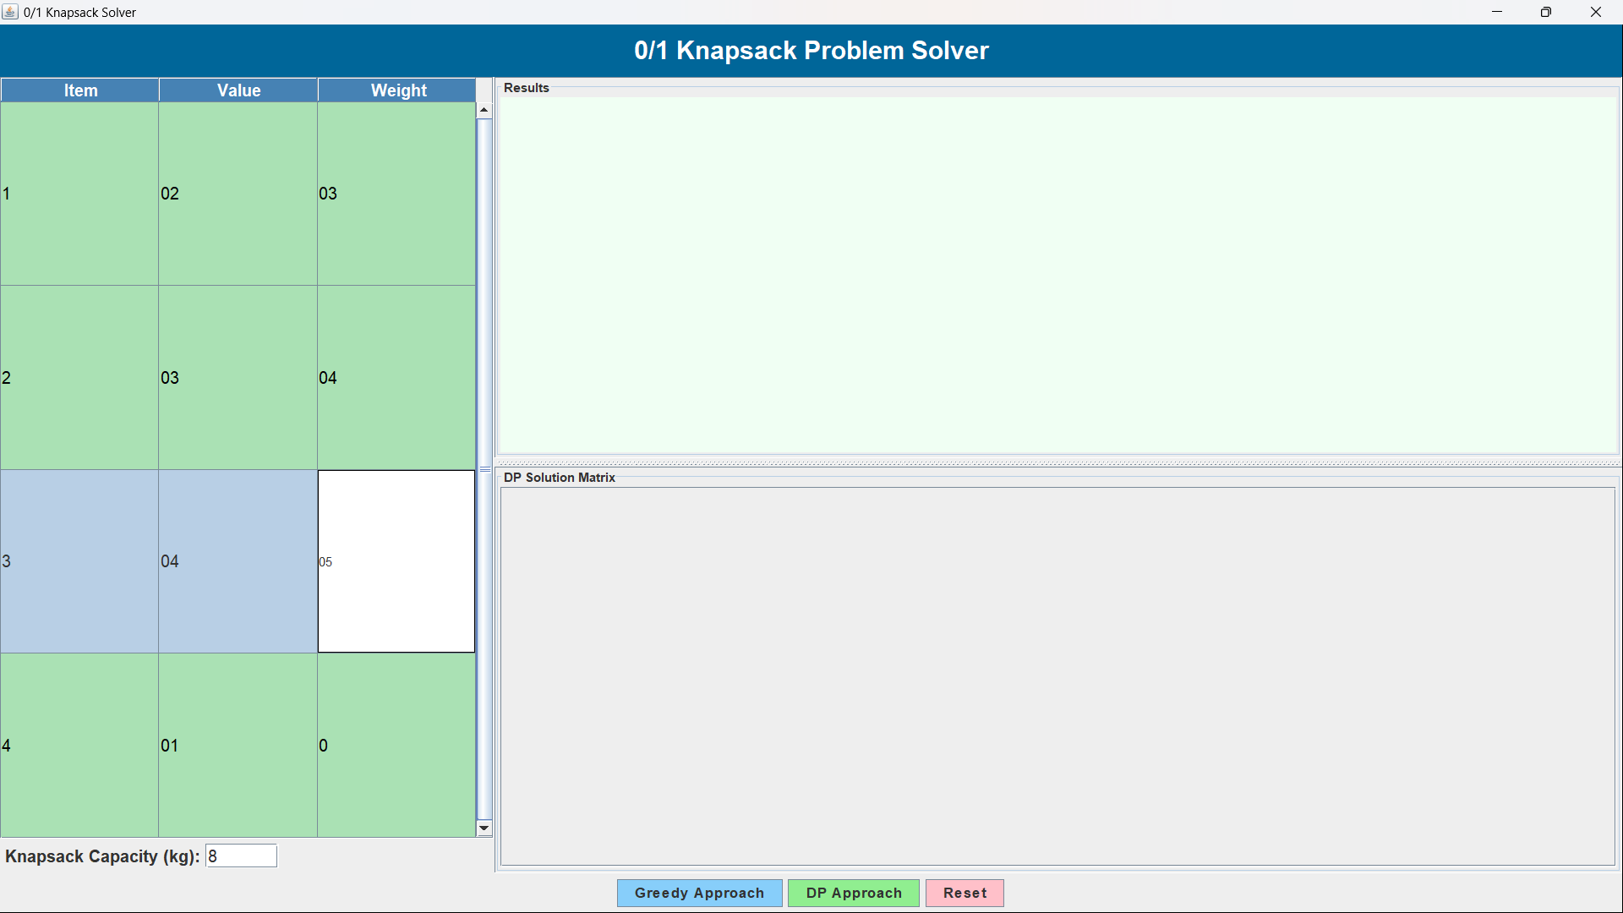

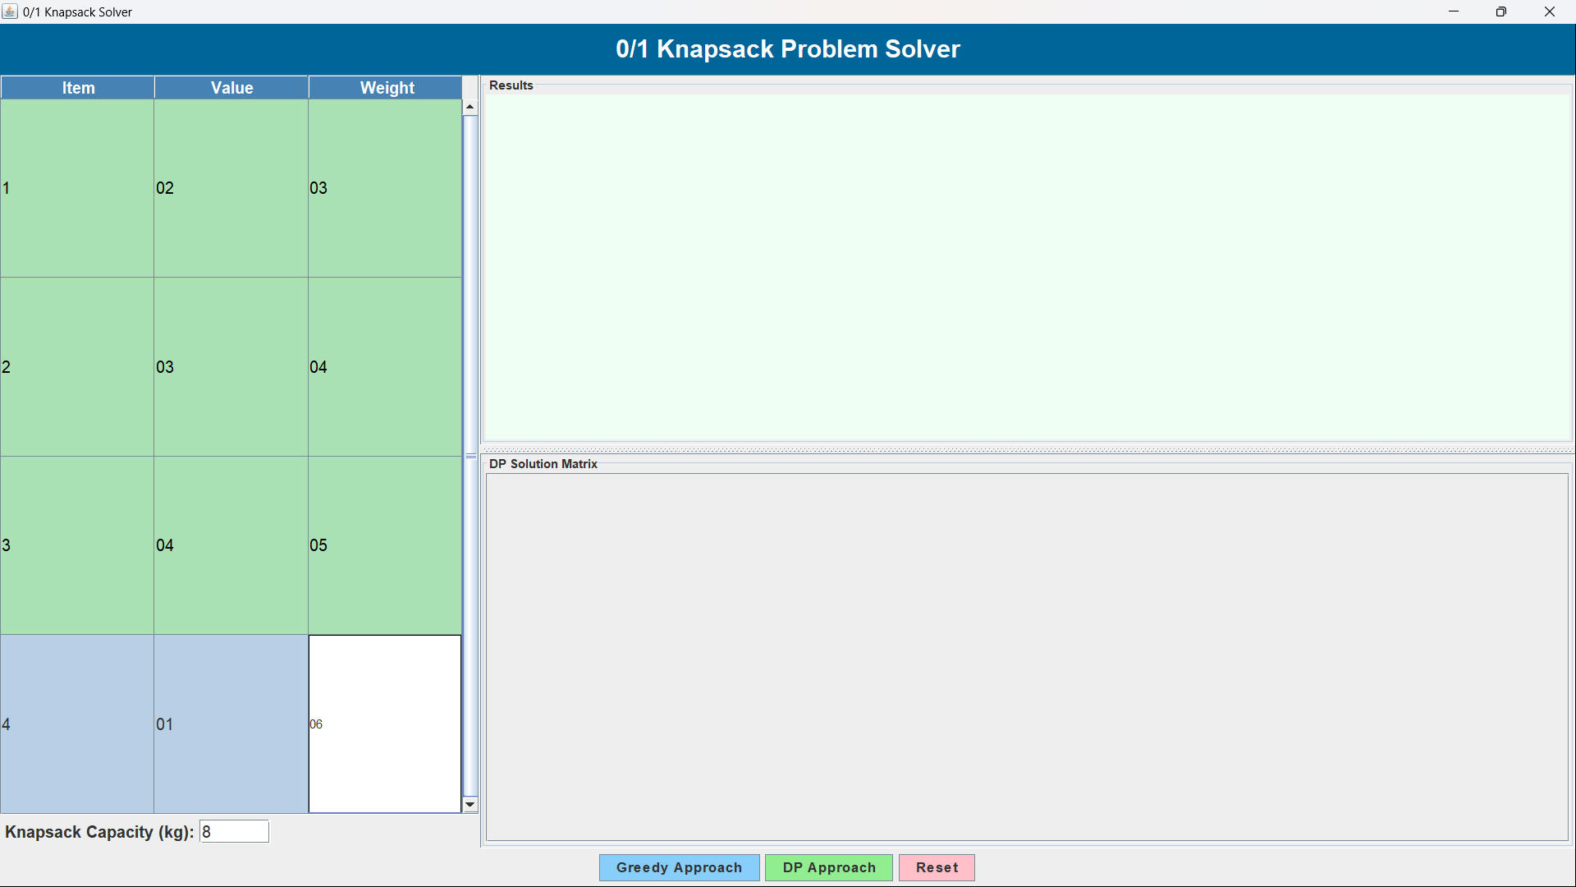

After entering all the values and weights in the input panel through GUI:
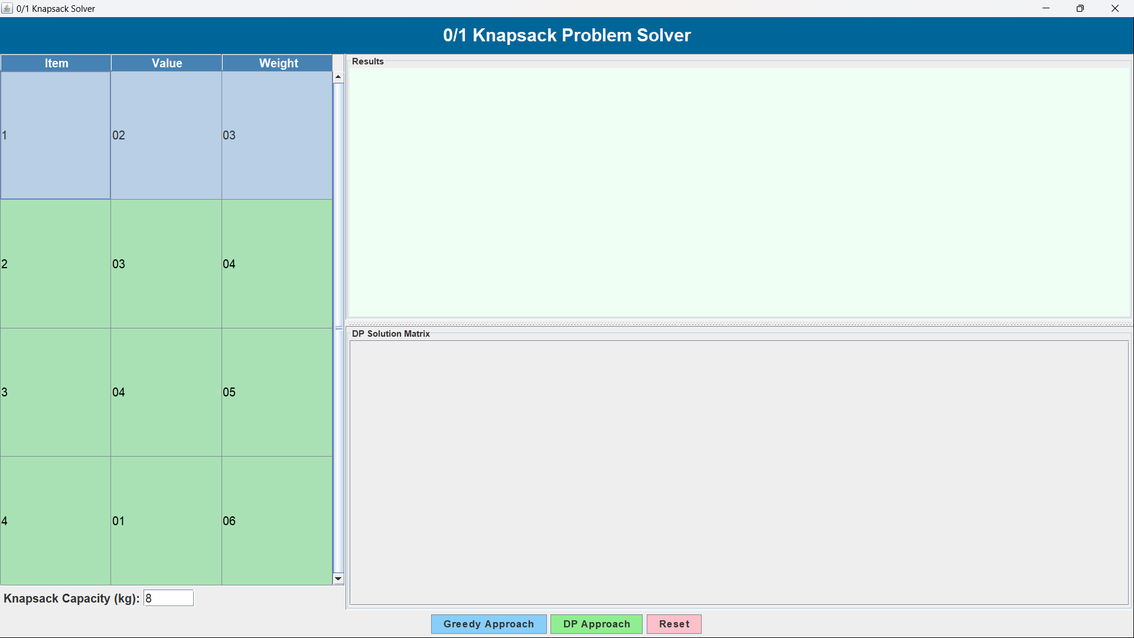

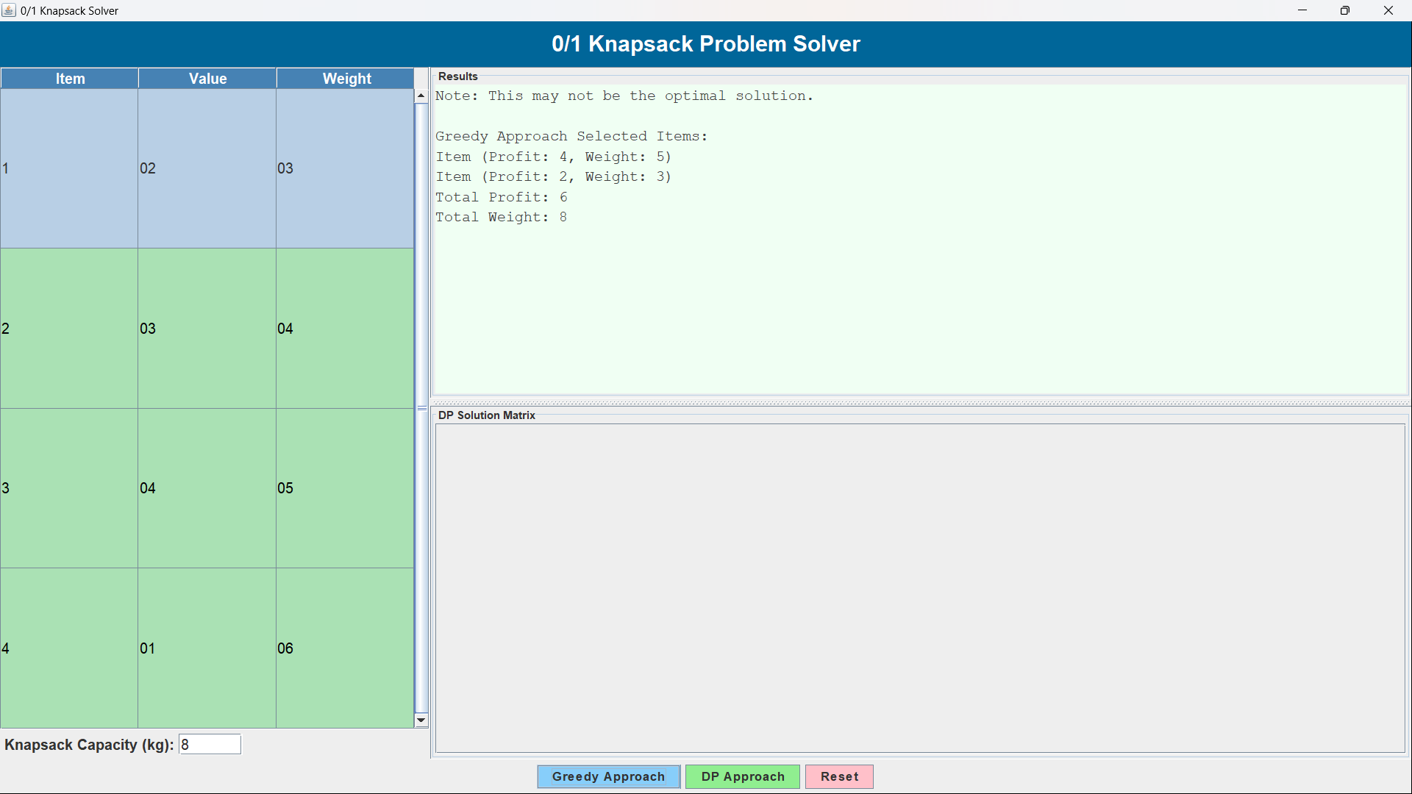
After pressing the Greedy Approach button, the result is displayed in the result panel.

After pressing the DP Approach button, the results and the DP Solution Matrix are displayed.

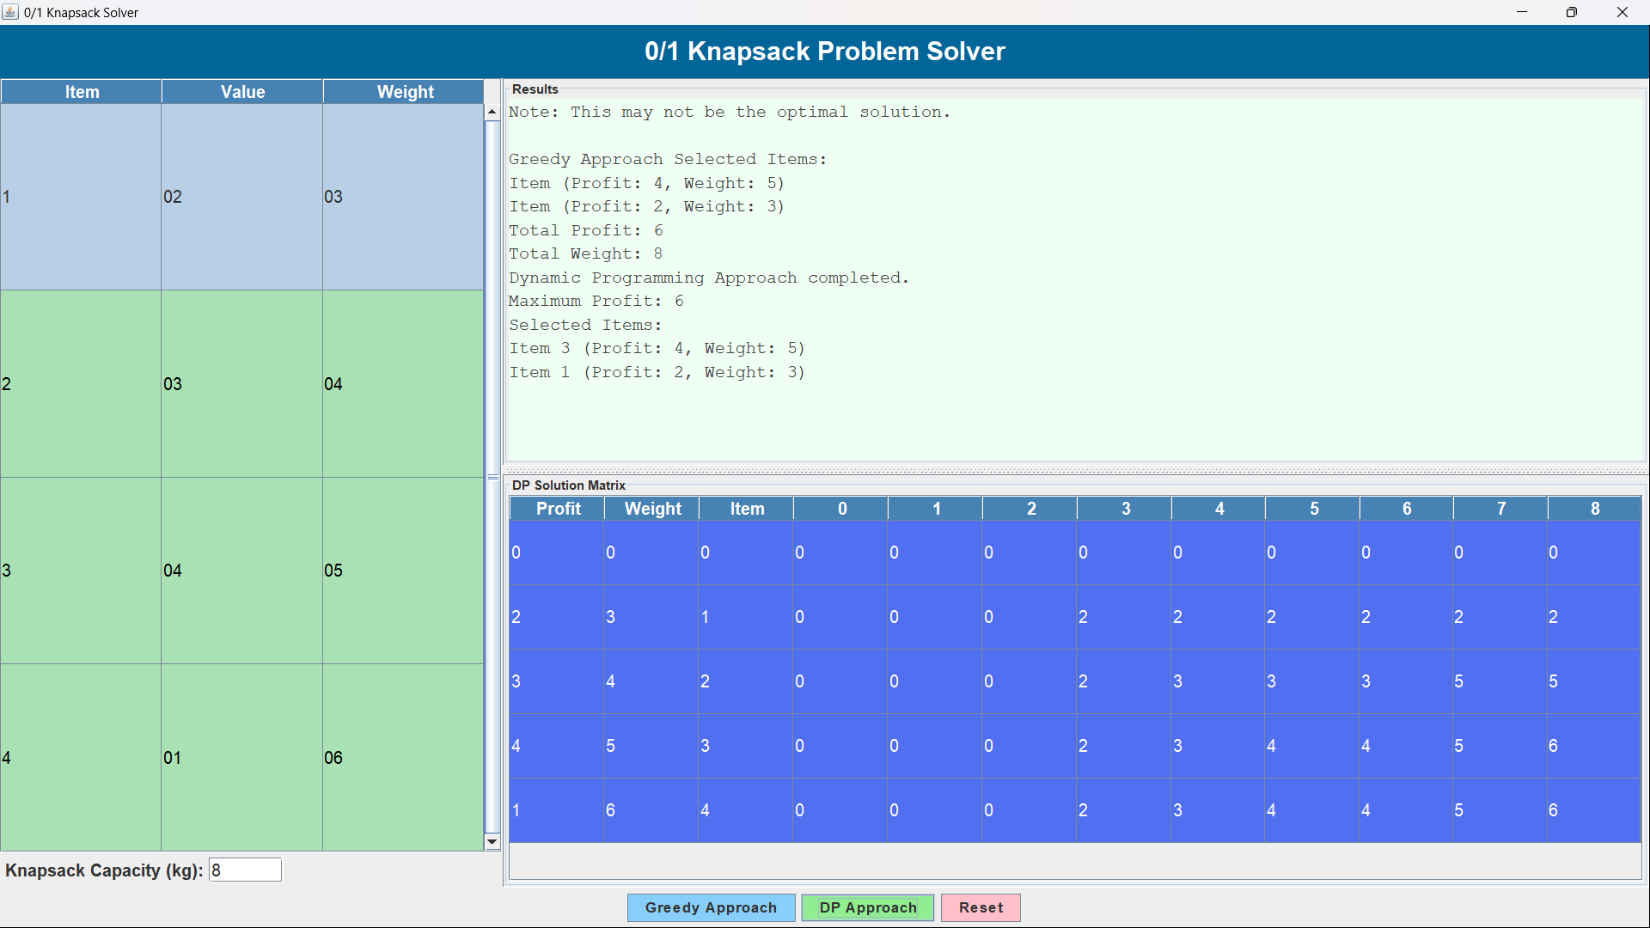

After pressing the reset button the results are cleared
