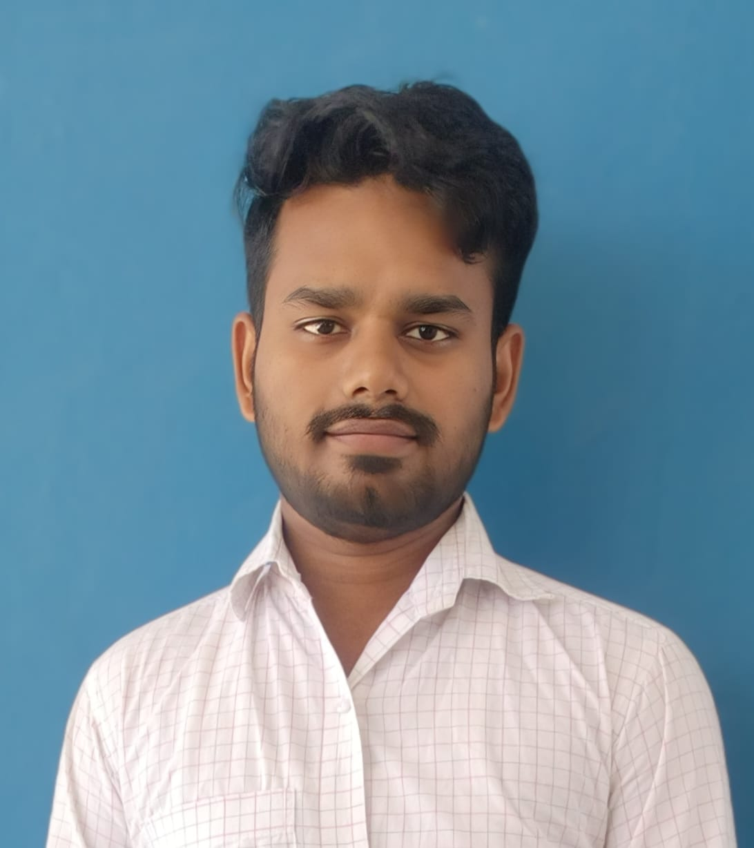

jitesh kumr bharti

software engineer



|  |  |  |  |
| --- | --- | --- | --- |
|  | Contact Home with solid fill  Daraundha,Siwan,Bihar 841233  Receiver with solid fill  +91 8434455389  Envelope with solid fill  [jiteshbharati90@gmail.com](mailto:jiteshbharati90@gmail.com) personal details  * Father’s Name : Birendra Bharati * Mother’s Name : Asha Devi * DOB : 28-12-1999  Key Skills  * JAVA * C Language  languagesEnglish  * HINDI  certificates  * Full Stack (09/2022 – 11/2022) * Infosys Springboard * React JS (07/2023 – 09/2023) * GUVI  social links **Linked in** :  [linkedin.com/in/jitesh-kumar-bharati-678272281](https://www.linkedin.com/in/jitesh-kumar-bharati-678272281)  **Git hub** :  <https://github.com/jiteshbharati90> |  | objective I am eager to kickstart my career as a Software Engineer. I am excited to apply my knowledge, learn from experienced professionals, and contribute to dynamic development projects while continuously enhancing my technical skills and problem-solving abilities.. education**b.tech (information technology)** Dhanalakshmi Srinivasan College of Engineering and technology  08/2020 – present 8.0105 CGPA **iNTERMEDIATE** Gorakh singh collage maharajganj, siwan, Bihar  06/2015 – 04/2017 61.2% **matriculation** S G S H/S Ujain Daraundha, Siwan, Bihar  03/2014 – 06/2015 65.2% technical skills  * Programming Language : Java , C * Frontend : Html, CSS, React.js, Bootstrap   : JavaScript   * Database : MongodB  project  * Real-Time Chat Website * This project aimed to create a dynamic and interactive platform for user to engage in instant messaging and collaborate discussions. * iNotebook – Web-Based Note-Taking Website * This project aimed to provide users with a seamless platform for creating, organizing, and securely storing their notes. |