

Project Interim Report

On

Password Complexity Validator (Using Core Java & OOP Concepts)
RU-100-05-00018
Object Oriented Programming with Java

SESSION: 2025-26

Submitted By
Jitesh Kumar Chandra
RU-25-10626

Bachelor of Computer Application
with AI and ML in association with Google

Under the Guidance of
Harsh Multani Sir

SCHOOL OF INFORMATION & TECHNOLOGY
RUNGTA INTERNATIONAL SKILLS UNIVERSITY
BHILAI, CG

(April 2026)

Abstract

In the modern digital era, security has become one of the most important aspects of any software system. With the rapid growth of online platforms such as banking, social media, and e-commerce, users are required to create accounts protected by passwords. However, many users tend to create weak passwords that are easy to remember but also easy to guess. This creates a serious security risk and may lead to unauthorized access, data theft, or identity misuse.

The main aim of this project is to design and implement a Password Complexity Validation System using Object-Oriented Programming (OOP) concepts in Java. This system ensures that users create strong and secure passwords by checking whether the password meets certain minimum requirements. These requirements include a minimum length of eight characters, the presence of at least one numeric digit, and the inclusion of at least one uppercase letter.

The project is designed in a modular way by dividing the functionality into different classes. The UserAccount class is responsible for storing user information such as username and password, while the SecurityValidator class is responsible for checking the strength of the password. This separation of responsibilities improves code readability, maintainability, and scalability.

Introduction

In today’s technology-driven world, almost every application requires user authentication. Whether it is logging into a social media account, accessing an email, or performing online banking, users must provide a username and password. Among these, the password plays a crucial role in ensuring the security of the system.

However, many users prefer to use simple and weak passwords such as “123456” or “password” because they are easy to remember. These weak passwords can be easily guessed or cracked using various hacking techniques, which poses a serious threat to data security. Therefore, it is necessary to enforce strong password policies in software systems.

This project focuses on creating a Password Complexity Validator using Java programming language and Object-Oriented Programming principles. The main goal is to ensure that the password entered by the user satisfies certain security conditions before it is accepted. These conditions include minimum length, inclusion of numeric characters, and use of uppercase letters.

The use of Object-Oriented Programming helps in organizing the code into different classes with specific responsibilities. This makes the program more structured, reusable, and easy to maintain. The project also helps in understanding how real-world applications implement validation mechanisms to enhance security.

By developing this project, we not only learn programming concepts but also understand the importance of data protection and secure coding practices. This project serves as a foundation for building more advanced security systems in the future.

Scope

This project is suitable for small-scale applications where basic password validation is required. It can be used in simple registration systems, student projects, or beginner-level applications.

Currently, the system performs basic validation such as checking password length, numeric characters, and uppercase letters. However, the project can be extended in the future by adding more advanced features such as special character validation, password encryption, and database storage.

With further development, this system can be integrated into larger applications such as websites, mobile apps, and enterprise systems to enhance security.

System Requirements

Hardware: Computer with 4GB RAM

Software: Java JDK, IDE (VS Code/Eclipse/Edit Plus)

Methodology

The working of the project follows a step-by-step approach:

First, the user enters the username and password.

A UserAccount object is created to store this information.

The object is passed to the SecurityValidator class.

The system checks the password length (must be at least 8 characters).

It then checks whether the password contains at least one numeric digit.

After that, it checks for at least one uppercase letter.

All conditions are combined to determine whether the password is valid or not.

The result is returned and displayed to the user.

This method ensures that the password is checked step-by-step and only accepted if all conditions are satisfied.

Flowchart

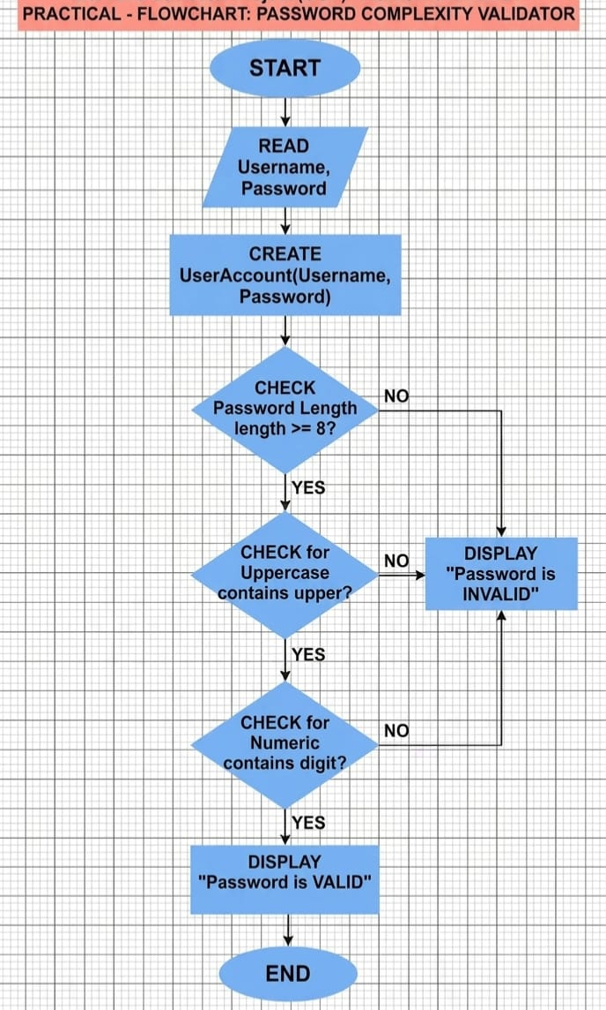

Implementation

The project is implemented using three main classes.

The UserAccount class is used to store user details such as username and password. The variables are declared private to protect data, and getter methods are used to access them.

The SecurityValidator class contains the main validation logic. It takes the password from the UserAccount object and checks whether it meets the required conditions. A loop is used to go through each character of the password and check if it contains digits and uppercase letters.

The Main class is responsible for running the program. It creates objects of the other classes and displays the result based on the validation.

This structure makes the program modular, easy to understand, and reusable.

Gantt Chart

- Planning & Structure

A Gantt chart helps you break the project into tasks (design, coding, testing, etc.) and set timelines. Even if it's already built once, rebuilding or modifying still needs planning.

Time Management

It shows:
When each task starts When it should finish
This helps avoid delays and last-minute panic.

Conclusion

This project successfully demonstrates the implementation of a Password Complexity Validation System using Object-Oriented Programming. It helps in understanding how secure password policies are applied in real-world applications.

By separating user data and validation logic, the system becomes more organized and maintainable. The project also improves programming skills and highlights the importance of cybersecurity.

Overall, this project provides a strong foundation for developing secure applications in the future.

Book Format:
[1] Author(s), *Book Title*, Edition. City: Publisher, Year.

Example:
[1] H. Schildt, *Java: The Complete Reference*, 11th ed. New York: McGraw-Hill, 2018.

Website Format:
[2] Author (if any), "Title of page," Website Name. [Online]. Available: URL

Example:
[2] Oracle, "Java Documentation," Oracle. [Online]. Available: https://docs.oracle.com

Conference Paper
Format:
[3] Author(s), "Paper title," in Proc. Conference Name, year, pp.
Example:
[3] S. Kumar, "AI in Education," in Proc. IEEE Conf. on AI, 2021, pp. 120-125.

Journal Article
Format:
[4] Author(s), "Title of paper," Journal Name, vol., no., pp., year.
Example:
[4] A. Sharma and R. Gupta, "Machine Learning Techniques," International Journal of AI, vol. 5,
no. 2, pp. 45-50, 2020.

