
Product Dissection for OYO Rooms

Company Overview:
OYO Rooms, founded in 2013 by Ritesh Agarwal, has transformed the hospitality industry by providing affordable and standardised accommodation to travellers worldwide. With a presence in over 80 countries, OYO partners with hotels, homes, and spaces to deliver quality experiences. Focused on technological innovation and customer-centric services, OYO ensures that travellers find verified, hygienic, and budget-friendly stays seamlessly through its platform.

Product Dissection and Real-World Problems Solved by OYO Rooms:
OYO, as a global hospitality platform, has addressed several challenges faced by travellers and hotel owners alike. By leveraging technology, standardising experiences, and creating a wide network of properties, OYO bridges the gap between demand for quality stays and supply of affordable accommodation.
Key problems addressed:
- Budget-Friendly Accommodation: OYO provides economical options without compromising on quality.
- Standardisation: Consistent room quality across properties.
- Hygiene & Safety: Post-COVID, OYO introduced 'Sanitised Stays' for safe travel.
- Instant Booking: OYO’s app and website facilitate quick, last-minute bookings.
- Verified Reviews: Genuine customer reviews enhance trust.
- Multiple Payment Options: Secure and flexible payment methods ensure convenience.
In conclusion, OYO has redefined travel accommodations by solving accessibility, affordability, and quality concerns, ensuring travellers have reliable choices across destinations.

Case Study: Real-World Problems and OYO Rooms Innovative Solutions

OYO is a global hospitality platform that connects travelers with affordable and quality stays also addressed significant real-world challenges through its innovative features
Problem 1: Limited Access to Budget-Friendly Hotels
Real-World Challenge:
Travellers struggled to find affordable stays without compromising on quality
OYO's Solution:
OYO’s partnered with hotels and homes to offer standardised, budget-friendly accommodations, making travel accessible to all

Problem 2: Hygiene and Safety Concerns Challenge
Real-World Challenge:
Especially post-pandemic, cleanliness became a priority.
.
OYO's Solution:
OYO’s ‘Sanitised Stays' initiative ensures properties meet strict hygiene standards.

Problem 3: Booking Hassles During Travel Challenge:
Real-World Challenge:
Last-minute bookings were stressful and uncertain.

OYO's Solution:
OYO’s platform provides real-time availability and instant confirmations, reducing traveller anxiety.

Problem 4: Trust Issues with Property Quality
Real-World Challenge:
Online listings often misrepresented property conditions

OYO's Solution:
OYO’s Verified listings and genuine customer reviews enhance transparency and trust.

Problem 5 : Limited Payment Flexibility
Real-World Challenge:
Travellers faced limited payment methods

OYO's Solution:
OYO’s Multiple options including OYO Wallet, UPI, credit/debit cards, and net banking.

Top Features of OYO’s:

- User Profiles: Users can manage their bookings, wallet balance, and reviews.
- Property Listings: Detailed hotel/home profiles including amenities, location, and pricing.
- Instant Booking: Real-time room availability and instant confirmations.
- Secure Payments: Multiple secure payment gateways and wallet integration.
- Reviews & Ratings: Verified guest feedback builds trust and improves quality control.
- Offers & Discounts: Regular deals and promotions to attract users.
- Location-Based Search: Users can search properties by city, area, or proximity.

Schema Description:
The OYO platform's schema captures all major user and property interactions. The design includes users, hotels, rooms, bookings, payments, reviews, offers, and locations. This structure supports efficient data flow and seamless user experience.
Entities:
- User Entity:
- UserID (PK)
- Name
- Email
- Phone
- RegistrationDate
- WalletBalance

- Hotel Entity:
- HotelID (PK)
- Name
- LocationID (FK)
- Rating
- Standardised (Yes/No)

- Room Entity:
- RoomID (PK)
- HotelID (FK)
- RoomType (Single/Double/Deluxe)
- PricePerNight
- AvailabilityStatus

- Booking Entity:
- BookingID (PK)
- UserID (FK)
- RoomID (FK)
- CheckInDate
- CheckOutDate
- BookingDate
- PaymentStatus

- Payment Entity:
- PaymentID (PK)
- BookingID (FK)
- PaymentMethod
- Amount
- PaymentDate

- Review Entity:
- ReviewID (PK)
- BookingID (FK)
- UserID (FK)
- Rating
- Comments
- ReviewDate

- Location Entity:
- LocationID (PK)
- City
- State
- Country

- Offer Entity:
- OfferID (PK)
- DiscountPercent
- ValidFrom
- ValidTo
- ApplicableHotelID (FK)

Relationships are:

- User books Booking
- Booking is for Room
- Room belongs to Hotel
- Hotel is located at Location
- Payment is linked to Booking
- User leaves Review after Booking
- Offer applies to Hotel

ER Diagram:

Let's construct an ER diagram that vividly portrays the relationships and attributes of the entities within the OYO schema. This ER diagram will serve as a visual representation, shedding light on the pivotal components of OYO’s data model. By employing this diagram, you'll gain a clearer grasp of the intricate interactions and connections that define the platform's dynamics.

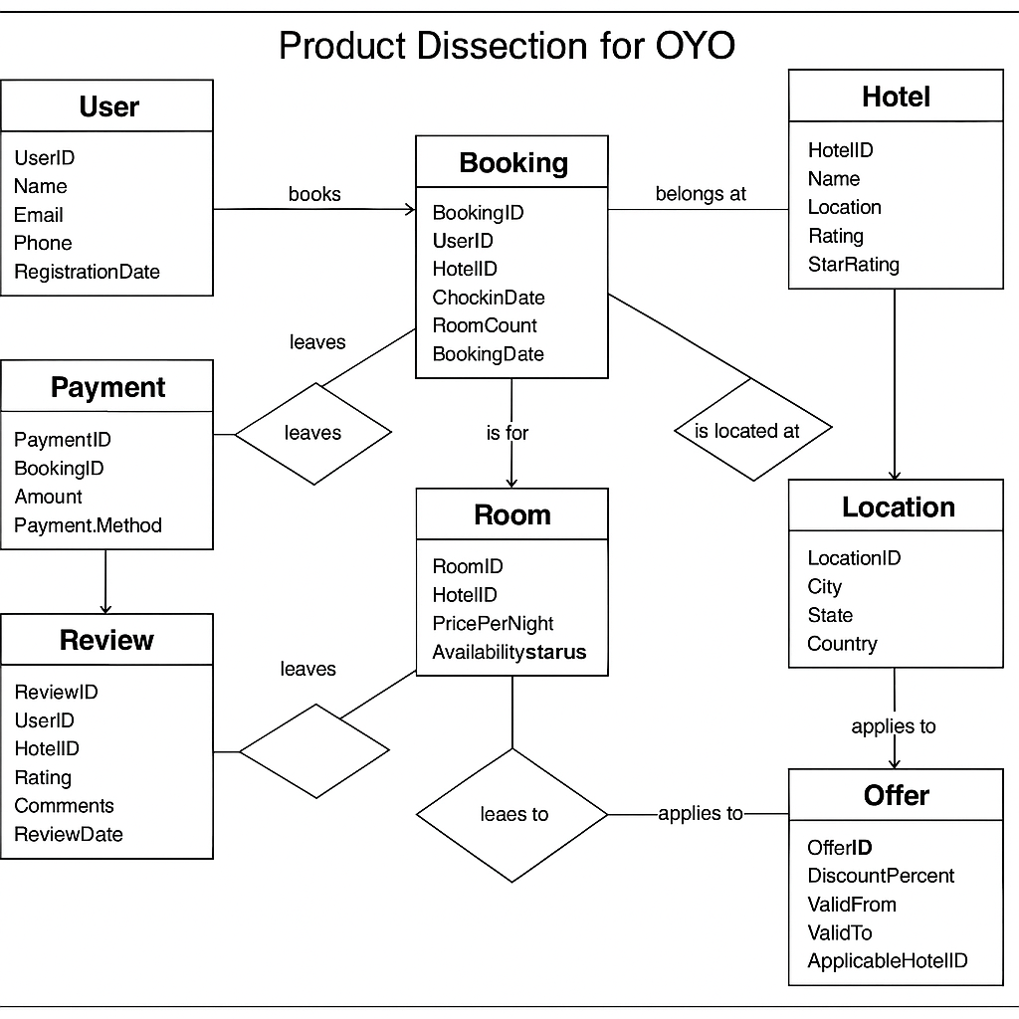

Conclusion:
In this case study, we explored how OYO Rooms has transformed the hospitality landscape through its innovative, tech-driven approach. The carefully designed schema captures critical components like users, bookings, payments, and reviews, ensuring a smooth experience for travellers and hotel partners alike. OYO’s relational database structure allows seamless management of millions of records while maintaining data integrity and supporting future growth.
By understanding this schema, we see how OYO efficiently addresses real-world travel challenges, enhancing the experience for millions of users globally.

