System set up
Put visual studio code in c drive create a folder inside vscode
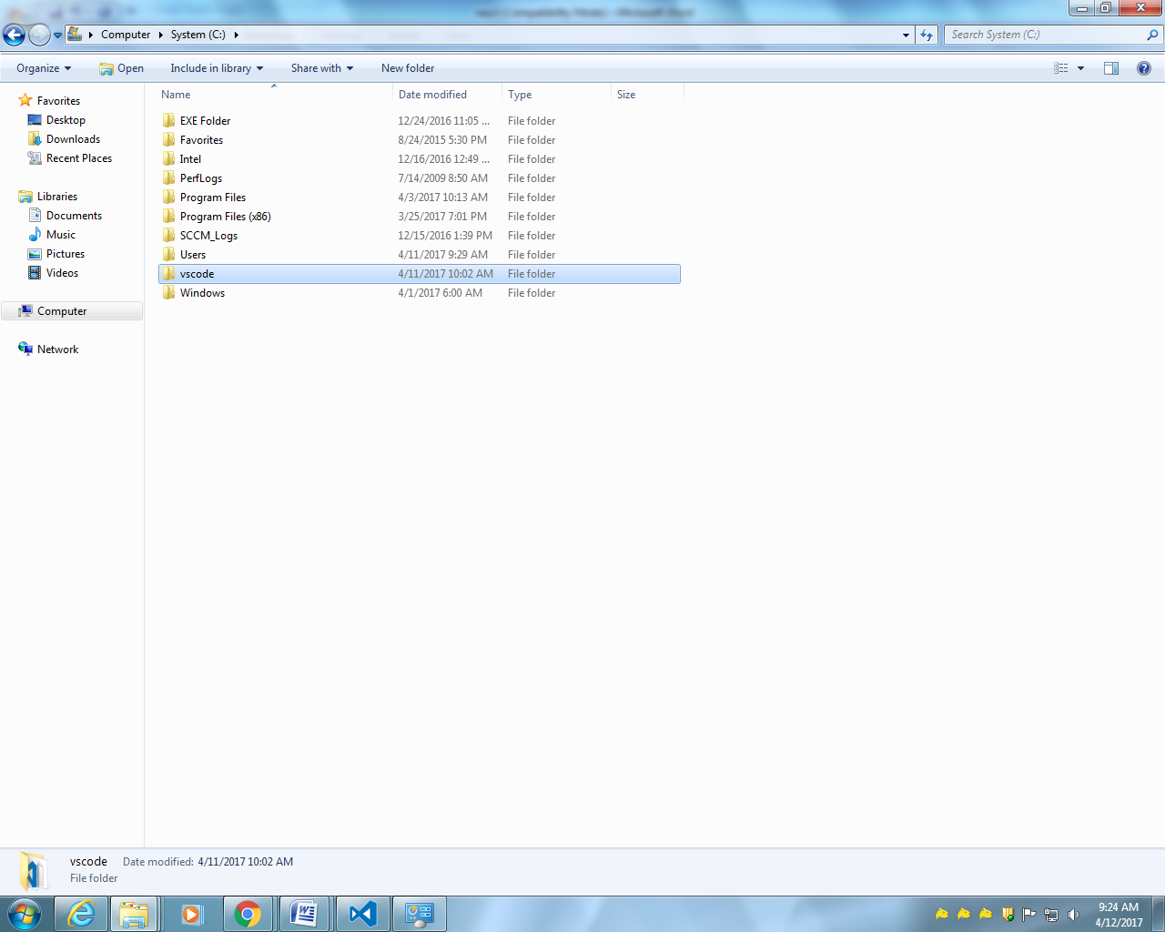
These many files should be there
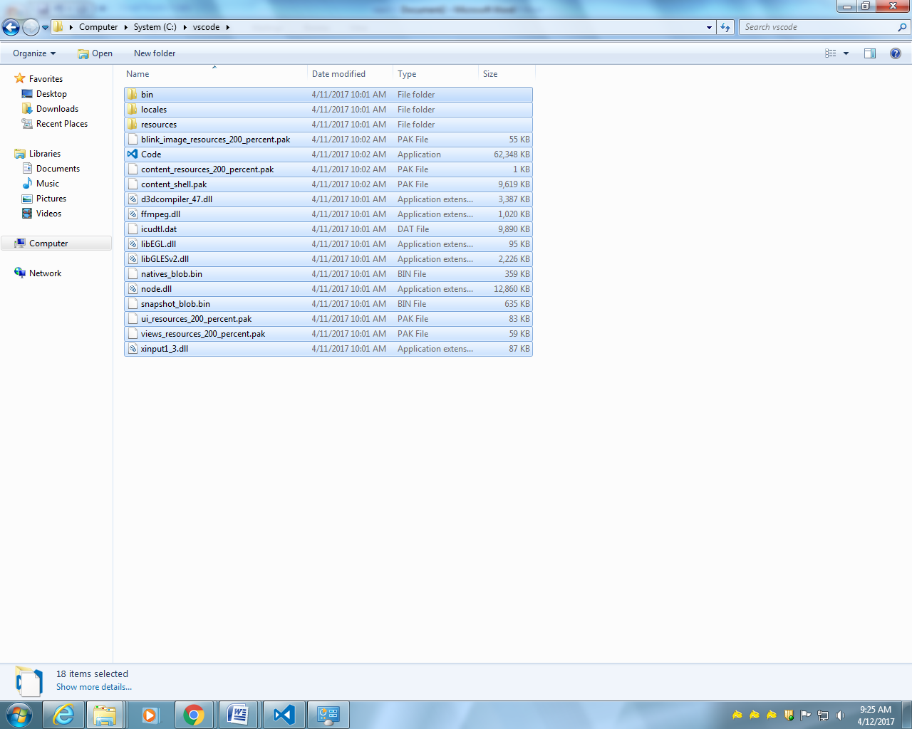
For node js put extract files directly in D drive
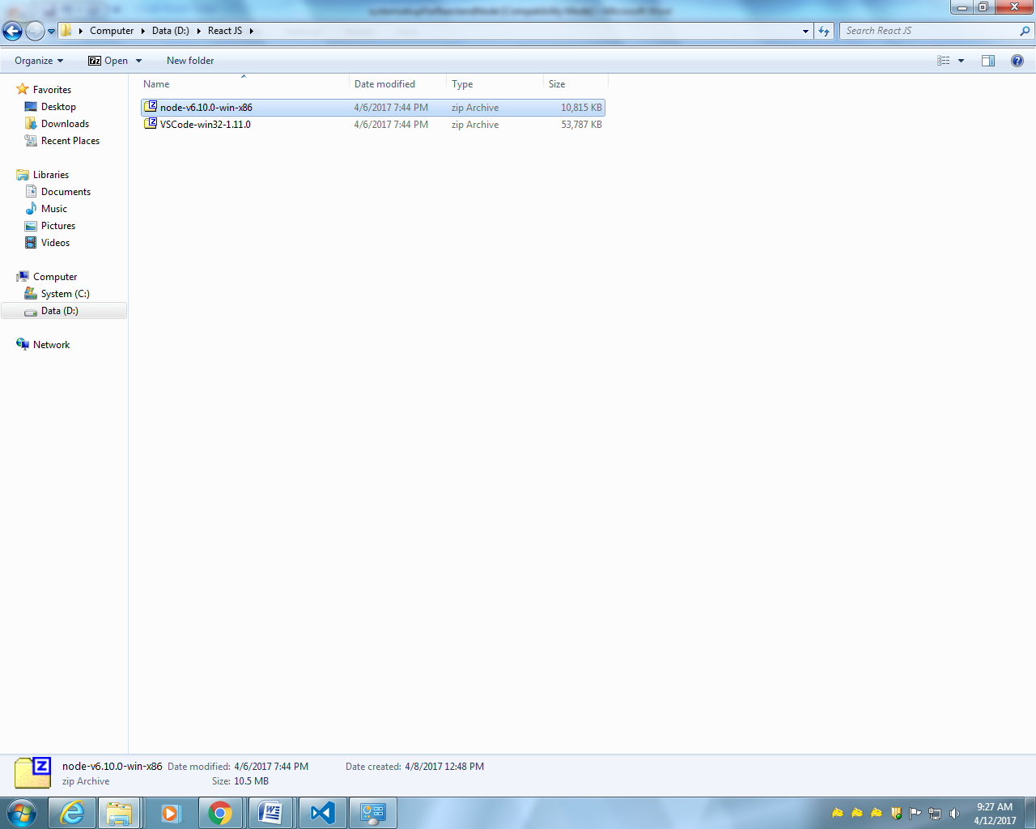
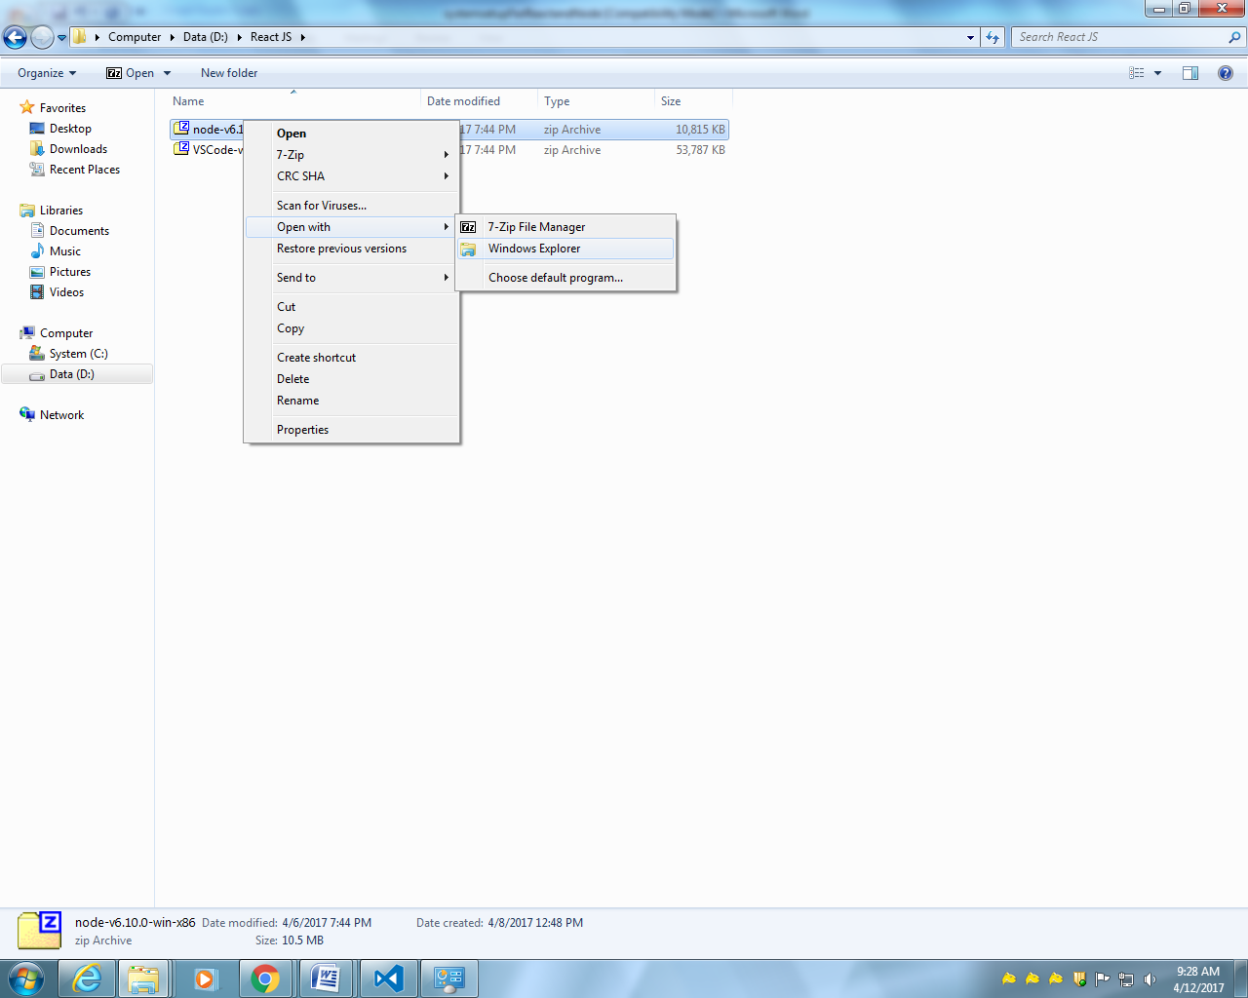
Create a folder nodejs and keep inside it
It should be like these
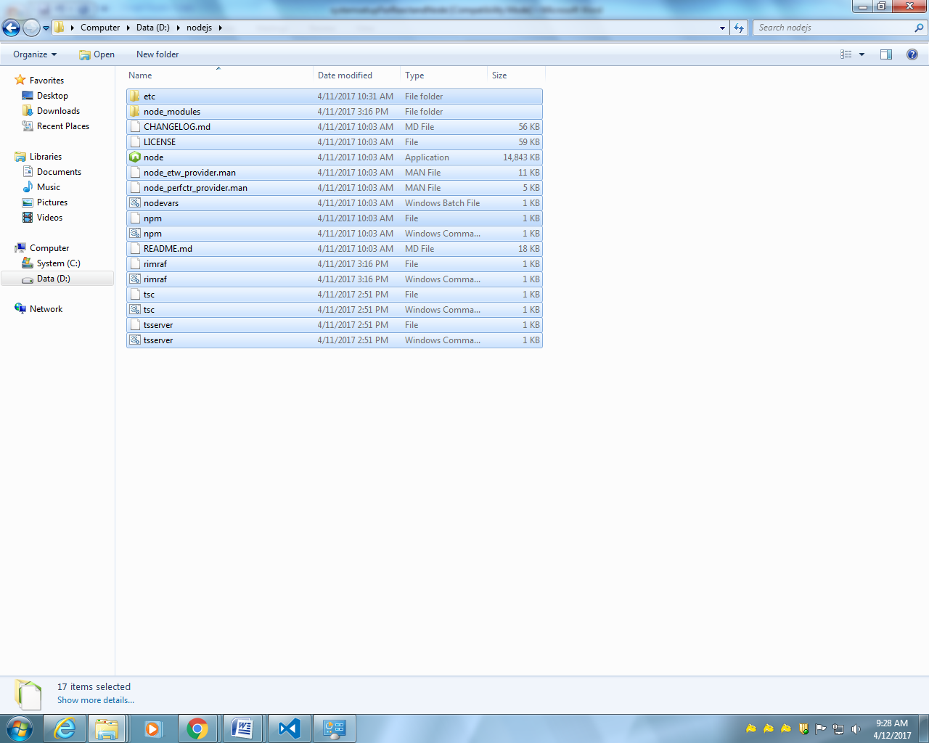
Then pin to task bar to visualstudio
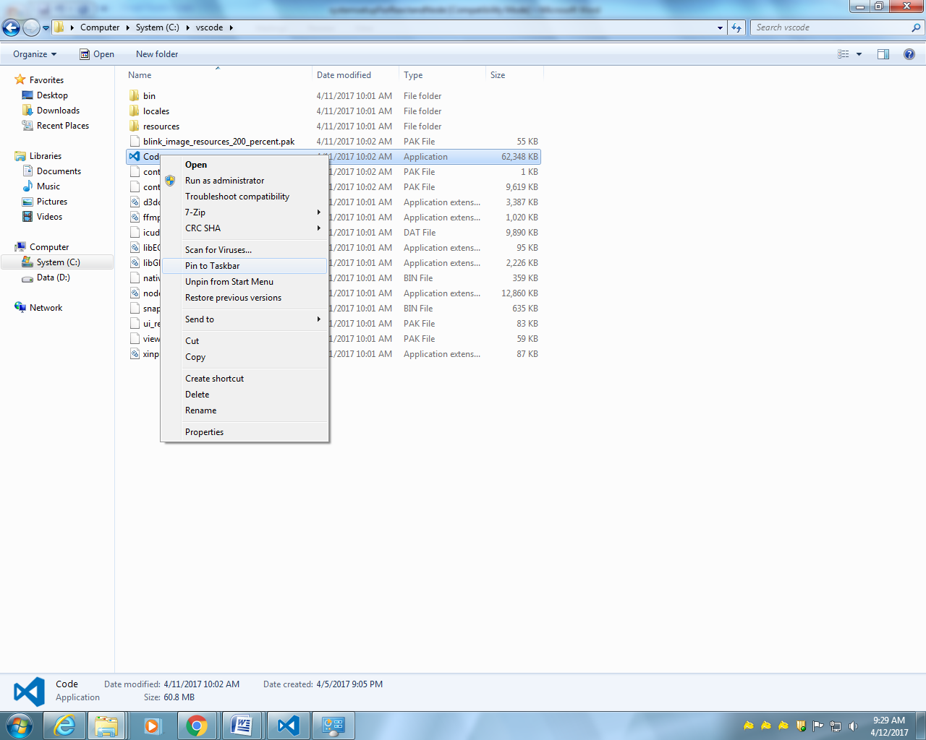

Go to properties
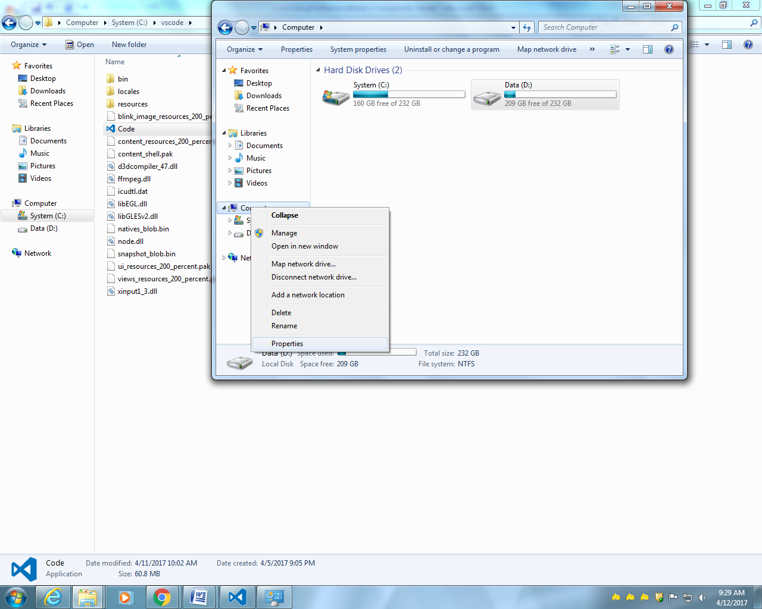
Advance system setting
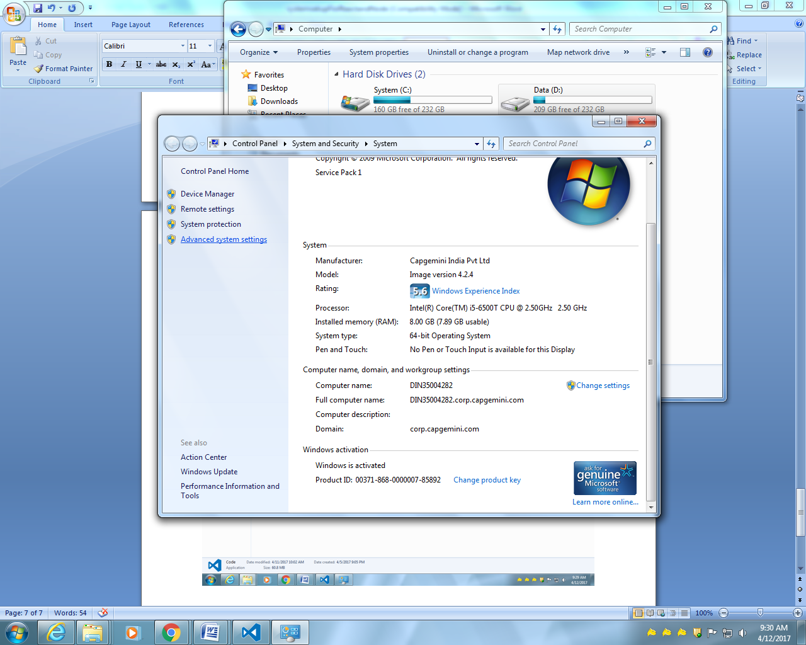
Then environment variables
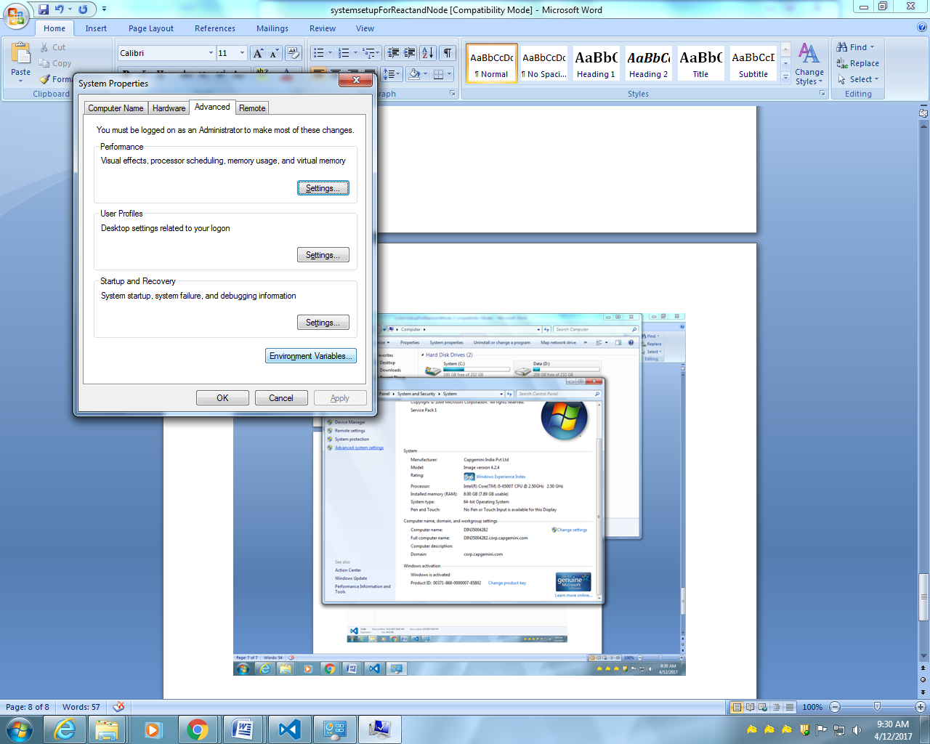
Create 2 new variables
Variable name variable value
NODE_PATH D:\nodejs\node_modules
PATH D:\nodejs

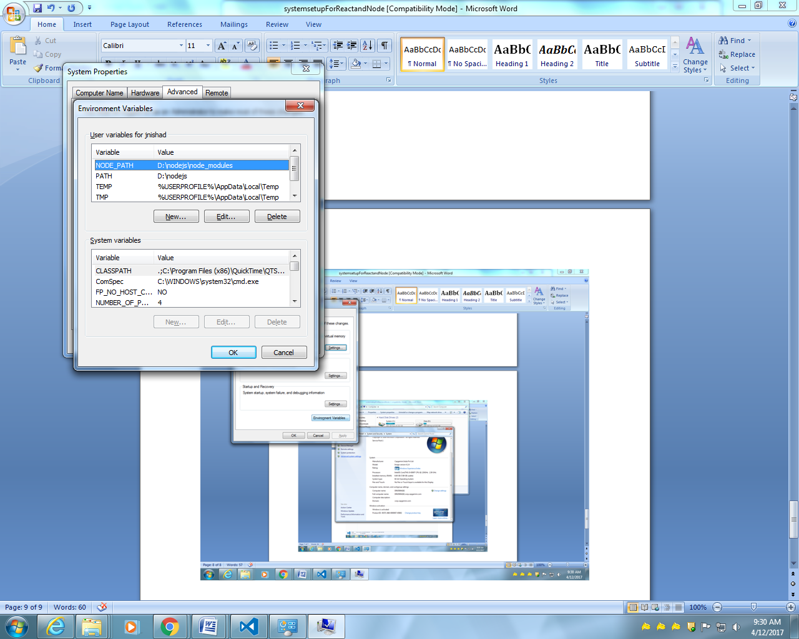

Open visual studio
Presss cntrl+button below Esc
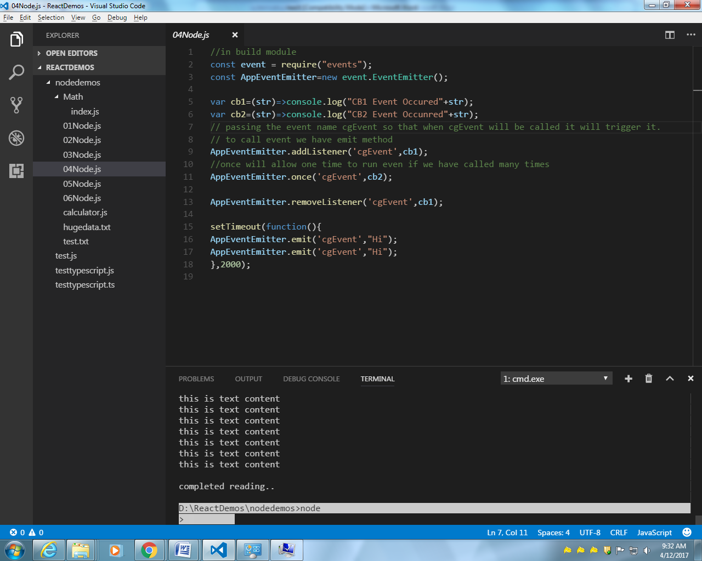

Type in terminal : node
It should give > sign.
To come out press two time cntrl+c
To run any test.js type node test.js
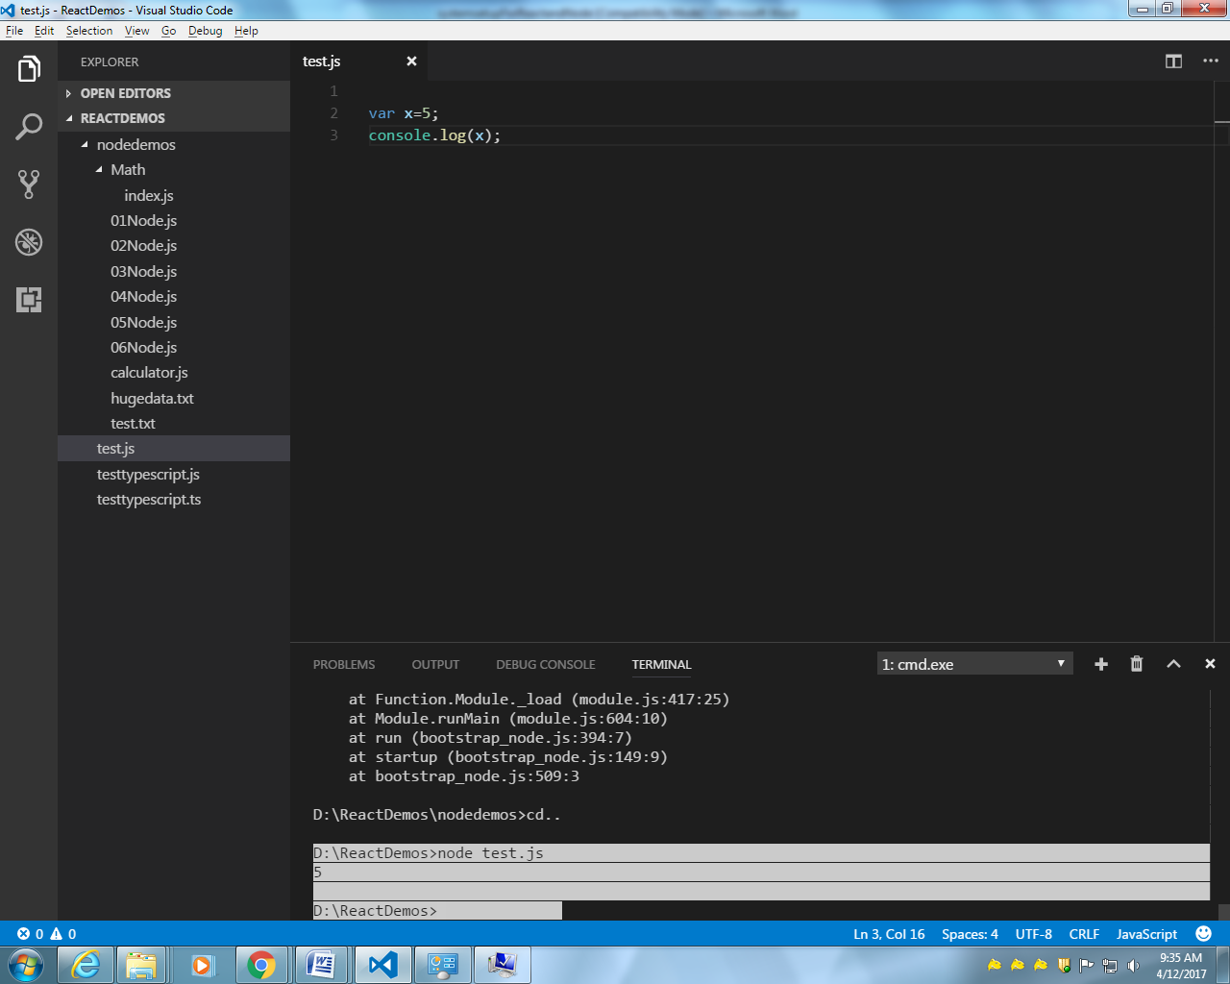

Can create a folder and point visual studio to that particular folder
