Go to computer >properties>set 2 new eniviornment variables >
Variable name variable value
NODE_PATH D:\nodejs\node_modules
PATH D:\nodejs
https://www.yammer.com/capgemini.com/#/users/1572839387/files
var employee={id:12,name:"jitesh"};
for(var prop in employee){

console.log(prop+":"+employee[prop]); //best practise
}
var numbers=[];
numbers.push(1);
numbers.push(2);
numbers.push(3);
numbers.push(4);
console.log(numbers);
numbers.pop();
console.log(numbers);
numbers.splice(numbers.indexOf(2),1);
console.log(numbers);
(function(a,b){
console.log(a+b);
})(4,5);

var add=function(){return 5};
console.log(typeof add());
console.log(typeof add);
Currying is nested function where function returns a function
function add(a){
return function(b){
return a+b;
}
}
console.log(add(4)(5));

event loop :search

Deferred execution
var addNumbers=function(a,b,fn){
var result;
setTimeout(function(){
result=a+b;
fn(result);
},5000);
}

addNumbers(3,4,function(res){
console.log(res);
});

Function passes through arguments goes in callback queue.
(function(){
})()

Closure:
(function () {
var year = 2017;
printYear = function () {
console.log(year);
}
incrementYear = function () {
year++;
}
setYear = function (y) {
year = y;
}
})();
printYear();
setYear(2000);
incrementYear();
printYear();
ie :chakra engine
chrome:v8
safari:spider monkey
call back is deprecated, now will use promise
these is how we call function t outside
(function () {
var data = 1000;
t=function(){
data = 2000;
console.log(data);
}
})();
t();

below code where test() is called it , local scope and same as
function test(){
}

(function () {
var data = 1000;
var test=function() {
data = 2000;
console.log(data);
}
})();

Test(2000);

Calculator:

var calculator = (function () {
var result;
fn1 = function (a, b) {
result = a + b;
return result;
};
fn2 = function (a, b) {
result = a * b;
return result;
}
return {
add: fn1,
multiply: fn2
}
})();

console.log(calculator.add(4,5));
console.log(calculator.multiply(4,5))

Promise
var promiseObj = Promise.resolve(5);
promiseObj.then(function (data) {
console.log("promise fullfilled " + data);
}, function (err) {
console.log("promise rejected" + err);
})

var promiseObj = Promise.reject("error occured");
promiseObj.then(function (data) {
console.log("promise fullfilled " + data);
}, function (err) {
console.log("promise rejected " + err);
})

Better way:
var promisObj = new Promise(function (resolve, reject) {
var randomNumber;
setTimeout(function () {
try {
randomNumber = Math.round(Math.random() * 10);
if (randomNumber >= 5) {
resolve(randomNumber);
}
else {
throw 'Number less then 5 Exception occured' + randomNumber;
}
}
catch (err) {
reject(err);
}
}, 1000);
});

promisObj.then(function(data){
console.log("promise fullfilled "+data);
},function(err){
console.log("promise rejected "+err);
});

Es6 :kangax

To install typescript command
npm install -g typescript

compile typescript:
tsc testtypescript.ts
extension for typescript is .ts

rimraf : to delete the file

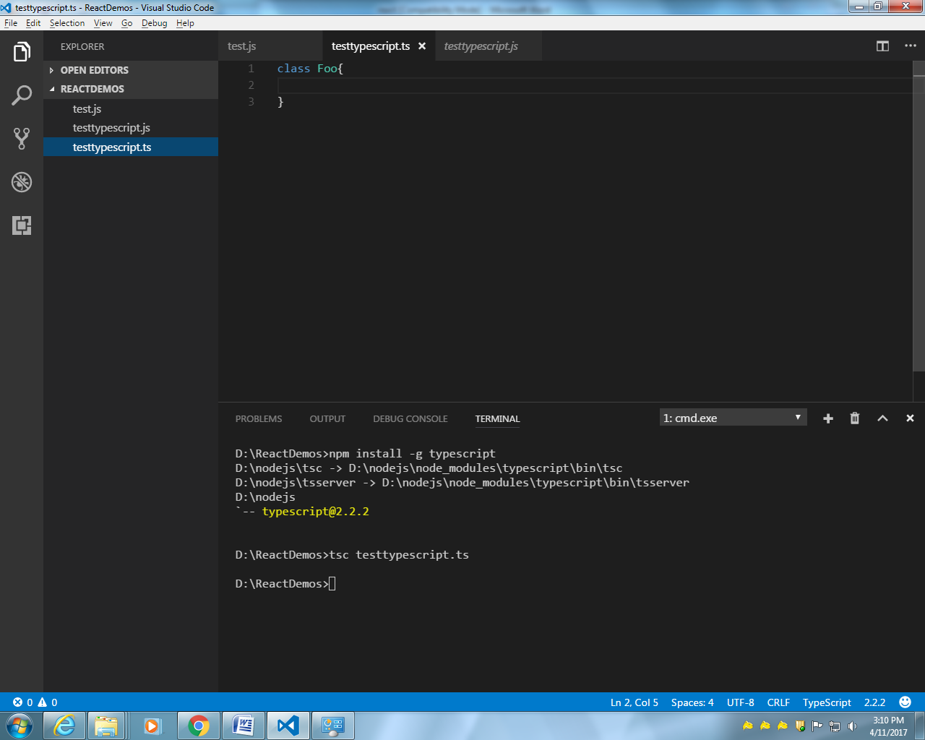

To convert typescript to ES 6
D:\ReactDemos>tsc testtypescript.ts --target ES6

Typescript
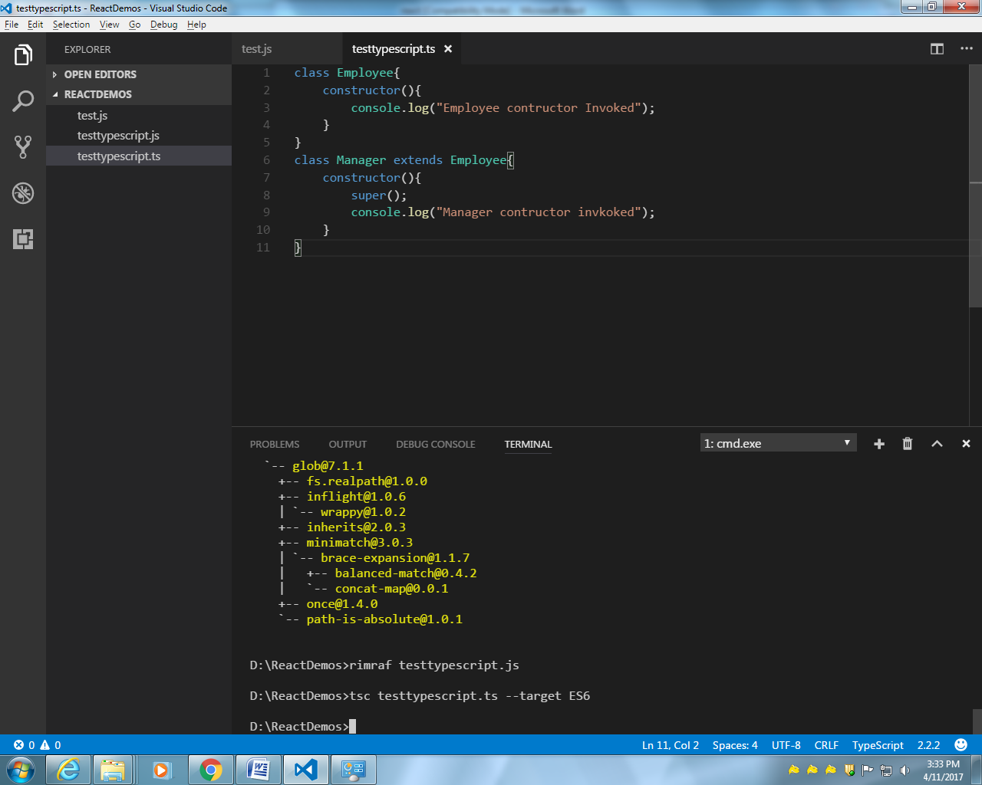
Es6
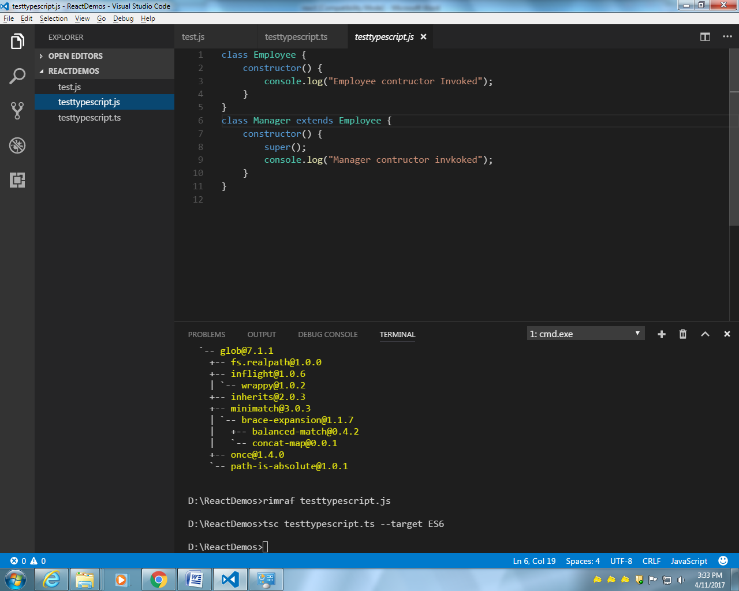

Same code in ES5
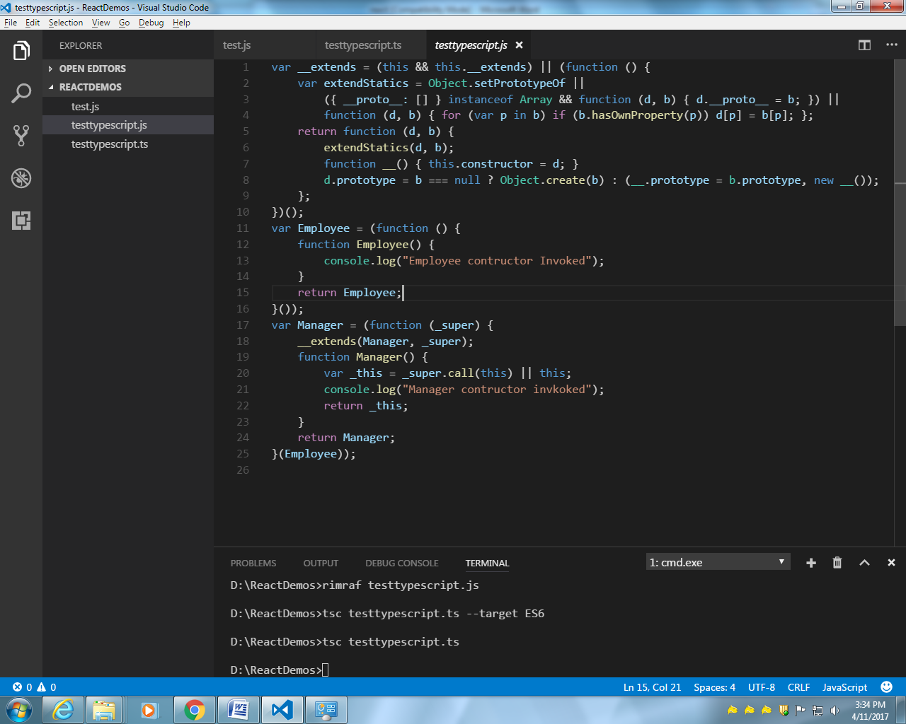
Install typescript
npm install -g typescript
install rimraf
D:\ReactDemos>npm install -g rimraf

Same code: typescript
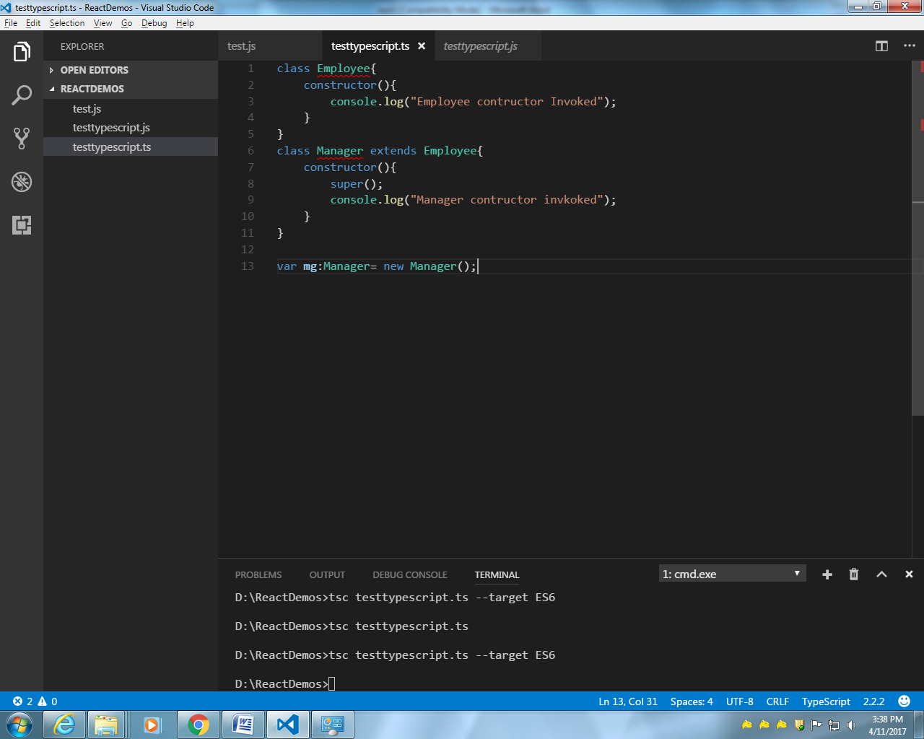

ES6
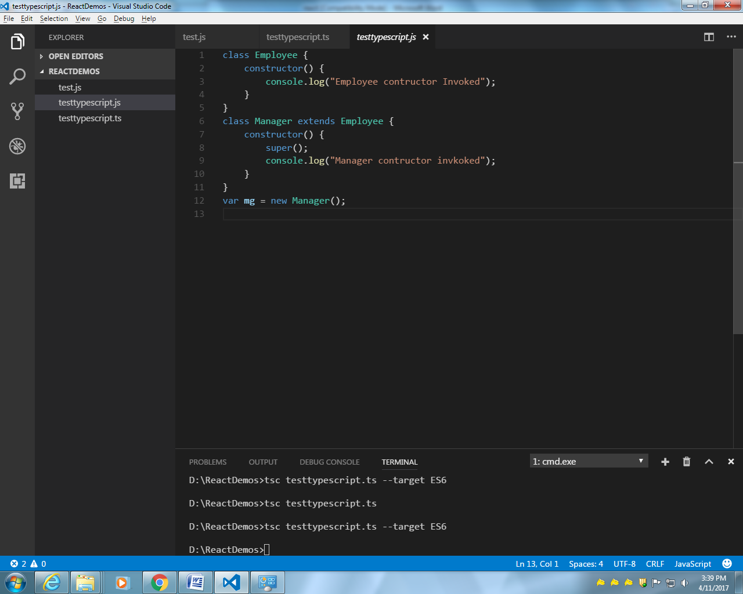
ES5
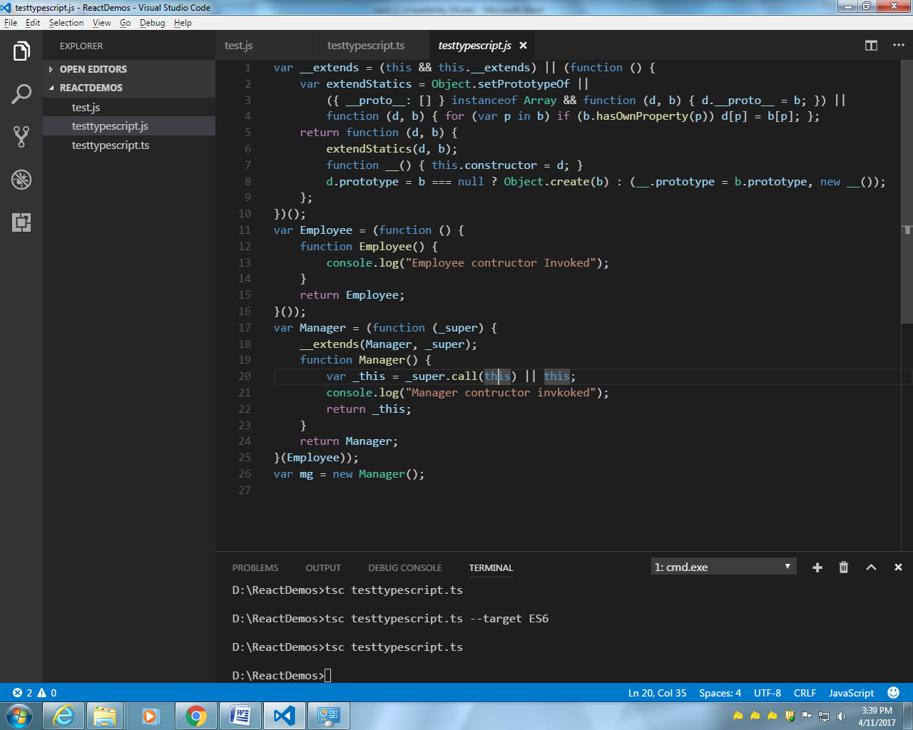

Typescript
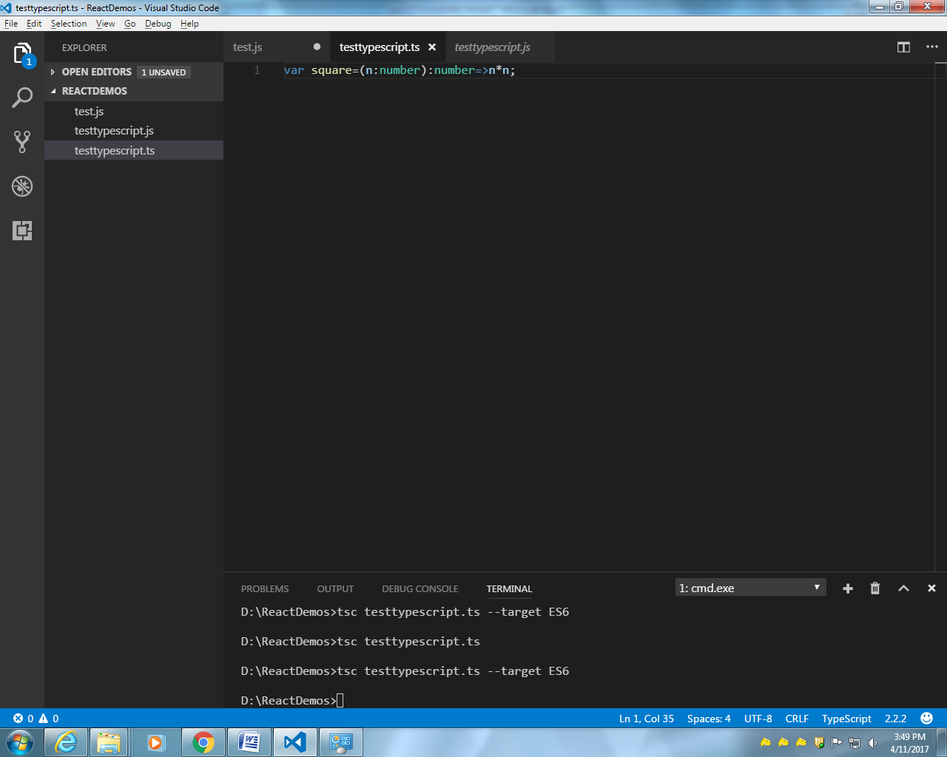
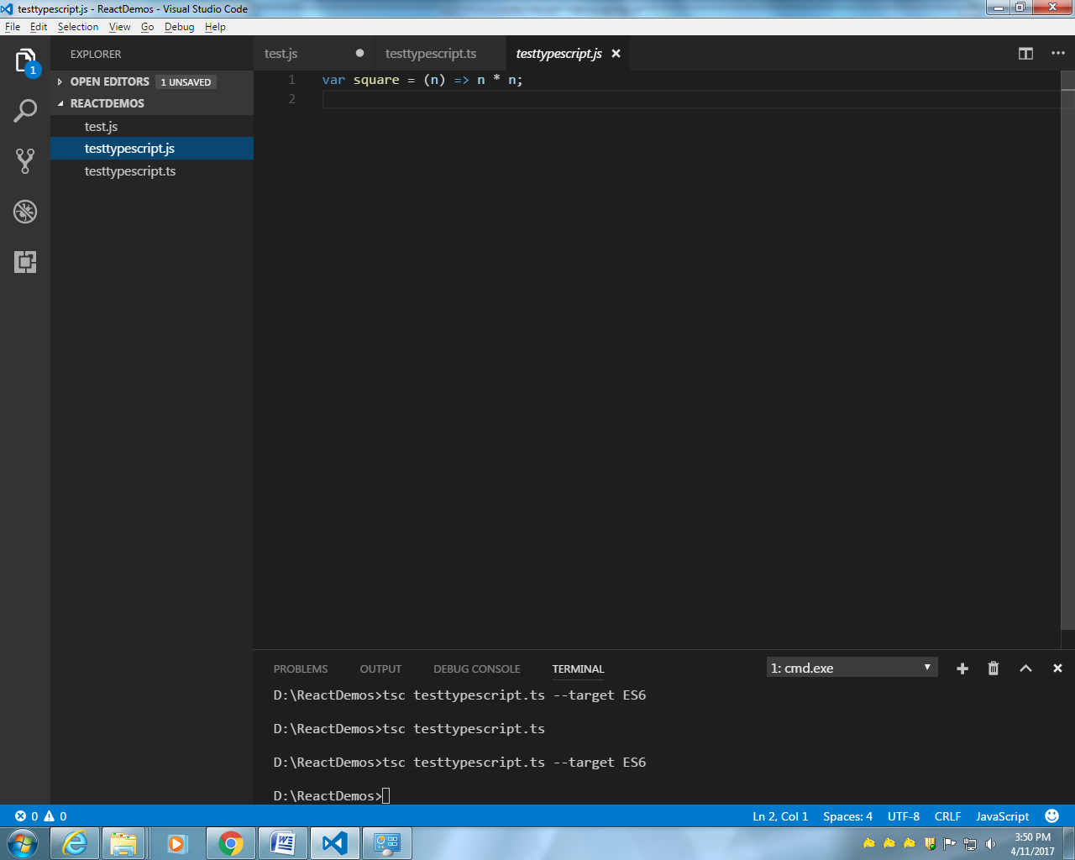
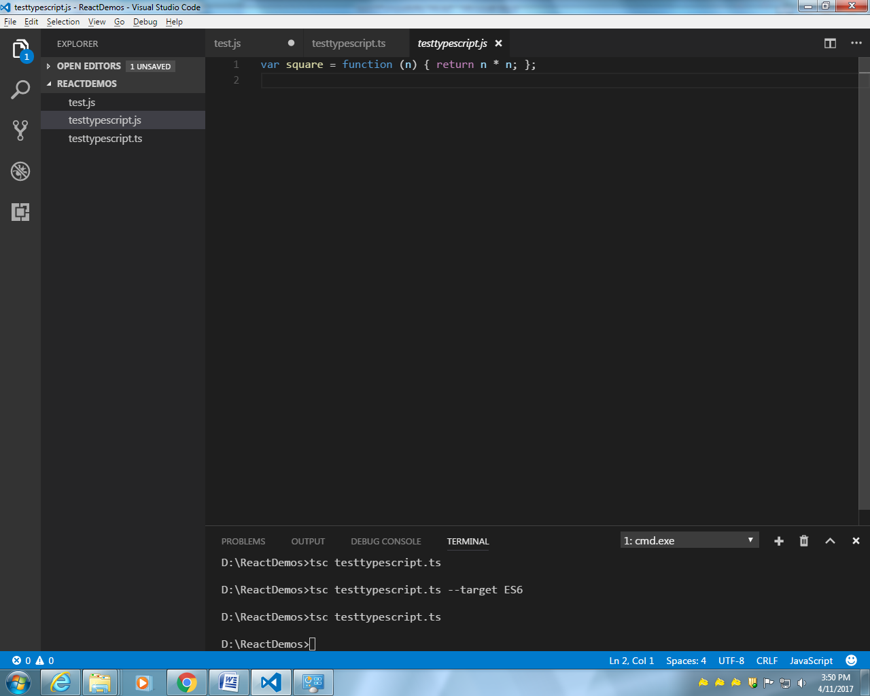

Node JS
1.inbuild module
var os = require('os');
console.log(os.platform());

// inbuild module
var os = require('os');
var path=require('path');
console.log(os.platform());
//__dirname :gives current directive
console.log(path.join(__dirname,"views"))

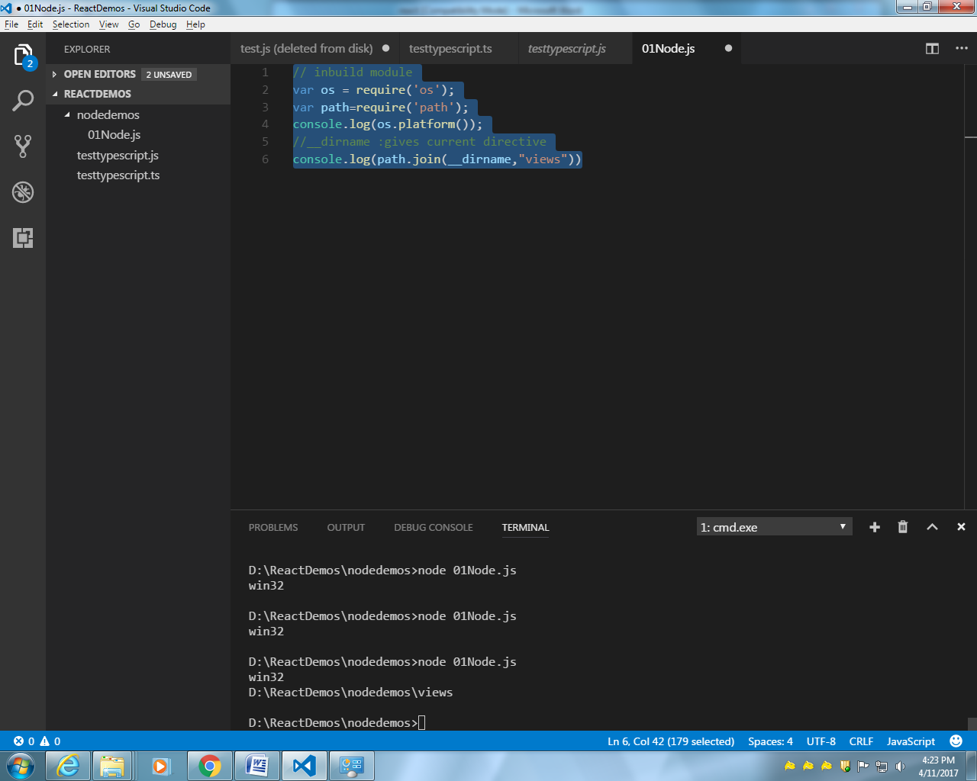
Creating our own module
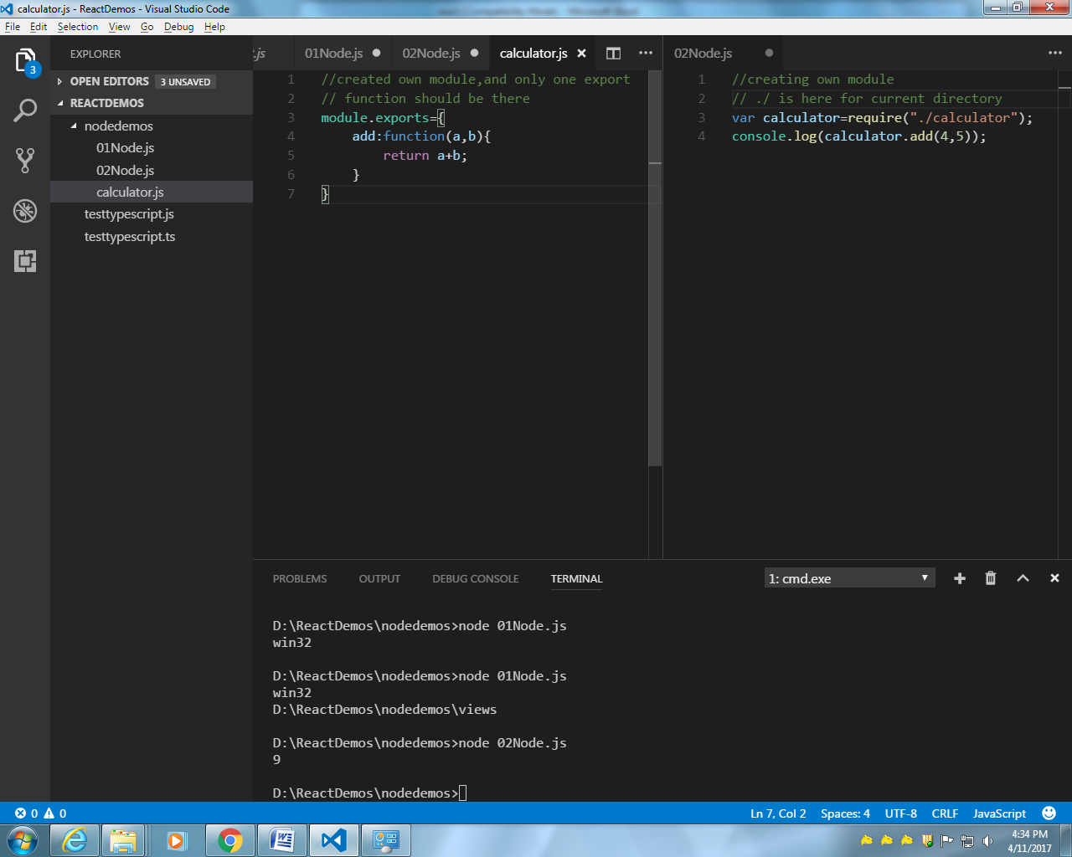

We are just providing the path till folder name, no need to mention till index.js
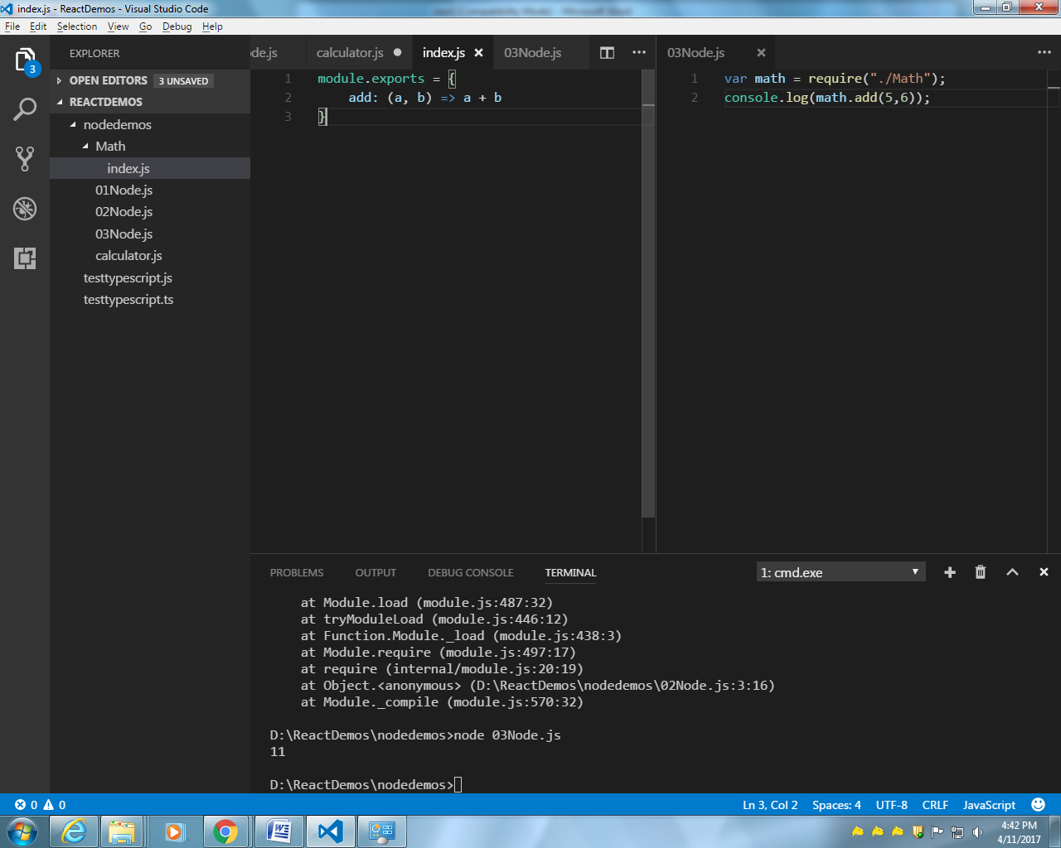
Created in build module and uses of events then addListener,addListernAll,emit,removeListener
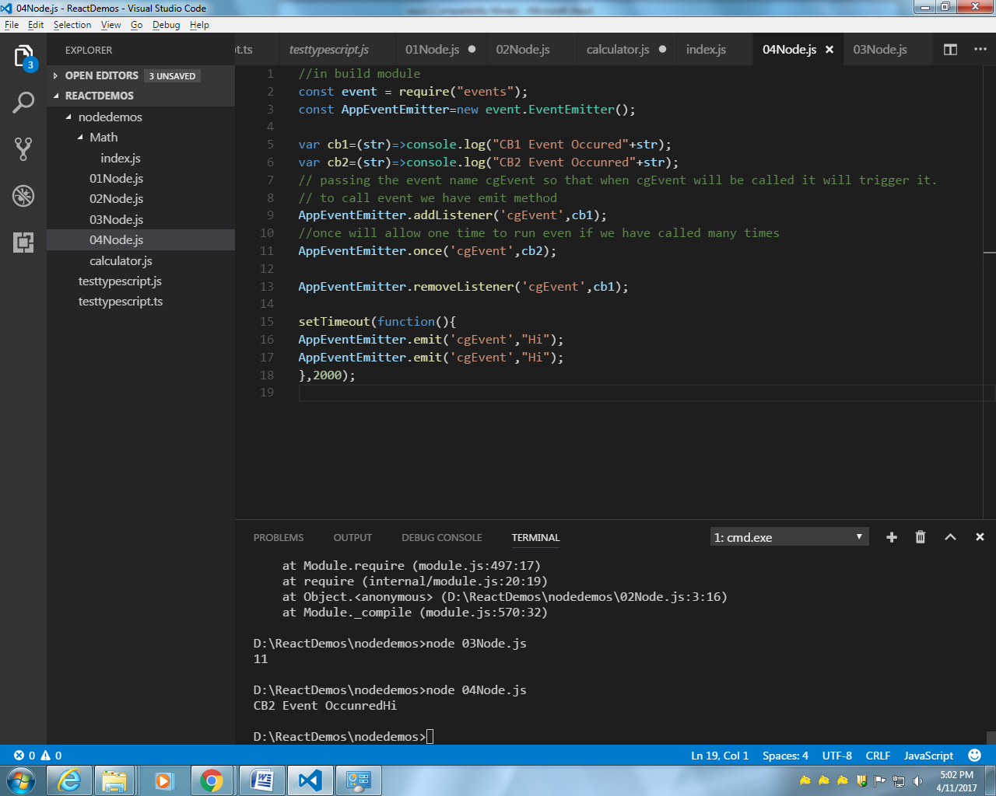

File system

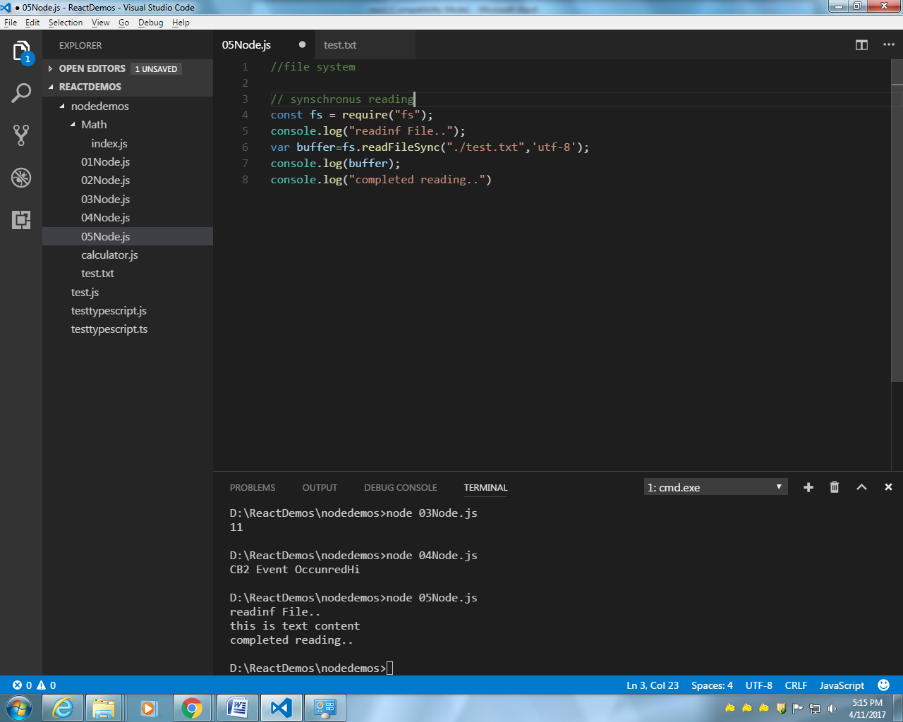
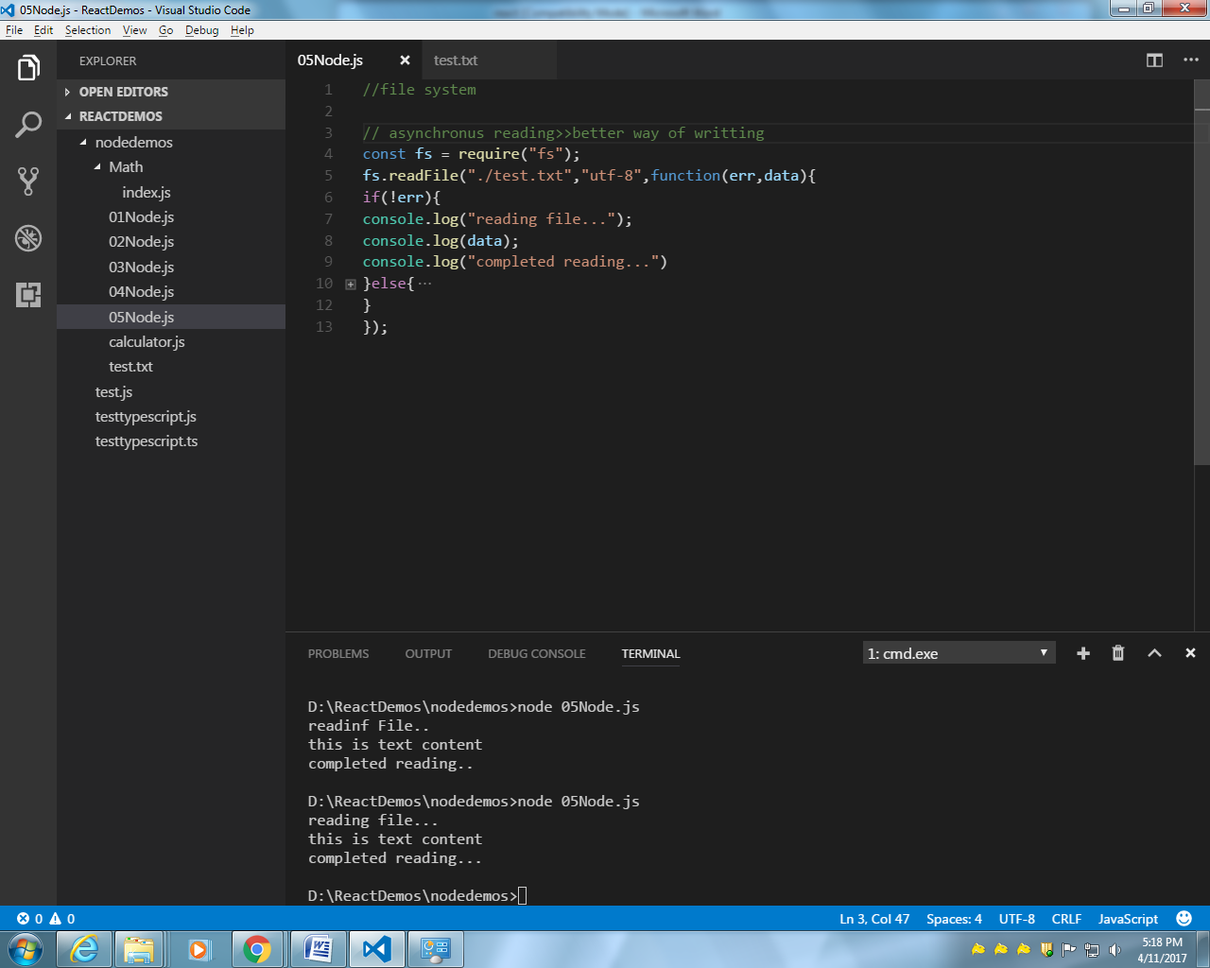
//file system

// asynchronus reading
const fs = require("fs");
fs.readFile("./test.txt","utf-8",function(err,data){
if(!err){
console.log("reading file...");
console.log(data);
console.log("completed reading...")
}else{
console.log("error occrred"+err);
}
});

