Webpack
Created a folder webpack inside ReactDemo
To bundle file we use webpack,
npm install -g webpack
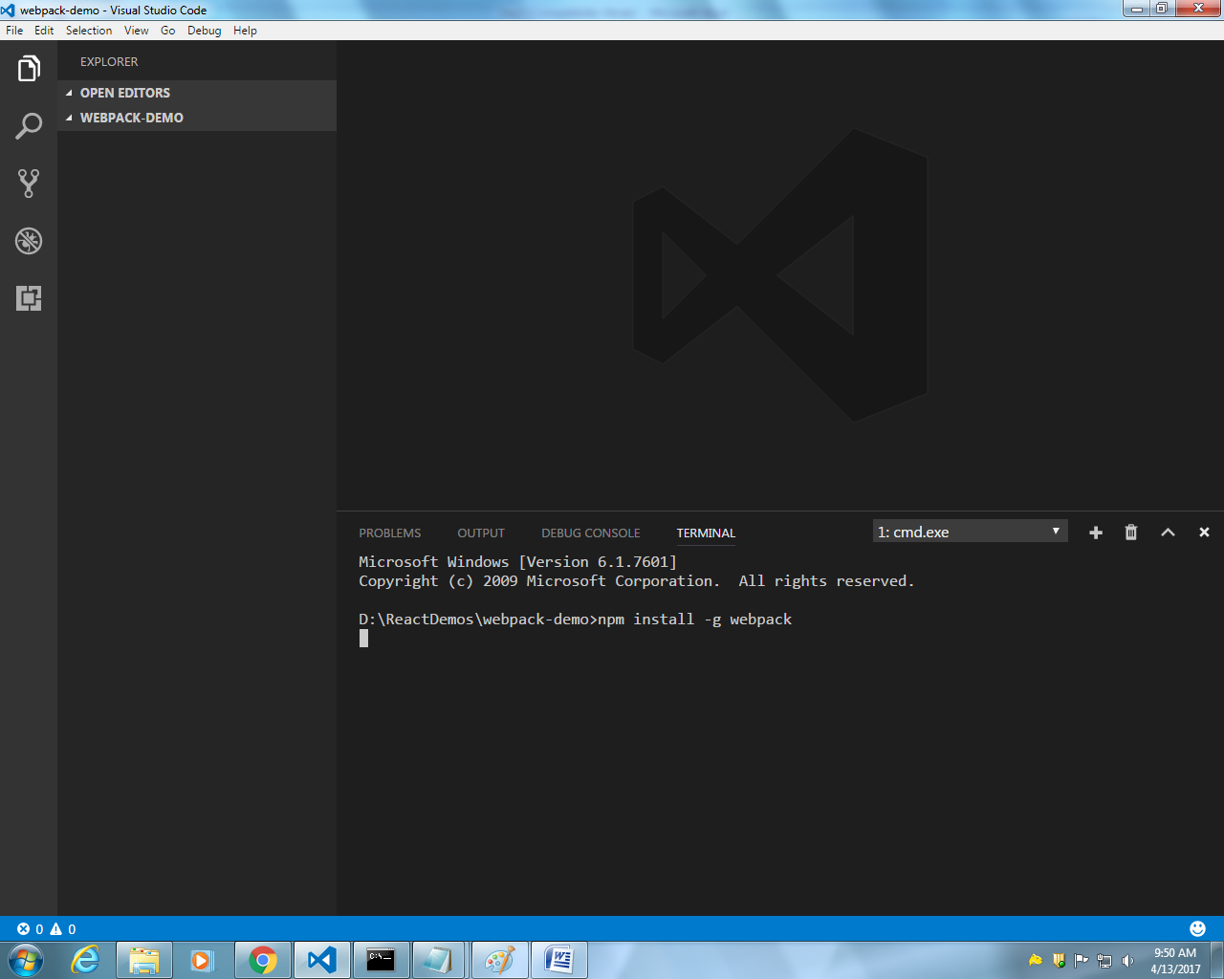
App.js has converted to bundle.js
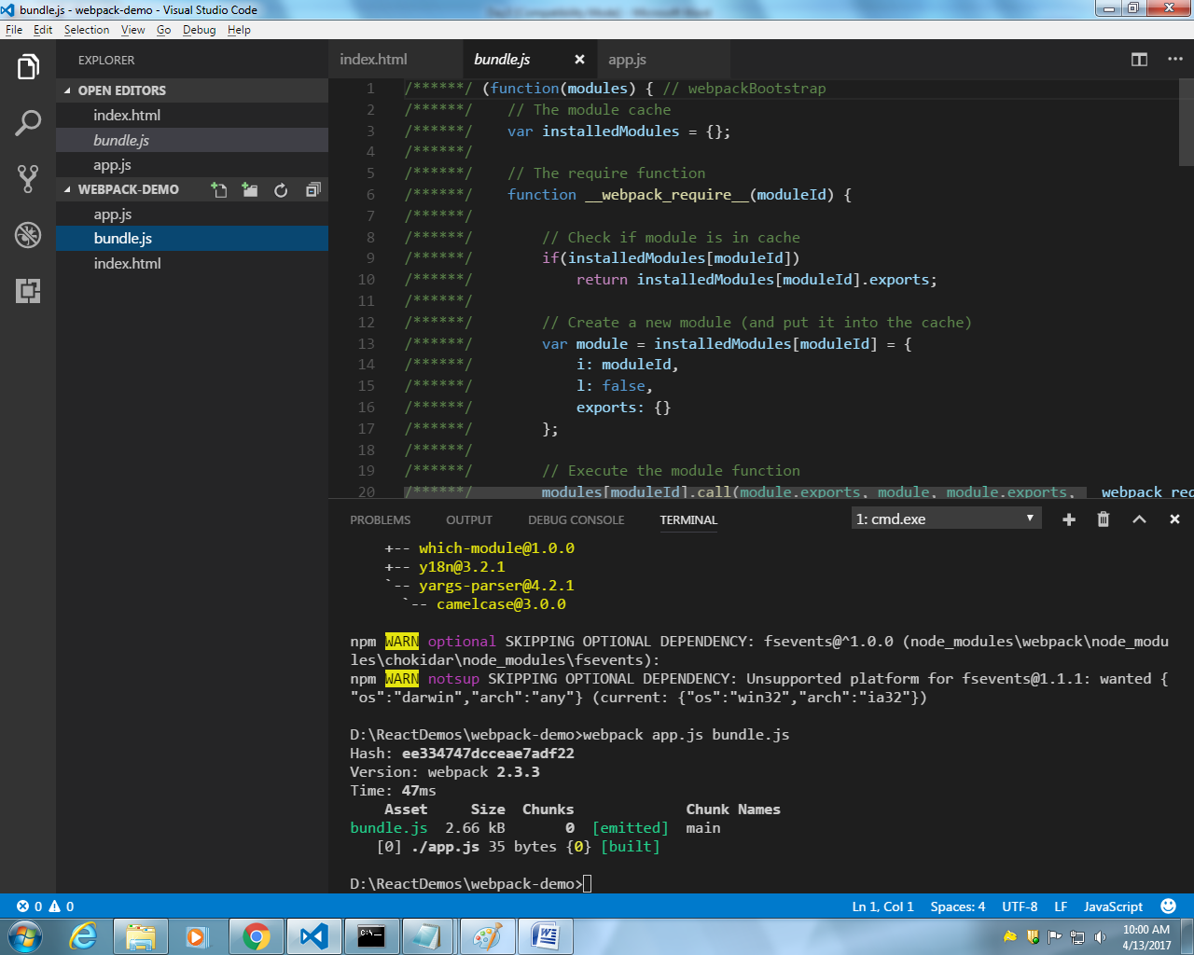

We mentioned bundle.js in index.html but after creation of bundle.js it can access and giving us output in console, below screen.
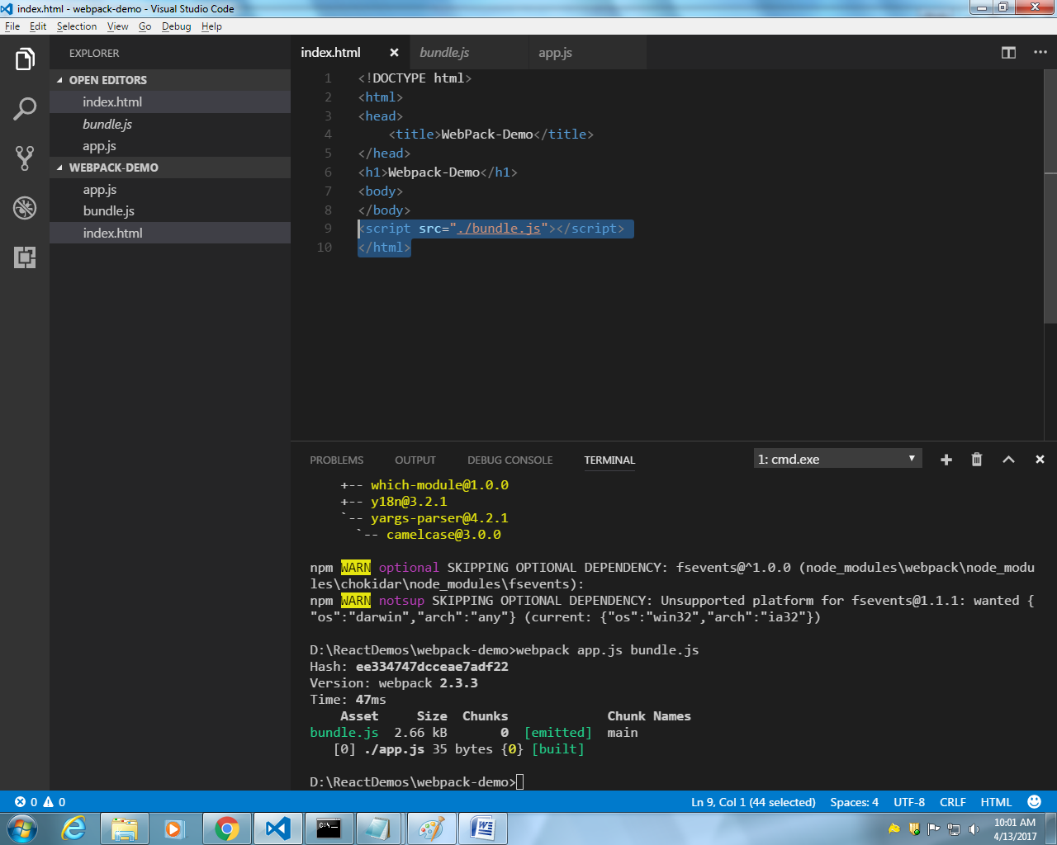
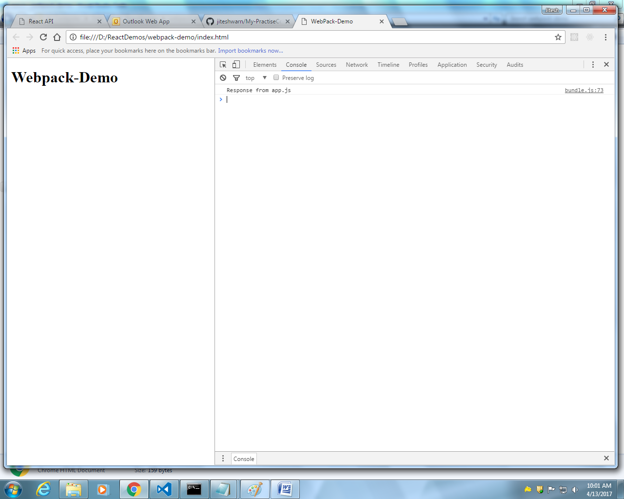

Delete bundle.js
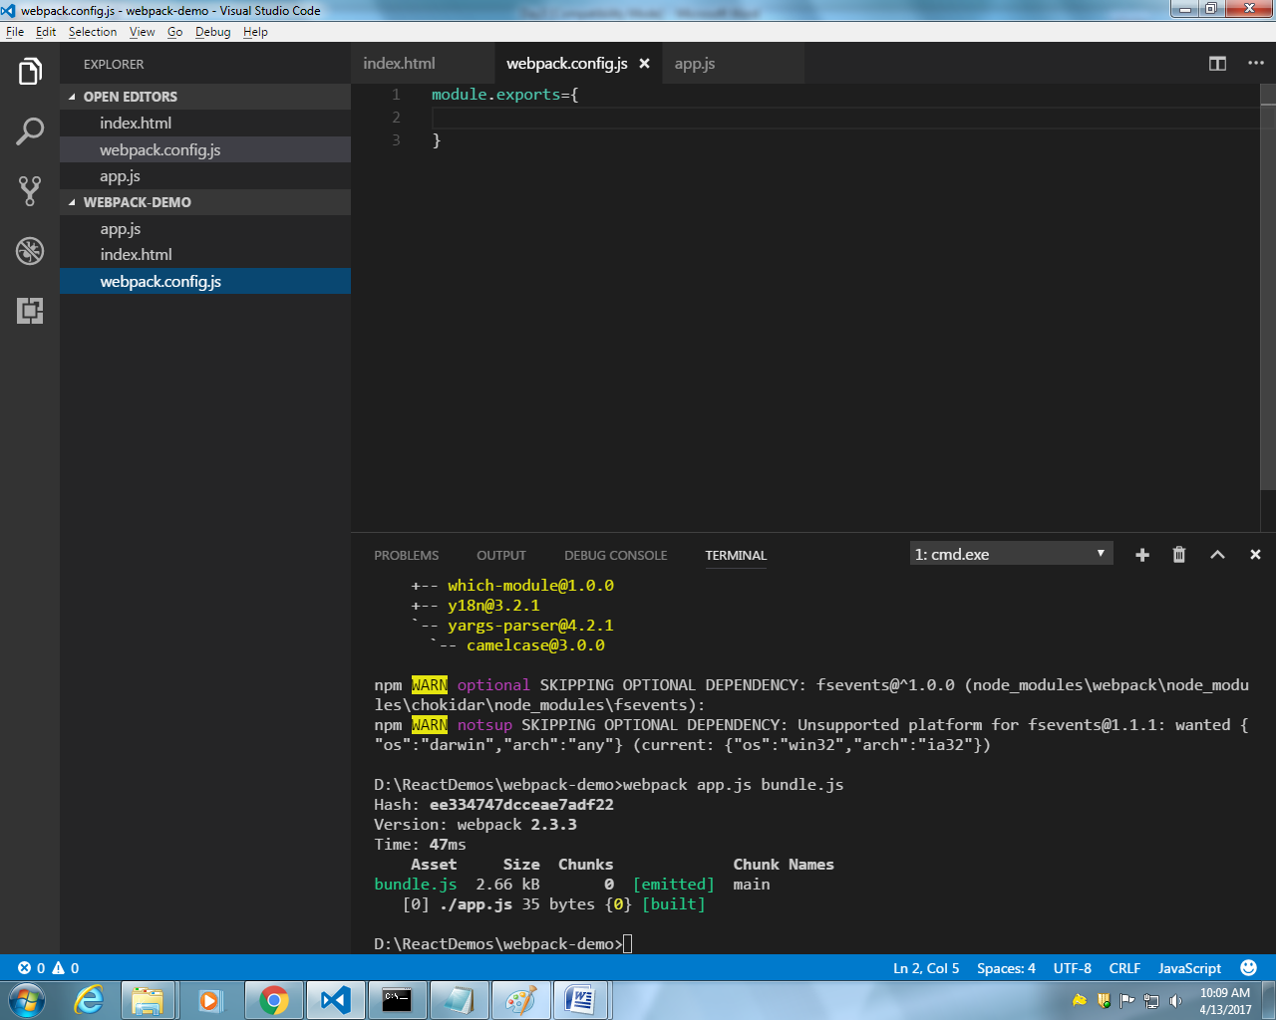
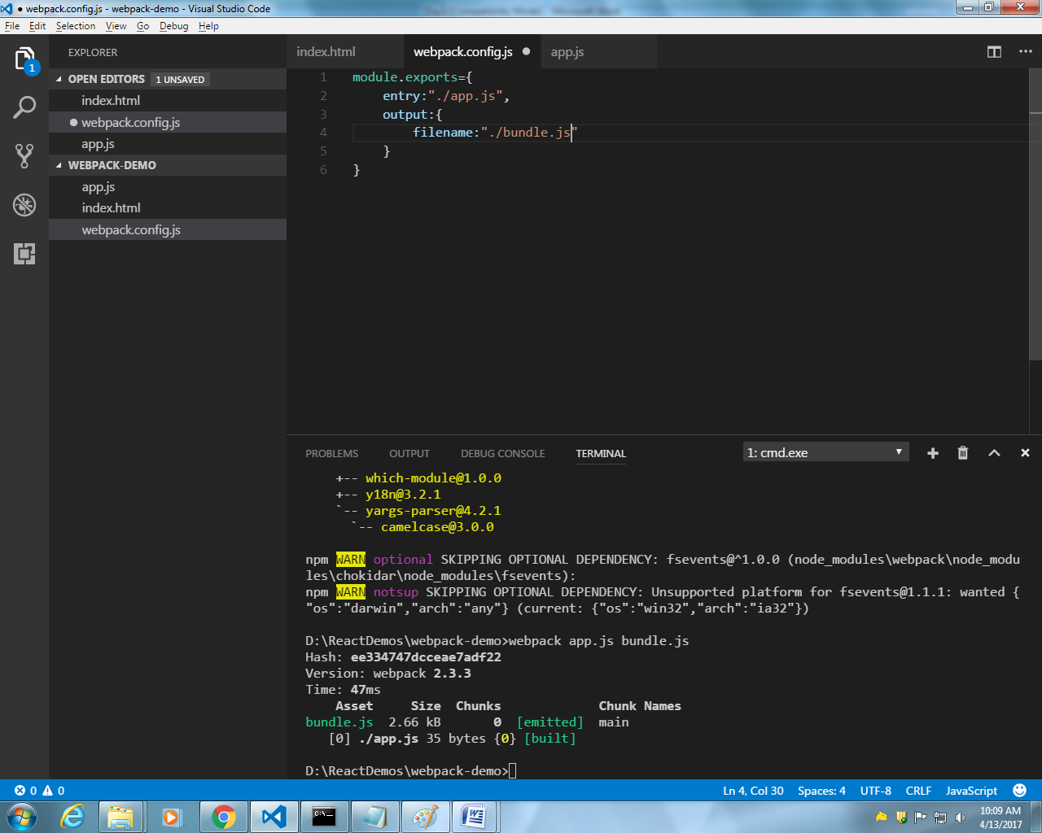
Enter webpack

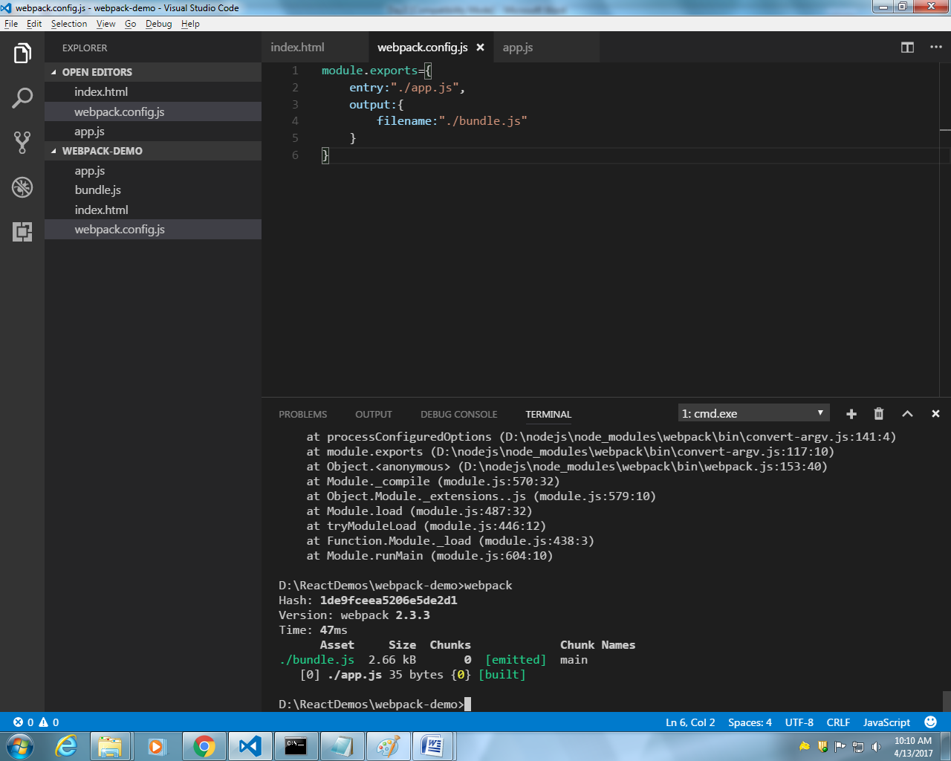

Tii above we were using file protocol, now creating
Creating server
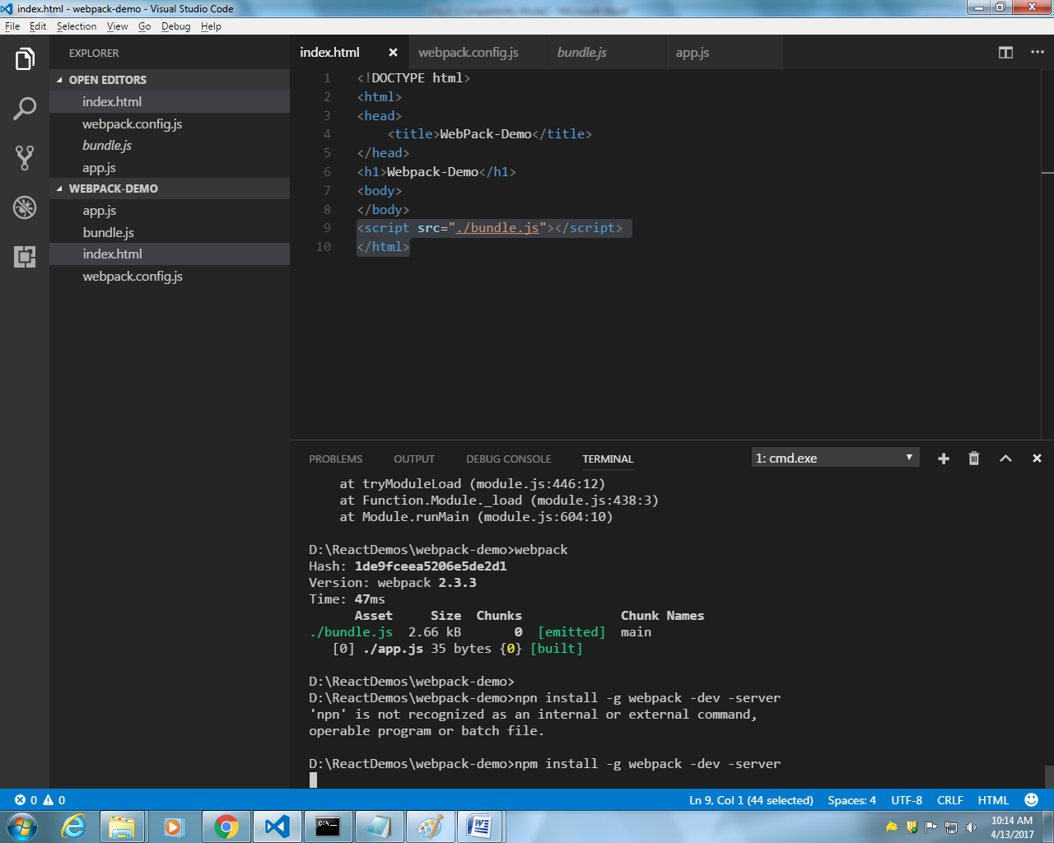
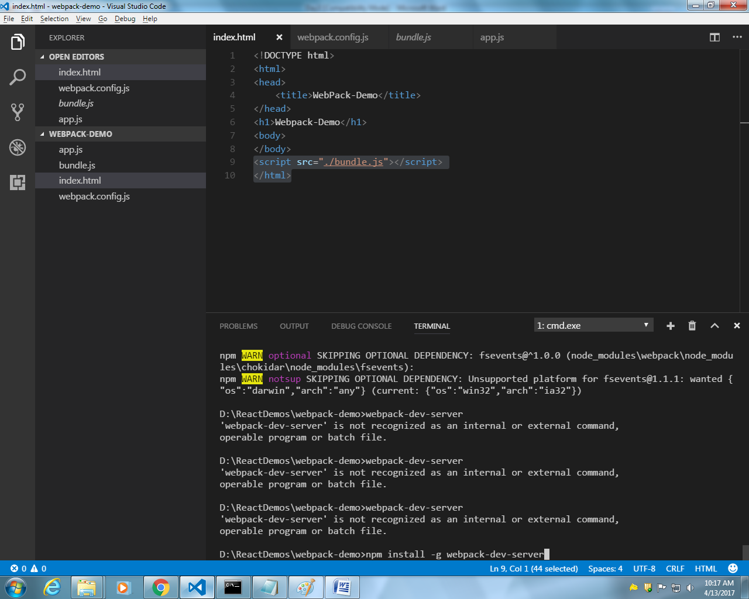
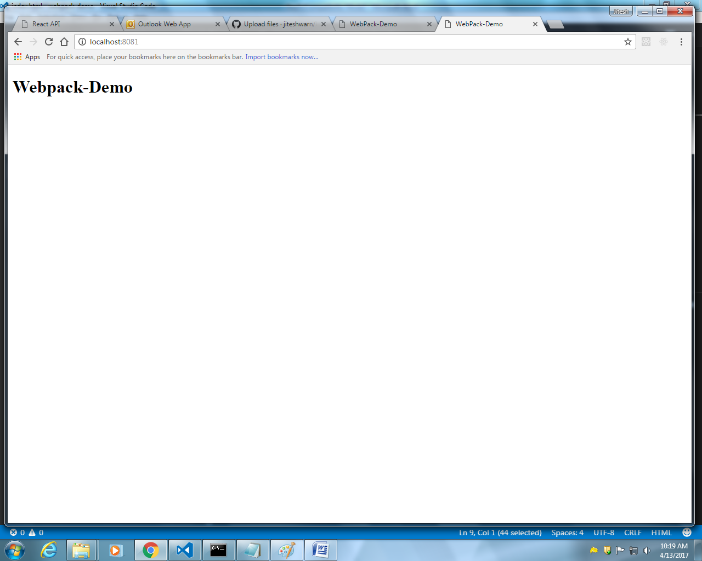
D:\ReactDemos\webpack-demo>npm install -g webpack-dev-server
D:\ReactDemos\webpack-demo>webpack-dev-server
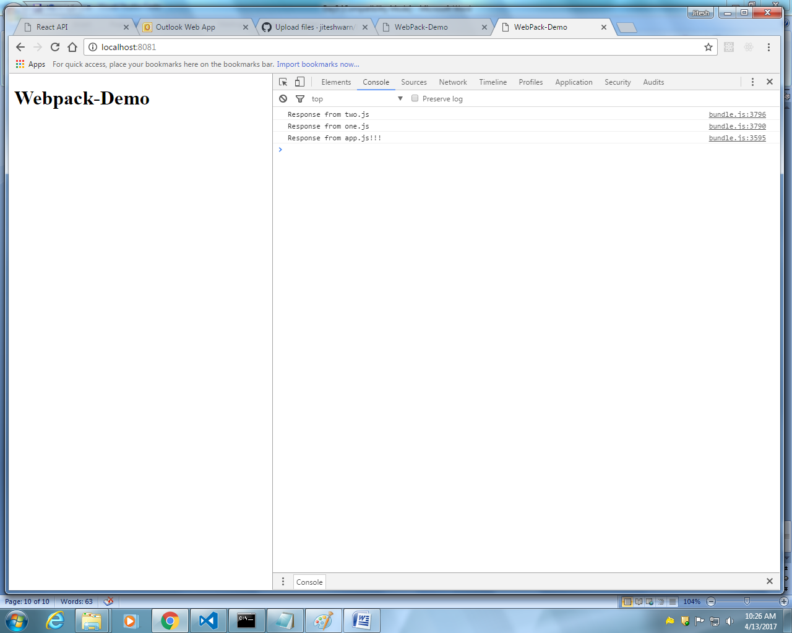

Created pacakage .json
Npm init
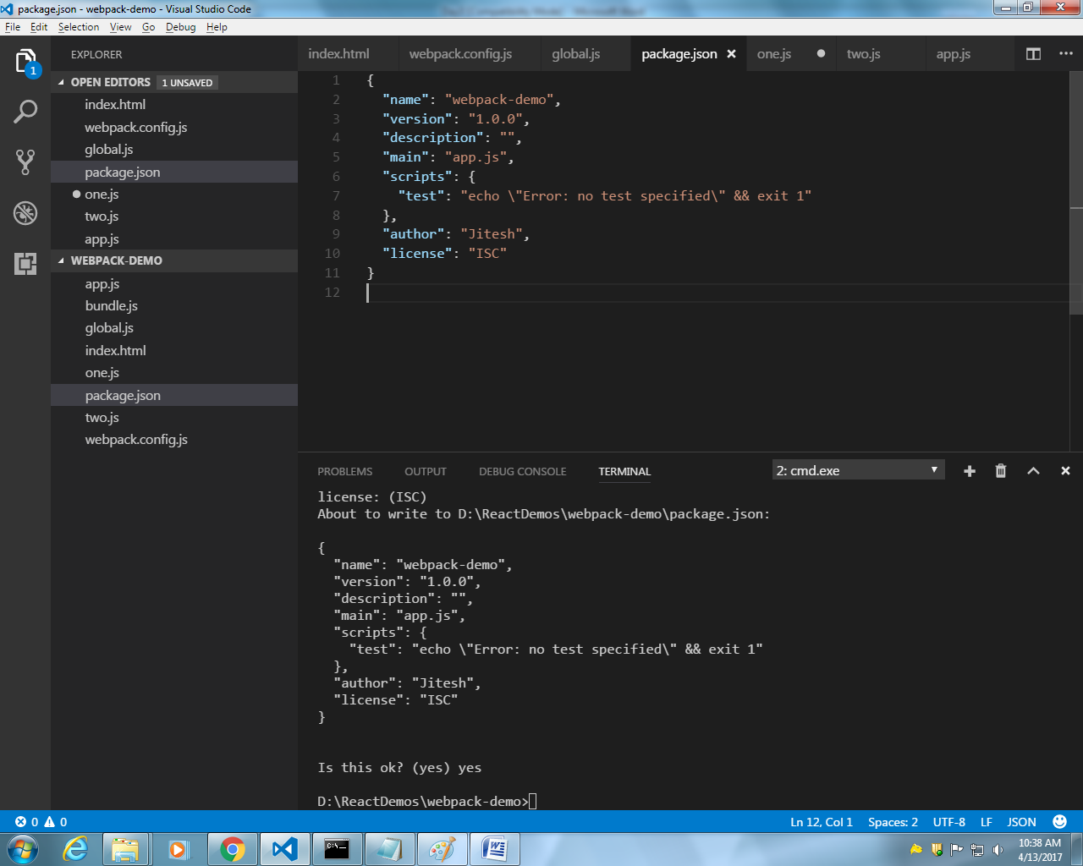
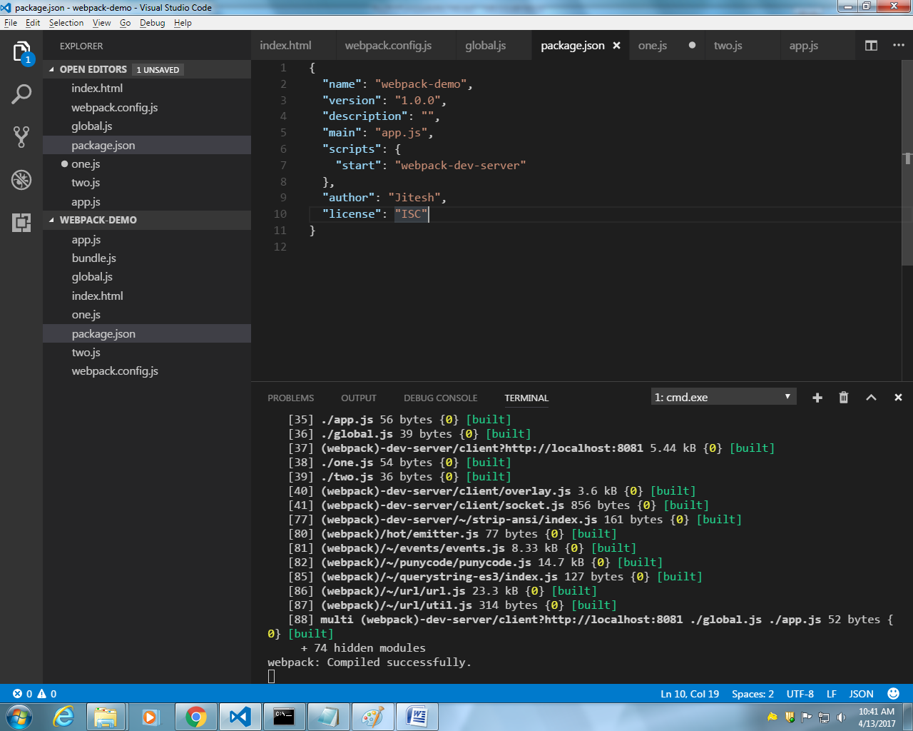
Then enter npm start to run the sever

Installing babel compiler to load other other extension files like .es6,.ts typescript
Currently we used to handle .js file
module.exports={
entry:["./global.js","./app.js"],
output:{
filename:"./bundle.js"
},
watch:true,
module:{
loaders:[
{
test:/^\.es6$/,
exclude:/^\node_modules$/,
loader:'babel-loader'
}
]
},
resolve:{
extensions:[".js",".es6"]
}
}

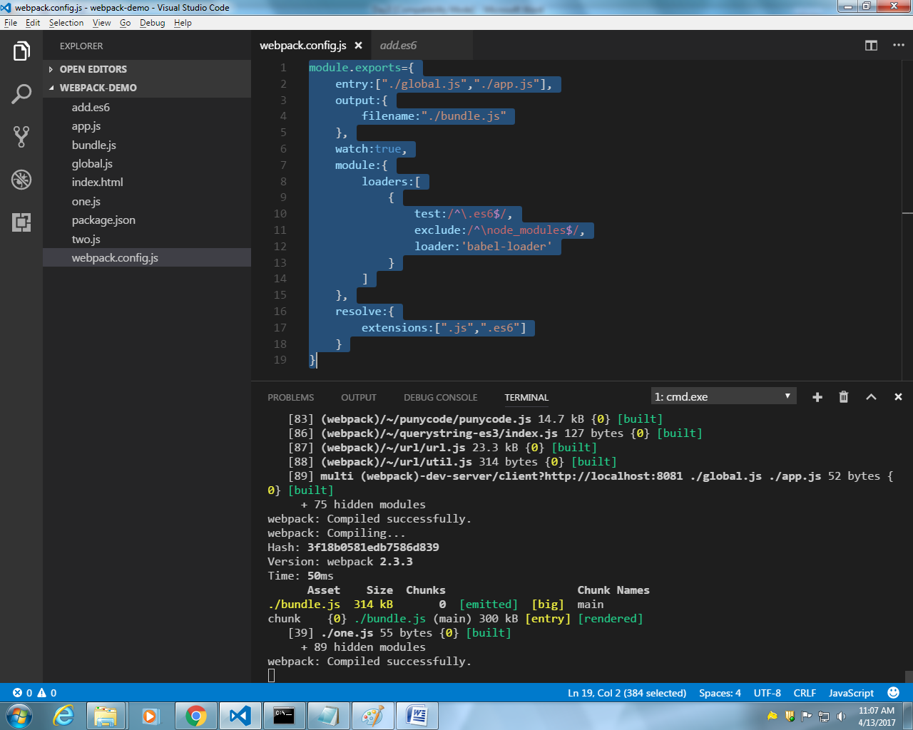
Bundle.js is created run time
And u want to download
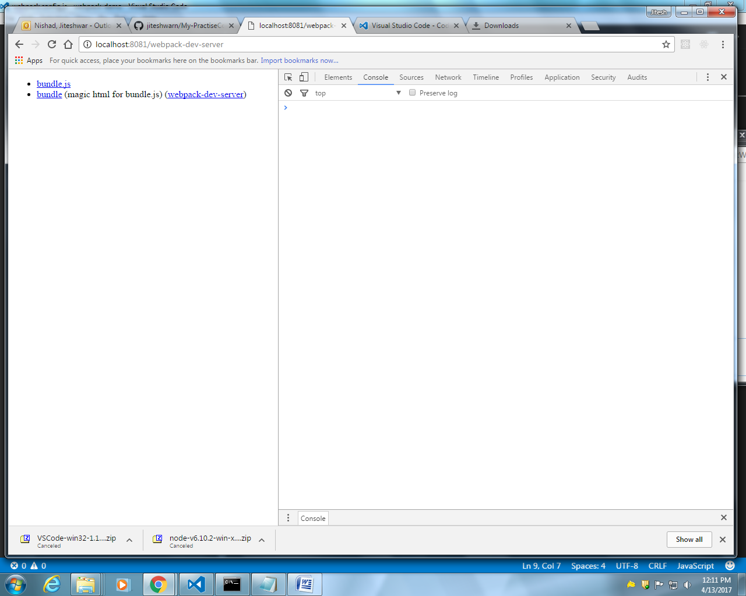

Adding css bootstrap to bundle
D:\ReactDemos\webpack-demo>npm install css-loader style-loader –D

Note: Once we have package.json with us , with having all dependency written then to install all software

