SWARM ROBOTICS FOR IRRIGATION

A PROJECT REPORT

Submitted by

KANDULA JITHENDRA SUBRAMANYAM – 20191ECE0148
KANTAGANI ARUN KUMAR – 20191ECE0151
KANTHETI TARUN MANIKANTA – 20191ECE0152
KATTA RAMPRASAD –20191ECE0159
KESANA KASEE VISWANADH –20191ECE0161

In partial fulfillment for the award of the degree of
BACHELOR OF TECHNOLOGY
in
ELECTRONICS AND COMMUNICATION ENGINEERING

DEPARTMENT OF ELECTRONICS AND COMMUNICATION ENGINEERING
SCHOOL OF ENGINEERING
Under the Guidance of
Dr M S DIVYA RANI
Head-Innovative Projects and Associate professor



PRESIDENCY UNIVERSITY
2022-2023



DEPARTMENT OF ELECTRONICS AND COMMUNICATION ENGINEERING

BONAFIDE CERTIFICATE

Certified that this report “SWARM ROBOTICS FOR IRRIGATION ” is a bonafide work of “KANDULA JITHENDRA SUBRAMANYAM (20191ECE0148), KANTAGANI ARUN KUMAR (20191ECE0151),KANTHETI TARUN MANIKANTA (20191ECE0152),KATTA RAM PRASAD (20191ECE0159), KESANA KASEE VISWANADH (20191ECE0161)”, who have successfully carried out the project work and submitted the report for partial fulfilment of the requirements for the award of the degree of BACHELOR OF TECHNOLOGY in ELECTRONICS AND COMMUNICATION ENGINEERING during 2022-23.

DR. M S DIVYA RANI  Project Guide  Electronics and Communication Engineering  Presidency University | Dr. Rajiv Ranjan Singh  HOD  Electronics and Communication Engineering  Presidency University | Dr. Shrishail Anadinni  Associate Dean  School of Engineering  Presidency University | Dr. Abdul Sharief  Dean  School of Engineering  Presidency University

Name and Signature of the Examiners

1)
2)

DECLARATION

We the students of final year B.Tech in Electronics and Communication Engineering at Presidency University, Bengaluru, named KANDULA JITHENDRA SUBRAMANYAM, KANTAGANI ARUN KUMAR,KANTHETI TARUN MANIKANTA,KATTA RAM PRASAD, KESANA KASEE VISWANADH, hereby declare that the project work titled “SWARM ROBOTICS FOR IRRIGATION” has been independently carried out by us and submitted in partial fulfillment for the award of the degree of Bachelor of Technology in Electronics and Communication Engineering during the academic year of 2022-23. Further, the matter embodied in the project has not been submitted previously by anybody for the award of any Degree or Diploma to any other institution.

KANDUAL JITHENDRA SUBRAMANYAM 20191ECE0148

KANTAGANI ARUN KUMAR 20191ECE0151

KANTHETI TARUN MANIKANTA 20191ECE0152

KATTA RAM PRASAD 20191ECE0159

KESANA KASEE VISWANADH 20191ECE0161

PLACE: BENGALURU

DATE: 05-JUNE 2023

ACKNOWLEDGEMENT

For completing this project work, We/I have received the support and the guidance from many people whom I would like to mention with deep sense of gratitude and indebtedness. We extend our gratitude to our beloved Chancellor, Pro-Vice Chancellor, and Registrar for their support and encouragement in completion of the project.

I would like to sincerely thank my internal guide Dr. M S DIYVA RANI, Associate professor, Department of Electronics and Communication Engineering, Presidency University, for her moral support, motivation, timely guidance and encouragement provided to us during the period of our project work.

I am also thankful to Dr. Rajiv Ranjan Singh, Professor, Head of the Department of Electronics and Communication Engineering, Presidency University, for his mentorship and encouragement.

We express our cordial thanks to Dr. Abdul Sharief, Dean, Dr. Shrishail B. Anadinni, Associate Dean (Core Branches), School of Engineering and the Management of Presidency University for providing the required facilities and intellectually stimulating environment that aided in the completion of my project work.

We are grateful to Mr. G. Tirumala Vasu and Dr. Gowri K, Project Coordinators, Department of Electronics and Communication Engineering, for facilitating research activities and timely assessments.

We are also grateful to Teaching and Non-Teaching staff of Department of Electronics and Communication Engineering and also staff from other departments who have extended their valuable help and cooperation.

Last but not the least, I wholeheartedly thank my family and friends for their constant encouragement and support without which the work would not have been complete.

KANDULA JITHENDRA SUBRAMANYAM
KANTAGANI ARUN KUMAR
KANTHETI TARUN MANIKANTA
KATTA RAM PRASAD
KESANA KASEE VISWANADH

ABSTRACT

SWARM ROBOTICS FOR IRRIGATION

This project explores the application of swarm robotics to the domain of agriculture, specifically for irrigation systems with plant disease detection and pesticide spraying capabilities. The system comprises two robots and one monitor, which work together to detect and prevent plant diseases. The robots are equipped with cameras that capture images of the plants, which are then processed using image processing techniques to detect any signs of disease. If a disease is detected, the robots collaborate to spray the affected area with pesticides, thereby reducing the spread of the disease. The system is designed to be scalable, fault-tolerant, and adaptable to different agricultural environments. The project aims to demonstrate the feasibility and effectiveness of swarm robotics for plant disease detection and control, as well as its potential impact on the future of agriculture. The results of the project show promising performance in terms of disease detection accuracy and efficient pesticide spraying, which could lead to improved crop yields, reduced labor costs, and a more sustainable approach to agriculture.
TABLE OF CONTENTS

Sl. No. | Title | Page Number
 | Acknowledgement | i-ii
 | Abstract | iii
 | Table of Contents | iv-v
 | List of Figures | vi
1 | INTRODUCTION | 8
1.1 | Swarm Robotics | 8
1.2 | Problem Statement | 8
1.3 | History | 9
1.4 | Advantages | 10
1.5 | Disadvantages | 10
1.6 | Applications in Agriculture | 11
1.7 | Applications in other domains | 11
2 | LITERATURE REVIEW | 12
2.1 | Development and Validation of a Deep Learning Algorithm for the Recognition of Plant Disease | 12
2.2 | Plant Leaf Disease Diagnosis from Color Imagery Using Co-Occurrence Matrix and Artificial Intelligence System | 12
2.3 | Prediction Models for Identification and Diagnosis of Tomato Plant Diseases | 13
2.4 | Swarm Robots in agriculture | 13
3 | OBJECTIVES | 14
3.1 | Measurement of Temperature and Humidity in the Field | 14
3.2 | Ploughing | 14
3.3 | Seed Sowing and Pest Detection and Control | 14
4 | METHODOLOGY | 15
4.1 | Raspberry Pi as a Platform for Robotics | 15
4.2 | Design and Fabrication of Swarm Robots | 16
4.3 | Robo Design | 18
5 | MATERIAL SELECTION | 20
5.1 | Materials Required | 20
5.2 | Power System | 23
5.3 | Power Management System | 24
6 | SOFTWARE REQUIREMENT SPECIFICATION | 25
6.1 | Requirement Specification | 25
6.2 | Hardware requirements | 25
6.3 | Software requirements | 26
7 | HARDWARE INTEGRATION | 27
7.1 | Motor Control | 27
7.2 | Sensor Integration | 28
7.3 | Camera Module | 29
8 | ALGORITHM | 32
8.1 | Image Loading | 32
8.2 | Image Processing | 32
8.3 | Image Rescaling | 32
8.4 | Model Prediction | 32
8.5 | Class Label Mapping | 32
8.6 | Displaying the image and prediction | 33
8.7 | Saving the prediction | 33
9 | EVALUATION OF IMAGE PERFORMANCE | 33
9.1 | Transmission Time Calculation | 33
10 | COMMUNICATION SYSTEM | 34
11 | STUDY AREA | 39
11.1 | Functional Requirement | 39
11.2 | Non-Functional Requirement | 39
11.3 | Architecture of DenseNet | 40
11.4 | DenseNet Architecture &components | 41
11.5 | DenseNet-121 Architecture | 44
12 | RESULTS
13 | FUTURE WORK
14 | CONCLUSION
15 | REFERENCES
LIST OF FIGURES

Figure  Number | Title | Page  Number
4.3.1 | Block Diagram of Robot1 | 18
4.3.2 | Block Diagram of Robot2 | 19
5.1.1 | Raspberry pi4 | 20
5.1.2 | Dc Motor | 20
5.1.3 | L298N Motor Driver | 21
5.1.4 | 2Channel Relay Module | 21
5.1.5 | 1Channel Relay Module | 22
5.1.6 | Dht11 | 22
5.2.1 | Lead Acid Battery | 23
5.2.2 | AA Battery | 23
5.2.3 | Power Bank | 24
10.1 | Communication Between Robot1 and server | 34
10.2 | Communication Between Robot2 and computer | 35
10.3 | Communication Between Robot1 and Robot2 | 37
11.3.1 | Architecture of DenseNet | 40
11.3.2 | Architecture of DenseNet with tensorflow | 41
11.4.1 | DenseBlock | 42
12.1 | Robot 1 | 46
12.2 | Robot 2 | 46
12.3 | Communication of Robot2 to Robot1 | 46
12.4 | Communication from server | 47
12.5 | Healthy leaf prediction | 47
12.6 | Unhealthy leaf prediction | 47

1 INTRODUCTION

1.1 SWARM ROBOTICS
The use of swarm robotics in agriculture has the potential to improve efficiency, reduce costs, and improve crop yields, while also minimizing environmental impact. In this project, we are using swarm robotics to monitor tomato plants for disease and to perform crop monitoring. The project involves two robots that move through the field and communicate with each other to efficiently cover the entire area. The robots are equipped with cameras that take pictures of the tomato plants and send them to a central monitoring system. The monitoring system analyzes the images and identifies any plants that are infected with disease. If a plant is infected, the monitoring system sends a command to the robot that detected the disease to spray pesticides. This project has the potential to improve the efficiency of disease detection and pesticide application, leading to improved crop yields and reduced costs.

1.2 PROBLEM STATEMENT
The agriculture industry is facing several challenges in the current era, including increasing demand for food production to meet the needs of the growing global population, shortage of labor, and environmental concerns. Traditional methods of farming are labor-intensive, time-consuming, and often yield lower crop productivity. Additionally, the increasing use of pesticides and chemicals in agriculture has led to environmental degradation and health hazards. Hence, there is a need for a technology that can enhance the efficiency of farming practices, reduce labor requirements, and minimize the use of pesticides while maximizing crop productivity.
In this context, the present project aims to address the problem of disease detection and crop monitoring in the agriculture industry using swarm robotics. The primary objective of this project is to design and develop a swarm of robots that can monitor the tomato plants in the field and detect any disease symptoms using image processing algorithms. The project also aims to investigate the potential of swarm robotics in enhancing the efficiency of farming practices and reducing the environmental impact of agriculture.

1.3 HISTORY
In the 1980s, the idea of swarm robots was developed, taking cues from social insects like termites, bees, and ants. Researchers started looking into the possibility of creating robotic systems that mimic these natural swarms' cooperative behaviour. The study of collective behaviour and emergent features in swarm systems led to the development of simulation models and computer-based experiments, which helped the field of swarm robotics acquire recognition in the 1990s.

The creation of the Kilobot project in 2009 marked a crucial turning point in swarm robotics. Small, inexpensive robots called Kilobots are created for swarm robotics research. Further swarm robotics research was driven by its scalability and cost. Swarm robotics became a recognised topic in the early 2000s as academics looked on decentralised design and control algorithms, control schemes, and coordination mechanisms for huge groups of robots.Swarm robotics finds use in the RoboCup Rescue tournament, which in 2005 established a league devoted only to swarm robotics. This contest encouraged the study and creation of swarm robots that could carry out search and rescue operations in challenging environments.Advancements in coordination algorithms allowed swarm robots to self-organize, distribute tasks, and make collective decisions based on local and global information.

A variety of swarm robot platforms, including the e-puck, MarXbot, and Droplet, were created, opening up new research opportunities. These systems provided distinct features and abilities that allowed for a variety of experiments and applications. In 2010, the Swarmanoid project sought to develop a heterogeneous swarm of robots by combining various robot types to achieve cooperative behaviour.

Swarm robots has begun to be used outside of research labs. Swarm robot technology was first investigated by the agriculture, construction, surveillance, and exploration industries, which led to practical applications in real-world scenarios. The use of machine learning and artificial intelligence approaches improved the swarm robots' capacity for learning and making decisions.

Swarm robotics is a discipline that is constantly developing thanks to developments in robotics, communication technology, and artificial intelligence. Research is now being done to solve issues with scalability, robustness, coordination, and the incorporation of swarm robots into real-world applications in a variety of fields.

1.4 Advantages of Swarm Robots in Agriculture:
- Increased efficiency
- Precision agriculture
- Scalability
- Reduced labor requirements
- Minimized soil compaction
- Real-time monitoring and data collection
- Flexibility and adaptability
- Reduced chemical use
- Increased safety
- Enhanced data-driven decision-making

1.5 Disadvantages of Swarm Robots in Agriculture:
- High initial investment
- Complexity of system management
- Limited capabilities for specialized tasks
- Dependency on technology
- Energy and battery limitations
- Need for connectivity and communication
- Environmental constraints
- Ethical considerations
- Limited adaptability to complex environments
- Lack of human intuition and decision-making
- Regulatory and legal considerations
- Limited public acceptance

1.6 Applications of Swarm Robots in Agriculture:
- Crop Monitoring and Inspection
- Pollination
- Precision Seeding and Planting
- Weed Management
- Crop Harvesting
- Soil Sampling and Analysis.
- Irrigation Management

1.7 Applications of Swarm Robots in Other Domains:
- Search and Rescue
- Surveillance and Security
- Construction and Infrastructure Maintenance
- Environmental Monitoring
- Logistics and Delivery
- Mapping and Exploration
- Manufacturing and Assembly

2 LITERATURE REVIEW

2.1Title: Development and Validation of a Deep Learning Algorithm for the Recognition of Plant Disease
Author: Sijiang Huang, Weijie Liu, Fei Qi and Kepeng Yang
Year: 2019
Crop health is the foundation for agricultural development. In some area, due to the lack of professional botanical experts, it is difficult to correctly diagnose the plant disease in the work of planting. In this paper, we propose a novel deep neural network structure that can reliably classify plant types and plant disease using a single image of plant leaf which enables the end-to- end diagnosis of plant disease. Our proposed model consists of two sub-models, a leaf segmentation model that employs a U-Net to separate the leaves in the original image from the background which effectively eliminates interference, and a plant disease classification model based on our proposed Two-head network that classifies plant diseases with the features extracted by various popular pre-trained models. We verified our model using the plant disease dataset with 8 plant species and 19 plant diseases provided by AI Challenger 2019. Experimental results demonstrate that our final model achieves a 0.9807 accuracy of plant classification and a 0.8745 accuracy of disease recognition. We believe that the technology in our model has great potential to become the basis of fully automatic reliable plant disease classification system which can be embedded into portable devices to assist farmers in the future.
2.2Title: Plant Leaf Disease Diagnosis from Color Imagery Using Co-Occurrence Matrix and Artificial Intelligence System
Author: Chaowalit Khitthuk, Arthit Srikaew, Kitti Attakitmongcol and Prayoth Kumsawat
Year: 2018
Using colour photography and disease feature analysis, this paper proposes a technique for diagnosing plant leaf diseases. The feature appearance can be efficiently salient thanks to the co-processing of the I and h components. To accurately classify four different image types illustrating grape leaf disease, the gray-level co-occurrence matrix and texture feature equation are used as statistical data in the simplified fuzzy ARTMAP. The outcomes are favourable and can be effectively used to identify and categorise plant leaf diseases in the actual world.

2.3Title: Prediction Models for Identification and Diagnosis of Tomato Plant Diseases
Author: Shradha Verma, Anuradha Chug, Amit Prakash Singh
Year: 2018
In this research, we give a survey on image processing and Internet of Things (IoT)-based detection and prediction models for tomato plant diseases. This study provides an overview of the existing methods and forecasting models for identifying, detecting, and quantifying tomato plant diseases that are based on image processing and the Internet of Things (IoT). This paper's primary goal was to identify the biological and computational components of disease diagnosis as well as the research to date. We plan to thoroughly merge and apply IoT sensors and imaging techniques, and examine the ramifications of both technologies coming together.
2.4Title of the paper: Swarm Robots in agriculture
Author: Ravi Nandan,Lokesh ,Nikita Balappa Narasannavar, Pratyusha S,Sampath
Algorithm: SWARM robotics is the study of how they are relatively simple physically embodied robots can be designed such that a desired collective behavior emerges from the local interactions between the robots and the environment.
Result: By developing swarm robots which can internally communicate with each other and perform the operations of ploughing, seeding and manuring. And a collision avoidance with the help of ultrasonic sensors which has a range of upto 100cm. So in the future the agriculture operations can be done by these robots which reduces the farmers workload.

3 OBJECTIVES
3.1 Measurement of Temperature and Humidity in the Field:
One of the objectives of the project is to use the swarm robots to measure temperature and humidity levels in the field. This data will be used to monitor the environmental conditions and determine when irrigation is required. When the temperature and humidity levels reach a certain threshold, the swarm robots will activate the water pump to irrigate the field and maintain optimal moisture levels for the crops.

3.2 Ploughing
One of the objectives of our project is to incorporate ploughing into the swarm robot's capabilities. Ploughing is a crucial step in farming as it helps loosen the soil and create pathways or tracks for uniform seed sowing. The design of the plough depends on factors such as soil type and desired ploughing depth based on the crop being grown.There are two main categories of ploughing mechanisms: manually driven tools and machine-driven tools. For our project, we have designed and dimensioned the plough tool to suit the size of the swarm robots. The angle of inclination and length of the tool have been calibrated to achieve the desired ploughing depth based on the specific crop and soil conditions.To operate the plough tool, we have integrated a 12V DC servomotor. Through coding, we can control the initial and final positions of the plough tool, ensuring precise and controlled ploughing. This automation of the ploughing process allows for efficient and uniform soil preparation, setting the foundation for successful crop growth.By incorporating ploughing into the swarm robot's capabilities, we aim to streamline farming operations, reduce manual labor, and optimize the overall farming process.

3.3 Seed Sowing and Pest Detection and Control
The project also focuses on utilizing the swarm robots for seed sowing and pest detection and control. The robots will be programmed to sow seeds at appropriate intervals and depths, ensuring uniform distribution and optimal growing conditions. Additionally, the robots will incorporate image processing techniques to detect pests or signs of diseases in the crops. If a pest or disease is detected, the robots will be capable of spraying pesticides or implementing appropriate control measures to mitigate the damage and protect the crops.

4 METHODOLOGY

4.1 Raspberry Pi as a Platform for Robotics:
Raspberry Pi has emerged as a popular and versatile platform for robotics due to its compact size, low cost, and powerful computing capabilities. It offers a wide range of features and functionalities that make it suitable for various robotic applications. The use of Raspberry Pi in robotics provides a flexible and scalable solution for building intelligent and autonomous systems.

The Raspberry Pi's hardware architecture allows for easy integration with motors, sensors, and other components commonly used in robotics. Its GPIO (General Purpose Input/Output) pins enable direct interfacing with external devices, making it convenient for controlling motors, capturing sensor data, and interacting with the environment. The availability of multiple USB ports further expands the connectivity options for adding additional sensors and peripherals.

4.1.1Raspberry Pi Features and Capabilities for Robotics:
Raspberry Pi offers several features and capabilities that make it well-suited for robotics projects:
a. Processing Power: With its powerful ARM-based processor and generous memory, Raspberry Pi can handle complex computations required for robotics tasks such as sensor data processing, decision-making algorithms, and real-time control.
b. Operating System Support: Raspberry Pi supports various operating systems, including Linux-based distributions like Raspbian, which provide a familiar and robust environment for software development. This allows developers to leverage existing libraries, frameworks, and tools for building robotics applications.
c. Camera Interface: The Raspberry Pi Camera Module provides high-quality imaging capabilities, enabling applications such as computer vision, object detection, and image processing. This makes it suitable for tasks like visual navigation, object recognition, and surveillance in robotic systems.

d. Network Connectivity: Raspberry Pi includes built-in networking options like Ethernet and Wi-Fi, enabling seamless integration with other devices and facilitating communication in distributed robotic systems. It also supports wireless communication protocols like Bluetooth, which can be utilized for controlling and coordinating multiple robots.

4.1.2Comparative Analysis of Robotics Development Platforms:
In the field of robotics, there are several development platforms available apart from Raspberry Pi. A comparative analysis of these platforms helps in understanding their strengths, limitations, and suitability for different applications.
Some commonly compared platforms include Arduino, BeagleBone, and NVIDIA Jetson. Each platform has its own set of features, computational capabilities, and development ecosystems. Factors such as processing power, input/output capabilities, community support, and software libraries need to be considered when selecting the most appropriate platform for a specific robotics project.

4.2 Design and Fabrication of Swarm Robots
4.2.1Requirements Analysis:
In our project, the requirements analysis phase involves determining the size, shape, and capabilities of the swarm robots needed for ploughing, seed sowing, pesticide spraying, and image capturing in the context of agricultural tasks.
Here is an overview of the requirements analysis specific to our project:

4.2.2Size and Shape:
- The size and shape of the swarm robots should be optimized for efficient operation in agricultural fields.
- They should be designed to navigate through the field without causing damage to the crops or the environment.
- The robots should have a compact and agile design, allowing them to maneuver through tight spaces and navigate uneven terrains.

4.2.3 Ploughing:
- The swarm robots should be equipped with a ploughing mechanism capable of loosening the soil and creating uniform tracks or paths for seed sowing.
- The design and dimensions of the plough tool should be suitable for the type of soil and crops in the field.
- The ploughing mechanism should be adjustable to achieve the desired ploughing depth based on crop requirements.

4.2.4Seed Sowing:
The swarm robots should have a seed sowing mechanism that can distribute seeds uniformly along the ploughed tracks. The mechanism should be adjustable to accommodate different seed sizes and sowing densities. It should ensure accurate and precise seed placement to optimize germination and crop growth.

4.2.5Pesticide Spraying:
The swarm robots should be equipped with a pesticide spraying system to detect and control plant diseases.The system should be capable of identifying diseased plants through image processing or other detection methods. Upon detection, the robots should be able to precisely apply pesticides to the affected plants while minimizing the use of chemicals.

4.2.6Image Capturing:
The swarm robots should be equipped with cameras to capture images of the crops for monitoring
and disease detection purposes.The image capturing system should provide high-resolution images that can be processed for disease identification. The robots should be able to transmit the captured images to a central monitoring system or server for analysis and decision-making.
By analyzing these requirements, we can determine the size, shape, and capabilities of the swarm robots that will be specifically designed and fabricated for our project. These requirements will guide the subsequent stages of the project, such as the design and fabrication process, to ensure the successful implementation of swarm robots for ploughing, seed sowing, pesticide spraying, and image capturing in agricultural applications.

4.3Robo design:
The design of the swarm robots plays a crucial role in achieving the desired functionalities and meeting the requirements of our project. Based on the requirements analysis, we have developed a detailed design for the swarm robots used in our project. Here is an overview of the robot design and the integration of key.

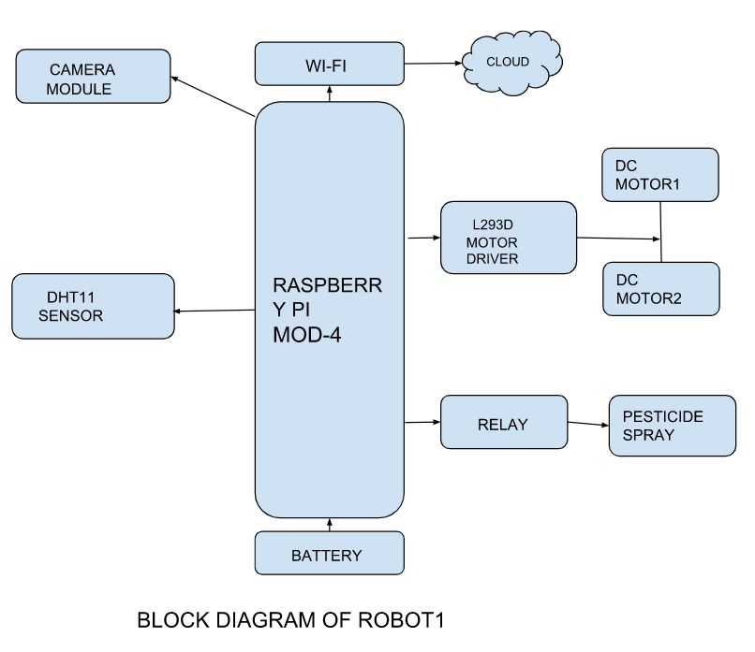

FIGURE 4.3.1

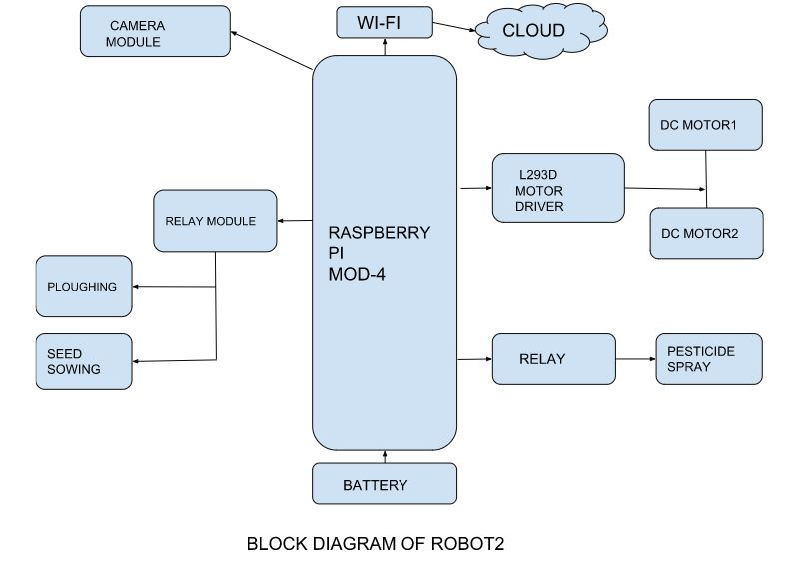
FIGURE 4.3.2

5 Material selection
5.1 Materials Required
Raspberry pi 4:
The Raspberry Pi 4 Model B was introduced in June 2019 and features a 1.5 GHz 64-bit quad core ARM Cortex-A72 processor, integrated Bluetooth 5, full gigabit Ethernet (throughput not limited), two USB 2.0 ports, two USB 3.0 ports, 1-8 GB of RAM, and support for dual monitors via two micro HDMI (HDMI Type D) ports.

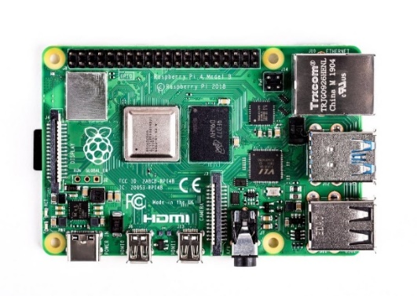

FIGURE 5.1.1

DC motor:
Dc motor refers to an electric motor that is powered by dc. This machine transforms electrical energy from a DC source into mechanical energy. A current-carrying conductor suffers a torque and an inclination to move when it is exposed to a magnetic field. In other words, a mechanical force is created when an electric field and a magnetic field interact.
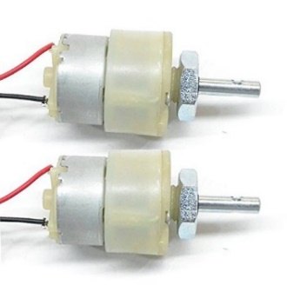

FIGURE 5.1.2

That is how the DC motor, often known as the direct current motor, operates. Motoring action is the term for this. Fleming's left hand rule states that if your left hand's thumb, middle finger and index finger are all extended perpendicular to one another and the index finger represents the direction of the magnetic field, the middle finger indicates the direction of the current, and the thumb represents the direction in which the shaft of the DC motor experiences force.
L298N Motor driver :
The twin H-Bridge motor driver L298N enables simultaneous speed and direction control of two DC motors. The module can run DC motors with peak currents up to 2A and voltages between 5 and 35V.A L298 Motor Driver IC, a 78M05 Voltage Regulator, resistors, capacitor, a Power LED, and a 5V jumper are all included in the L298N Motor Driver module.
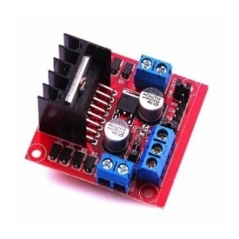

FIGURE 5.1.3
Two Channel relay module:
A handy board that may be used to manage high voltage, high current loads including motors, solenoid valves, lamps, and AC loads is the 2 Channels Relay Module. It is made to connect to microcontrollers like the Arduino, PIC, and others.A relay board with one channel can switch one load, whereas a relay board with two channels can switch two loads independently.
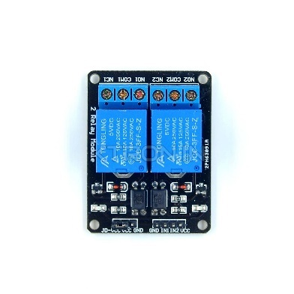

FIGURE 5.1.4

One Channel relay module:
An electrical switch controlled by an electromagnet is known as a power relay module. A separate low-power signal from a microcontroller activates the electromagnet. The electromagnet pulls to either open or close an electrical circuit when it is energized.
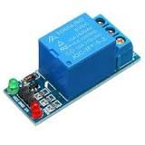

FIGURE 5.1.5
DHT 11:
This DHT11 Temperature and Humidity Sensor has both a temperature and humidity sensor capability, as well as a calibrated digital signal output. It has an 8-bit high-performance microcontroller built in. High reliability and exceptional long-term stability are guaranteed by its technology. A resistive element and a sensor for wet NTC temperature measurement devices are both included in this sensor. It is of exceptional quality, responds quickly, is interference-resistant, and performs well. Each DHT11 sensor has a humidity calibration chamber with exceptionally accurate calibration.
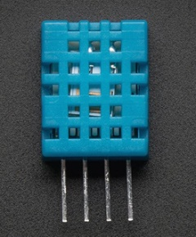

FIGURE 5.1.6
We should refer to the signals that internal sensors pick up as calibration coefficients, which are recorded in the OTP programmed memory. It is integrated to make the single-wire serial interface system quick and simple. Small size, low power, and signal transmission distances of up to 20 meters make it possible for even the most demanding applications. 4-pin single row pin package is the item. convenient connection, provision of customized packages based on users requirements.
5.2 Power System:
Power source selection:
Lead acid battery:
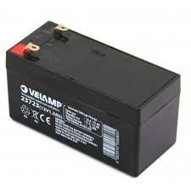
For robots competing in competitions, a 12V 1.3Ah rechargeable lead acid battery is typically used. With this kind of battery, wired or wireless robots operate at high speed for an extended period of time. The most popular all-purpose battery is the Seal Lead Acid (SLA) rechargeable battery.

FIGURE 5.2.1
SLA has the advantages of being inexpensive, reliable, and requiring minimal maintenance. However, it is regarded as substantial weight for some robotic applications. Any normal DC power supply will work to charge SLA batteries as long as it delivers the right voltage to your battery.
AA battery:
AA batteries provide a portable and easily replaceable power option, ensuring uninterrupted operation in case the primary battery is depleted or requires recharging. The use of AA batteries enhances the flexibility and reliability of our swarm robots, allowing for extended field operations without the need for immediate recharging.


FIGURE 5.2.2

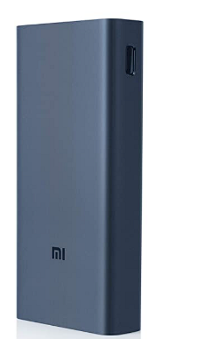
Power bank:
Our swarm robots use a Mi power bank, which acts as an effective and dependable energy source, to power the Raspberry Pi boards. The Mi power bank provides the necessary power output to guarantee the Raspberry Pi boards operate at their peak efficiency during the operation. It offers a steady and stable power supply to support the computing needs of our swarm robotics system thanks to its portable design and long-lasting battery capacity.

FIGURE 5.2.3

5.3Power management system:
The power limits and requirements of the robotic system are essential for guaranteeing reliable operation. Specific power requirements, voltage and current restrictions, and factors affecting overall power consumption apply to components. A power management system has been created to address these needs and limitations. This system takes component restrictions and readily available power sources into account. Reliability is ensured by using the right power supplies, such as lead-acid batteries and AA batteries. Additionally, a power bank specifically designed for Raspberry Pi boards offers consistent and uninterrupted power.

We add the individual component voltages to determine the robot's overall voltage:
Raspberry Pi voltage plus DC motor voltage plus motor driver voltage plus relay module voltage equals total voltage.
Voltage total equals 5.25V + 6V + 5V + 5V
Voltage total = 21.25V

We must now take voltage drop into account if we are to keep this voltage throughout the robot. Resistance in the wiring and connectors causes voltage drop. To guarantee that each component receives the necessary voltage, it is critical to reduce voltage drop.

6 SOFTWARE REQUIREMENT SPECIFICATION
6.1Requirement specification:
The item headway handle's foundation is described in detail in the Framework Requirement Specification (SRS), which is a key document. It lists a building's requirements and describes any significant features of the building. A SRS basically represents an organization's perception (in creating) of a customer's or potential client's edge work conditions at a specific point in time (often before any actual design or change work). It's a two-way insurance strategy that makes sure both the customer and the affiliation are aware of the requirements of exchange from that angle at any given time.
A rigorous examination of the report can identify oversights, incorrect assumptions, and inconsistencies before the plan is put into place for the change cycle, when these problems are less difficult to resolve. This minimises headway effort. The SRS describes the end product but not the process that led to it, serving as a springboard for changes to the finished product in the future.
The SRS might also want to be changed, be that as it is able to it offers a basis to persisted with advent appraisal. In direct terms, programming want assure is the start phase of the item change pastime. The SRS implies unraveling the musings inside the brains of the customers – the records, right into a formal chronicle – the yield of the crucial level. in this way the yield of the extent is an arranged of officially determined requirements, which in a certainly best global are performed and incessant, even as the facts has none of those homes.
6.2 Hardware requirements
Processor : Intel i5 3.0 GHz
RAM : 16 GB and above
System type : 64-bit Operating system
Hard disk : 500 GB

6.3 Software requirements
1. Operating system : Windows 8/10
2. Programming Language : Python
3. Library : Matplotlib, numpy, Pandas, Sckit-learn,
Tensorflow ,Keras,Joblib, Scikit-Image.
4. Simulation tool : Anaconda Navigator IDE 3.7.4,
(jupyter Notebook).

7 Hardware Integration
7.1 Motor Control: Interfacing and Controlling Motors with Raspberry Pi
The integration of motors with the Raspberry Pi for controlling the movement of the robot. The motor control is an essential part of the overall system, enabling the robot to navigate its environment effectively.

GPIO Pins:
The following GPIO pins are used for motor control:
Right Motor:
- GPIO pin for motor 1 (forward): 14
- GPIO pin for motor 1 (backward): 17
Left Motor:
- GPIO pin for motor 2 (forward): 15
- GPIO pin for motor 2 (backward): 18

Motor Control Algorithm:
The provided code demonstrates the implementation of a motor control class called "Driver" in the "motor.py" file. This class encapsulates the functionality required to control the motors connected to the specified GPIO pins.
The "Driver" class includes the following methods:
__init__(self): Initializes the GPIO pins and sets up the board.
stop(self): Stops the motors by setting all GPIO pins to False.
right(self): Rotates the robot to the right by controlling the GPIO pins.
forward(self): Moves the robot forward by controlling the GPIO pins.
forward1(self): Moves the robot forward for a specific duration (5 seconds) and performs specific actions based on the lane and count variables.
backward(self): Moves the robot backward by controlling the GPIO pins.
left(self): Rotates the robot to the left by controlling the GPIO pins.
cleanup(self): Cleans up the GPIO pins and performs necessary cleanup operations.
Integration with Robot Control:
The provided code integrates the motor control class into the main control logic of the robot. Here's how it works:
The main loop continuously reads the current status from the "current_status.txt" file.
Based on the status, specific actions are performed using the motor control class.
If the status is 'f', the robot moves forward by calling the forward() method.
If the status is 'f1', the robot moves forward for a specific duration and performs additional actions based on the lane and count variables by calling the forward1() method.
If the status is 's', the robot stops by calling the stop() method.
If the status is 'RUT' or 'LUT', the robot performs a right or left U-turn respectively, by calling the respective methods (right() and left()).
If the status is 'pon', the robot turns on a pump by controlling the specified GPIO pin.
If the status is 'poff', the robot turns off the pump by controlling the specified GPIO pin.

7.2 Sensor Integration: Ultrasonic Sensors for Obstacle Detection and Navigation
Ultrasonic sensors play a crucial role in the robotic system for obstacle detection and navigation. These sensors utilize sound waves to determine the distance between the robot and surrounding objects. In our project, we integrated ultrasonic sensors with the Raspberry Pi to enable real-time obstacle detection and safe navigation.
GPIO Pin Configuration: To interface the ultrasonic sensors with the Raspberry Pi, we connected the following GPIO pins:
GPIO_TRIG: This pin is connected to pin 5 (BCM) on the Raspberry Pi. It is used to trigger the ultrasonic sensor for distance measurement.
GPIO_ECHO: This pin is connected to pin 6 (BCM) on the Raspberry Pi. It receives the echo signal from the ultrasonic sensor to calculate the time taken for the sound wave to bounce back.
Distance Calculation:
The distance between the robot and an object is calculated using the time taken for the sound wave to travel to the object and back.
The mathematical calculation used for distance calculation is as follows:
- Set the GPIO_TRIG pin to LOW for a brief period (10 microseconds) to ensure a clean trigger pulse.
- Set the GPIO_TRIG pin to HIGH for 10 microseconds to send an ultrasonic burst.
- Set the GPIO_TRIG pin back to LOW to end the burst.
- Measure the time it takes for the GPIO_ECHO pin to go from LOW to HIGH and then back to LOW. This represents the time taken for the sound wave to travel to the object and back.
- Calculate the pulse duration by subtracting the start time from the bounce back time.
- Use the pulse duration to calculate the distance using the formula: distance = pulse_duration * speed_of_sound / 2.
- The speed of sound is approximately 343 meters per second. By multiplying the pulse duration by 17150, we obtain the distance in centimeters.

Obstacle Detection and Navigation:
Using the distance measurements obtained from the ultrasonic sensors, the robot's software logic determines whether there is an obstacle in its path. If the distance is below a predefined threshold (e.g., 20 centimeters), an obstacle is detected, and the robot takes appropriate actions to avoid it. This information is communicated to the motor control module to stop or change the robot's direction accordingly.
The ultrasonic sensors continuously monitor the surrounding environment, allowing the robot to navigate autonomously while avoiding collisions with obstacles.
By integrating ultrasonic sensors into our robotic system and implementing obstacle detection and navigation algorithms, we ensure the safety and efficient movement of the robot in its environment.

7.3 Camera Module: Utilizing PiCamera for Image Capture and Processing
The camera module is a critical component of our robotic system, allowing us to capture images and perform image processing tasks. We integrated the PiCamera module with the Raspberry Pi to enable image capture, analysis, and transmission.

GPIO Pin Configuration:
No GPIO pins are directly involved in the connection between the Raspberry Pi and the PiCamera module. The camera module connects to the dedicated camera connector on the Raspberry Pi board.
Image Capture:
To capture images, we utilized the PiCamera library, which provides a convenient interface for controlling the camera module.
The following steps outline the image capture process:
- Initialize the PiCamera object to interact with the camera module.
- Preview the camera feed using the start_preview() function to ensure proper framing and focus.
- Set a suitable delay using the sleep() function to allow the camera to adjust and stabilize.
- Capture an image using the capture() function, specifying the file path and name for the image file.
- Stop the camera preview using the stop_preview() function to conserve system resources.
Image Processing:
The captured images can be further processed using various image processing algorithms to extract useful information or perform specific tasks. These algorithms can include object detection, image filtering, feature extraction, and more. The specific image processing techniques employed depend on the application requirements and objectives of the robotic system.
Image Transmission
TCP/IP Socket Communication for Image Transmission
In the context of image transmission in robotics, TCP/IP socket communication is a commonly used method for transmitting images between different components of a system. TCP/IP (Transmission control Protocol/internet Protocol) is a set of protocols that governs conversation over the internet and neighborhood networks.

TCP/IP socket communication involves establishing a connection between a sender and a receiver through a network socket. The sender, in this case, is responsible for capturing and encoding the image data, while the receiver is responsible for decoding and displaying the transmitted image.

The image transmission process typically follows these steps:
- Sender-side processing: The image captured by a camera or sensor is processed and encoded into a suitable format for transmission. Common formats include JPEG, PNG, or even raw pixel data.
- Establishing a connection: The sender creates a socket and establishes a TCP/IP connection with the receiver. This connection ensures reliable and ordered data transfer.
- Sending image data: The sender sequentially transmits the image data over the established connection. The data is divided into packets and sent in a streaming fashion.
- Receiver-side processing: On the receiver side, the socket connection is accepted, and the received packets are reconstructed into a complete image.
- Image decoding and display: The receiver decodes the received image data based on the encoding format used by the sender. Once decoded, the image is displayed or further processed as required.

8 Algorithmic Workflow for Tomato Plant Disease Prediction from Received Images
To process the received image and predict the disease of a tomato plant, the following steps are typically involved:
8.1 Image Loading:
Algorithm: load_img from tensorflow.keras.utils
Definition: This algorithm loads the image from the specified file path.
Usage: The image is loaded using load_img to obtain the image data.
8.2 Image Preprocessing:
Algorithm: img_to_array from tensorflow.keras.utils
Definition: This algorithm converts the loaded image into a NumPy array.
Usage: The loaded image is converted to a NumPy array using img_to_array to prepare it for further processing.
8.3 Image Rescaling:
Algorithm: Element-wise division by 255
Definition: This algorithm scales the pixel values of the image between 0 and 1.
Usage: The pixel values of the image array are divided by 255 to normalize them in the range of 0 to 1.
8.4 Model Prediction:
Algorithm: predict method of the loaded model
Definition: This algorithm uses the pre-trained model to predict the class probabilities or labels for the input image.
Usage: The pre-processed image is passed to the predict method of the loaded model, which returns the predicted class probabilities or labels.
8.5 Class Label Mapping:
Algorithm: Class label mapping dictionary
Definition: This algorithm maps the numerical class labels to their corresponding disease names.
Usage: The predicted class label is used as an index to retrieve the corresponding disease name from the class label mapping dictionary.

8.6 Displaying the Image and Prediction:
Algorithm: imshow and show from matplotlib.pyplot
Definition: These algorithms display the input image and the predicted disease label.
Usage: The input image is displayed using imshow, and the predicted disease label is shown.

8.7 Saving the Prediction:
Algorithm: File I/O operations
Definition: This algorithm saves the predicted disease label to a file or database for further use or reference.
Usage: The predicted disease label can be saved to a file using file I/O operations.

9 Evaluation of Image Transmission Performance
To assess the performance of the image transmission process in our robotic system, we conducted an evaluation to measure the efficiency and reliability of transmitting images from the Raspberry Pi to a remote receiver. The evaluation involved analyzing the transmission time and assessing the image quality.
9.1Transmission Time Calculation:
To measure the transmission time, we recorded the time taken from the start of the image transmission to its completion. We used the time module in Python to obtain accurate timestamps. The transmission time was calculated as the difference between the start time and the end time of the image transmission process.
Transmission Time = End Time - Start Time

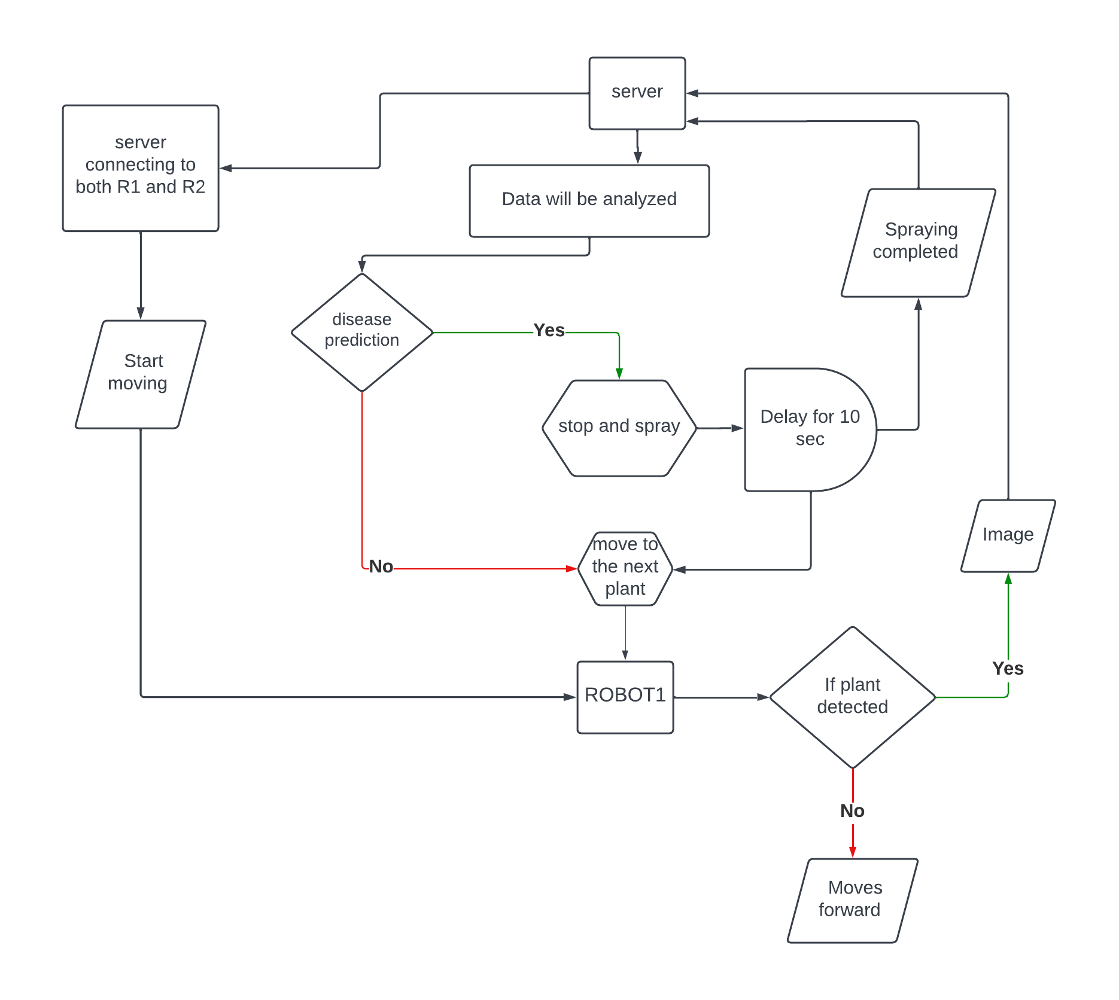
10 COMMUNICATION SYSTEM

FIGURE 10.1
Communication system between robot1 and server

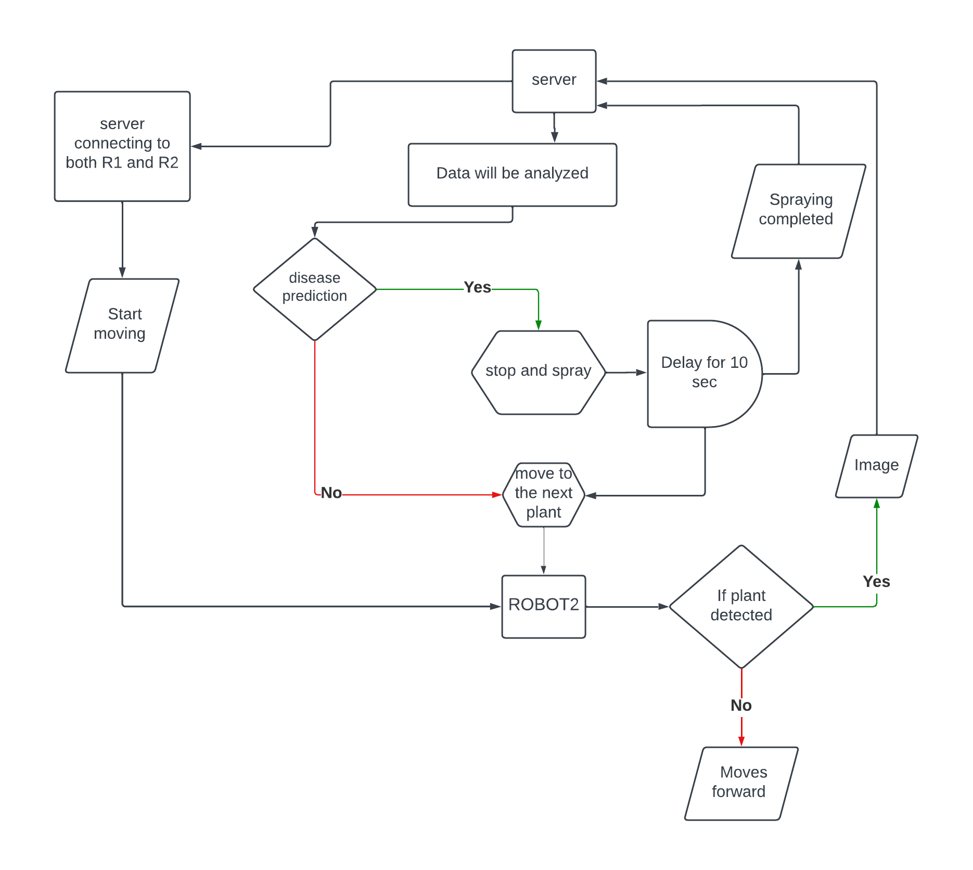

FIGURE 10.2
Communication system between robot2 and computer

The server acts as a central component in the robotic system, connecting to both R1 and R2. Its primary function is to receive data from the robots and analyze it for further processing.

When the server receives the command to start, the robots (R1 and R2) begin moving towards the plants in the field. Using ultrasonic sensors, the robots detect the presence of plants. If a plant is detected, the robot stops and captures an image of the plant. This image is then transmitted to the server for analysis.

The server employs image processing techniques to analyze the captured images and predict if any disease is present in the plant. If no disease is detected, the robot proceeds to the next plant. However, if a disease is predicted, the robots initiate the spraying process to eliminate the disease. The spraying continues for a specified duration, typically ten seconds, ensuring effective coverage.

After completing the spraying process, the robots send a signal to the server indicating that spraying is completed. The server updates its records accordingly and instructs the robots to move to the next plant. This iterative process of plant detection, image analysis, disease prediction, spraying, and moving to the next plant continues until all plants in the field are examined.

By implementing this system, the robots can efficiently identify and treat diseased plants, minimizing the spread of diseases and ensuring the health of the crop. The integration of the server, robots, and image processing technologies enables real-time monitoring and decision-making, optimizing the effectiveness of the spraying operation.

Overall, this robotic system offers an automated and efficient approach to plant disease detection and treatment in agricultural fields. The server's role in connecting and coordinating the activities of the robots, along with its data analysis capabilities, enhances the system's performance and contributes to effective disease management in the field.

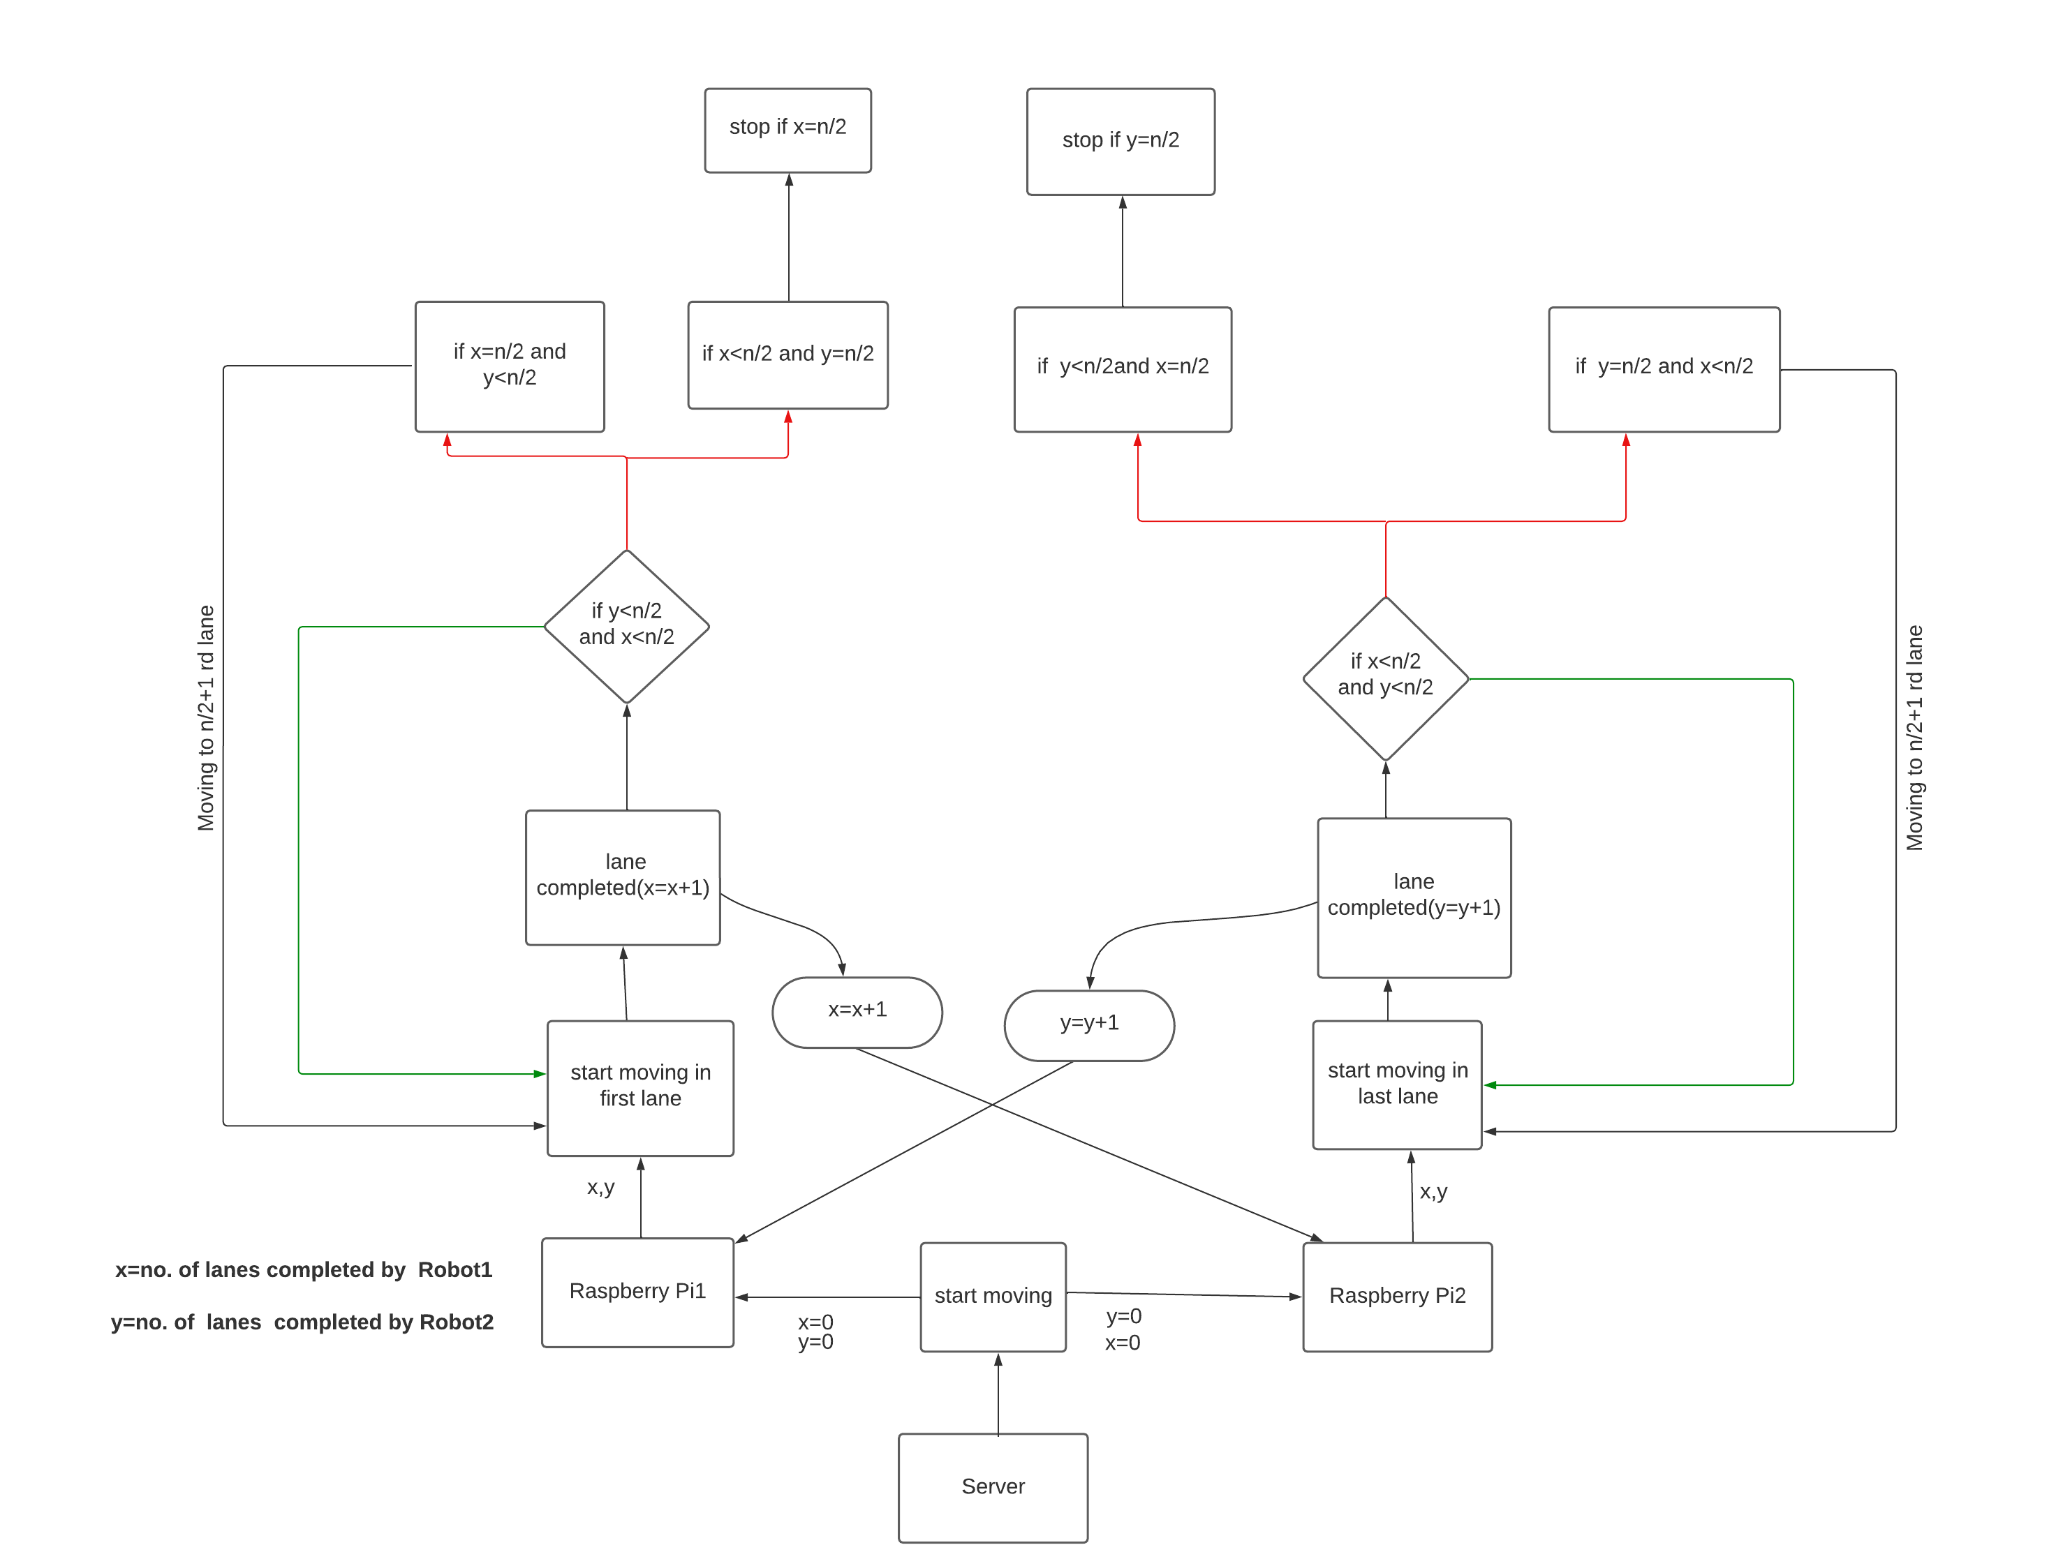

FIGURE 10.3
Communication between Robot1 and Robot 2

The coordination and lane completion process between Robot1 and Robot2 in the robotic system are as follows:

- The robots receive a command from the server to start moving in the first lane.
- Both Robot1 and Robot2 begin moving simultaneously in the lane.
- When a lane is completed, Robot1 increments its lane counter (x) and sends this information to Robot2.
- Upon receiving the lane completion update from Robot1, Robot2 increments its lane counter (y) and sends this information back to Robot1.
- The robots continue this back-and-forth communication, updating their respective lane counters based on completed lanes.
- If Robot1 completes its assigned lanes faster than Robot2, Robot1 proceeds to enter and complete the remaining lanes assigned to Robot2, while Robot2 waits for further instructions.
- Conversely, if Robot2 completes its assigned lanes faster than Robot1, Robot2 enters and completes the remaining lanes assigned to Robot1, while Robot1 waits for further instructions.
- This process continues until both Robot1 and Robot2 have completed all the assigned lanes.
- The Raspberry Pi 1 and Raspberry Pi 2 handle the coordination and communication between the robots, updating their lane counters and ensuring a synchronized lane completion process.
The server plays a crucial role in issuing commands, tracking the lane completion progress, and coordinating the movement of Robot1 and Robot2.

11 Study Area
11.1Functional Requirement
An explanation of the service that the software must provide is contained in a functional requirement (FR). It describes a piece of software or a software system. A function is nothing more than the inputs, behaviour, and outputs of the software system. A system's likely function can be determined by a computation, data manipulation, business process, user interaction, or any other specialised feature. Functional Specification is another name for functional requirements. One of the most crucial elements in terms of the overall mechanism of modules is the project's functional requirements.
Here, the functional prerequisites are:
• Using the most recent dataset of plant leaves that are of extremely high quality.
• Producing evaluation metrics pixels with excellent data.
• Use a deep learning multi-scale image block-level fully convolutional neural network (CNN) algorithm to classify the data.
• Using the preprocessing task
• Use a deep neural network, such as CNN, to determine the denseNet121 architecture's optimal performance.
• The robot's Pi Camera takes pictures and uploads them to a server.
• The server forecasts the illness and instructs the robot.
• Socket programming is used for robot and server communication.
11.2Non-Functional Requirement
Usability
The customer committed to asking for ambush pressure in moving to a distinct framework with a different condition and acknowledged being usual about the buyer interactions.

Reliability
Both the Project Director and the Test Designer should be able to see the work the Programmer has made.

Security
Following the framework while counting bugs must provide crucial security and prevent the entire process from slamming.

Performance
Performance becomes a significant consideration because the framework will be run on a single web server and a single database server that are both hidden.

Portability
This is necessary when the web server that is supporting the framework stalls out due to a few faults, necessitating the transfer of their framework to another framework.

Reusability
The framework should be broken up into manageable components that can easily be included into other frameworks with minimal effort.Technologies applied.

  - Architecture of DenseNet-121
Introduction to DenseNet
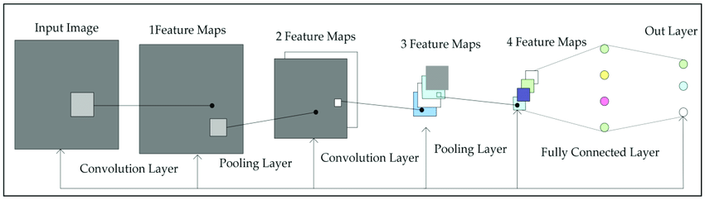
The first convolutional layer, which gets the input, is the only one in a standard feed-forward convolutional neural network (CNN) that receives the output of the convolutional layer before it. This convolutional layer then creates an output feature map, which is then passed on to the subsequent convolutional layer. For 'L' layers, there are 'L' direct connections, one between each layer and the following layer

FIGURE 11.3.1
The 'vanishing gradient' problem, however, emerges when the CNN has more layers, or as it gets deeper. This means that as the channel for information from the input to the output layers lengthens, it may cause some information to 'vanish' or get lost, which hinders the network's capacity to train efficiently.
By altering the typical CNN architecture and streamlining the connectivity between layers, DenseNets alleviate this issue. Each layer in a DenseNet architecture is connected to every other layer directly, giving rise to the moniker Densely Connected Convolutional Network. There are L(L+1)/2 direct connections between 'L' layers.
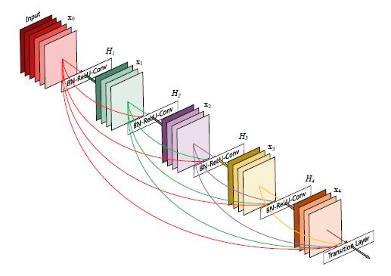
FIGURE 11.3.2

11.4 DenseNet Architecture & Components
Additives of Dense Net include:
  - Connectivity
  - Dense Blocks
  - boom rate
  - Bottleneck layers
Connectivity
The feature maps from all the preceding layers are concatenated and utilised as inputs in each layer rather than being averaged. Because duplicate feature mappings are removed, DenseNets require fewer parameters than an equivalent standard CNN, allowing for feature reuse. As a result, the lth layer receives as input the feature-maps of all layers before it, x0,...,xl-1:
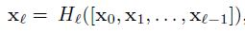
where [x0,x1,...,xl-1] represents the concatenation of feature maps, or the output from all layers prior to l (0,...,l-1). To make implementation simpler, Hl's many inputs are combined into a single tensor.

Dense Blocks
When the size of feature maps varies, it is not possible to use the concatenation method. However, downsampling of layers, which minimises the size of feature-maps through dimensionality reduction to enable faster calculation speeds, is a crucial component of CNNs.
This is made possible by the division of DenseNets into DenseBlocks, where the size of the feature maps inside a block is kept constant but the number of filters between them changes. Transition Layers are the layers in between the blocks that cut the number of channels in half compared to the number of channels currently in use.
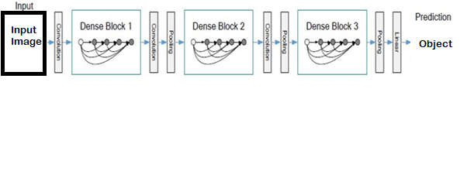
FIGURE 11.4.1
According to the equation above, Hl is defined for each layer as a composite function that performs batch normalisation (BN), a rectified linear unit (ReLU), and a convolution (Conv) in that order.

Growth Charge

The features can be regarded as the network's overall status. After passing through each thick layer, the size of the feature map increases because each layer adds 'K' features on top of the global state (pre-existing features). The network's growth rate, denoted by the parameter "K," controls how much information is added to each layer of the network. The lth layer has input feature-maps if each function H l generates k feature maps, where k0 is the number of channels in the input layer. DenseNets can have very narrow layers, which is different from current network architectures.

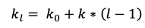

Bottleneck layers

Despite the fact that each layer only generates k output feature-maps, there might be a large number of inputs, especially for higher layers. To increase computing efficiency and speed, a 1x1 convolution layer might be added as a bottleneck layer before each 3x3 convolution.

11.5 DenseNet-121 Architecture

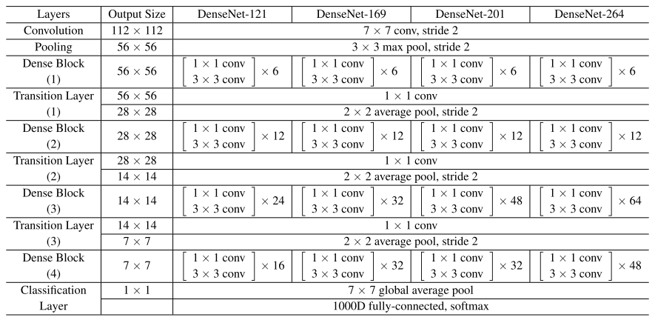
FIGURE 11.5.1
The table above provides a summary of the many architectures used to build the ImageNet database. The number of pixels shifted across the input matrix called the stride. The filters are moved 'n' pixels at a time when the stride parameter is set to 'n' (the default value is 1).
- Fundamental convolution layer with sixty four filters of size 7X7 and a stride of two
- Number one pooling layer with 3x3 max pooling and a stride of
- Dense Block 1 with 2 convolutions repeated 6 instances
- Transition layer 1 (1 Conv + 1 Avg Pool)
- Dense Block 2 with 2 convolutions repeated 12 times
- Transition layer 2 (1 Conv + 1 Avg Pool)
- Dense Block three with 2 convolutions repeated 24 instances
- Transition layer 3 (1 Conv + 1 Avg Pool)
- Dense Block four with 2 convolutions repeated sixteen instances
- International average Pooling layer- accepts all of the characteristic maps of the network to perform type
Output layer
Consequently, DenseNet-121 has the subsequent layers:
- 1 7x7 Convolution
- 58 3x3 Convolution
- 61 1x1 Convolution
- Four Avg Pool
- 1 completely related Layer
In short, DenseNet-121 has one hundred twenty Convolutions and four AvgPool.
Deeper layers can use features that were extracted earlier because all levels, including those in the same dense block and transition layers, distribute their weights over numerous inputs.
The layers in the second and third dense blocks give the output of the transition layers the least weights since they produce a lot of redundant features.
Additionally, even though the final layers employ the weights of the entire dense block, it's possible that higher level features are created farther into the model because there appeared to be a larger concentration on final feature maps in trials.

12 RESULTS
Robot 1 Robot 2
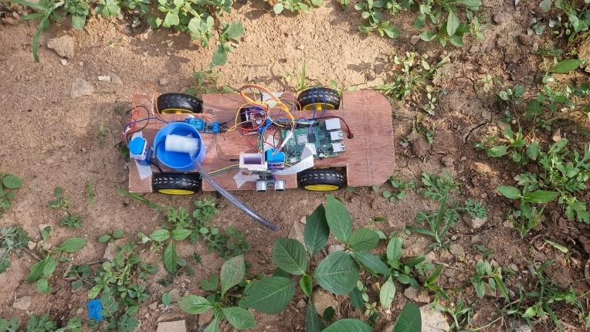
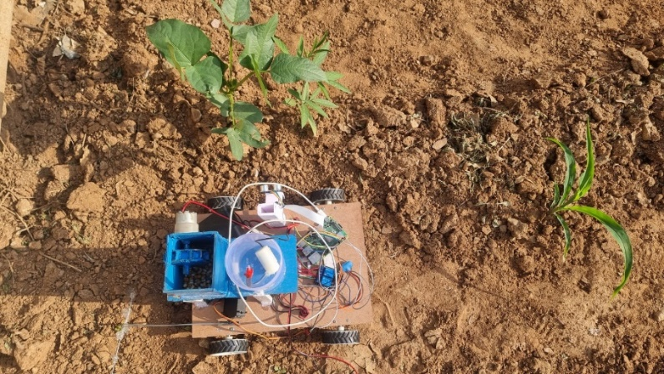

FIGURE 12.1 FIGURE 12.2

Communication:
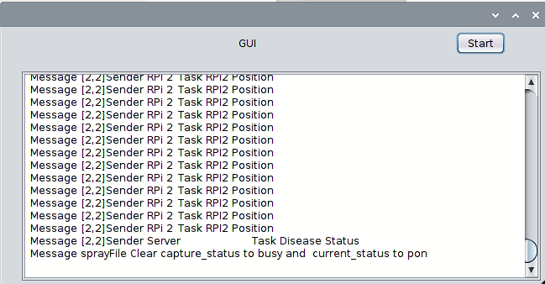
FIGURE 12.3
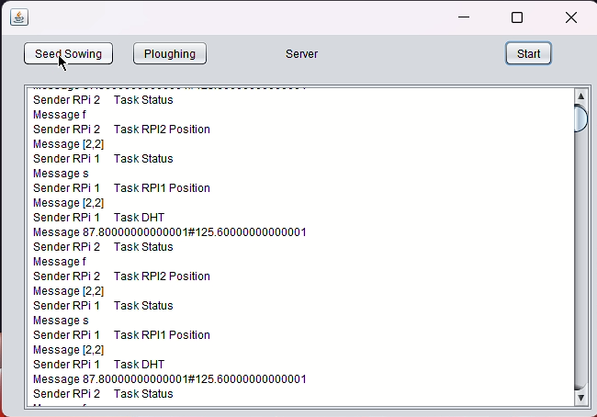

FIGURE 12.4
Prediction:
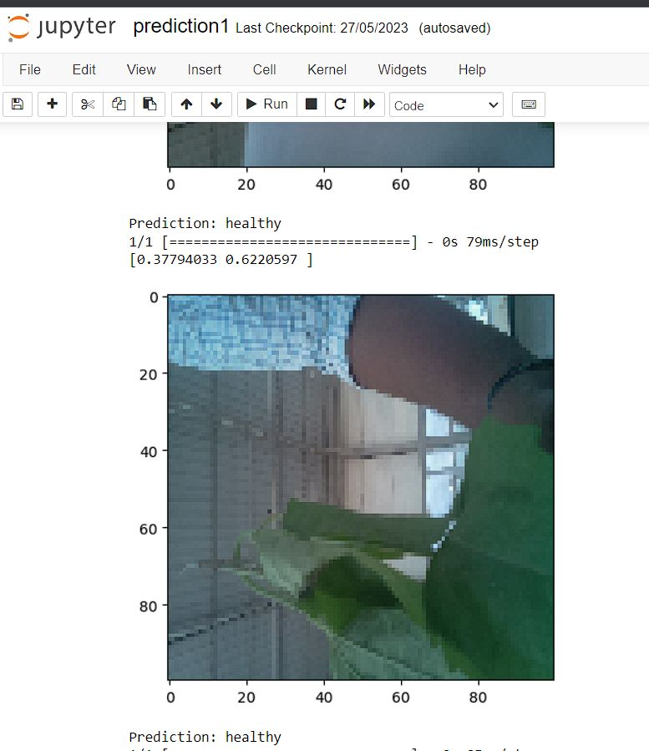
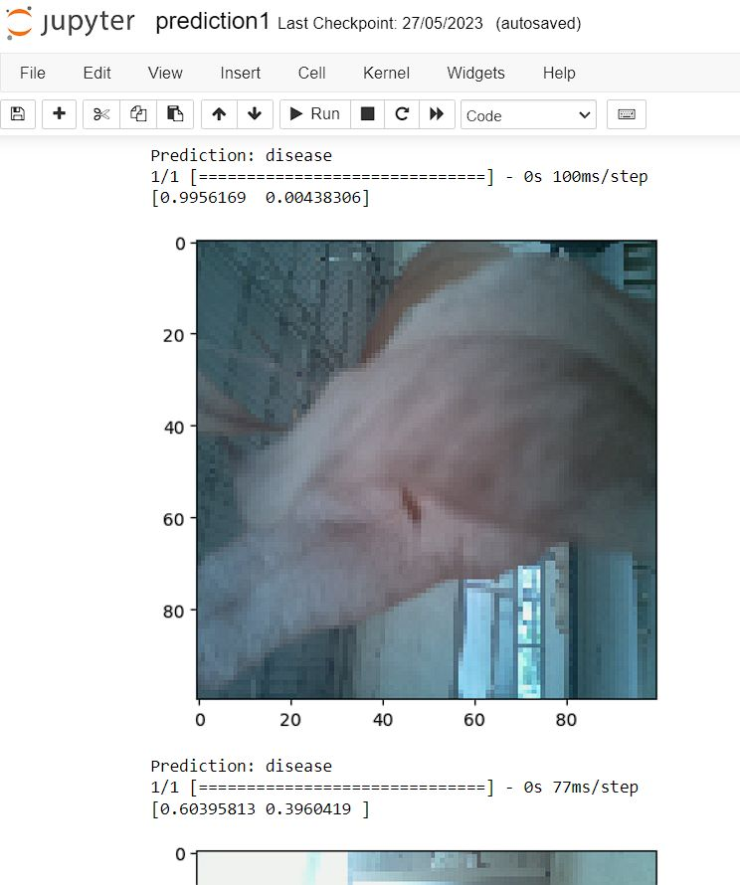

FIGURE 12.5 FIGURE 12.6
Predicted : Healthy Predicted : Disease

13 Future Work
Future Enhancements and Extensions of the Swarm Robotic System
- Improved Communication and Coordination: Develop advanced communication protocols and coordination mechanisms to enhance the interaction and collaboration between swarm robots. This could involve optimizing the communication range, bandwidth, and reliability, as well as designing efficient message-passing algorithms.
- Enhanced Sensing and Perception: Integrate advanced sensors and perception capabilities into swarm robots to improve their ability to sense and understand the environment. This may include incorporating vision systems, LiDAR, or other sensors to enable accurate localization, mapping, object detection, and tracking.
- Adaptive Swarm Behavior: Implement adaptive behaviors in swarm robots to allow them to dynamically adjust their strategies and decision-making based on the feedback received from the environment or other robots. This could involve learning algorithms that enable robots to adapt their behaviors through experience or by sharing information with other members of the swarm.
- Swarm Robotic Learning: Explore the application of machine learning and artificial intelligence techniques to enable swarm robots to learn from their interactions and improve their performance over time. This may include reinforcement learning, evolutionary algorithms, or swarm intelligence approaches to optimize collective behavior and decision-making.
- Fault Tolerance and Robustness: Design swarm robotic systems with built-in fault tolerance mechanisms to ensure the system can continue functioning even in the presence of individual robot failures or communication disruptions. This could involve redundancy, self-repairing capabilities, or adaptive algorithms to reconfigure the swarm in response to failures.
- Scalability and Expansion: Develop strategies and algorithms to scale up swarm robotic systems to larger groups of robots. This may involve addressing scalability challenges related to communication, coordination, and task allocation as the number of robots increases.

14 CONCLUSION
Summary of project objectives and Achievements
In this project, we have successfully developed a swarm robotic system capable of performing coordinated tasks in a decentralized manner. Inspired by the collective behavior of social insects, we explored the concept of swarm robotics and its applications in various domains. Through the implementation of multi-robot coordination algorithms and communication protocols, our system demonstrated efficient task allocation and collaboration among the swarm robots.

The system's architecture allowed for the seamless integration of individual robots, enabling them to share information, make collective decisions, and accomplish complex missions. By leveraging advanced sensing capabilities, such as vision systems and proximity sensors, the robots were able to perceive and navigate their environment effectively. Additionally, the incorporation of machine learning techniques enhanced the system's adaptability and decision-making capabilities.

15 REFERENCES
- Antanasio D.Overview of swarm intelligence. Swarm Intelligence; 2010.Available:https://www.cpp.edu Retrieved: 6th January 2020​
- Deneubourg JL, Pasteels JM, VerhaegheJC. Probabilistic behaviour in ants: A strategy of errors. Journal of Theoretical Biology. 1983;105(2):259-271.​
- Karthik Narayanan, Vinayak Honkote, Dibyendu Ghosh, Swamy Baldev (13 May 2019) “Energy Efficient Communication with Lossless Data Encoding for Swarm Robot Coordination” 2380-6923/19/$31.00 ©2019 IEEE DOI 10.1109/VLSID.2019.00118.​
- Hybrid Feature-Based Disease Detection in Plant Leaf Using Convolutional Neural Network, Bayesian Optimized SVM, and Random Forest Classifier Ashutosh Kumar Singh,1SVN Sreenivasu,2U.S.B. K. Mahalaxmi,3HimanshuSharma,4Dinesh D.Patil,5and Evans Asenso https://doi.org/10.1155/2022/2845320
- Swarm Robots in Mechanized Agricultural Operations: Roadmap for Research Daniel Albiero, D. Sc.*. Angel Pontin Garcia, D. Sc.*. Claudio Kiyoshi Umezu, D. Sc.*. Rodrigo Leme de Paulo, En
- Li Lu, Dunwei Gong (2008) “Robot Path Planning in Unknown Environments Using Particle Swarm Optimization” 978-0- 7695-3304-9/08 $25.00 © 2008 IEEE DOI 10.1109/ICNC.2008.923 Robot Path Planning in Unknown Environments Using Particle Swarm Optimization | IEEE Conference Publication | IEEE Xplore
- Arvin, F.; Samsudin, K.; Ramli, A. Development of ir-based short-range communication techniques for swarm robot applications. Adv. Electr. Comput. Eng. 2010, 10, 61–68. [Google Scholar] [CrossRef]
- Gigliotta, O.; Mirolli, M.; Nolfi, S. Communication based dynamic role allocation in a group of homogeneous robots. Nat. Comput. 2014, 13, 391–402. [Google Scholar] [CrossRef]

