

J R O Sirimanne

MIS 3104 Individual Project interim Report

Name of Candidate: J R O Sirimanne

Registration No.: 2013 MIS 021 Index No: 13770213

Email Address: jro@ucsc.cmb.ac.lk Contact No: 071-6374-696

Title of project: Privacy and security implications on Wireless (Wi-Fi)

This Project: New Project ☐ Repeat Project ☐

………….…………………………

Signature of candidate Date: 30 / 09 /2015

Privacy and Security Implications on Wireless (Wi-Fi) Tomography

By

J. R. O. Sirimanne

Supervised by

Dr. Chamath Keppitiyagama

BSc (Colombo), MSc (UBC), PhD (UBC)

University of Colombo School of Computing

Colombo 7

SRI LANKA

October 01, 2015

Preface

The intended audience of this document is the academic staff of the University Of Colombo School Of Computing so that they may determine whether the project should be approved as proposed, approved with modifications, or not approved.

Table of Contents

1. Introduction 5

1.1 Devices, Technologies and Definitions 5

1.1.1 Radio Tomographic Imaging 5

1.1.2 Privacy 6

1.2 Motivation 6

1.3 Aims and Objectives 6

1.4 Research Question 7

Design 7

Chapter 1

# Introduction

At present day Wi-Fi is the popular wireless networking technology that uses radio waves to provide wireless high-speed Internet and network connections. Wi-Fi connections support millions of people in homes, businesses, and public locations around the world supporting them to be connected at every possible time. There is a possibility to track people movements by observing just the signal strength of these Wi-Fi networks.

## Devices, Technologies and Definitions

For this study an ordinary wireless access point and a Laptop with wireless interface that is capable of publishing signal strengths in decibel (dB) values will be used as hardware devices.

## Decibel

## Received signal strength (RSS).

## Radio Tomographic Imaging

Tomography refers to imaging by sections or sectioning, through the use of any kind of penetrating wave. Radio tomographic imaging (RTI) is an emerging application which offers a new way to image passive objects in buildings and outdoor environments using received signal strength indicator (RSSI). [1]

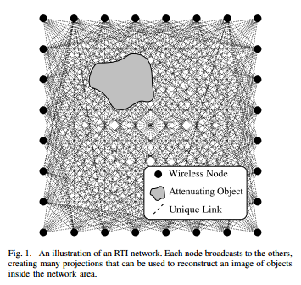

Figure - An illustration of an RTI network. Each node broadcasts to the others, creating many projections that can be used to reconstruct an image of objects inside the network area. [2]

## Privacy

Privacy has many meanings. The most general is freedom from interference or intrusion, the right "to be let alone," a formulation cited by Louis Brandeis and Samuel Warren in their groundbreaking 1890 paper on privacy. [4] This recognizes that each person has a sphere of existence and activity that properly belongs to that individual alone, where he or she should be free of constraint, coercion, and even uninvited observation. As we would say today, each of us needs our own "space." Most would recognize the protected sphere to include personal opinions, personal communications, and how one behaves behind closed doors, at least as long as these do not lead to any significant threats to society. Many would also include behavior within the family and other intimate relationships in that sphere. [3]

## Motivation

There are many security implementations to preserve privacy of a person when connected and using the network. Research shows when an object moves inside a wireless area that objects causes the received signal strength indicator (RSSI) to be dropped. By tracking these drops we can map the path and movements of the object. Apart from providing internet and network access Wi-Fi is used in sensor networks to transfer data gathered from sensors. These sensor networks power and enable modern concepts like smart homes, smart power, smart cities, Internet of things etc. With all these usage of Wi-Fi increases rapidly and in a small area there can be many Wi-Fi networks. Issue with this is by using wireless tomography technologies we can track movements of people unknowing to them that someone is tracking them.

Currently there are no security implementations to safeguard people for above type of privacy breaches and many are unaware about the security issues related to available tomographic techniques.

## Aims and Objectives

Wireless internet is a very common method of providing Internet and networking facilities to people and devices. With such common used technology it should be safe to use. In this research, I will design, test and evaluate diffident real world scenarios of wireless implementations to determine and prove the effects to wireless signal strength when a human is present and find the scenarios that are vulnerable to privacy breaches.

## Research Question

With this study we are researching to answer two questions that arise with above mentioned problems.

1. Is there significant amount of wireless signal strength drop when there are human presences in a room?
2. How accurately we can identify human presence by observing received signal strength indicator (RSSI) values.

Chapter 3

## Design

In the design stage scenarios are developed to answer research questions and test them to confirm that the project can be taken forward. In the initial design face primary scenarios are developed. For these scenarios there are three variables

1. Data gathering computer
2. Wireless access point
3. Person

Scenario 1

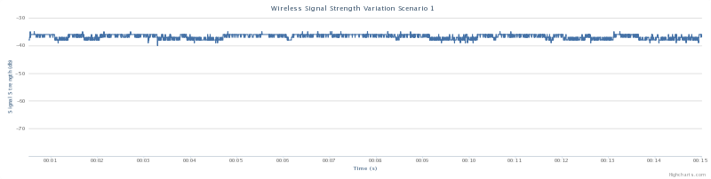

Scenario 2

Scenario 3

Scenario 4

Scenario 5

Scenario 6

Scenario 7

Scenario 8

Scenario 9

Scenario 10

Scenario 11

Scenario 12

Scenario 12.1

Scenario 12.2

Scenario 12.3

Scenario 13

Scenario 14

Scenario 15

Scenario 16

Chapter 4

Implementation

To be continued

Chapter 5

Evaluation

To be continued.

Chapter 6

Conclusion and Future Work

To be continued

References

[1] University of Utah. (2015 October, 01). *Radio Tomographic Imaging* [Online]. Available: http://span.ece.utah.edu/radio-tomographic-imaging [Accessed 3 Oct. 2015].

[2] J. Wilson and N. Patwari, “Radio tomographic imaging with wireless networks,” IEEE Transactions on Mobile Computing, vol. 9, no. 5, pp. 621–632, May 2010. Published, 01/08/2010.

[3] Michael McFarland, SJ. *What is Privacy?* [online] Scu.edu. Available at: http://www.scu.edu/ethics/practicing/focusareas/technology/internet/privacy/what-is-privacy.html [Accessed 3 Oct. 2015].

[4] Samuel D. Warren and Louis D. Brandeis, "The Right to Privacy," Harvard Law Review, 4 (5), (1890): 193-220, p. 195, citing Judge Cooley in Cooley on Torts, 2nd ed.