

J R O Sirimanne

MIS 3104 Individual Project interim Report

Name of Candidate: J R O Sirimanne

Registration No.: 2013 MIS 021 Index No: 13770213

Email Address: jro@ucsc.cmb.ac.lk Contact No: 071-6374-696

Title of project: Privacy and security implications on Wireless (Wi-Fi)

This Project: New Project ☐ Repeat Project ☐

………….…………………………

Signature of candidate Date: 30 / 09 /2015

Privacy and Security Implications on Wireless (Wi-Fi) Tomography

By

J. R. O. Sirimanne

Supervised by

Dr. Chamath Keppitiyagama

BSc (Colombo), MSc (UBC), PhD (UBC)

University of Colombo School of Computing

Colombo 7

SRI LANKA

October 01, 2015

Preface

The intended audience of this document is the academic staff of the University Of Colombo School Of Computing so that they may determine whether the project should be approved as proposed, approved with modifications, or not approved.

Table of Contents

Table of Figures 5

1. Introduction 6

1.1 Hardware Devices 6

1.1.1 Wireless access point 6

1.1.2 Signal Strength Capturing laptop 7

1.2 Technologies 7

1.2.1 Wi-Fi 7

1.2.2 Radio Tomographic Imaging 8

1.3 Definitions 9

1.3.1 Decibel 9

1.3.2 Received Signal Strength Indicator(RSSI). 9

1.3.3 Privacy 9

1.4 Motivation 10

1.5 Aims and Objectives 10

1.6 Research Question 10

2 Background 12

3 Design 13

3.1 Scenarios 13

3.2 Scenario Diagrams 13

# Table of Figures

Figure 1- Wireless Access point Simplest usage 6

Figure 2 - DSL-2750U Wireless N ADSL2+ Wi-Fi Router 7

Figure 3- Wi-Fi logo 7

Figure 4 - An illustration of an RTI network. Each node broadcasts to the others, creating many projections that can be used to reconstruct an image of objects inside the network area. [2] 8

Chapter 1

# Introduction

At present day Wi-Fi is the popular wireless networking technology that uses radio waves to provide wireless high-speed Internet and network connections. Wi-Fi connections support millions of people in homes, businesses, and public locations around the world supporting them to be connected at every possible time. There is a possibility to track people movements by observing just the signal strength of these Wi-Fi networks.

## Definitions

## Decibel

The decibel (dB) is a logarithmic unit that expresses the ratio of two values of a physical quantity, often power or intensity. One of these quantities is often a reference value and in this case the decibel expresses the absolute level of the physical quantity. The number of decibels is ten times the logarithm to base 10 of the ratio of two power quantities or of the ratio of the squares of two field amplitude quantities. One decibel is one tenth of one bel, named in honor of Alexander Graham Bell; however, the bel is seldom used. The definition of the decibel is based on the measurement of power in telephony of the early 20th century in the Bell System in the United States. Today, the unit is used for a wide variety of measurements in science and engineering, most prominently in acoustics, electronics, and control theory. In electronics, the gains of amplifiers, attenuation of signals, and signal-to-noise ratios are often expressed in decibels. The decibel confers a number of advantages, such as the ability to conveniently represent very large or small numbers, and the ability to carry out multiplication of ratios by simple addition and subtraction. By contrast, use of the decibel complicates operations of addition and subtraction. [7]

## Received Signal Strength Indicator (RSSI)

## Privacy

Privacy has many meanings. The most general is freedom from interference or intrusion, the right "to be let alone," a formulation cited by Louis Brandeis and Samuel Warren in their groundbreaking 1890 paper on privacy. [4] This recognizes that each person has a sphere of existence and activity that properly belongs to that individual alone, where he or she should be free of constraint, coercion, and even uninvited observation. As we would say today, each of us needs our own "space." Most would recognize the protected sphere to include personal opinions, personal communications, and how one behaves behind closed doors, at least as long as these do not lead to any significant threats to society. Many would also include behavior within the family and other intimate relationships in that sphere. [3]

## Hardware Devices

For this study an ordinary wireless access point and a Laptop with wireless (Wi-Fi) interface that is capable of publishing signal strengths in decibel (dB) values will be used as hardware devices.

## Wireless access point

In computer networking, a wireless access point (AP) is a device that allows wireless devices to connect to a wired network using Wi-Fi, or related standards. The AP usually connects to a router (via a wired network) as a standalone device, but it can also be an integral component of the router itself. [8].

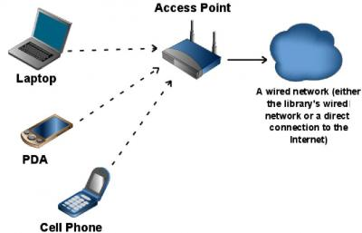

Figure 1- Wireless Access point Simplest usage

*(Source: http://www.techsoupforlibraries.org/files/images/wireless_network.img_assist_custom.jpg)*

For this study I used a D-Link Wireless N300 ADSL Modem Router (Model Number DSL-2750U) which is a very common wireless access point used in Sri Lanka.

The DSL-2750U Wireless N ADSL2+ Wi-Fi Router connects a group of users to the Internet, allowing multiple computers at home or the office to share an integrated high-speed ADSL2/2+ interface. It provides high-performance 802.11n wireless access for wireless networked computers, 4 built-in Ethernet ports, firewall protection, and QoS for smooth and secure download/upload of photos, files, music, video, and e-mail over the Internet. [9]

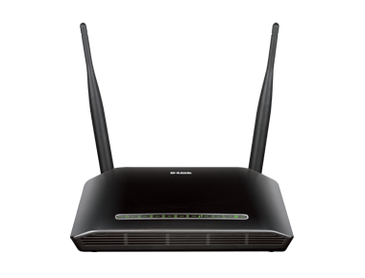

Figure - DSL-2750U Wireless N ADSL2+ Wi-Fi Router

*(Source: http://115.124.123.225/new/products/DSL-2750u/DSL-2750u.png)*

## Signal Strength Capturing laptop

RSSI value of the Wireless signal is needed for the study.

## Technologies

Technology sections describes the technologies used for this study.

## Wi-Fi

Wi-Fi (or WiFi) is a local area wireless computer networking technology that allows electronic devices to network, mainly using the 2.4 gigahertz (12 cm) UHF and 5 gigahertz (6 cm) SHF ISM radio bands. [5] Wi-Fi standards are defined by IEEE 802.11 standard. IEEE 802.11 is a set of media access control (MAC) and physical layer (PHY) specifications for implementing wireless local area network (WLAN) computer communication in the 2.4, 3.6, 5, and 60 GHz frequency bands. They are created and maintained by the IEEE LAN/MAN Standards Committee (IEEE 802). The base version of the standard was released in 1997, and has had subsequent amendments. The standard and amendments provide the basis for wireless network products using the Wi-Fi brand. While each amendment is officially revoked when it is incorporated in the latest version of the standard, the corporate world tends to market to the revisions because they concisely denote capabilities of their products. As a result, in the market place, each revision tends to become its own standard. [6]

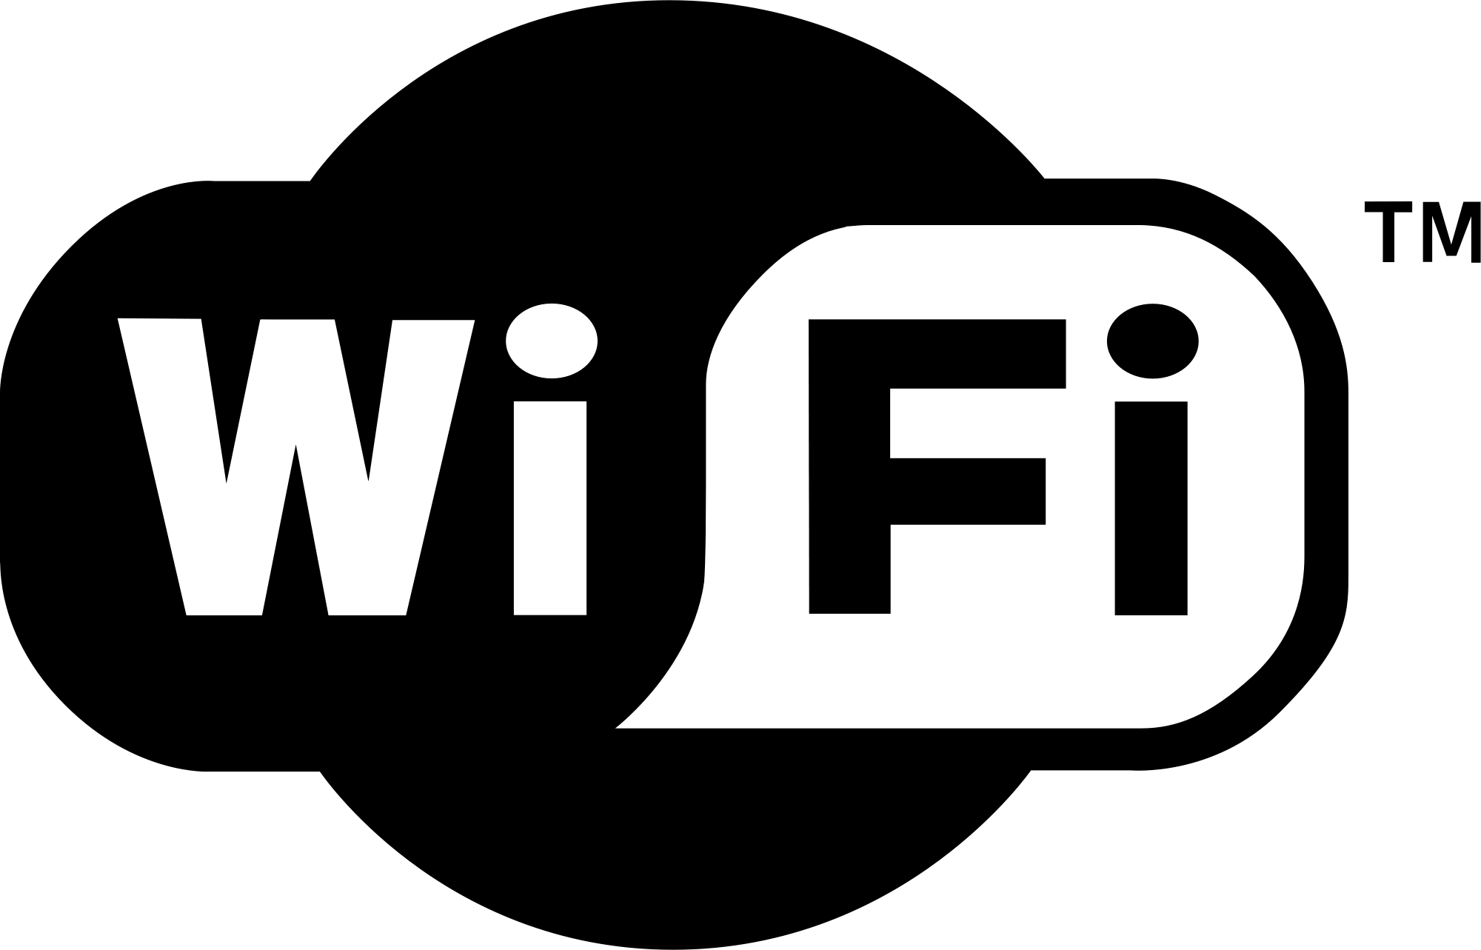

Figure 3- Wi-Fi logo

(Source: https://upload.wikimedia.org/wikipedia/commons/thumb/3/32/Wi-Fi_Logo.svg/2000px-Wi-Fi_Logo.svg.png)

## Radio Tomographic Imaging

Tomography refers to imaging by sections or sectioning, through the use of any kind of penetrating wave. Radio tomographic imaging (RTI) is an emerging application which offers a new way to image passive objects in buildings and outdoor environments using received signal strength indicator (RSSI). [1]

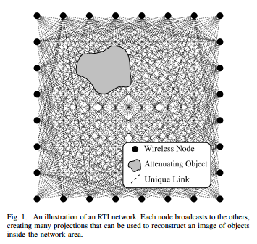

Figure 4 - An illustration of an RTI network. Each node broadcasts to the others, creating many projections that can be used to reconstruct an image of objects inside the network area. [2]

*(Source: http://span.ece.utah.edu/uploads/RTINetwork.png)*

## Motivation

There are many security implementations to preserve privacy of a person when connected and using the network. Research shows when an object moves inside a wireless area that objects causes the received signal strength indicator (RSSI) to be dropped. By tracking these drops we can map the path and movements of the object. Apart from providing internet and network access Wi-Fi is used in sensor networks to transfer data gathered from sensors. These sensor networks power and enable modern concepts like smart homes, smart power, smart cities, Internet of things etc. With all these usage of Wi-Fi increases rapidly and in a small area there can be many Wi-Fi networks. Issue with this is by using wireless tomography technologies we can track movements of people unknowing to them that someone is tracking them.

Currently there are no security implementations to safeguard people for above type of privacy breaches and many are unaware about the security issues related to available tomographic techniques.

## Aims and Objectives

Wireless internet is a very common method of providing Internet and networking facilities to people and devices. With such common used technology it should be safe to use. In this research, I will design, test and evaluate diffident real world scenarios of wireless implementations to determine and prove the effects to wireless signal strength when a human is present and find the scenarios that are vulnerable to privacy breaches.

## Research Question

With this study we are researching to answer two questions that arise with above mentioned problems.

1. Is there a significant amount of wireless signal strength drop when there is a human inside the line of sight of the wireless access point and data gathering computer?
2. How accurately we can identify human presence by observing received signal strength indicator (RSSI) values.

Chapter 2

# Background

Chapter 3

# Design

In the design stage, scenarios are developed to answer research questions and test them.

## Scenarios

In the initial design face primary scenarios are developed to answer first research question(Is there a significant amount of wireless signal strength drop when there is a human inside the line of sight of the wireless access point and data gathering computer?).

For initial scenarios there are three variables

1. Data gathering computer
2. Wireless access point
3. Person

## Scenario Diagrams

In these diagrams we have used symbols to represent objects below table describes the symbols.

|  |  |
| --- | --- |
| Symbol | Resemblance |
|  | Wireless access point |
|  | Data gathering computer |
|  | Human |

Table - Symbols and resemblance

Scenario 1

Scenario 2

Scenario 3

Scenario 4

Scenario 5

Scenario 6

Scenario 7

Scenario 8

Scenario 9

Scenario 10

Scenario 11

Scenario 12

Scenario 13

Scenario 14

Scenario 15

Scenario 16

Chapter 4

Testing

Scenario 12.1

Scenario 12.2

Scenario 12.3

To be continued

Chapter 5

Evaluation

To be continued.

Chapter 6

Conclusion and Future Work

To be continued

References

[1] University of Utah. (2015 October, 01). *Radio Tomographic Imaging* [Online]. Available: http://span.ece.utah.edu/radio-tomographic-imaging [Accessed 3 Oct. 2015].

[2] J. Wilson and N. Patwari, “Radio tomographic imaging with wireless networks,” IEEE Transactions on Mobile Computing, vol. 9, no. 5, pp. 621–632, May 2010. Published, 01/08/2010.

[3] Michael McFarland, SJ. *What is Privacy?* [online] Scu.edu. Available at: http://www.scu.edu/ethics/practicing/focusareas/technology/internet/privacy/what-is-privacy.html [Accessed 3 Oct. 2015].

[4] Samuel D. Warren and Louis D. Brandeis, "The Right to Privacy," Harvard Law Review, 4 (5), (1890): 193-220, p. 195, citing Judge Cooley in Cooley on Torts, 2nd ed.

[5] Wikipedia, (2015). *Wi-Fi*. [online] Available at: https://en.wikipedia.org/wiki/Wi-Fi [Accessed 5 Oct. 2015].

[6] Wikipedia, (2015). *IEEE 802.11*. [online] Available at: https://en.wikipedia.org/wiki/IEEE_802.11 [Accessed 5 Oct. 2015].

[7] Wikipedia, (2015). *Decibel*. [online] Available at: https://en.wikipedia.org/wiki/Decibel [Accessed 5 Oct. 2015].

[8] Wikipedia, (2015). *Wireless access point*. [online] Available at: https://en.wikipedia.org/wiki/Wireless_access_point [Accessed 5 Oct. 2015].

[9] Dlink.co.in, (2015). D-Link Wireless N ADSL2+ 4-Port Wi-Fi Router. [online] Available at: http://www.dlink.co.in/products/?pid=452 [Accessed 5 Oct. 2015].