DBMS LAB RECORD
EXPERIMENT – 1
DDL Commands – CREATE, ALTER, DROP

AIM
To create and alter database tables using Data Definition Language (DDL) commands.
ALGORITHM
- Start the MySQL environment and select the required database.
- Create the STUDENT, FACULTY, DEPARTMENT and COURSE tables with the specified columns and data types.
- Use the DESC command to verify the structure of each created table.
- Alter the FACULTY table by adding the Dept column with VARCHAR(10) datatype.
- Verify the modified FACULTY table using the DESC command and stop.
QUERY / PROGRAM
-- 1. Create STUDENT table
CREATE TABLE student1 (
Regno INT(3),
sname VARCHAR(15),
gender CHAR(1),
DOB DATE,
Mno INT(10),
city VARCHAR(20)
);
DESC student1;
-- 2. Create FACULTY table
CREATE TABLE Faculty (
Facno VARCHAR(5),
Facname VARCHAR(20),
gender CHAR(1),
DOB DATE,
DOJ DATE,
mobileno VARCHAR(10)
);
DESC Faculty;
-- 3. Create DEPARTMENT table
CREATE TABLE department (
DeptNo VARCHAR(5),
DeptName VARCHAR(20),
DeptHead VARCHAR(10)
);
DESC department;
-- 4. Create COURSE table
CREATE TABLE course (
CourseNo VARCHAR(5),
CourseDesc VARCHAR(15),
CourseType CHAR(1),
Semno CHAR(1),
Hallno CHAR(1),
Facno VARCHAR(5)
);
DESC course;
-- 5. Add Dept column to FACULTY
ALTER TABLE Faculty ADD dept VARCHAR(10);
DESC Faculty;
OUTPUT
Output 1 – Creation and verification of STUDENT table
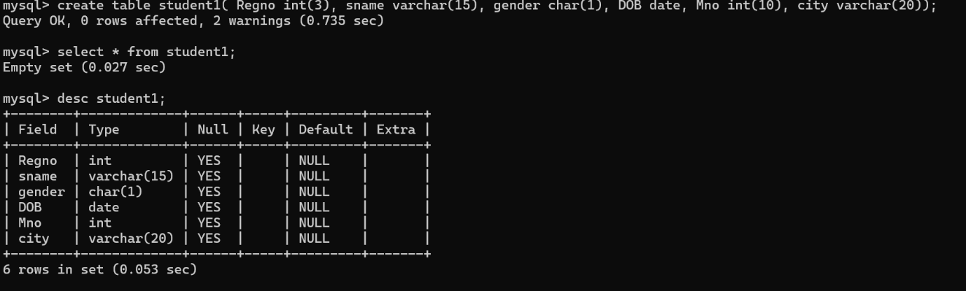
Output 2 – Creation and verification of FACULTY table
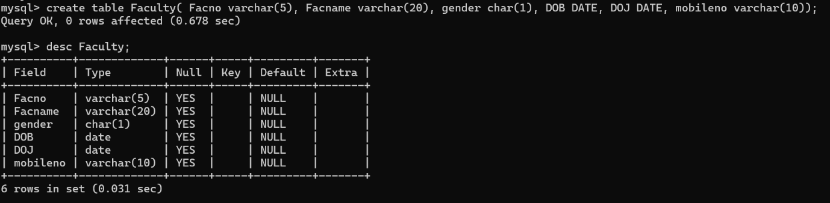
Output 3 – Creation and verification of DEPARTMENT table
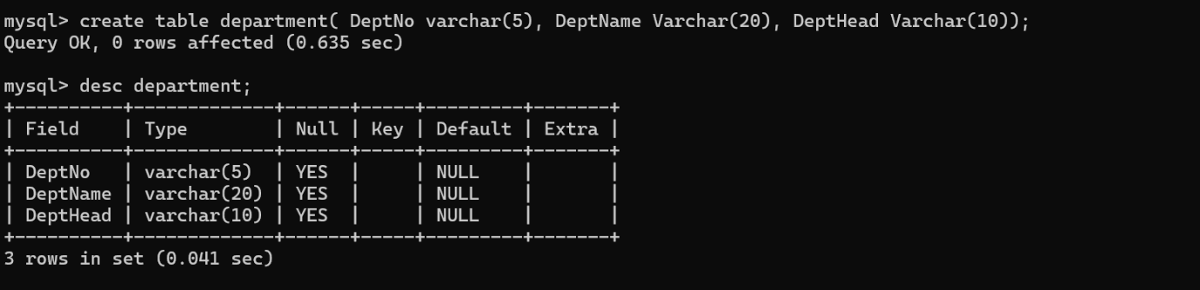
Output 4 – Creation and verification of COURSE table
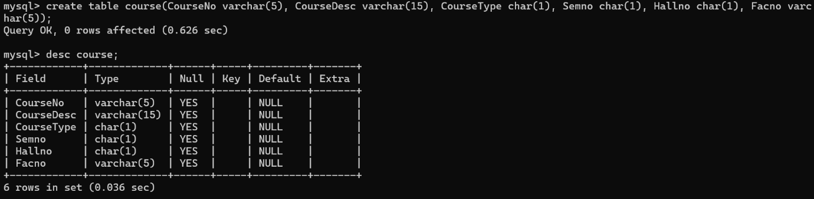
Output 5 – ALTER command adding Dept column to FACULTY
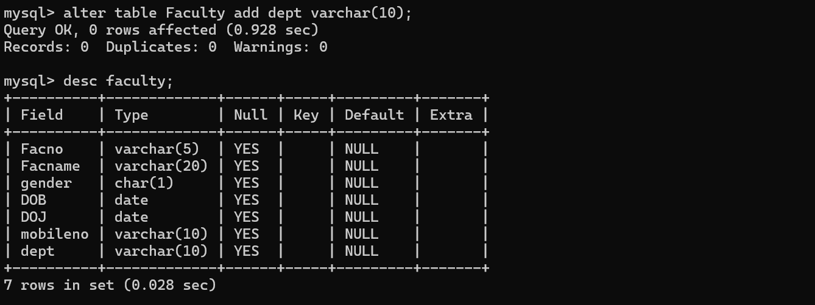
RESULT
Thus, the required tables were created and the FACULTY table was modified successfully using DDL commands.

