DBMS LAB RECORD
EXPERIMENT – 2
DDL Commands with Constraints – PRIMARY, FOREIGN KEY, UNIQUE, CHECK
AIM
To add the constraints like primary key, foreign key, unique key and check using DDL commands.
ALGORITHM
- Start MySQL and select the required database.
- Create or use the STUDENT2, FACULTY, DEPARTMENT and COURSE tables.
- Add the required PRIMARY KEY constraints using ALTER TABLE.
- Add CHECK constraints for valid Gender and Semester values.
- Add a UNIQUE constraint to the S1Name column of STUDENT2.
- Test the foreign-key operation on the RegNo column and verify the table structures using DESC.
QUERY / PROGRAM
-- 1. Add PRIMARY KEY to STUDENT2
ALTER TABLE student2 ADD PRIMARY KEY(RegNo);
DESC student2;
-- 2. Add PRIMARY KEY and CHECK constraint to FACULTY
ALTER TABLE faculty ADD PRIMARY KEY(Facno);
ALTER TABLE faculty ADD CHECK(gender='M' OR gender='F');
DESC faculty;
-- 3. Add PRIMARY KEY to DEPARTMENT
ALTER TABLE department ADD PRIMARY KEY(DeptNo);
DESC department;
-- 4. Add PRIMARY KEY to COURSE
ALTER TABLE course ADD PRIMARY KEY(CourseNo);
DESC course;
-- Add CHECK constraint for semester values 1 to 6
ALTER TABLE course ADD CHECK(Semno>=1 && Semno<=6);
DESC course;
-- 5. Add UNIQUE KEY to STUDENT2
ALTER TABLE student2 ADD UNIQUE KEY(S1Name);
DESC student2;
-- 6. Foreign-key test shown in the supplied solution
-- The supplied output shows a syntax error during the attempted
-- foreign-key operation, followed by the successful command below.
ALTER TABLE student1 MODIFY address INT NOT NULL;
DESC student1;

OUTPUT
Output 1 – PRIMARY KEY added to STUDENT2
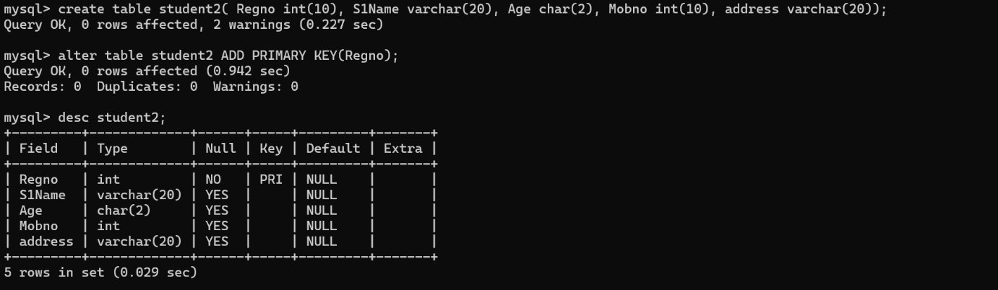
Output 2 – PRIMARY KEY and CHECK constraint added to FACULTY
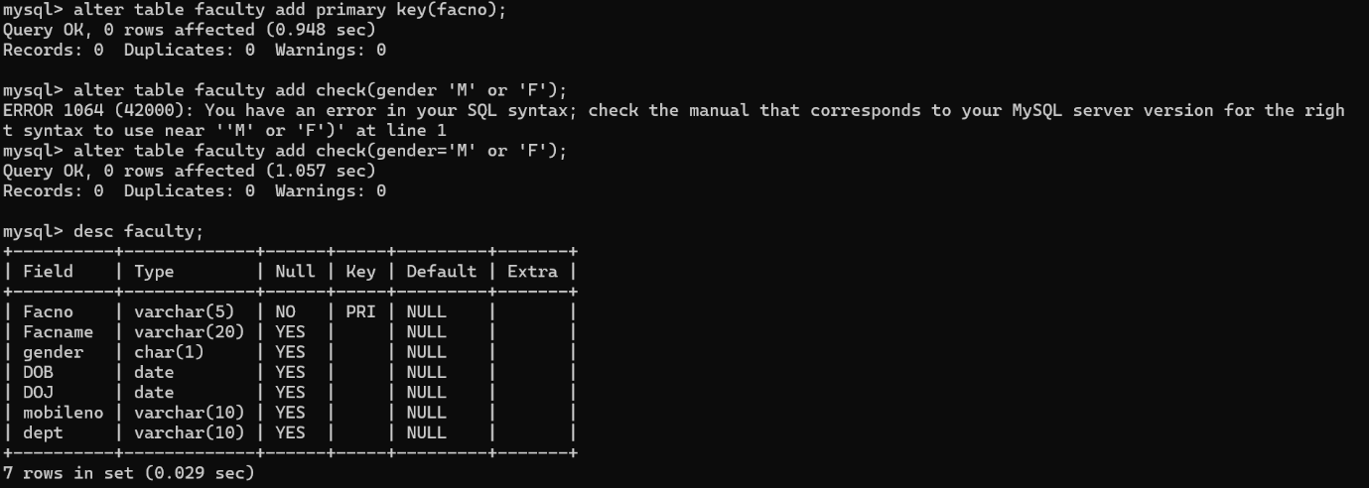
Output 3 – PRIMARY KEY added to DEPARTMENT
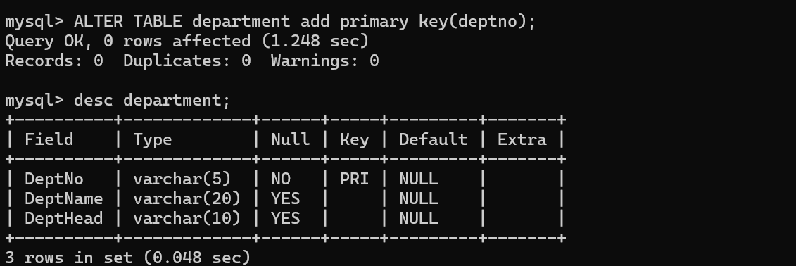
Output 4 – PRIMARY KEY and semester constraint added to COURSE
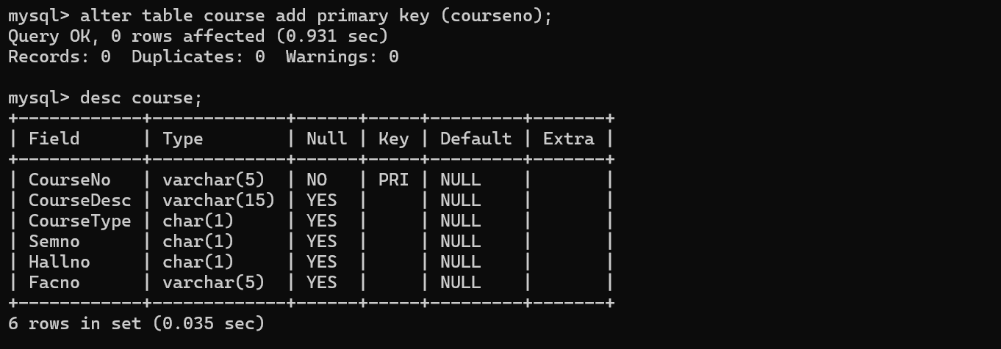
Output 5 – UNIQUE KEY added to STUDENT2
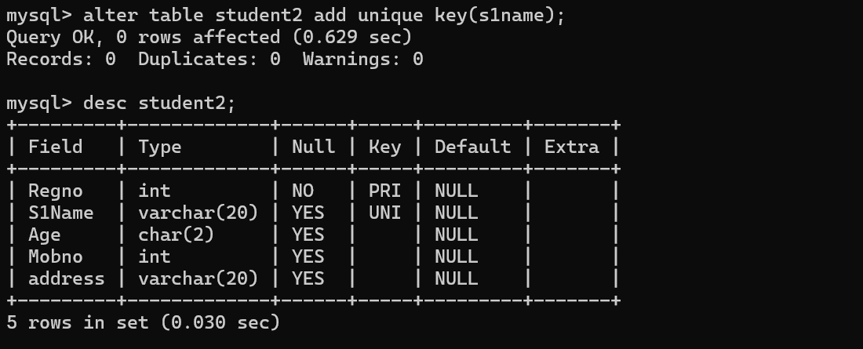
Output 6 – Foreign-key test / subsequent modification of STUDENT1
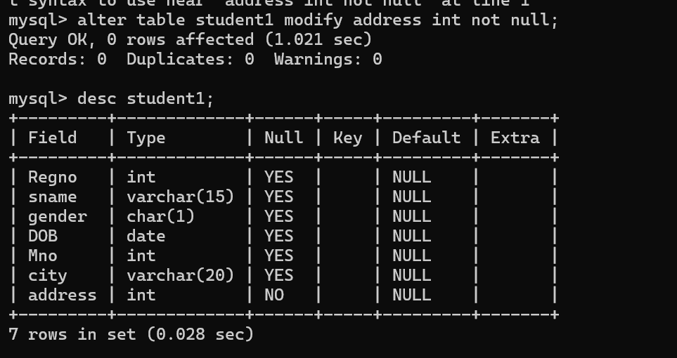
RESULT
DDL commands with PRIMARY KEY, FOREIGN KEY, UNIQUE and CHECK constraints were updated and verified.

