DBMS LAB RECORD
EXPERIMENT – 3
DML Commands – INSERT, SELECT
AIM
To perform Data Manipulation Language (DML) Commands such as INSERT, SELECT in the table.
ALGORITHM
- Start MySQL and select the required database.
- Insert records into all five tables using the INSERT command.
- Use the SELECT command to retrieve the records from each table.
- Verify that the inserted records are displayed correctly.
- Stop the execution.
QUERY / PROGRAM
-- 1. Populate the five tables
INSERT INTO student1
VALUES
(1,'Raj','M','2004-03-02',1234567890,'Chennai'),
(2,'Shru','F','2005-04-03',987654321,'Chennai'),
(3,'Sam','M','2006-05-04',246813579,'Chennai');
INSERT INTO faculty
VALUES
(123,'YAHOO','M','2001-02-03','2005-06-07',12345678,'CS','N'),
(135,'FireFox','M','2004-05-06','2008-09-10',192837465,'EEE','Y'),
(456,'GOOGLE','F','2002-03-04','2006-07-08',12345678,'ECE','N'),
(789,'BING','F','2003-04-05','2007-08-09',987654321,'CSBS','N');
INSERT INTO department
VALUES
(1,'CS','123'),
(2,'ECE','456'),
(3,'EEE','135');
INSERT INTO course
VALUES
('C001','Computer Science 101','L','1','H001','123'),
('C002','Mathematics 101','L','2','H002','456'),
('C003','Physics 101','L','1','H003','789');
INSERT INTO studentscores
VALUES
(1,'C001',75),
(2,'C002',80),
(3,'C003',65);
-- 2. View all records from the five tables
SELECT * FROM student1;
SELECT * FROM faculty;
SELECT * FROM department;
SELECT * FROM course;
SELECT * FROM studentscores;
OUTPUT
Output – INSERT and SELECT operation on STUDENT table
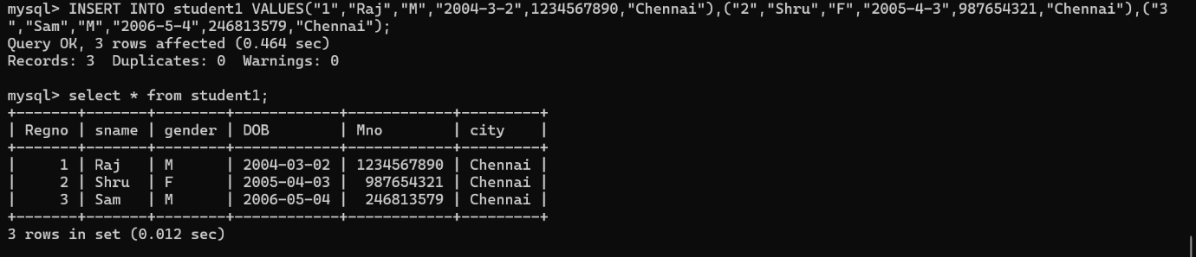
RESULT
Data Manipulation Language (DML) commands such as INSERT and SELECT are performed in the five tables.

