DBMS LAB RECORD
EXPERIMENT – 4
DML Commands with Constraints – UPDATE, DELETE
AIM
To perform Data Manipulation Language (DML) Commands such as UPDATE, DELETE in the table.
ALGORITHM
- Start MySQL and select the required database.
- Update the required student record using the UPDATE command.
- Delete the faculty record whose resigned status is 'y'.
- Modify the age of the faculty member named 'mohan' to 59.
- Delete all faculty records having age 65 or above.
- Use SELECT statements to verify each operation.
QUERY / PROGRAM
-- 1. Update the student name
UPDATE student SET sname='Ram' WHERE Regno=1;
SELECT * FROM student;
-- 2. Delete the faculty member who resigned
DELETE FROM faculty WHERE resigned='y';
SELECT * FROM faculty;
-- 3. Modify the age of faculty member 'mohan'
UPDATE faculty SET age=59 WHERE facname='mohan';
SELECT * FROM faculty;
-- 4. Remove faculty members having age 65 or above
DELETE FROM faculty WHERE age>=65;
SELECT * FROM faculty;
OUTPUT
Output 1 – Updating the student name
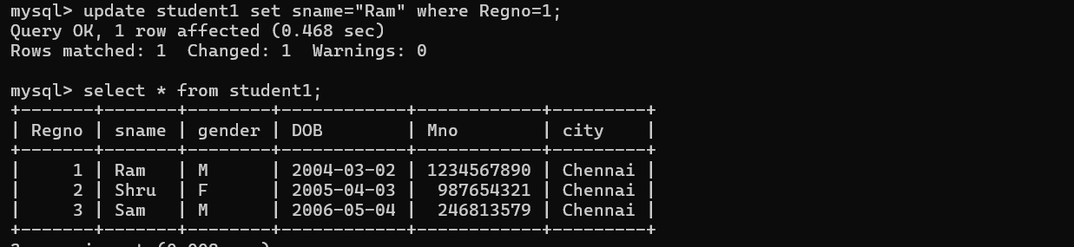
Output 2 – Deleting the resigned faculty member
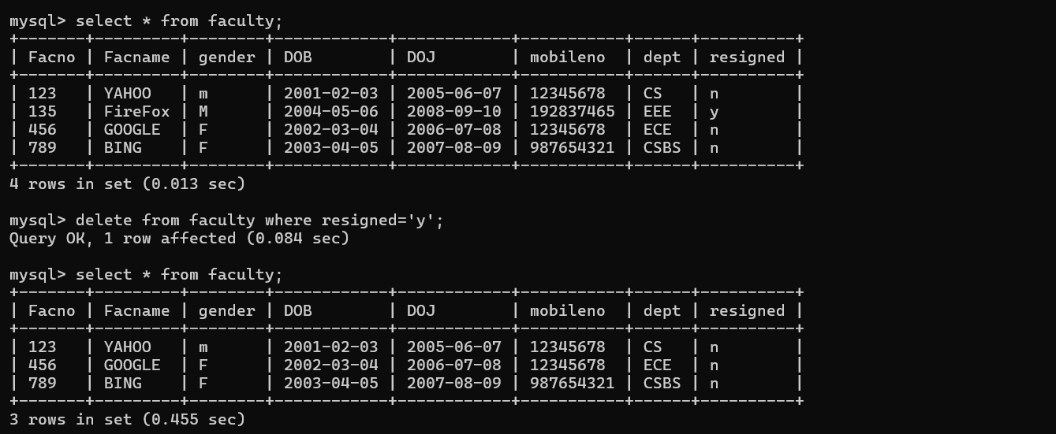
Output 3 – Updating and deleting faculty records based on age
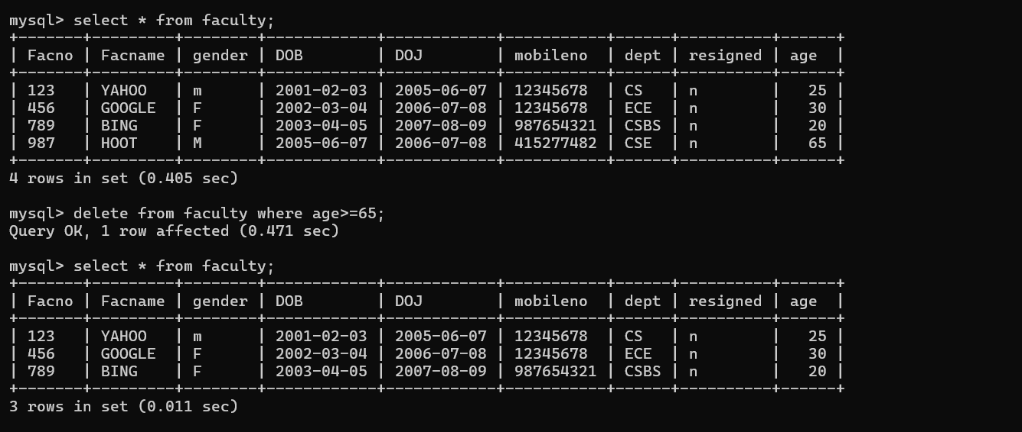
RESULT
Data Manipulation Language (DML) commands such as UPDATE and DELETE are performed successfully.

