DBMS LAB RECORD
EXPERIMENT – 10
Database with VIEW and INDEX
AIM
To create view and index on the given relation.
ALGORITHM
- Create a view using the required employee columns.
- Query the view to verify its contents.
- Create an index on the required employee attribute.
- Display the index information and verify the operation.
- Drop the index after use.
QUERY / PROGRAM
-- VIEW
CREATE VIEW v1 AS
SELECT employee_id, salary
FROM employees1;
SELECT * FROM v1;
INSERT INTO v1 VALUES (14,110000);
DELETE FROM v1 WHERE employee_id=14;
-- INDEX 1: salary
CREATE INDEX index1 ON employees1(salary);
SELECT firstname FROM employees1 WHERE salary>145000;
DROP INDEX index1 ON employees1;
-- INDEX 2: employee_id
CREATE INDEX index1 ON employees1(employee_id);
SELECT firstname FROM employees1 WHERE employee_id=10;
DROP INDEX index1 ON employees1;
OUTPUT
1) View output
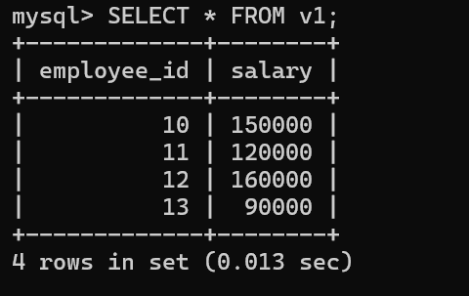
2) Index information
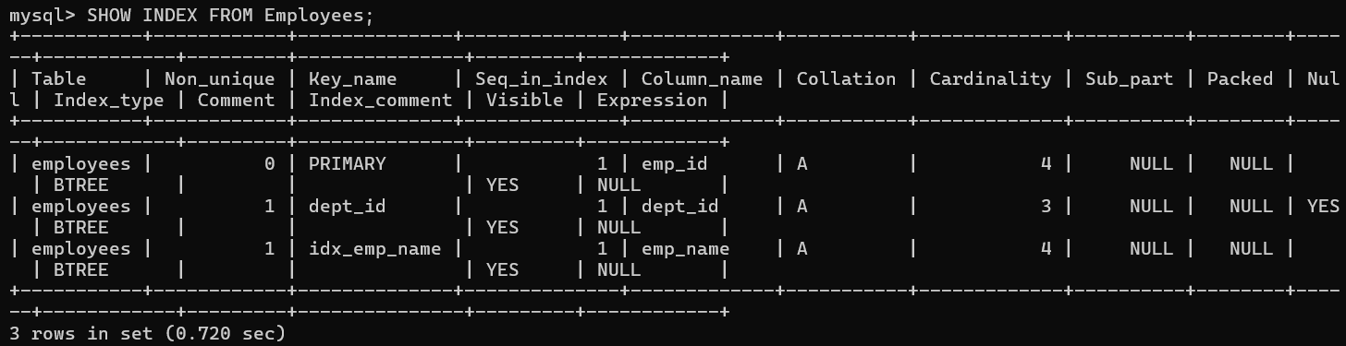
3) Index operation
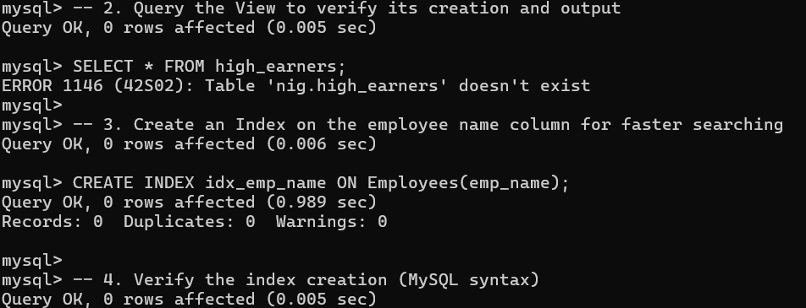
RESULT
The records from the tables are displayed using view and index on the given relation.

