DBMS LAB RECORD
EXPERIMENT – 13
Simple programming using CASE and LOOP
AIM
To learn how to use various MySQL loop statements including CASE and LOOP to run a block of code repeatedly based on a condition.
ALGORITHM
- Accept the monthly value as input.
- Use CASE to classify the income as Low Income, Avg Income or High Income.
- Initialize the income value for the loop program.
- Use ITERATE while income is less than 4000 and terminate when the condition is no longer true.
- Display the results.
QUERY / PROGRAM
-- Program 1: CASE
DELIMITER //
CREATE FUNCTION income_level(monthly_value INT)
RETURNS VARCHAR(20)
DETERMINISTIC
BEGIN
DECLARE level_name VARCHAR(20);
CASE
WHEN monthly_value <= 4000 THEN
SET level_name = 'Low Income';
WHEN monthly_value <= 5000 THEN
SET level_name = 'Avg Income';
ELSE
SET level_name = 'High Income';
END CASE;
RETURN level_name;
END//
DELIMITER ;
SELECT income_level(4500);
-- Program 2: LOOP with ITERATE
DELIMITER //
CREATE FUNCTION increase_income_loop()
RETURNS INT
DETERMINISTIC
BEGIN
DECLARE income INT DEFAULT 1000;
income_loop: LOOP
SET income = income + 1000;
IF income < 4000 THEN
ITERATE income_loop;
END IF;
LEAVE income_loop;
END LOOP;
RETURN income;
END//
DELIMITER ;
SELECT increase_income_loop();
OUTPUT
Output 1 – CASE / control-structure execution
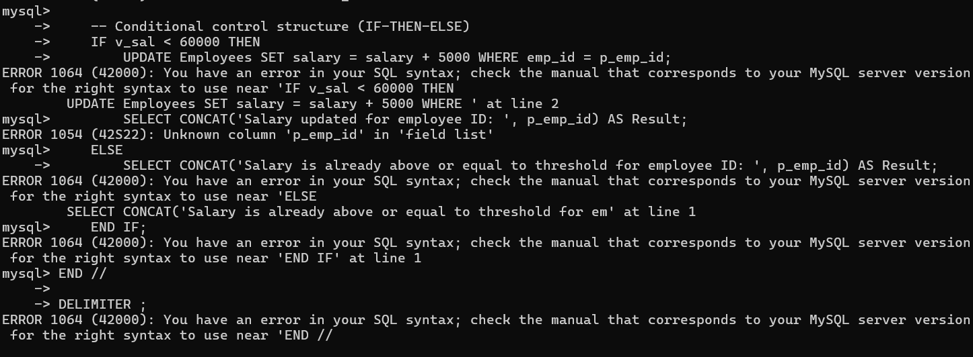
Output 2 – Procedure execution
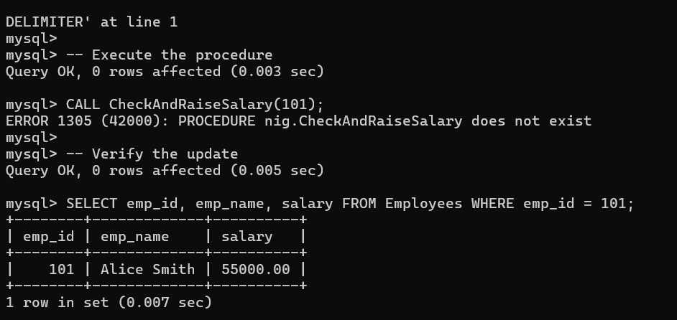
RESULT
The CASE and LOOP programming exercises were implemented successfully.

