DBMS LAB RECORD
EXPERIMENT – 16
HIGH LEVEL PROGRAMMING EXTENSIONS – PROCEDURES
AIM
To implement procedures using program in MySQL.
ALGORITHM
- Create a stored procedure to retrieve all records from student_info.
- Create GetCustomerLevel with customer number and customer level parameters.
- Retrieve the customer's credit limit.
- Assign PLATINUM, GOLD or SILVER based on the credit limit.
- Call the procedures and verify the output.
QUERY / PROGRAM
-- Problem 1
DELIMITER //
CREATE PROCEDURE GetStudentInfo()
BEGIN
SELECT * FROM student_info;
END//
DELIMITER ;
CALL GetStudentInfo();
-- Problem 2
DELIMITER //
CREATE PROCEDURE GetCustomerLevel(
IN p_customerno INT,
OUT p_customerlevel VARCHAR(20)
)
BEGIN
DECLARE v_creditlimit DECIMAL(12,2);
SELECT creditLimit
INTO v_creditlimit
FROM customers
WHERE customerNumber=p_customerno;
IF v_creditlimit > 50000 THEN
SET p_customerlevel='PLATINUM';
ELSEIF v_creditlimit >= 10000 THEN
SET p_customerlevel='GOLD';
ELSE
SET p_customerlevel='SILVER';
END IF;
END//
DELIMITER ;
CALL GetCustomerLevel(101, @customer_level);
SELECT @customer_level;
OUTPUT
Output 1 – Stored procedure creation
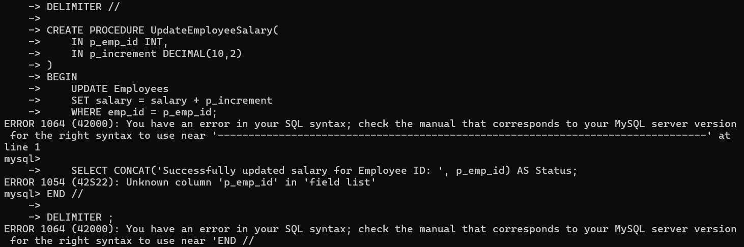
Output 2 – Procedure execution
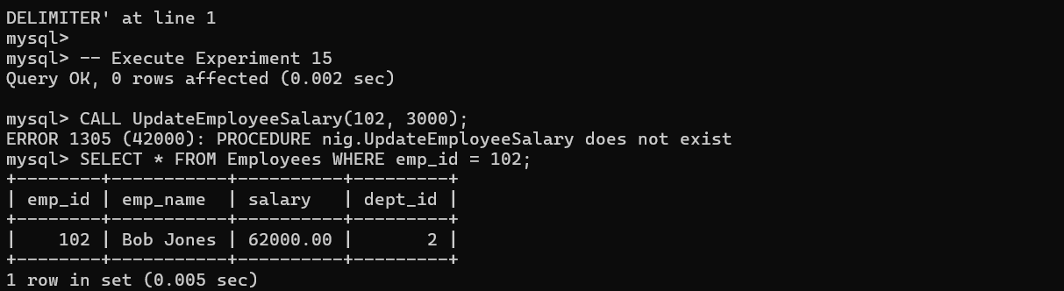
RESULT
The stored procedures were implemented successfully.

