DBMS LAB RECORD
EXPERIMENT – 17
HIGH LEVEL PROGRAMMING EXTENSIONS – FUNCTIONS
AIM
To implement Functions using program in MySQL.
ALGORITHM
- Create a function that accepts a customer's credit limit.
- Use IF conditions to return PLATINUM, GOLD or SILVER.
- Set the MySQL recursion depth for the recursive procedure.
- Create a recursive procedure to compute the factorial of a number.
- Call the function and procedure and verify the results.
QUERY / PROGRAM
-- Program 1: Customer level function
DELIMITER //
CREATE FUNCTION GetCustomerLevelByCredit(
credit_limit DECIMAL(12,2)
)
RETURNS VARCHAR(20)
DETERMINISTIC
BEGIN
IF credit_limit > 50000 THEN
RETURN 'PLATINUM';
ELSEIF credit_limit >= 10000 THEN
RETURN 'GOLD';
ELSE
RETURN 'SILVER';
END IF;
END//
DELIMITER ;
SELECT GetCustomerLevelByCredit(60000);
-- Program 2: Recursive factorial procedure
SET @@SESSION.max_sp_recursion_depth = 255;
DELIMITER //
CREATE PROCEDURE Factorial(
IN n INT,
OUT result BIGINT
)
BEGIN
IF n <= 1 THEN
SET result = 1;
ELSE
CALL Factorial(n-1, @temp);
SET result = n * @temp;
END IF;
END//
DELIMITER ;
CALL Factorial(5, @result);
SELECT @result;
OUTPUT
Output 1 – Stored function
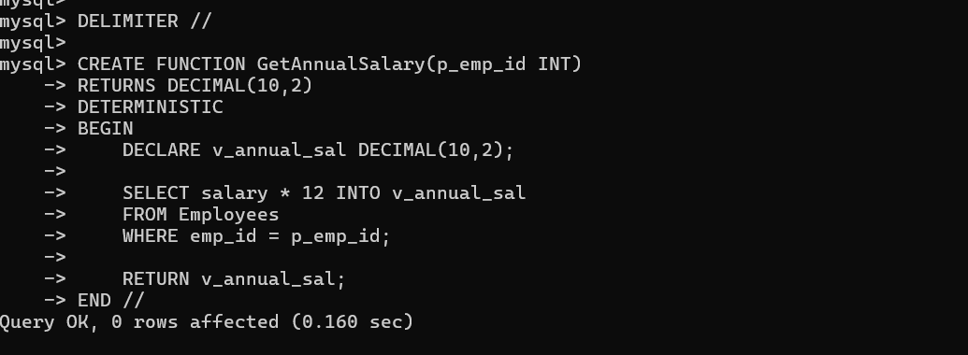
Output 2 – Function result
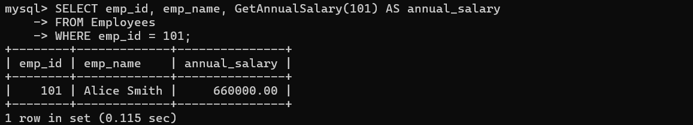
RESULT
The functions using program in MySQL were executed successfully.

