DBMS LAB RECORD
EXPERIMENT – 18
HIGH LEVEL LANGUAGE EXTENSION WITH CURSORS
AIM
To implement Cursors using program in MySQL.
ALGORITHM
- Create the employees table and insert employee email records.
- Declare an explicit cursor for the employee email column.
- Open the cursor and fetch each email one by one.
- Append each email to the email list until all rows are processed.
- Close the cursor and display the final email list.
QUERY / PROGRAM
CREATE TABLE employees(
id INTEGER,
Name VARCHAR(100),
email VARCHAR(100)
);
INSERT INTO employees VALUES
(1,'Harry Potter','pharry@warnerbros.com'),
(2,'Clark Kent','kclark@dccomics.com'),
(3,'Tony Stark','stony@marvel.com');
DELIMITER $$
CREATE PROCEDURE build_email_list(
INOUT email_list VARCHAR(4000)
)
BEGIN
DECLARE v_finished INTEGER DEFAULT 0;
DECLARE v_email VARCHAR(100) DEFAULT '';
DECLARE email_cursor CURSOR FOR
SELECT email FROM employees;
DECLARE CONTINUE HANDLER FOR NOT FOUND
SET v_finished = 1;
OPEN email_cursor;
get_email: LOOP
FETCH email_cursor INTO v_email;
IF v_finished = 1 THEN
LEAVE get_email;
END IF;
SET email_list = CONCAT(v_email, ';', email_list);
END LOOP get_email;
CLOSE email_cursor;
END$$
DELIMITER ;
SET @email_list='';
CALL build_email_list(@email_list);
SELECT @email_list;
OUTPUT
Output 1 – Cursor procedure call
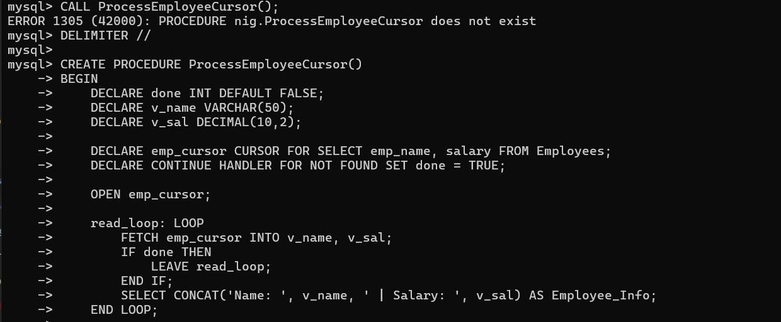
Output 2 – Successful cursor execution
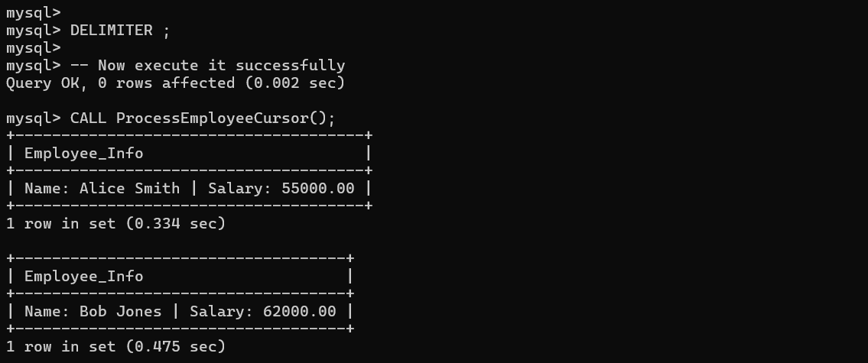
RESULT
Thus the Cursor program using MySQL is executed successfully.

