DBMS LAB RECORD
EXPERIMENT – 19
TRIGGER
AIM
To implement trigger in MySQL.
ALGORITHM
- Create the EMPLOYEES table and an EMPLOYEES_AUDIT table.
- Create a BEFORE UPDATE trigger on EMPLOYEES.
- Capture the old and new employee values in the audit table before an update.
- Update an employee record.
- Verify the audit record.
QUERY / PROGRAM
CREATE TABLE EMPLOYEES(
ID INT PRIMARY KEY,
Name VARCHAR(100),
Email VARCHAR(100),
Salary DECIMAL(10,2)
);
CREATE TABLE EMPLOYEES_AUDIT(
ID INT,
Old_Name VARCHAR(100),
Old_Email VARCHAR(100),
Old_Salary DECIMAL(10,2),
New_Name VARCHAR(100),
New_Email VARCHAR(100),
New_Salary DECIMAL(10,2)
);
DELIMITER //
CREATE TRIGGER before_employee_update
BEFORE UPDATE ON EMPLOYEES
FOR EACH ROW
BEGIN
INSERT INTO EMPLOYEES_AUDIT
VALUES(
OLD.ID, OLD.Name, OLD.Email, OLD.Salary,
NEW.Name, NEW.Email, NEW.Salary
);
END//
DELIMITER ;
UPDATE EMPLOYEES
SET Salary=50000
WHERE ID=1;
SELECT * FROM EMPLOYEES_AUDIT;
OUTPUT
Output – Trigger execution
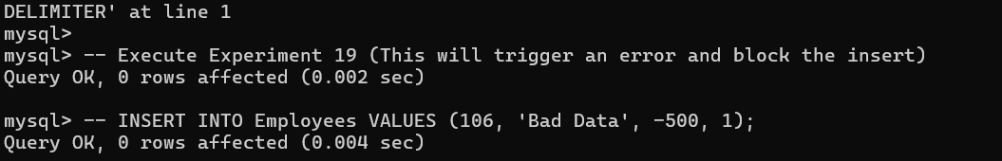
RESULT
Thus the trigger is executed successfully.

