DBMS LAB RECORD
EXPERIMENT – 6
SELECT with Various Clause – BETWEEN, IN, Aggregate Function
AIM
To view the records from the tables using SELECT commands with BETWEEN, IN, Aggregate functions.
ALGORITHM
- Start MySQL and select the required database.
- Use IN and BETWEEN operators to filter the required course and score records.
- Use aggregate functions such as AVG, MAX, MIN, SUM and COUNT on the register table.
- Use GROUP BY and JOIN where required to obtain results for each course or student.
- Execute the queries and verify the output.
QUERY / PROGRAM
-- IN & BETWEEN
-- 1. List the type of the specified courses
SELECT CourseType
FROM course
WHERE CourseDesc IN ('ComputerScience', 'Mathematics');
-- 2. Find CourseNos whose scores are between 50 and 80
SELECT CourseNo
FROM register
WHERE Mark BETWEEN 50 AND 80;
-- AGGREGATE
-- 3. Find the average mark of C002
SELECT AVG(Mark)
FROM register
WHERE CourseNo='C002';
-- 4. Find maximum and minimum mark for C002
SELECT MAX(Mark), MIN(Mark)
FROM register
WHERE CourseNo='C002';
-- 5. Find maximum, minimum and average mark for each course
SELECT CourseNo, MAX(Mark), MIN(Mark), AVG(Mark)
FROM register
GROUP BY CourseNo;
-- 6. Display course names and average mark
SELECT c.CourseDesc, AVG(r.Mark)
FROM course c
JOIN register r ON c.CourseNo=r.CourseNo
GROUP BY c.CourseNo, c.CourseDesc;
-- 7. Calculate the sum of all scores
SELECT SUM(Mark)
FROM register;
-- 8. Count students registered for each course
SELECT CourseNo, COUNT(StudentNo)
FROM register
GROUP BY CourseNo;
-- 9. Display course description and number of registered students
SELECT c.CourseDesc, COUNT(r.StudentNo)
FROM course c
JOIN register r ON c.CourseNo=r.CourseNo
GROUP BY c.CourseNo, c.CourseDesc;
-- 10. Count courses registered by each student
SELECT StudentNo, COUNT(CourseNo)
FROM register
GROUP BY StudentNo;
OUTPUT
1) Course type using IN
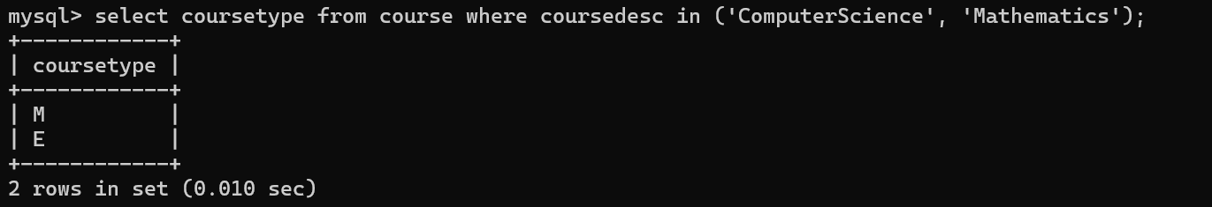
2) Course numbers with marks between 50 and 80
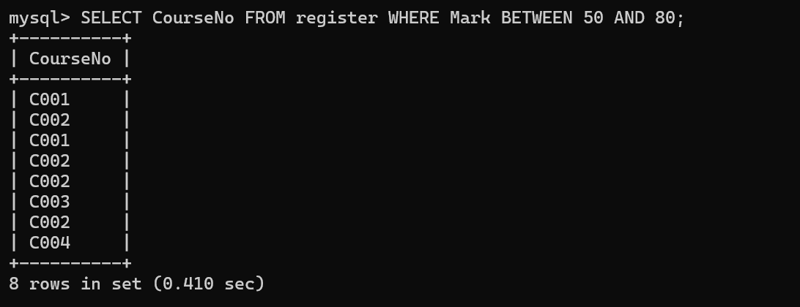
3) Average mark of C002
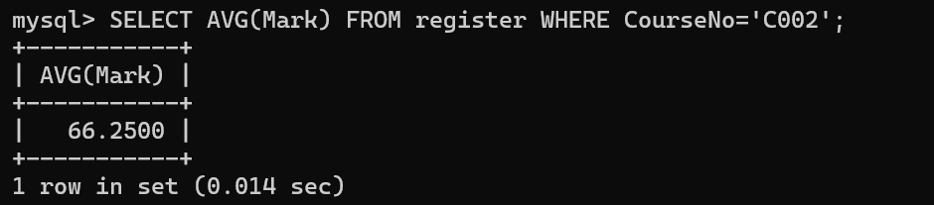
4) Maximum and minimum mark of C002
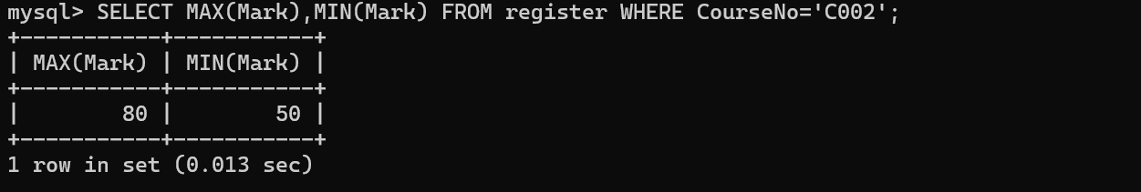
5) Maximum, minimum and average mark for each course
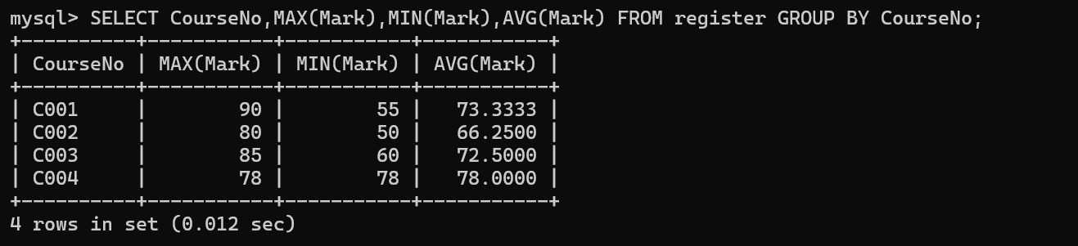
6) Course description and average mark
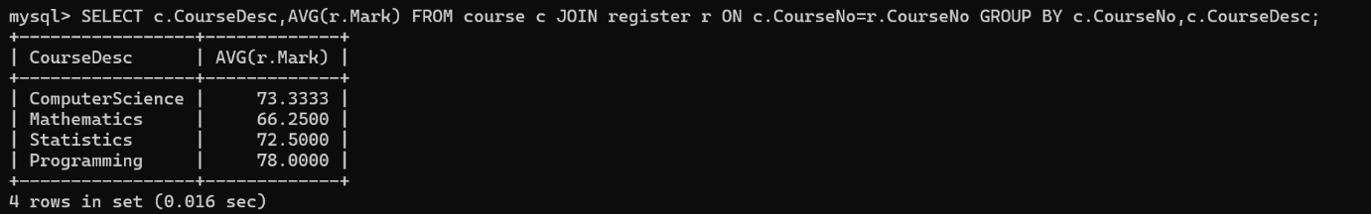
7) Sum of all scores
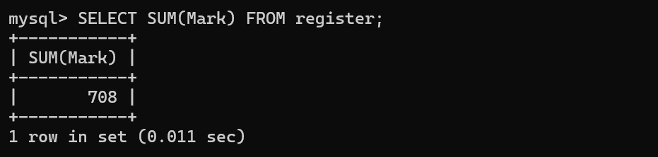
8) Number of students registered for each course
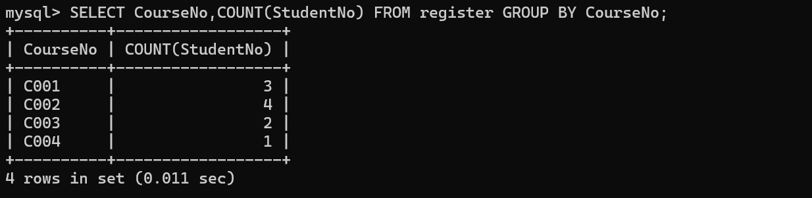
9) Course description and number of registered students
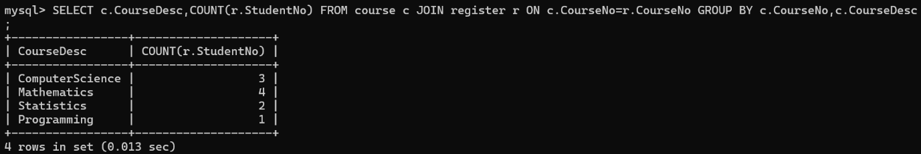
10) Number of courses registered by each student
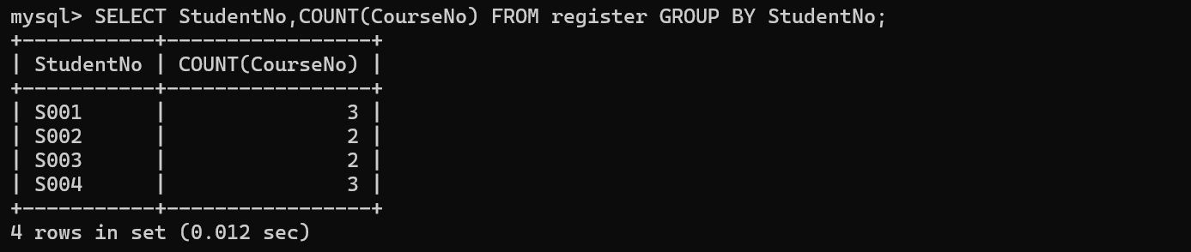
RESULT
The records were successfully retrieved using BETWEEN, IN and aggregate functions.

