DBMS LAB RECORD
EXPERIMENT – 7
SELECT with Various Clause – GROUP BY, HAVING, ORDER BY
AIM
To view the records from the tables using SELECT commands with Group By, Having, Order By.
ALGORITHM
- Start MySQL and select the required database.
- Use GROUP BY with COUNT to obtain grouped records.
- Use HAVING where required to filter groups.
- Use ORDER BY to sort the required records.
- Execute and verify the results.
QUERY / PROGRAM
-- GROUP BY / HAVING
SELECT c.CourseDesc, COUNT(r.StudentNo)
FROM course c JOIN register r ON c.CourseNo=r.CourseNo
GROUP BY c.CourseNo, c.CourseDesc;
SELECT StudentNo, COUNT(CourseNo)
FROM register
GROUP BY StudentNo;
-- ORDER BY
SELECT StudentName, StudentNo
FROM student
ORDER BY StudentNo ASC;
SELECT *
FROM faculty
ORDER BY DOJ ASC;
OUTPUT
1) Students registered for each course
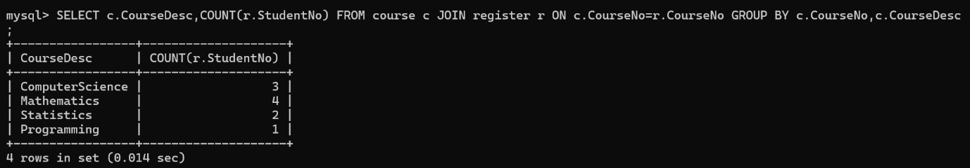
2) Courses registered by each student
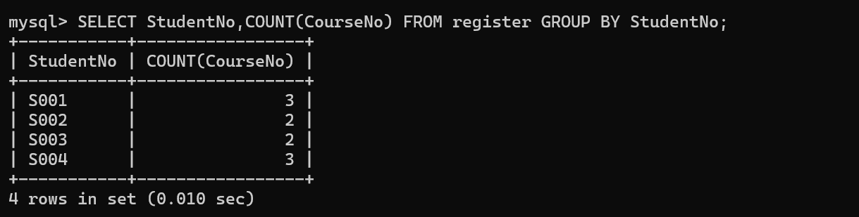
3) Students in ascending order of Reg No.
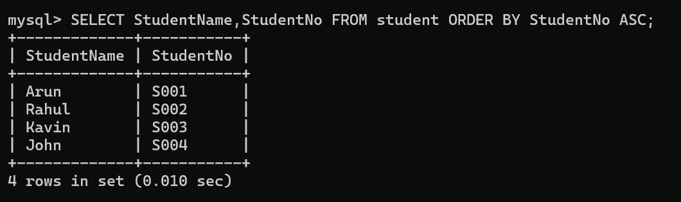
4) Faculty in order of older faculty first
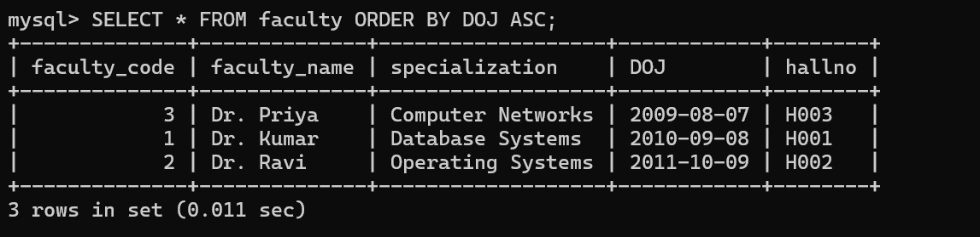
RESULT
The records from the tables are displayed using SELECT commands with GROUP BY, HAVING and ORDER BY.

