DBMS LAB RECORD
EXPERIMENT – 8
Query with Sub Query & Correlated Query
AIM
To perform subquery and correlated query on the given relations.
ALGORITHM
- Start MySQL and select the required database.
- Use a subquery to compare values with an aggregate result.
- Use GROUP BY and HAVING to identify students with more than one assessment.
- Use ORDER BY/LIMIT to find the most recently joined faculty.
- Use a correlated subquery to compare each course score with its course average.
QUERY / PROGRAM
-- 1. Scores greater than overall average
SELECT StudentNo, CourseNo, Mark
FROM register
WHERE Mark > (SELECT AVG(Mark) FROM register);
-- 2. Students with more than one assessment
SELECT s.StudentName, COUNT(r.CourseNo)
FROM student s JOIN register r ON s.StudentNo=r.StudentNo
GROUP BY s.StudentNo, s.StudentName
HAVING COUNT(r.CourseNo)>1;
-- 3. Faculty who joined most recently
SELECT faculty_name, DOJ
FROM faculty
ORDER BY DOJ DESC LIMIT 1;
-- 4. Scores greater than the average of their own course
SELECT CourseNo, Mark
FROM register r
WHERE Mark > (
SELECT AVG(Mark)
FROM register r2
WHERE r2.CourseNo=r.CourseNo
);
OUTPUT
1) Score greater than average score
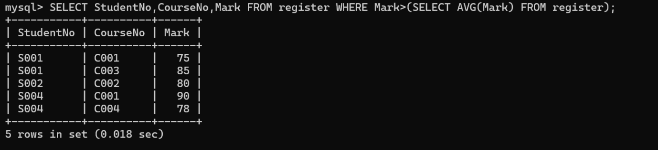
2) Students with more than one assessment
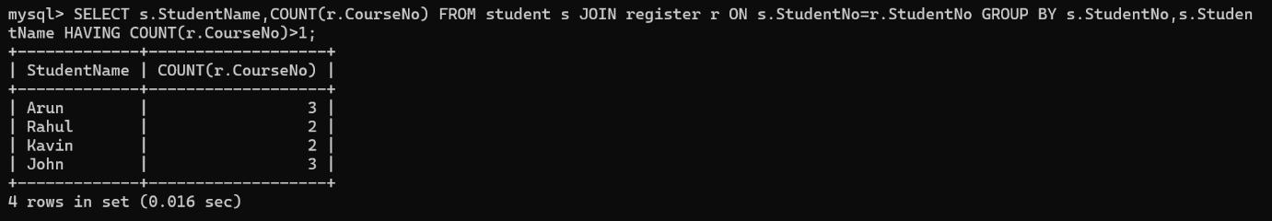
3) Faculty who joined recently
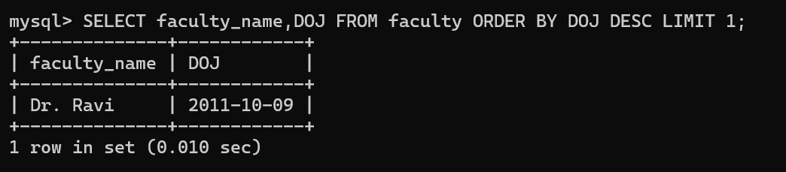
4) Course and score above course average
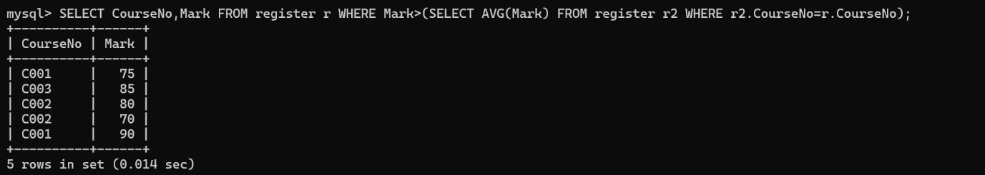
RESULT
The records from the tables are displayed using Sub-Query and Correlated Sub-Query.

