DBMS LAB RECORD
EXPERIMENT – 9
Query with Joins – EquiJoin, InnerJoin, OuterJoin
AIM
To perform JOIN using Equi Join, Inner Join, Outer Join on the given relation.
ALGORITHM
- Start MySQL and select the required database.
- Join FACULTY and DEPARTMENT using the common department number.
- Use an OUTER JOIN to find students with no registered course score.
- Join COURSE, FACULTY and DEPARTMENT to retrieve the required course details.
- Verify the outputs.
QUERY / PROGRAM
-- 1. Departments where faculty members are working
SELECT faculty.faculty_code, faculty.faculty_name,
department.DeptNo, department.DeptName
FROM faculty, department
WHERE faculty.deptno=department.DeptNo;
-- 2. Students with no course score
SELECT student.StudentName, register.CourseNo
FROM student
LEFT OUTER JOIN register
ON student.StudentNo=register.StudentNo
WHERE register.CourseNo IS NULL;
-- 3. Courses taken by the specified faculty
SELECT course.CourseNo, course.CourseDesc
FROM course, faculty, department
WHERE course.Hallno=faculty.hallno
AND faculty.deptno=department.DeptNo
AND department.DeptName='Sales'
AND faculty.faculty_name='Ratnam';
OUTPUT
1) Departments where faculty members work
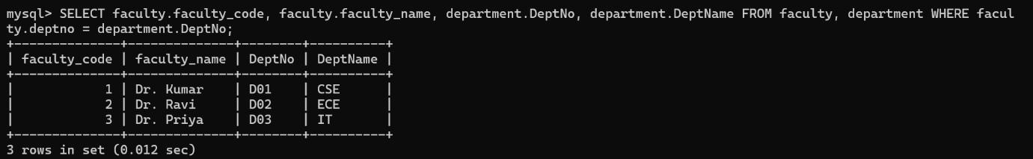
2) Student with no score
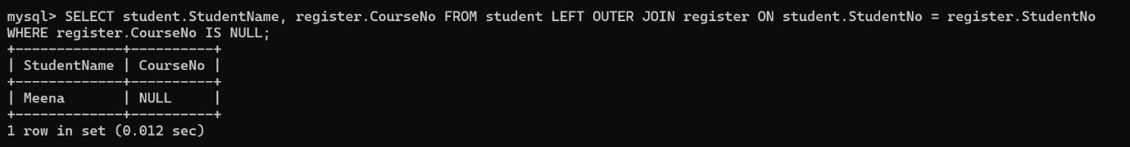
3) Courses taken by the specified faculty
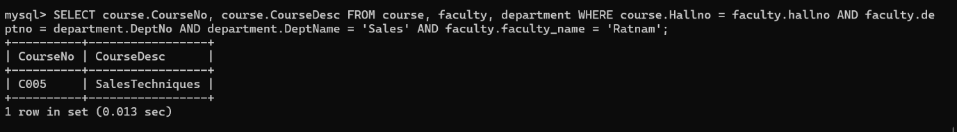
RESULT
The records from the tables are displayed using JOIN using EquiJoin, InnerJoin, OuterJoin.

