DBMS LAB RECORD
EXPERIMENT – 5
SELECT with Various Clause – WHERE, Pattern Matching
AIM
To view the records from the tables using SELECT commands with WHERE Clause and Pattern matching.
ALGORITHM
- Start MySQL and select the required database.
- Use SELECT statements with the WHERE clause to filter records according to the given conditions.
- Use the LIKE operator with % and _ wildcards for pattern matching.
- Execute each query and observe the returned records.
- Stop the execution.
QUERY / PROGRAM
-- WHERE
-- 1. Display registration number, student name and date of birth
SELECT reg_no, sname, DOB
FROM student;
-- 2. Display all female students
SELECT *
FROM student
WHERE gender='F';
-- 3. List students registered for C001
SELECT *
FROM student
WHERE courseno='C001';
-- 4. Display faculty who joined before November 2014
SELECT *
FROM faculty
WHERE DOJ<'2014-11-1';
-- 5. Display courses not allotted to H001
SELECT *
FROM course
WHERE hallno!='H001';
-- LIKE / Pattern Matching
-- 6. Students whose name ends with 'sh'
SELECT *
FROM student
WHERE sname LIKE '%sh';
-- 7. Students whose name contains 'sh'
SELECT *
FROM student
WHERE sname LIKE '%sh%';
-- 8. Students in cities containing 'Sal'
SELECT *
FROM student
WHERE location LIKE '%SAL%';
-- 9. Students whose names do not contain six letters
SELECT *
FROM student
WHERE sname NOT LIKE '______';
-- 10. Students whose names contain 'am'
SELECT *
FROM student
WHERE sname LIKE '%am%';
OUTPUT
1) Registration number, student name and date of birth
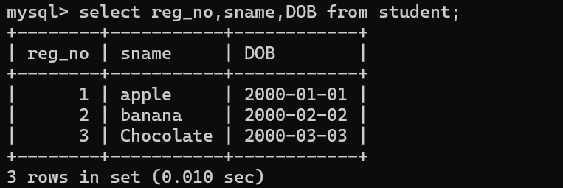
2) Female students
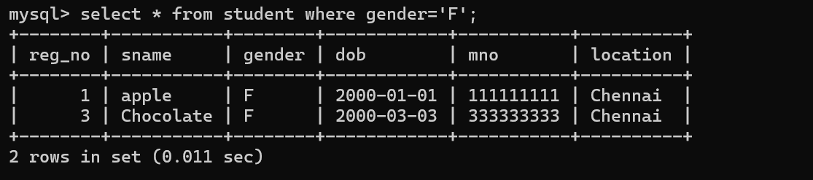
3) Students registered for C001
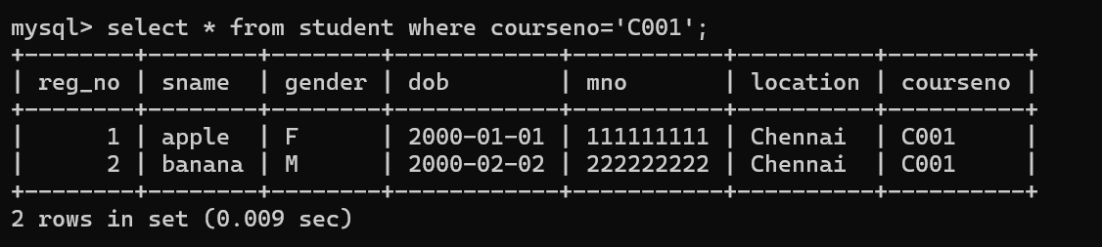
4) Faculty joined before November 2014
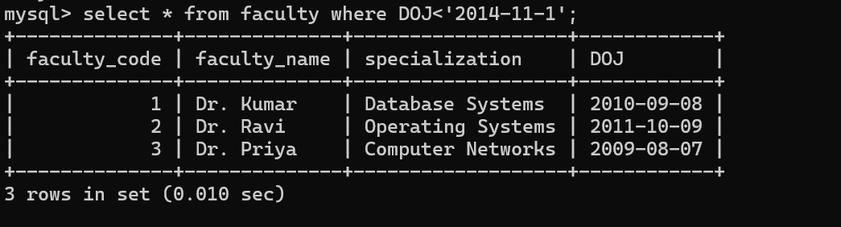
5) Courses not allotted to H001
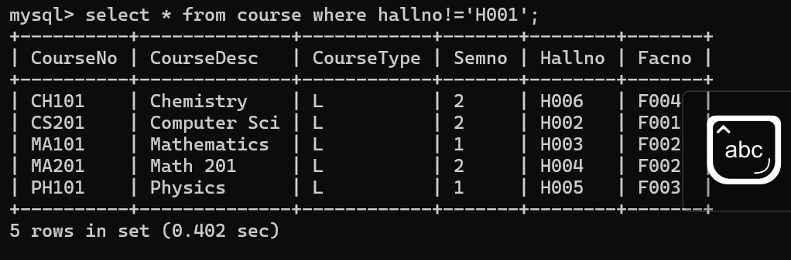
6) Names ending with 'sh'
7) Names containing 'sh'
8) Cities containing 'Sal'
9) Names not containing six letters
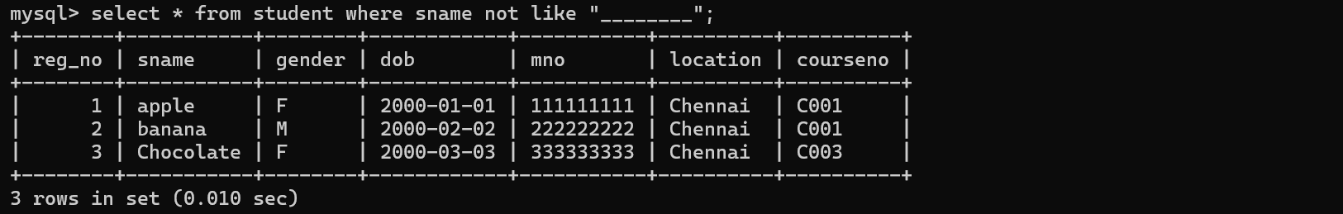
10) Names containing 'am'
RESULT
The records from the tables are displayed using SELECT commands with WHERE Clause and Pattern matching.

