EXPERIMENT NO. 9
ARDUINO BASED MANUAL ELECTRONIC COUNTER USING PROTEUS
AIM:
To write an Embedded C program for Manual Electronic counter using Arduino IDE and Proteus.
SOFTWARE REQUIRED:
- Proteus 8 Professional
- Arduino IDE
ALGORITHM:
1. Configure the push button as INPUT_PULLUP and the segment pins as outputs.
2. Read the push button state.
3. On each button press, move to the next digit state.
4. Display digits 0 to 9 using the corresponding segment patterns.
5. After 9, return to 0 and continue.
PROGRAM:
int x0,x1,x2,x3,x4,x5,x6,x7,x8,x9;
int delay_time=200;
void setup() {
pinMode(12, INPUT_PULLUP);
pinMode(1, OUTPUT); pinMode(2, OUTPUT);
pinMode(3, OUTPUT); pinMode(4, OUTPUT);
pinMode(5, OUTPUT); pinMode(6, OUTPUT);
pinMode(7, OUTPUT);
}
void loop() {
int sensorVal = digitalRead(12);
if (sensorVal == LOW) {
x0=true;
while(x0){
zero(); sensorVal=digitalRead(12);
if(sensorVal==LOW){ x1=true; x0=false; }
}
while(x1){
one(); sensorVal=digitalRead(12);
if(sensorVal==LOW){ x2=true; x1=false; }
}
while(x2){
two(); sensorVal=digitalRead(12);
if(sensorVal==LOW){ x3=true; x2=false; }
}
while(x3){
three(); sensorVal=digitalRead(12);
if(sensorVal==LOW){ x4=true; x3=false; }
}
while(x4){
four(); sensorVal=digitalRead(12);
if(sensorVal==LOW){ x5=true; x4=false; }
}
while(x5){
five(); sensorVal=digitalRead(12);
if(sensorVal==LOW){ x6=true; x5=false; }
}
while(x6){
six(); sensorVal=digitalRead(12);
if(sensorVal==LOW){ x7=true; x6=false; }
}
while(x7){
seven(); sensorVal=digitalRead(12);
if(sensorVal==LOW){ x8=true; x7=false; }
}
while(x8){
eight(); sensorVal=digitalRead(12);
if(sensorVal==LOW){ x9=true; x8=false; }
}
while(x9){
nine(); sensorVal=digitalRead(12);
if(sensorVal==LOW){ x0=true; x9=false; }
}
}
}
void zero(){
for(int i=1;i<7;i++) digitalWrite(i,HIGH);
digitalWrite(7,LOW); delay(delay_time);
}
void one(){
digitalWrite(1,LOW); digitalWrite(2,HIGH); digitalWrite(3,HIGH);
digitalWrite(4,LOW); digitalWrite(5,LOW); digitalWrite(6,LOW);
digitalWrite(7,LOW); delay(delay_time);
}
void two(){
digitalWrite(1,HIGH); digitalWrite(2,HIGH); digitalWrite(3,LOW);
digitalWrite(4,HIGH); digitalWrite(5,HIGH); digitalWrite(6,LOW);
digitalWrite(7,HIGH); delay(delay_time);
}
void three(){
digitalWrite(1,HIGH); digitalWrite(2,HIGH); digitalWrite(3,HIGH);
digitalWrite(4,HIGH); digitalWrite(5,LOW); digitalWrite(6,LOW);
digitalWrite(7,HIGH); delay(delay_time);
}
void four(){
digitalWrite(1,LOW); digitalWrite(2,HIGH); digitalWrite(3,HIGH);
digitalWrite(4,LOW); digitalWrite(5,LOW); digitalWrite(6,HIGH);
digitalWrite(7,HIGH); delay(delay_time);
}
void five(){
digitalWrite(1,HIGH); digitalWrite(2,LOW); digitalWrite(3,HIGH);
digitalWrite(4,HIGH); digitalWrite(5,LOW); digitalWrite(6,HIGH);
digitalWrite(7,HIGH); delay(delay_time);
}
void six(){
digitalWrite(1,HIGH); digitalWrite(2,LOW); digitalWrite(3,HIGH);
digitalWrite(4,HIGH); digitalWrite(5,HIGH); digitalWrite(6,HIGH);
digitalWrite(7,HIGH); delay(delay_time);
}
void seven(){
digitalWrite(1,HIGH); digitalWrite(2,HIGH); digitalWrite(3,HIGH);
digitalWrite(4,LOW); digitalWrite(5,LOW); digitalWrite(6,LOW);
digitalWrite(7,LOW); delay(delay_time);
}
void eight(){
for(int i=1;i<=7;i++) digitalWrite(i,HIGH);
delay(delay_time);
}
void nine(){
digitalWrite(1,HIGH); digitalWrite(2,HIGH); digitalWrite(3,HIGH);
digitalWrite(4,HIGH); digitalWrite(5,LOW); digitalWrite(6,HIGH);
digitalWrite(7,HIGH); delay(delay_time);
}
OUTPUT:
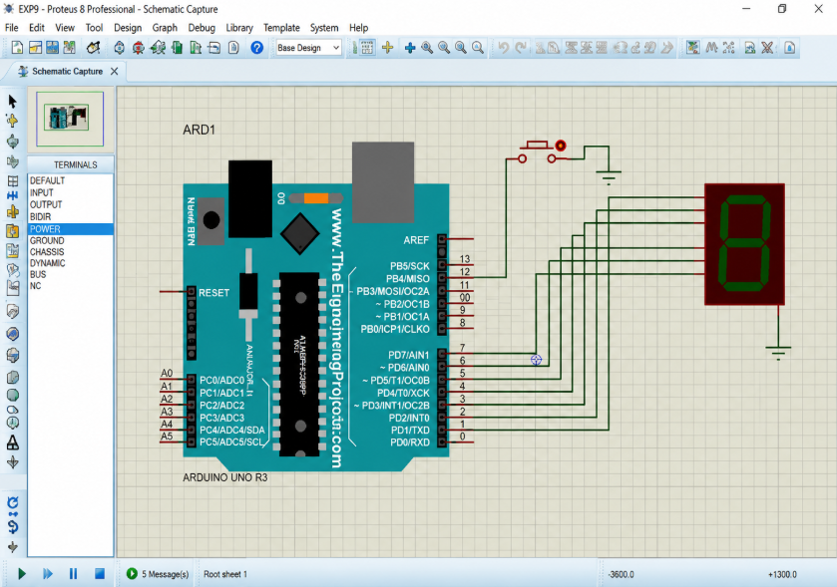
Output reference image supplied for this experiment.
OBSERVATION:
The seven-segment display changes to the next digit when the push button is pressed.
RESULT:
Thus, the Arduino based manual electronic counter was successfully implemented and verified in Proteus.

