**WEEK-6 :**

**1 (a) Write a program in assembly language to print single character on screen.**

ORG 100h

MOV DX, OFFSET msg_input

MOV AH, 09h

INT 21h

MOV AH, 01h

INT 21h

MOV BL, AL

MOV DX, OFFSET msg_output

MOV AH, 09h

INT 21h

MOV DL, BL

MOV AH, 02h

INT 21h

MOV AH, 4Ch

INT 21h

msg_input DB 'Enter a character: $'

msg_output DB 0Dh,0Ah, 'The entered character is:$'

END

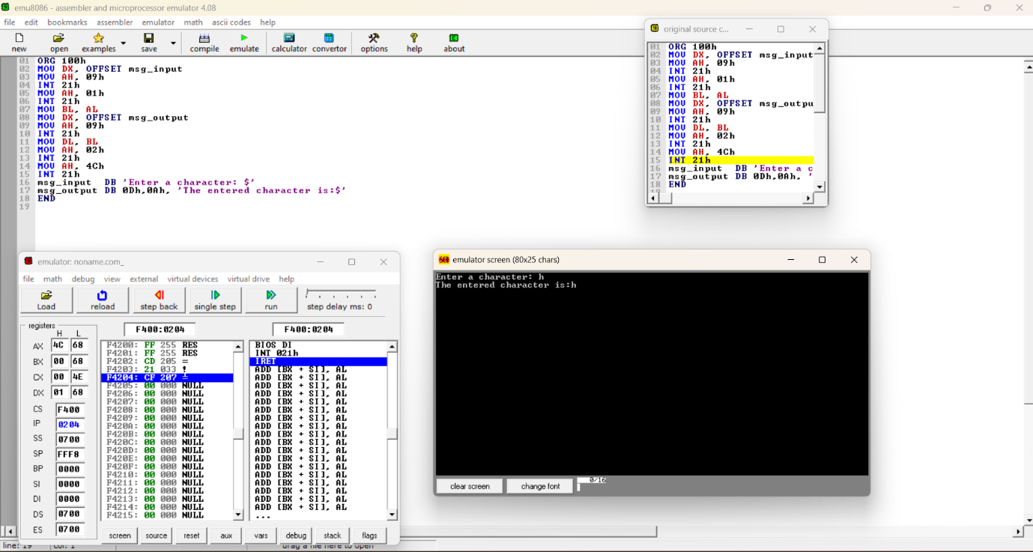

**1(b) Write an assembly language program to convert an upper-case letter to the corresponding lower-case letter.**

ORG 100h

MOV DX, OFFSET msg_input

MOV AH, 09h

INT 21h

MOV AH, 01h

INT 21h

MOV DL, AL

MOV BL,AL

CMP AL, 'A'

JL NotUpperCase

CMP AL, 'Z'

JG NotUpperCase

ADD BL, 20h

MOV DX, OFFSET msg_output

MOV AH, 09h

INT 21h

MOV DL, BL

MOV AH, 02h

INT 21h

JMP EndProgram

NotUpperCase:

MOV DX, OFFSET msg_error

MOV AH, 09h

INT 21h

EndProgram:

MOV AH, 4Ch

INT 21h

msg_input DB 'Enter an uppercase letter: $'

msg_output DB 0Dh, 0Ah, 'The lowercase letter is: $'

msg_error DB 0Dh, 0Ah, 'Error: Not an uppercase letter! $'

END

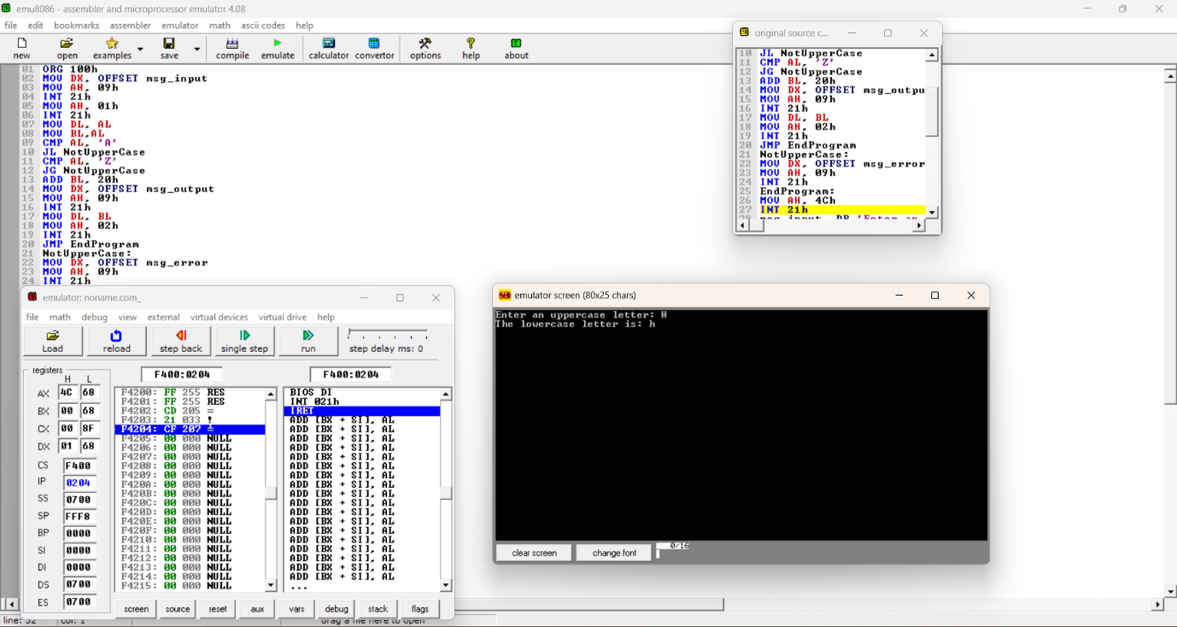

**2. (a) Write a program in assembly language to print multiple characters on screen.**

ORG 100h

MAXLEN EQU 50

MOV DX, OFFSET msg_input

MOV AH, 09h

INT 21h

LEA DI, buffer

ReadLoop:

MOV AH, 01h

INT 21h

CMP AL, 0Dh

JE PrintMessage

MOV [DI], AL

INC DI

CMP DI, OFFSET buffer + MAXLEN

JB ReadLoop

PrintMessage:

MOV BYTE PTR [DI], '$'

MOV DX, OFFSET msg_output

MOV AH, 09h

INT 21h

MOV DX, OFFSET buffer

MOV AH, 09h

INT 21h

EndProgram:

MOV AH, 4Ch

INT 21h

msg_input DB 'Enter your message: $'

msg_output DB 0Dh, 0Ah, 'You entered: $'

buffer DB MAXLEN DUP('$')

END

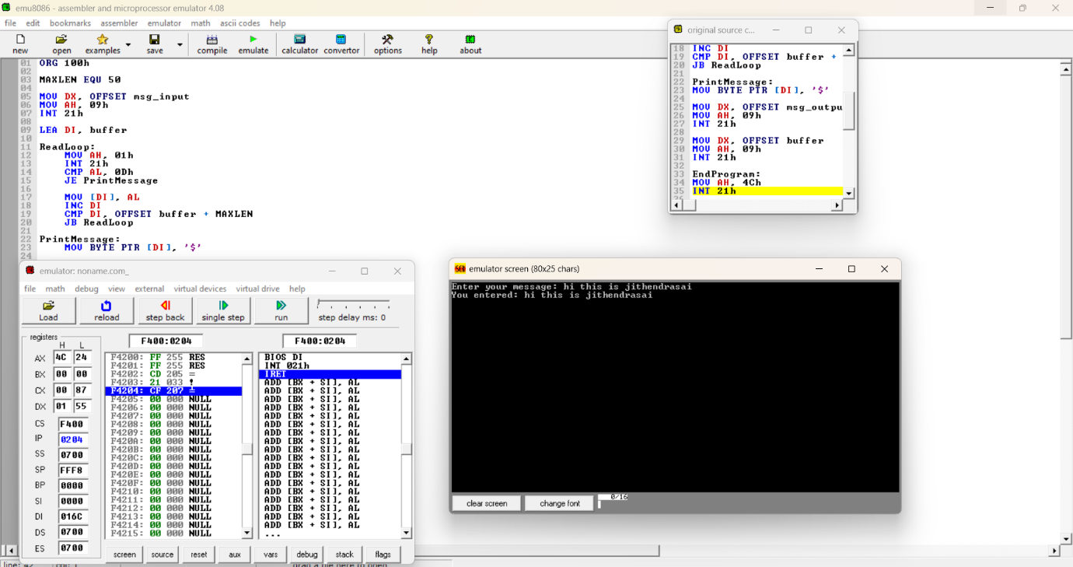

**2(b) Write an assembly language program to convert a lower-case letter to the corresponding upper-case letter.**

ORG 100h

MOV DX, OFFSET msg_input

MOV AH, 09h

INT 21h

MOV AH, 01h

INT 21h

MOV DL, AL

MOV BL,AL

CMP AL, 'a'

JL NotLowerCase

CMP AL, 'z'

JG NotLowerCase

SUB BL, 20h

MOV DX, OFFSET msg_output

MOV AH, 09h

INT 21h

MOV DL, BL

MOV AH, 02h

INT 21h

JMP EndProgram

NotLowerCase:

MOV DX, OFFSET msg_error

MOV AH, 09h

INT 21h

EndProgram:

MOV AH, 4Ch

INT 21h

msg_input DB 'Enter a lowercase letter: $'

msg_output DB 0Dh, 0Ah, 'The uppercase letter is: $'

msg_error DB 0Dh, 0Ah, 'Error: Not a lowercase letter! $'

END

