ORG 100h ; Origin, to spevify that the program starts at 100h (COM file format)

; Display message "Enter an uppercase letter: "

MOV DX, OFFSET msg_input ; Load the address of the message

MOV AH, 09h ; Function 09h of INT 21h is used to display a string

INT 21h ; Call DOS interrupt to print the message

; Read a single character from the user

MOV AH, 01h ; Function 01h of INT 21h is used to read a character

INT 21h ; Call DOS interrupt to get the character

MOV AL, AL ; Store the input character in AL

mov Bl,Al

; Check if the character is an uppercase letter (A-Z)

CMP AL, '0' ; Compare AL with 'A'

JL NotDigit ; If the input is less than 'A', it is not uppercase

CMP AL, '9' ; Compare AL with 'Z'

JG NotDigit ; If the input is greater than 'Z', it is not uppercase

; Convert the uppercase letter to lowercase

;ADD AL, 20h ; Add 32 (20h) to convert uppercase to lowercase

; Print the message "The lowercase letter is: "

MOV DX, OFFSET msg_output ; Load the address of the output message

MOV AH, 09h ; Function 09h of INT 21h is used to display a string

INT 21h ; Call DOS interrupt to print the output message

; Print the converted lowercase letter

MOV DL, BL ; Move the lowercase letter to DL

MOV AH, 02h ; Function 02h of INT 21h is used to print a single character

INT 21h ; Call DOS interrupt to print the character

JMP EndProgram ; Jump to the end of the program

NotDigit:

; If the input is not an uppercase letter, display an error message

MOV DX, OFFSET msg_error ; Load the address of the error message

MOV AH, 09h ; Function 09h of INT 21h is used to display a string

INT 21h ; Call DOS interrupt to print the error message

EndProgram:

; Terminate the program

MOV AH, 4Ch ; Function 4Ch of INT 21h terminates the program

INT 21h ; Call DOS interrupt to exit

msg_input DB 'Enter a digit: $'

msg_output DB 0Dh, 0Ah, 'The entered digit is: $' ; Output message

msg_error DB 0Dh, 0Ah, 'Error: Not a digit! $' ; Error message

END ; End of program  
  
  
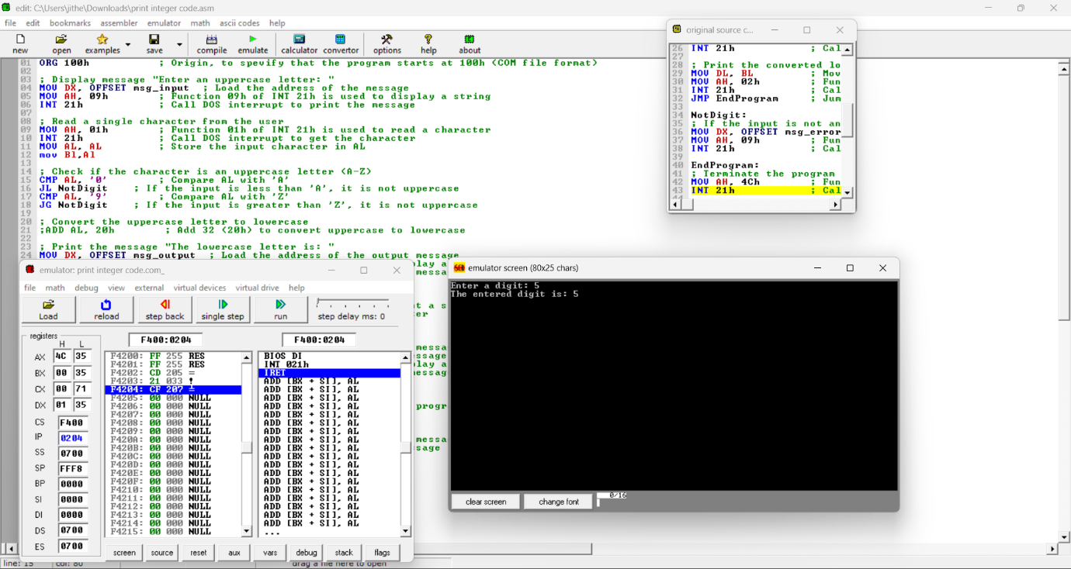

ORG 100h ; Origin, to specify that the program starts at 100h (COM file format)

; Display message "Enter the first digit: "

MOV DX, OFFSET msg_input1 ; Load the address of the first input message

MOV AH, 09h ; Function 09h of INT 21h is used to display a string

INT 21h ; Call DOS interrupt to print the message

; Read the first digit from the user

MOV AH, 01h ; Function 01h of INT 21h is used to read a character

INT 21h ; Call DOS interrupt to get the character

SUB AL, '0' ; Convert ASCII to integer by subtracting '0'

MOV BL, AL ; Store the first digit in BL

; Display message "Enter the second digit: "

MOV DX, OFFSET msg_input2 ; Load the address of the second input message

MOV AH, 09h ; Function 09h of INT 21h is used to display a string

INT 21h ; Call DOS interrupt to print the message

; Read the second digit from the user

MOV AH, 01h ; Function 01h of INT 21h is used to read a character

INT 21h ; Call DOS interrupt to get the character

SUB AL, '0' ; Convert ASCII to integer by subtracting '0'

MOV BH, AL ; Store the second digit in BH

; Perform the subtraction (first digit - second digit)

MOV AL, BL ; Move the first digit to AL

SUB BL, BH ; Subtract the second digit from the first

; Check if the result is negative

JS Negative ; Jump to Negative if the result is less than zero

; If result is positive or zero, display the result

ADD BL, '0' ; Convert the result back to ASCII by adding '0'

; Display message "The result is: "

MOV DX, OFFSET msg_output ; Load the address of the output message

MOV AH, 09h ; Function 09h of INT 21h is used to display a string

INT 21h ; Call DOS interrupt to print the output message

; Print the result of the subtraction

MOV DL, BL ; Move the result to DL for printing

MOV AH, 02h ; Function 02h of INT 21h is used to print a single character

INT 21h ; Call DOS interrupt to print the result

JMP EndProgram ; Jump to end of program

Negative:

; If the result is negative, display an alert message

MOV DX, OFFSET msg_output2 ; Load the address of the negative output message

MOV AH, 09h ; Function 09h of INT 21h is used to display a string

INT 21h ; Call DOS interrupt to print the negative alert message

EndProgram:

; Terminate the program

MOV AH, 4Ch ; Function 4Ch of INT 21h terminates the program

INT 21h ; Call DOS interrupt to exit

msg_input1 DB 'Enter the first digit: $'

msg_input2 DB 0Dh, 0Ah, 'Enter the second digit: $'

msg_output DB 0Dh, 0Ah, 'The result is: $' ; Output message

msg_output2 DB 0Dh, 0Ah, 'The result is a negative number$' ; Negative result message

END ; End of program  
  
  
