;code for adding two 8-bit hexadecimal numbers

org 100h

num1 db 12h

num2 db 1Ah

start:

mov al,num1

add al,num2

mov bl, al

;converting the higher nibble

mov ah, al

and ah,0F0h

shr ah, 4

add ah, 30h

cmp ah, 39h

jle first_bit

add ah,7

first_bit:

mov dl,ah

mov ah,02h

int 21h

;converting the lower nibble

mov ah,bl

and ah,0Fh

add ah,30h

cmp ah,39h

jle second_bit

add ah,7

second_bit:

mov dl,ah

mov ah,02h

int 21h

ret

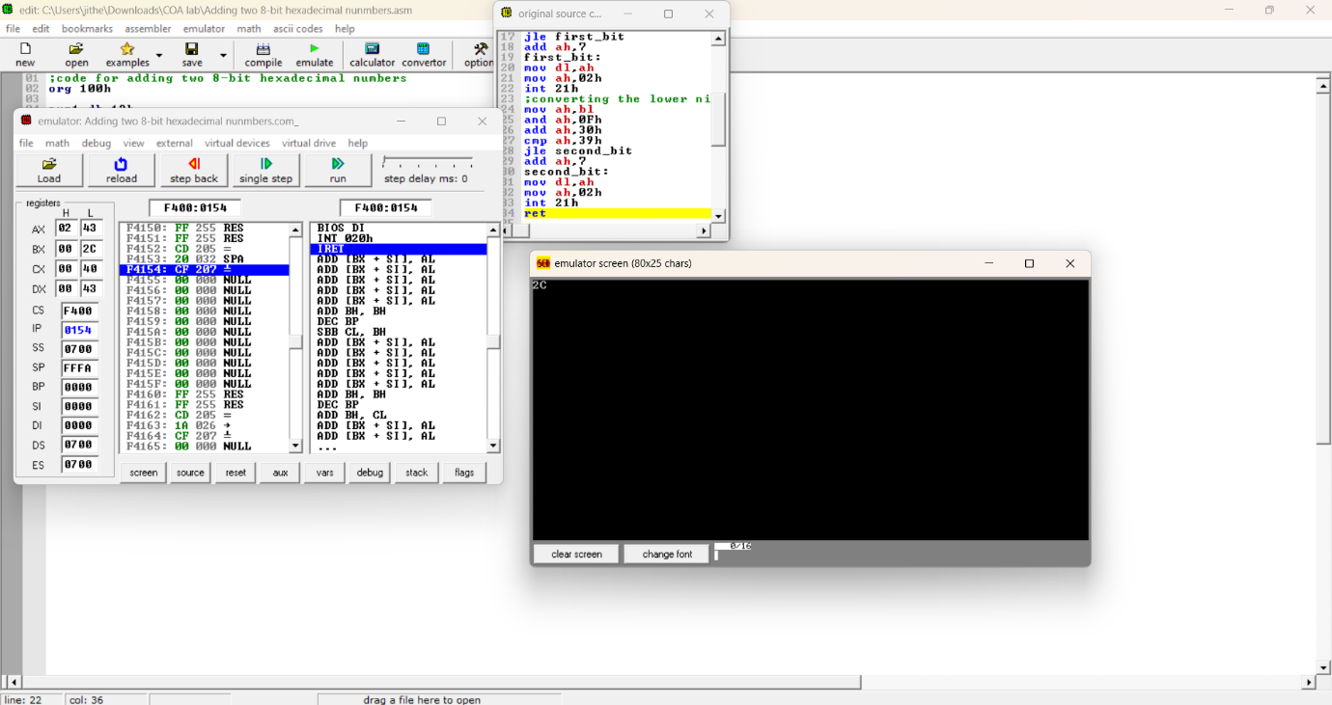

org 100h

jmp start

start:

mov ax,1234h

add ax,4567h

mov bx,ax

and ax,0F000h

shr ax,12

add ax,30h

cmp ax,39h

jle first_bit

add ax,7h

first_bit:

mov dx,ax

mov ah,02h

int 21h

mov ax,bx

and ax,0F00h

shr ax,8

add ax,30h

cmp ax,39h

jle second_bit

add ax,7h

second_bit:

mov dx,ax

mov ah,02h

int 21h

mov ax,bx

and ax,00F0h

shr ax,4

add ax,30h

cmp ax,39h

jle third_bit

add ax,7h

third_bit:

mov dx,ax

mov ah,02h

int 21h

mov ax,bx

and ax,000Fh

add ax,30h

cmp ax,39h

jle fourth_bit

add ax,7h

fourth_bit:

mov dx,ax

mov ah,02h

int 21h

ret

