org 100h

num1 db 54h

num2 db 31h

start:

mov al,num1

sub al,num2

mov bl,al

mov ah,al

and ah,0f0h

shr ah,4

add ah,30h

cmp ah,39h

jle print_first_digit

add ah,7

print_first_digit:

mov dl,ah

mov ah,02h

int 21h

mov ah,bl

and ah,0Fh

add ah,30h

cmp ah,39h

jle print_second_digit

add ah,7

print_second_digit:

mov dl,ah

mov ah,02h

int 21h

mov ah,4Ch

int 21h  
  
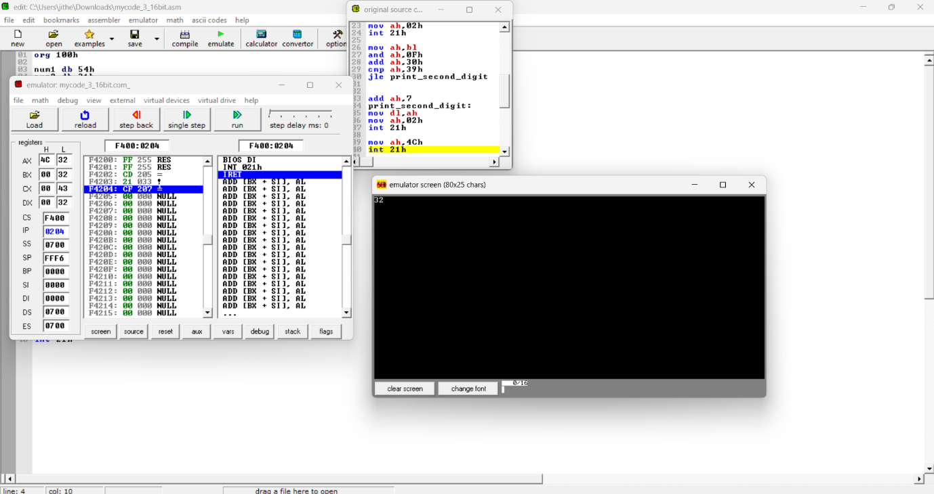

num1 dw 3620h

num2 dw 2921h

start:

mov ax, num1

sub ax, num2

mov bx, ax

mov ah, bh

shr ah, 4

add ah, 30h

cmp ah, 39h

jle print_high_nibble

add ah, 7

print_high_nibble:

mov dl, ah

mov ah, 02h

int 21h

mov ah, bh

and ah, 0fh

add ah, 30h

cmp ah, 39h

jle print_low_nibble

add ah, 7

print_low_nibble:

mov dl, ah

mov ah, 02h

int 21h

mov ah, bl

shr ah, 4

add ah, 30h

cmp ah, 39h

jle print_high_nibble2

add ah, 7

print_high_nibble2:

mov dl, ah

mov ah, 02h

int 21h

mov ah, bl

and ah, 0fh

add ah, 30h

cmp ah, 39h

jle print_low_nibble2

add ah, 7

print_low_nibble2:

mov dl, ah

mov ah, 02h

int 21h

mov ah, 4ch

int 21h

