**Application Demo**

1. Create a Environment and install flask, flask-mysqldb.

python -m venv jithesh

.\jithesh\Scripts\activate

python -m pip install --upgrade pip

python -m pip install flask

pip install flask-mysqldb

1. Created a Simple static authentication for the CRUD Web Application on Localhost

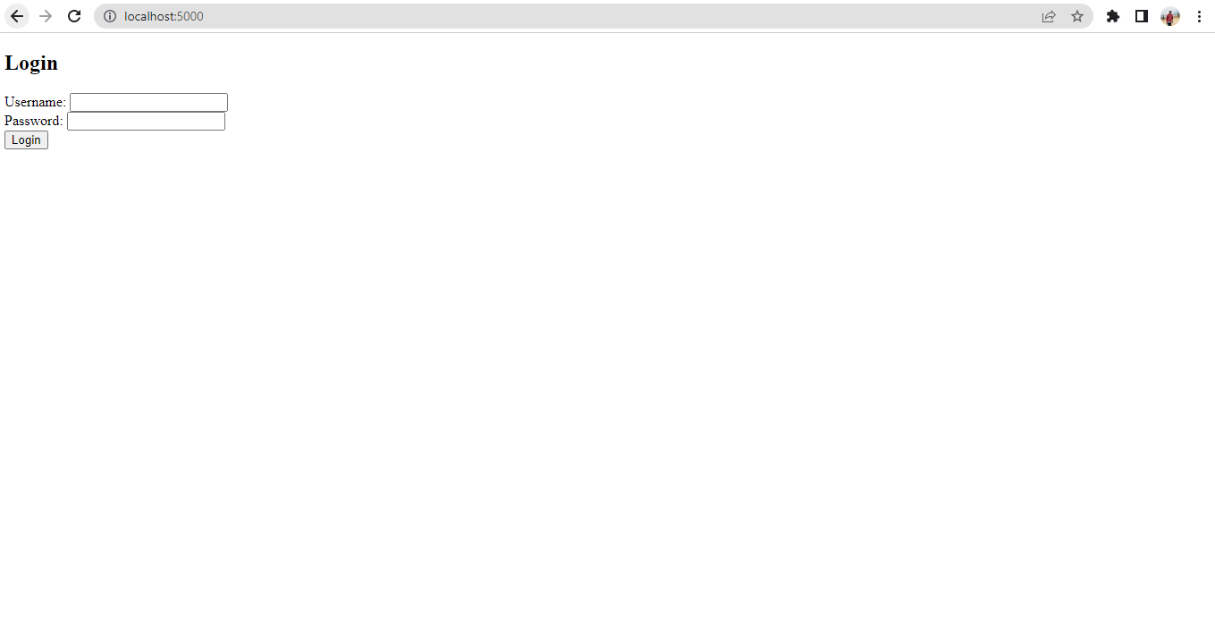

Username is: jithesh

Password is: jithesh123

1. Below snipet is the application which helps to perform CRUD operations (/index is redirected after successful authentication)

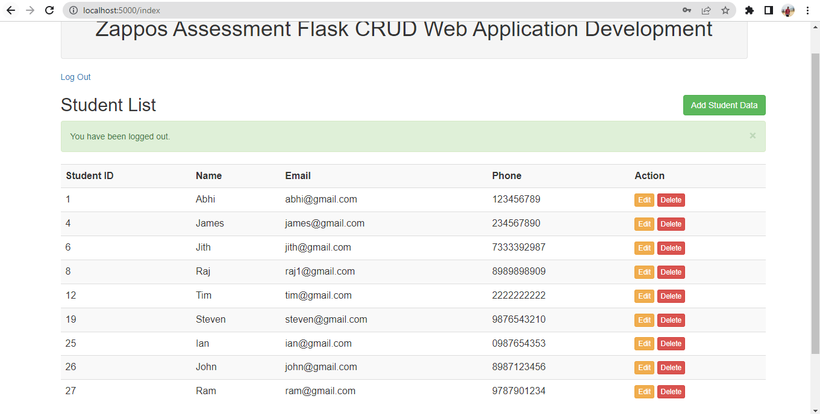

1. CRUD Operations

Create a CRUD database and a student table using the below queries. Also insert records into students table.

CREATE database CRUD;

USE CRUD;

CREATE TABLE students (

    id INT AUTO_INCREMENT PRIMARY KEY,

    name VARCHAR(100),

    email VARCHAR(255),

    phone VARCHAR(20)

) AUTO_INCREMENT = 10;

 DROP TABLE STUDENTS;

 INSERT INTO students (id, name, email, phone) VALUES

(1, 'Abhi', 'abhi@gmail.com', '908393481'),

(8, 'Raj', 'raj1@gmail.com', '8989898909'),

(6, 'Jith', 'jith@gmail.com', '7333392987'),

(5, 'Akash', 'aksha@gmail.com', '2341234567'),

(4, 'James', 'james@gmail.com', '234567890'),

(12, 'Tim', 'tim@gmail.com', '2222222222'),

(19, 'Steven', 'steven@gmail.com', '9876543210'),

(25, 'Ian', 'ian@gmail.com', '0987654353');

select * from students;

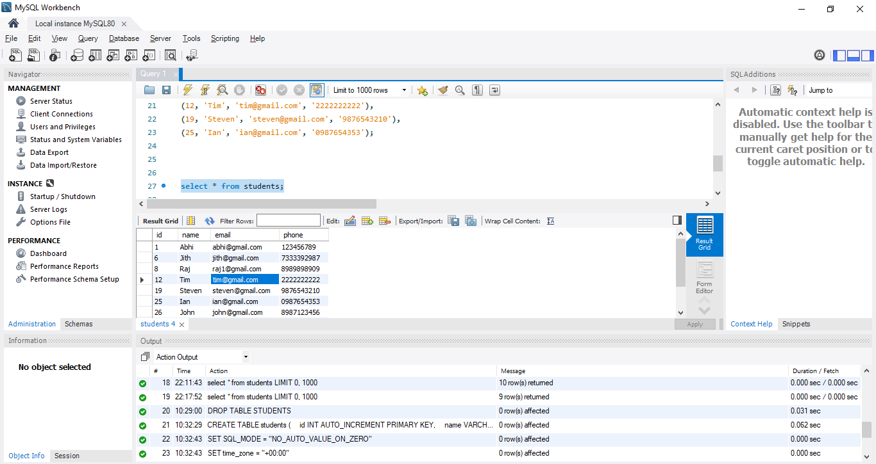

1. Add Student Data – Click on Add student data button on top right

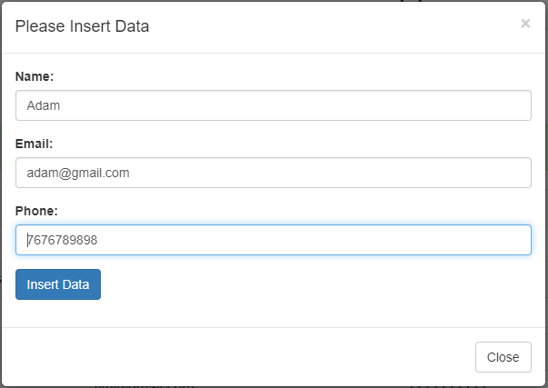

Adam Data is inserted and it can be seen in the below screenshot. It also displays that the data is inserted successfully.

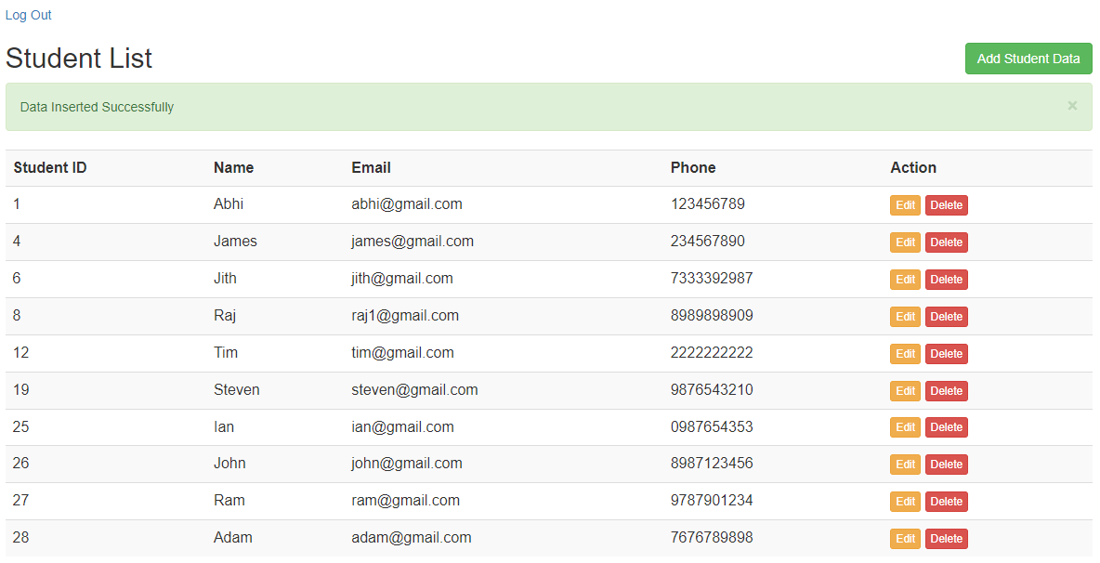

1. Update record – Click on Edit button under Action

Edit Adam’s phone number from 7676789898 to 8567909123. In below snippet it shows that the data is updated successfully and phone number is updated accordingly.

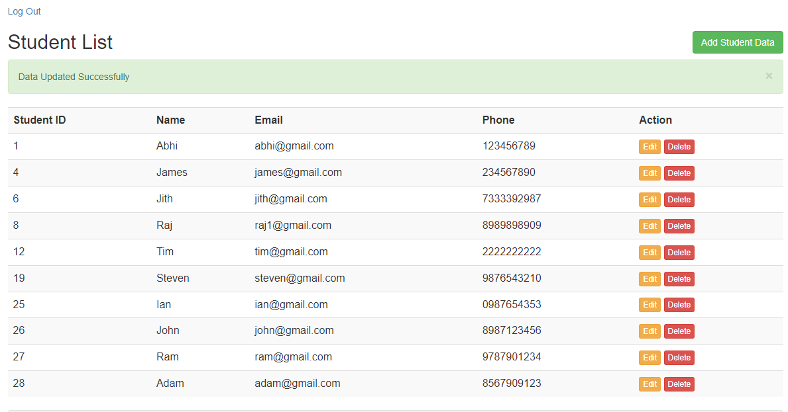

1. Delete a record – Click on Delete button under action

Delete James Record having Student ID: 4. Click on delete button and it pops up a message if you are sure to delete the record.

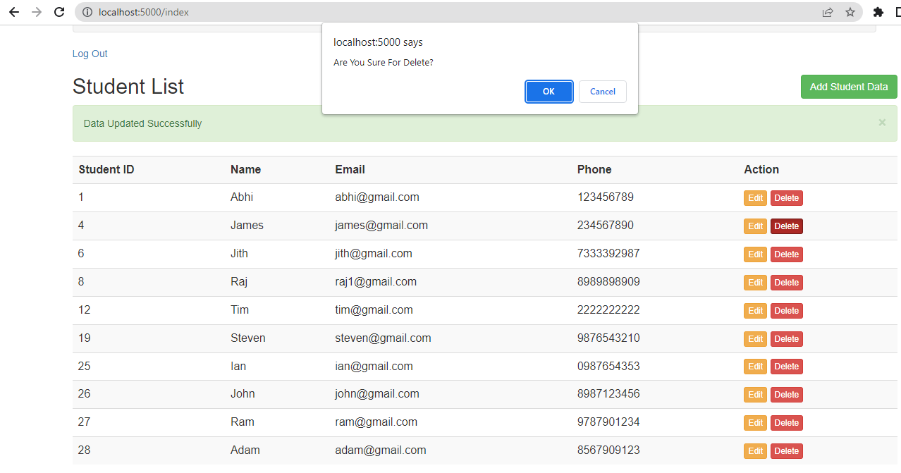

In the below snippet it displays a message that the record has been deleted successfully. James record is not seen in the students list.

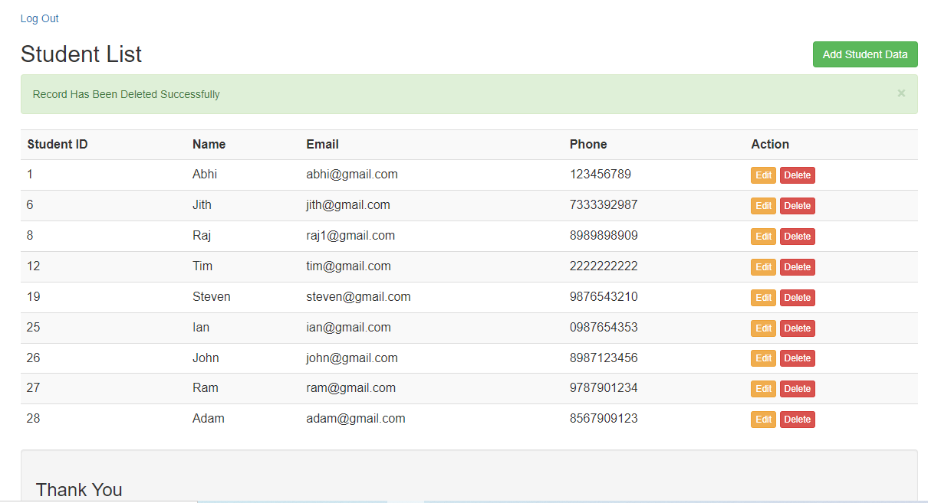

1. Logout After performing all the CRUD Operations

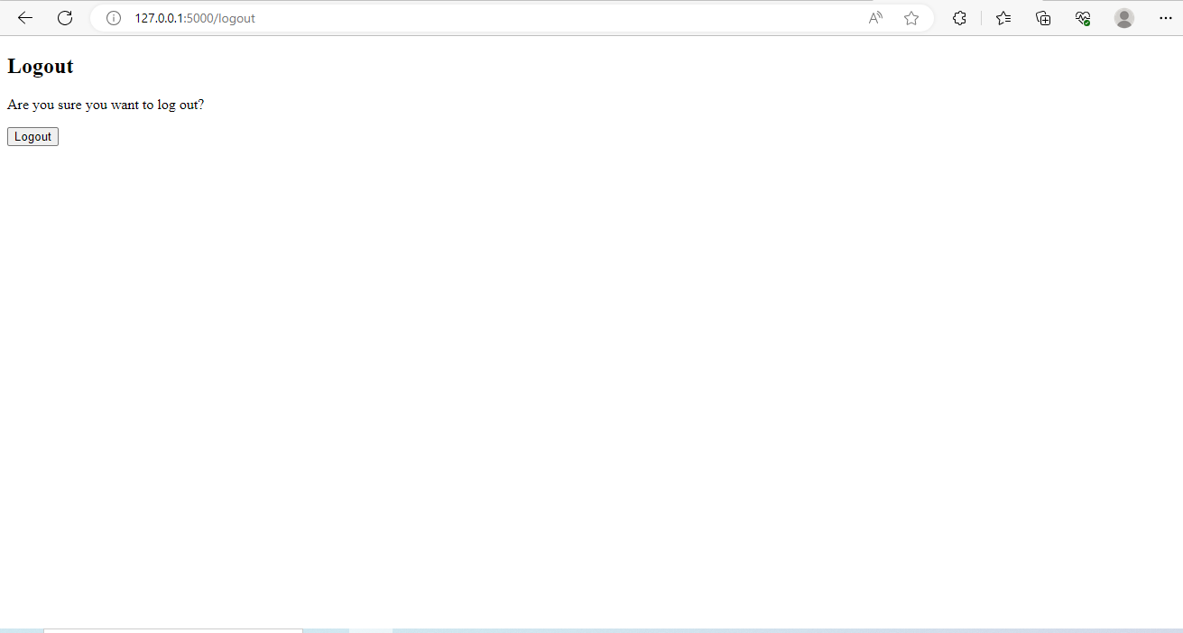

After Clicking on Logout Button the page will be redirected to Login Page

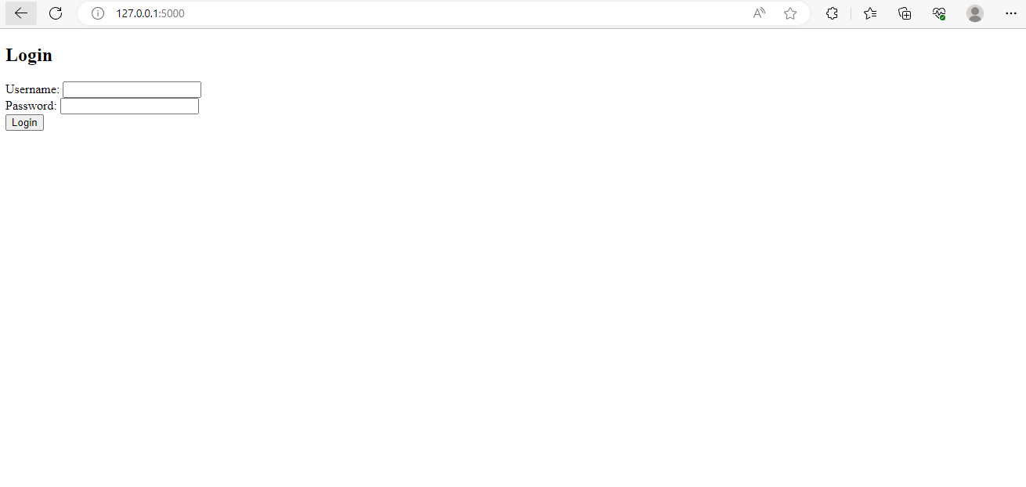

1. In requirements.txt I have mentioned the dependencies required to build the application as it helps in containerizing the application
2. Docker file is written to copy all the application codes and requirements file to the working directory of the container and the CMD[“flask”,”run”] runs the application and it will be exposed on port 5000