citi_sm

**Solace POC Documentation**

TIBCO iProcess and AMX BPM to Solace Integration

**Written By**

**North America DevOps TIBCO**

\*GCT GLOBAL CTO NAM DevOps TIBCO

Revision 1.0

Last Revised on 1/05/2018

**JMS Connectivity from TIBCO iProcess with solace**

1. Create the solace objects for iProcess connectivity such as message-vpn, connection factories, endpoints, username and client acl properties as mentioned in BW connectivity section.

icl-slvmr-va02(configure)# create message-vpn iprocess\_vpn

icl-slvmr-va02(configure/message-vpn)# authentication

icl-slvmr-va02(configure/message-vpn/authentication)# user-class client

icl-slvmr-va02(...message-vpn/authentication/user-class)# basic auth-type none

icl-slvmr-va02(...message-vpn/authentication/user-class)# exit

icl-slvmr-va02(configure/message-vpn/authentication)# exit

icl-slvmr-va02(configure/message-vpn)# no shutdown

icl-slvmr-va02(configure/message-vpn)# exit

icl-slvmr-va02(configure)# message-spool message-vpn iprocess\_vpn

icl-slvmr-va02(configure/message-spool)# max-spool-usage 2000

icl-slvmr-va02(configure/message-spool)# exit

icl-slvmr-va02(configure)# client-profile default message-vpn iprocess\_vpn

icl-slvmr-va02(configure/client-profile)# message-spool allow-guaranteed-message-receive

icl-slvmr-va02(configure/client-profile)# message-spool allow-guaranteed-message-send

icl-slvmr-va02(configure/client-profile)# message-spool allow-transacted-sessions

icl-slvmr-va02(configure/client-profile)# exit

icl-slvmr-va02(configure)# create client-username ipe\_user message-vpn iprocess\_vpn

icl-slvmr-va02(configure/client-username)# acl-profile default

icl-slvmr-va02(configure/client-username)# client-profile default

icl-slvmr-va02(configure/client-username)# no shutdown

icl-slvmr-va02(configure/client-username)# exit

icl-slvmr-va02(configure)# message-spool message-vpn iprocess\_vpn

icl-slvmr-va02(configure/message-spool)# create queue TestQueueiPe1

icl-slvmr-va02(configure/message-spool/queue)#

icl-slvmr-va02(configure/message-spool/queue)# access-type exclusive

icl-slvmr-va02(configure/message-spool/queue)# max-spool-usage 2000

icl-slvmr-va02(configure/message-spool/queue)# permission all delete

icl-slvmr-va02(configure/message-spool/queue)# no shutdown

icl-slvmr-va02(configure/message-spool/queue)# exit

icl-slvmr-va02(configure/message-spool)# exit

icl-slvmr-va02(configure)# jndi message-vpn iprocess\_vpn

icl-slvmr-va02(configure/jndi)# create connection-factory JNDI/CF/ipe

icl-slvmr-va02(configure/jndi/connection-factory)# property-list messaging-properties

icl-slvmr-va02(...jndi/connection-factory/property-list)# property default-delivery-mode persistent

icl-slvmr-va02(...jndi/connection-factory/property-list)# exit

icl-slvmr-va02(configure/jndi/connection-factory)# property-list transport-properties

icl-slvmr-va02(...jndi/connection-factory/property-list)# property direct-transport false

icl-slvmr-va02(...jndi/connection-factory/property-list)# property "reconnect-retry-wait" "3000"

icl-slvmr-va02(...jndi/connection-factory/property-list)# property "reconnect-retries" "20"

icl-slvmr-va02(...jndi/connection-factory/property-list)# property "connect-retries-per-host" "1"

icl-slvmr-va02(...jndi/connection-factory/property-list)# property "connect-retries" "1"

icl-slvmr-va02(...jndi/connection-factory/property-list)# exit

icl-slvmr-va02(configure/jndi/connection-factory)# exit

icl-slvmr-va02(configure/jndi)# create queue JNDIQreq1

icl-slvmr-va02(configure/jndi/queue)# property physical-name TestQueueiPe1

icl-slvmr-va02(configure/jndi/queue)# exit

icl-slvmr-va02(configure/jndi)# no shutdown

icl-slvmr-va02(configure/jndi)# exit

1. Update the below entries in the file $SWDIR/etc/iapjms\_classpath.properties

classpath.internal.common=common\_swprocess\_library.jar,common\_bootstrap\_library.jar,common\_utils\_library.jar,commons-lang-2.6.jar,commons-logging-1.1.3.jar

classpath.ems.1=jms.jar,tibjms.jar,tibjmsadmin.jar,tibcrypt.jar,slf4j-api-1.4.2.jar,slf4j-simple-1.4.2.jar,sol-jms-10.2.2.jar,sol-jcsmp-10.2.2.jar,sol-common-10.2.2.jar

1. Comment the existing EMS configuration and add the solace VMR details in $SWDIR/etc/iapjms.properties

IAPJMSConnect.InitialContextFactory=com.solacesystems.jndi.SolJNDIInitialContextFactory

IAPJMSConnect.InitialURL=smf://10.40.57.174:55555

IAPJMSConnect.TopicConnectionFactory=JNDI/CF/ipe

IAPJMSConnect.SecurityPrinciple=ipe\_user

IAPJMSConnect.SecurityCredentials=

IAPJMSConnect.SecurityEncryption=PLAIN

IAPJMSConnect.Persistent=Y

IAPJMSConnect.Priority=1

IAPJMSConnect.TimeToLive=0

1. Place the below jars in the location $SWDIR/jmslib/ems/

sol-common-10.2.2.jar

sol-jcsmp-10.2.2.jar

sol-jms-10.2.2.jar

1. Place the below jars in the location $SWDIR/jar/

commons-lang-2.6.jar

commons-logging-1.1.3.jar

geronimo-jms\_1.1\_spec-1.1.1.jar

org.osgi.annotation-6.0.0.jar

1. Place the below jars in the location $SWDIR/eaijava/libs/repository/emsclient

sol-common-10.2.2.jar

sol-jcsmp-10.2.2.jar

sol-jms-10.2.2.jar

commons-lang-2.6.jar

commons-logging-1.1.3.jar

geronimo-jms\_1.1\_spec-1.1.1.jar

org.osgi.annotation-6.0.0.jar

log4j-1.2.17.jar

1. Update iProcess EAI JAVA EMS details in DB as below.

Location = $SWDIR/\_otherInfo/Hlocal/delta/

bash-4.1$ cat provider.txt

[provider]

NAME=RELIPRO

URL=smf://10.40.57.174:55555

JNDI\_USER=ipe\_user@iprocess\_vpn

FACTORY=com.solacesystems.jndi.SolJNDIInitialContextFactory

[end]

[provider]

NAME=RELEMS

URL=smf://10.40.57.174:55555

JNDI\_USER=ipe\_user@iprocess\_vpn

FACTORY=com.solacesystems.jndi.SolJNDIInitialContextFactory

[end]

bash-4.1$ cat dest.txt

[dest]

EndPointName=RELIPRO

JNDIQuqueName=TestQueueiPe3

FACTORY=JNDI/CF/ipe

ProviderName=RELIPRO

[end]

[dest]

EndPointName=RELEMS

JNDIQuqueName=TestQueueiPe4

FACTORY=JNDI/CF/ipe

ProviderName=RELEMS

[end]

Location = $SWDIR/\_otherInfo/Hlocal/bin

Execute below command

./iProcStart

1. Execute the below command to update message-vpn

$SWDIR/util/swadm set\_attribute 0 IAPJMS 0 JVMPROPS -DSolace\_JMS\_VPN=iprocess\_vpn

1. Shutdown the iProcess node and start it with clean logs.
2. Check the IAPJMS connection status at Solace VMR once the node is up and running fine.

Connection from IAPJMS will be established at Solace VMR side.

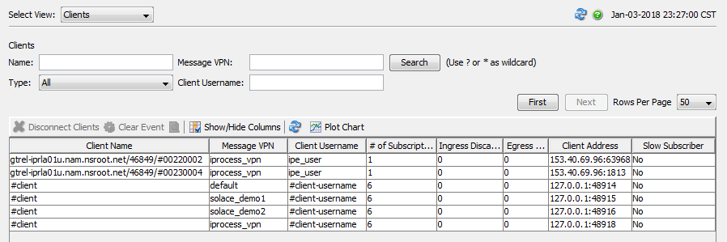

1. Initiate some EAI actions from iProcess workspace or CI/SOA eclipse front end portal to check the EAI JAVA call.

if the EAI actions has JMS call, then we can see the message is getting posted at the respective queue which will be waiting to be get consumed by BW.

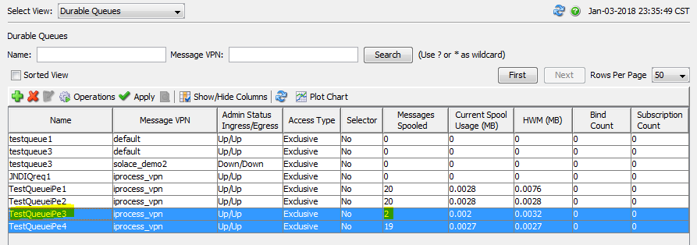

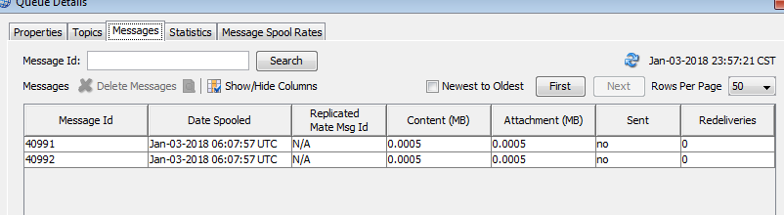

**JMS Connectivity from TIBCO AMX BPM with solace**

Regarding AMX BPM, TIBCO has confirmed that we cannot use or connect to solace directly from AMX BPM product or from its service layer. They are advising us to use BW as integration layer between AMX BPM and Solace if we need to use solace for any purpose.  This is applicable to AMX BPM version 4.x as well.

The reason given by TIBCO for this is, AMX BPM uses EMS in a number of areas internally such as - SOAP/JMS I/O, Service virtualization bindings, AMX Administration commands flow and internal virtualization of the link between the process engine and the work manager. All of these uses proprietary capabilities that are only available in TIBCO EMS.

Hence, it is really not possible to use Solace as an EMS replacement with AMX BPM.