**DFD : HOUSEBOAT MANAGEMENT SYSTEM**

CONTEXT DIAGRAM FOR HOUSEBOAT MANAGEMENT SYSYTEM

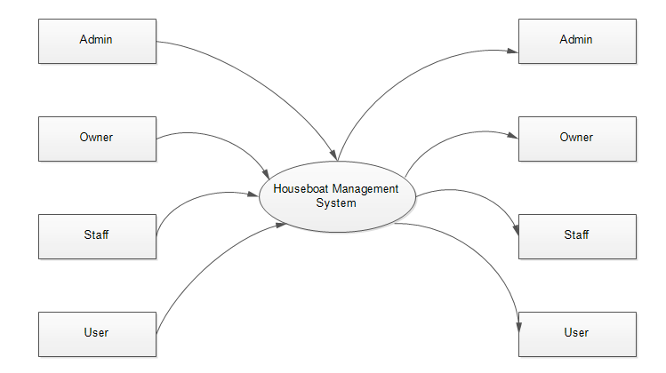

LEVEL-1 DFD FOR ADMIN

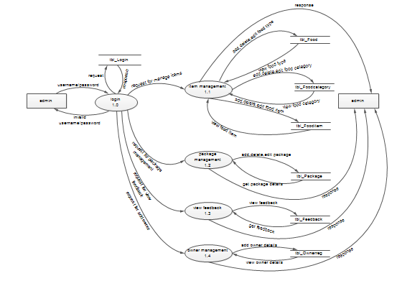

LEVEL- 2 DFD FOR ADMIN

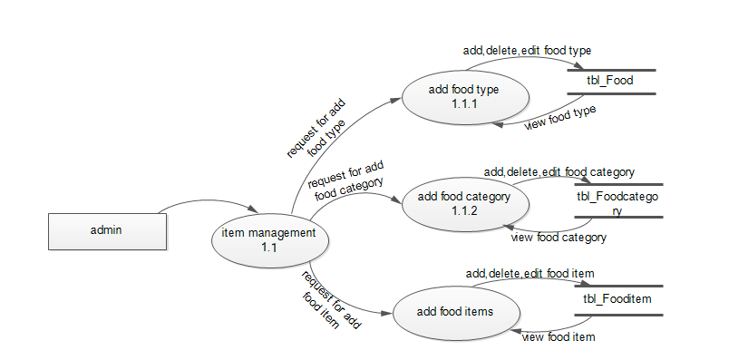

LEVEL- 1 DFD FOR OWNER

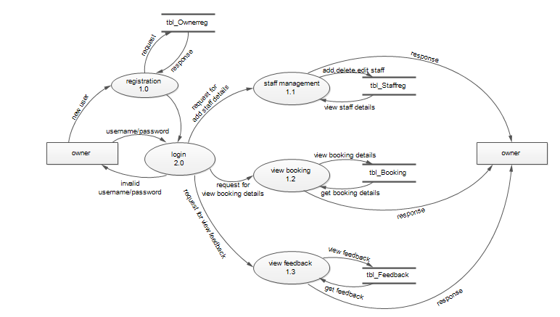

LEVEL -1 DFD FOR STAFF

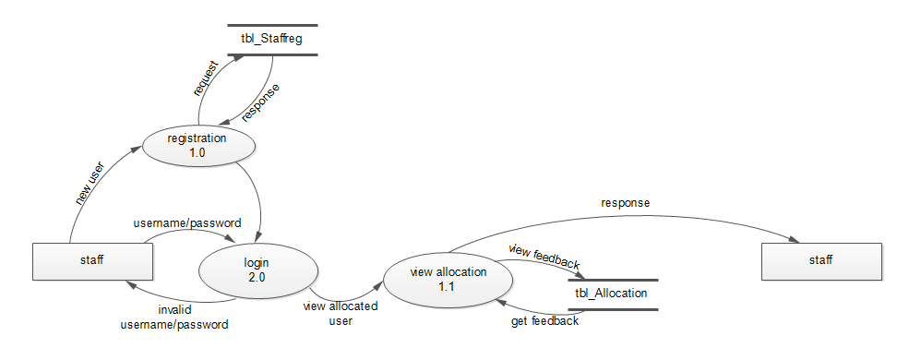

LEVEL -1 DFD FOR USER

